PROJECT REPORT
ON
“Study on recycling community of local communities”

PREPARED BY :

Saloni anil singh tomar
sneha rajnish Rai
Sakshi Sunil Dewade
ruchita Ashok kedare

BACHELOR OF COMMERCE SEMESTER: - V
UNDER THE GUIDENC
PROF. SHARMIL KARVE

PROF. VAIBHAV NARULE

B.K BIRLA NIGHT COLLAGE OF ARTS, SCIENCE, AND COMMERCE, KALYAN

ACADEMIC YEAR: - 202 6-2 7

DECLARATION

I Ms. Sonam Rajesh Yadav , Student of B.K. Birla Night College, Institute studying In T.Y.
BCom. Hereby declare that I have completed the ﬁeld project
entitled “Study on recycling community of local communities”In the area of commerce during the academic year 2026-27.

The report work isoriginal and the information / data included in the report istrue emerging from the primary and / secondary data gathered and analyzed aspart of thisproject.

Due credit isextended on the work of Literature/secondary survey by endorsing it in the bibliography asper prescribed format.

Signature of the student with date Saloni anil singh tomar

DECLARATION

I Ms. Anjali sunil chauhan , Student of B.K. Birla Night College, Institute studying In T.Y. BCom. Hereby declare that I have completed the ﬁeld project entitled “ Study on recycling community of local communities” In the area of
commerce during the academic year 2026-27.

The report work isoriginal and the information / data included in the report istrue
emerging from the primary and / secondary data gathered and analyzed aspart of thisproject.

Due credit isextended on the work of Literature/secondary survey by endorsing it in the bibliography asper prescribed format.

Signature of the student with date Anjali
sneha rajnish Rai

DECLARATION

I Ms. Sonia Shuddhodhan Jadhav , Student of B.K. Birla Night College, Institute studying In T.Y. BCom. Hereby declare that I have completed the ﬁeld project entitled “ Study on recycling community of local communities” In the area of
commerce during the academic year 2026-27

The report work isoriginal and the information / data included in the report istrue emerging from the primary and / secondary data gathered and analyzed aspart of thisproject.

Due credit isextended on the work of Literature/secondary survey by endorsing it in the bibliography asper prescribed format.

Signature of the student with date
Sakshi Sunil Dewade

DECLARATION

I Ms. Ankita Tanaji Gaikwad , Student of B.K. Birla Night College, Institute studying In T.Y. BCom. Hereby declare that I have completed the ﬁeld project entitled “ Study on recycling community of local communities” In the area of
commerce during the academic year 2026-27

The report work isoriginal and the information / data included in the report istrue emerging from the primary and / secondary data gathered and analyzed aspart of thisproject.

Due credit isextended on the work of Literature/secondary survey by endorsing it in the bibliography asper prescribed format.

Signature of the student with date ruchita Ashok kedare



Kalyan Citizens’ Education Society’s
B. K. Birla Night Arts, Science and Commerce College, Kalyan
(Aﬃliated to University of Mumbai)
B.K. BIRLA COLLEGE CAMPUS ROAD, GAURIPADA, KALYAN (WEST) – 421301

CERTIFICTE

I hereby certify that, Ms. Sonam Rajesh Yadav, student of B.K. Birla Night College, Studying in
S.Y. BCom. Hascompleted a project titled “Study on recycling community of local communities ” in the area of commerce specialization for academic year 2026-27To the best of my knowledge the work of the student isoriginal and the information included in the project iscorrect

Internal Guide Head of the Department Principal

Kalyan Citizens’ Education Society’s
B. K. Birla Night Arts, Science and Commerce College, Kalyan
(Aﬃliated to University of Mumbai)
B.K. BIRLA COLLEGE CAMPUS ROAD, GAURIPADA, KALYAN (WEST) – 421301

CERTIFICTE

I hereby certify that, Ms.anjali sunil chauhan, student of B.K. Birla Night College, Studying in
S.Y. BCom. Hascompleted a project titled “Study on recycling community of local communities” in the area of commerce specialization for academic year 2026-27To the best of my knowledge the work of the student isoriginal and the information included in the project iscorrect

Internal Guide Head of the Department Principal

Kalyan Citizens’ Education Society’s
B. K. Birla Night Arts, Science and Commerce College, Kalyan
(Aﬃliated to University of Mumbai)
B.K. BIRLA COLLEGE CAMPUS ROAD, GAURIPADA, KALYAN (WEST) – 421301

CERTIFICTE

I hereby certify that, Ms. Sonia Shuddhodhan Jadhav , student of B.K. Birla Night College, Studying in S.Y. BCom. Hascompleted a project titled “Study on recycling community of local communities” in the area of commerce specialization for academic year 2026-27To the best of my knowledge the work of the student isoriginal and the information included in the project iscorrect

Internal Guide Head of the Department Principal

Kalyan Citizens’ Education Society’s
B. K. Birla Night Arts, Science and Commerce College, Kalyan
(Aﬃliated to University of Mumbai)
B.K. BIRLA COLLEGE CAMPUS ROAD, GAURIPADA, KALYAN (WEST) – 421301

CERTIFICTE

I hereby certify that, Ms. Ankita Tanaji Gaikwad, student of B.K. Birla Night College, Studying in
S.Y. BCom. Hascompleted a project titled “Study on recycling community of local communities” in the area of commerce specialization for academic year 2026-27To the best of my knowledge the work of the student isoriginal and the information included in the project iscorrect

Internal Guide Head of the Department Principal

Kalyan Citizens’ Education Society’s
B. K. Birla Night Arts, Science and Commerce College, Kalyan
(Aﬃliated to University of Mumbai)
B.K. BIRLA COLLEGE CAMPUS ROAD, GAURIPADA, KALYAN (WEST) – 421301

CERTIFICTE

I hereby certify that, Ms. Udhita Rajesh Jadhav , student of B.K. Birla Night College, Studying in
S.Y. BCom. Hascompleted a project titled “Study on recycling community of local communities” in the area of commerce specialization for academic year 2026-27To the best of my knowledge the work of the student isoriginal and the information included in the project iscorrect

Internal Guide Head of the Department Principal

ACKNOWLEDEGMENT

To list who all have helped usisdiﬃcult because they are so numerousand the Depth isso enormous.
We would like to acknowledge the following asbeing idealistic channelsand fresh Dimension in the completion of thisproject.
We take thisopportunity to thank the University of Mumbai for giving uschance to do thisproject.
We would like to thank our Director and Principal for providing the necessary facilitiesrequired for completion of thisproject.

We would also like to expressour sincere gratitude towardsour project guide,
Prof. Sharmila Karve , Prof.Vaibhav Narule whose guidance and care made the project successful.

Lastly, we would like to thank each and every person who directly or indirectly helped usin the completion of the project.

GUIDE INTERACTION DIARY FORM

We, the undersigned Ms. Anjali Shiv Shankar Padhy, Ms. Aarti surendar jaiswar, Mr. Shrikant Jayprakash Jaiswar, Mr. Krishna Rajesh Gaud, Mr. Sahil Azamal Shah, studying in the
T.Y. BCOM year of BACHLOR OF COMMERCE full time
course isdoing our project work under the guidance of MS. SHARMILA KARVE , wish to state that we have met our internal guide on the following datesmentioned below for project guidelines: -

Sr.No. | Date | Signature of the Internal Guide
1)
2)
3)
4)
5)

6)

Signature of the candidate Signature of Internal Guide

INDEX

 | CHAPTER NO. | TOPIC NAME | PAGE NO.
 | 1) | INTRODUCTION | 15
 | 2) | NEED AND SIGNIFICANCE OF THE STUDY | 26
 | 3) | OBJECTIVE | 32
 | 4) | REASEARCH METHODOLOGY | 35
 | 5) | OBSERVATION | 52
 | 6) | FIELD WORK DESCRIPTION | 54
 | 7) | CONCLUSION | 62

CHAPTER – 01 INTRODUCTION
INTRODUCTION
In today'sworld, environmental protection ha sbecome one of the most important responsibilitiesof individuals, communities, businesses, and governments. Rapid population growth, urbanization, increasing consumption, and changing lifestyleshave resulted in a signiﬁcant increase in the amount of waste generated every day. Among different typesof waste, packaging waste hasbecome a major environmental concern. Plastic bags, plastic containers, wrappers, disposable cups, thermocol , and other single-use packaging materialsare commonly used because they are inexpensive, lightweight, and convenient.
However, many of these materialscreate serious
problemsbecause they remain in the environment for a very long time and are often diﬃcult to manage after use.

Local small vendorsare an important part of the economy and daily life of communities. Street food sellers, vegetable and fruit vendors, small grocery shops, tea stalls, ﬂower sellers, small bakeries, handicraft sellers, and other local businessesprovide useful productsand servicesto people. Packaging isan essential part of their daily activitiesbecause vendorsneed to carry, protect, store, and deliver productsto customers. However, many small vendorshave limited
ﬁnancial resourcesand may not have enough information about environmentally friendly packaging alternatives.

The Green CraftsProject focuseson creating awarenessamong local small vendorsawarenessamong local small vendorsabout sustainable packaging and helping them identify simple, affordable, and practical alternativesto harmful packaging materials. The project combinesenvironmental awarenesswith creativity and practical action. It encouragesthe use of materialsthat can be reused, recycled, composted, or naturally decomposed.

The purpose isnot simply to tell vendorsto stop using plastic. Instead, the project aimsto understand their actual packaging needs, identify the diﬃcultiesthey face, introduce suitable alternatives, and encourage gradual changesthat are realistic for their businesses.

- - -

- Meaning of Green Crafts

The term “Green Crafts” refersto creative products, activities, and solutionsthat are designed with concern for the environment. Green craftsgenerally involve the responsible use of materials, reduction of waste, reuse of available resources, and creation of useful
productswithout causing unnecessary environmental damage.

Craft activitiescan play an important role in environmental education. Materialssuch asold newspapers, cardboard, cloth, paper, natural ﬁbres, used paper bags, plant-based materials, and other reusable itemscan sometimesbe transformed into useful packaging products. For example, newspapersand paper can be folded or designed into simple wrapping materials, while old cloth can be converted into reusable bags.

Green craftscan therefore connect creativity, sustainability, and practical problem-solving. Instead of treating waste materialsonly asrubbish, the project encouragespeople to think about how some materialscan be reused or converted into useful products.

For local vendors, green craftscan provide ideasfor packaging that are simple and visually attractive while also reducing dependence on disposable plastic. In some cases, locally available materialscan be used, which may help reduce transportation and unnecessary expenses.

- - -

- Understanding Sustainable Packaging Packaging isthe material or container used to
protect, store, transport, present, or deliver a product. Packaging isnecessary for many businessesbecause it protectsproductsfrom dust, moisture, damage, and contamination. It can also make productseasier to carry and provide information to customers.

However, packaging becomesan environmental problem when it isdesigned mainly for short-term use but remainsin the environment for a long time. Sustainable packaging attemptsto reduce thisenvironmental impact.

Sustainable packaging can be understood aspackaging that considersenvironmental, social, and economic factorsthroughout itslife cycle. It aimsto use resourcesresponsibly, reduce unnecessary material, encourage reuse and recycling, and minimize waste.

Examplesof potentially more sustainable packaging choicesinclude:

- Reusable cloth bags
- Paper bagsmade from responsibly sourced or recycled paper
- Cardboard boxesthat can be reused or recycled
- Reusable containers
- Properly designed paper wrapping
- Packaging made from suitable plant-based or compostable materials
- Recycled- material packaging

The best packaging choice dependson the product, cost, availability, durability, hygiene requirements, and local waste-management facilities. Therefore, sustainable packaging doesnot mean that one material issuitable for every vendor.

- - -
- The Problem of Single- Use Packaging Single-use packaging isdesigned to be used
once and then discarded. Plastic bags, wrappers, cups, takeaway containers, and other disposable itemsare common examples.

The convenience of single-use packaging hascontributed to itswidespread use. Customersoften expect productsto be packed quickly and cheaply. Vendorsmay therefore choose disposable packaging because it iseasily available and requireslittle preparation.

However, the large-scale use of disposable packaging createsa signiﬁcant waste-management challenge. When waste isnot properly collected, separated, recycled, or treated, it may enter streets, drains, rivers, agricultural areas, and other partsof the environment.
Plastic waste can also break down into smaller piecescalled microplastics, which can persist in the environment. Waste accumulation can affect animals, water bodies, soil, and the overall cleanlinessof communities.

The problem isespecially important at the local level because small quantitiesof packaging waste produced by thousandsof vendorsand consumerscan add up to a very large amount.

Therefore, reducing unnecessary single-use packaging isan important part of creating cleaner and more sustainable communities.

- - -

- Role of Local Small Vendors

Local small vendorsare at the centre of thisproject because they interact directly with customersevery day. Their packaging decisionscan inﬂuence the amount and type of waste generated in a community.

A small food vendor may provide customerswith food in disposable containers. A vegetable seller may use plastic bags. A grocery shop may provide several plastic bagsfor different products. A tea or snack seller may use disposable cupsand containers.
Although each individual vendor may use only a small quantity of packaging, the combined effect can be considerable.

At the same time, it isimportant to understand that vendorsface practical challenges. Many small businessesoperate with limited budgets. They must consider the price of packaging, customer expectations, storage space, availability of materials, convenience, and the time required for packing.

Therefore, sustainable packaging solutionsmust be affordable, accessible, convenient, and appropriate for local businesses.

The Green CraftsProject recognizesvendorsnot asthe cause of the environmental problem, but asimportant partnersin solving it.

- - -

- Need for AwarenessAmong Vendors

Awarenessisone of the most important componentsof environmental sustainability. People cannot alwaysmake environmentally responsible choicesif they do not know about the consequencesof their actionsor the alternativesavailable to them.

Some vendorsmay continue using conventional
packaging simply because it isfamiliar and easily available. They may not know about reusable or recyclable alternatives. Othersmay know about sustainable materialsbut believe that they are too expensive or diﬃcult to obtain.

The project therefore aimsto create awarenessthrough simple communication and practical demonstrations.

Instead of using complicated scientiﬁc language, the project can explain:

- What packaging waste is.
- Why excessive disposable packaging isa problem.
- How packaging affectsthe environment.
- What sustainable packaging means.
- Which alternativesmay be suitable for their business.
- How reusable packaging can reduce waste.
- How customerscan be encouraged to make sustainable choices.
- How packaging waste can be separated for recycling or proper disposal.

Awarenessbecomesmore effective when people can see and understand practical alternativesrather than only receiving theoretical information.

- - -

- Environmental Importance of Sustainable Packaging

Sustainable packaging can contribute to environmental protection in several ways.

First, it can help reduce waste generation. If a reusable bag replacesseveral disposable bagsover time, the total number of discarded bagscan decrease.

Second, sustainable packaging can encourage resource conservation. Reusing materialsmeansthat fewer new materialsmay be required for every transaction.

Third, recycling and reuse can help reduce the amount of waste sent to landﬁllsor other disposal facilities.

Fourth, reducing unnecessary packaging can help lower the environmental impactsassociated with producing, transporting, and disposing of packaging materials.

Sustainable packaging can also contribute to cleaner public spaces. When fewer disposable materialsare thrown away, streets, markets, drains, and public areasmay remain cleaner.

Environmental sustainability istherefore not only
a global issue. It beginswith everyday activitiesin homes, schools, markets, shops, and communities.

- - -

- Sustainable Packaging and Consumer Behaviour

Packaging choicesare inﬂuenced not only by vendorsbut also by customers. Many customersprefer packaging that isconvenient, clean, attractive, and easy to carry.

Some customersmay automatically expect a separate plastic bag even when it isnot necessary. Othersmay be willing to carry reusable bagsor containers.

Therefore, consumer awarenessisan important part of sustainable packaging.

Vendorscan help by communicating simple messagessuch as:

- “Bring your reusable bag.”
- “Choose reusable packaging.”
- “Avoid unnecessary packaging.”
- “Reuse before you discard.”
- “Keep our market clean.”

Such messagescan encourage customersto
participate in reducing packaging waste.

A change in customer behaviour can also make it easier for vendorsto adopt sustainable packaging. When customersbegin requesting environmentally friendly options, vendorsmay have greater motivation to provide them.

- - -

- Reduce, Reuse and Recycle

The principlesof Reduce, Reuse, and Recycle are central to the Green CraftsProject.

Reduce

The ﬁrst priority isto reduce unnecessary packaging. If a product doesnot require an additional layer of packaging, that layer can be avoided.

Reuse

Materialsthat can safely be used multiple timesshould be reused. Reusable cloth bagsand suitable reusable containersare examples.

Recycle

Materialsthat cannot be reused can, where appropriate, be separated and sent for recycling.
Paper, cardboard, glass, and certain plasticsmay enter recycling systemsdepending on local facilitiesand material quality.

The order isimportant because recycling alone doesnot solve the problem of excessive consumption. Reducing unnecessary material use and encouraging reuse can prevent waste before it iscreated.
-- -

CHAPTER-0 2
NEED AND SIGNIFICANCE
OF THE STUDY

NEED AND SIGNIFICANCE OF THE STUDY

Packaging isan essential part of buying and selling products. However, excessive use of single-use packaging hasincreased the amount of waste generated in local marketsand communities.
Small vendorsoften depend on inexpensive and easily available packaging materialsbecause they need to control their businessexpensesand satisfy customers.

The need for thisstudy arisesfrom the increasing importance of reducing unnecessary packaging waste and encouraging practical alternatives.
Small vendorsare an important part of the local economy, and even small changesin their packaging practicescan contribute to reducing waste when adopted by many businesses.

The study issigniﬁcant for the following reasons:

- Environmental protection: It createsawarenessabout the environmental impact of packaging waste.
- Waste reduction: It encouragesvendorsand customersto reduce unnecessary disposable packaging.
- Sustainable practices: It introducespractical alternativessuch asreusable bags, suitable paper packaging, and reusable containers.
- Economic awareness: It considersthe cost and availability of packaging alternativesfor small businesses.
- Community participation: It encouragesvendors, customers, students, and local communitiesto work together.
- Creative learning: Green craft activitiesdemonstrate how useful productscan be developed from suitable reusable or recycled materials.
- Behavioural change: It encouragespeople to make environmentally responsible choicesin their daily lives.
- Support for local vendors: Rather than simply criticizing existing practices, the study attemptsto understand vendors' problemsand provide realistic suggestions.
The study istherefore important because it connectsenvironmental awarenesswith the practical needsof local businesses.
---

AIM OF THE PROJECT

The main aim of the Green CraftsProject is:

“To study the packaging practicesof local small vendorsand create awarenessabout affordable, practical, and environmentally responsible sustainable packaging alternatives.”

The project also aimsto encourage cooperation between vendorsand customersso that sustainable packaging becomeseasier to adopt in the local community.

---

CHAPTER-03 OBJECTIVE

OBJECTIVE

To study the packaging practicesused by local small vendorsand create awarenessabout eco-friendly and sustainable packaging. The project aimsto encourage vendorsto reduce the use of single-use plasticsby adopting affordable, reusable, recyclable, and biodegradable packaging alternatives, thereby reducing waste and protecting the environment

The speciﬁc objectivesof the project are:

- To study the typesof packaging materialscommonly used by local small vendors.
- To understand the reasonsbehind the use of conventional packaging.
- To assessthe level of awarenessamong vendorsabout sustainable packaging.
- To identify suitable packaging alternativesfor different typesof vendors.
- To understand the diﬃcultiesvendorsface while adopting sustainable packaging.
- To create awarenessabout reducing unnecessary packaging.
- To promote the principlesof Reduce, Reuse, and
Recycle.
- To demonstrate simple green craft packaging ideas.
- To encourage customersto use reusable bagsand containerswhere appropriate.
- To provide practical recommendationsto local vendors.
- To encourage community participation in environmental protection.
- To study whether small changesin packaging practicescan contribute to waste reduction

CHAPTER-04
Research Methodology

Research Methodology
- Introduction
The present research project, titled “Green Crafts:
A Study to Make Aware and Help Sustainable Packaging for Local Small Vendors,” aimsto study the packaging practicesfollowed by small local vendorsand to create awarenessabout environmentally responsible packaging alternatives. Packaging playsan important role in the buying and selling of productsbecause it protectsgoods, makestransportation easier, and providesconvenience to customers. However, the excessive use of single-use and non-biodegradable packaging can contribute to environmental pollution and increase the amount of waste generated in local communities.
Small vendorsare an important part of the local
economy. They include grocery sellers, vegetable and fruit vendors, food stalls, small retailers, bakery shops, stationery shops, and other small businesses. These vendorsoften require inexpensive and easily available packaging materials. Therefore, encouraging sustainable packaging among them requiresan understanding of their actual needs, ﬁnancial limitations, customer preferences, and availability of alternative materials.
Thisresearch usesa combination of primary and
secondary research methods. Primary research involvesdirect interaction with local vendors, questionnaires, interviews, observations, and feedback. Secondary research involvesstudying information about sustainable packaging, waste management, recyclable materials, biodegradable alternatives, and environmentally friendly
practices.
The research also includesa practical Green Craftsactivity, where simple sustainable packaging modelsare developed from suitable reusable, recycled, or environmentally friendly materials. These modelsare used to demonstrate practical alternativesto conventional packaging.
- Research Design
The research followsa descriptive and exploratory research design.
The descriptive component isused to understand the existing packaging practicesof local small vendors. It examineswhat typesof packaging materialsare being used, why vendorsprefer them, how frequently they use them, and how they manage packaging waste.
The exploratory component focuseson identifying possible sustainable packaging solutions. It exploresvendors’ awareness, willingnessto adopt environmentally friendly alternatives, and the diﬃcultiesthey may face while making such a change.
The study therefore followsa practical sequence: Existing practice → Data collection → Problem identiﬁcation → Research on alternatives→ Green Craftsdevelopment → Awareness→ Feedback → Analysis→ Recommendations
Thisdesign allowsthe research to move from identifying the problem to suggesting practical solutions.
- Objectivesof the Research
The methodology wasdeveloped according to the
following objectives:
To study the packaging practicesfollowed by local small vendors.
To identify commonly used packaging materials. To understand the reasonsbehind vendors' choice of packaging.
To assessthe level of awarenessregarding sustainable packaging.
To identify environmental and practical problemsassociated with current packaging practices.
To study affordable and practical alternativesto conventional packaging.
To develop simple sustainable packaging modelsthrough Green Crafts.
To create awarenessamong local vendorsabout sustainable packaging.
To understand the willingnessof vendorsto adopt environmentally friendly alternatives.
To collect feedback from vendorsregarding the usefulnessand practicality of the suggested alternatives.
To provide practical recommendationsfor reducing unnecessary packaging waste.
- Study Area
The research isconducted in a selected local market or community where a number of small vendorsoperate. The study area may include grocery stores, vegetable and fruit stalls, food vendors, small retail shops, stationery stores, and other businessesthat regularly provide packaging to customers.
The area isselected because it providesan
opportunity to observe different packaging practiceswithin a relatively accessible community. Studying vendorsfrom different typesof businesseshelpsprovide a broader understanding of packaging requirements.
The research focusesparticularly on vendorswho use packaging materialsdirectly for customers.
Large supermarkets, factories, and major commercial businessesare excluded because their packaging systemsand ﬁnancial resourcesmay be signiﬁcantly different from those of small local vendors.
- Selection of Sample
A small sample of local vendorsisselected for the research. The sample may consist of approximately 15–30 vendors, depending on the size and availability of the local market.
The vendorsare selected to represent different typesof small businesses. For example: Grocery shops
Fruit and vegetable sellersFood and snack vendorsBakery shops
Stationery shopsSmall retail stores
The study usespurposive sampling, because vendorswho regularly use packaging materialsare speciﬁcally selected for participation.
The sample iskept manageable so that detailed interaction and observation can be conducted with each participant.
- Primary Data Collection
Primary data refersto information collected directly by the researcher from the selected vendors.
The following methodsare used for primary data collection:
  - Questionnaire
A structured questionnaire isprepared using simple and clear questions. The questionnaire focuseson packaging habits, awareness, costs, availability, customer preferences, and willingnessto use sustainable alternatives.
Sample questionsinclude:
What type of packaging do you commonly provide to customers?
Which packaging material do you use most frequently?
Why do you prefer thismaterial?
How often do you purchase packaging materials? What factorsinﬂuence your choice of packaging? Are you aware of sustainable packaging alternatives?
Have you previously used reusable or recyclable packaging?
What diﬃcultiesprevent you from using sustainable packaging?
Do customersshow interest in eco-friendly packaging?
Would you consider using sustainable packaging if it were affordable?
Which sustainable packaging alternative would be most suitable for your business?
Would you be interested in using locally prepared
Green Craftspackaging?
The questionnaire can contain both closed-ended and open-ended questions. Closed-ended questionsmake the data easier to analyse, while open-ended questionsallow vendorsto expresstheir opinions.
- Personal Interviewsand DiscussionsIn addition to the questionnaire, informal
interviewsare conducted with selected vendors. The purpose of these discussionsisto obtain detailed information that may not be captured through a questionnaire.
The researcher discusses:
Packaging costsAvailability of materialsCustomer expectationsStorage requirementsStrength and durability Convenience of packaging Environmental concerns
Problemswith sustainable alternatives
Vendorsare encouraged to share their experiencesfreely. Their suggestionsare recorded and considered when developing the Green Craftsmodels.
The interviewshelp the researcher understand that packaging decisionsare inﬂuenced not only by environmental awarenessbut also by cost, convenience, product safety, customer demand, and availability.
- Direct Observation
Direct observation isan important part of the
research methodology.
During visitsto the selected vendors, the researcher observesactual packaging practiceswithout interfering with normal businessactivities. The following aspectsare observed:
Type of packaging used
Approximate frequency of packaging use Whether packaging issingle-use or reusable Whether customersbring their own bagsWhether vendorsreuse packaging Availability of alternative materials
How used packaging iscollected or discarded Whether packaging isunnecessarily excessive Whether recyclable materialsare separated The observationsare recorded using an observation checklist or research notebook.
For example, if a grocery shop usesplastic carry bagsfor most purchases, thispractice isrecorded. If a vendor reusescardboard boxesor paper bags, thisisalso recorded asa positive existing practice.
- Secondary Research
Secondary research isconducted to develop background knowledge about sustainable packaging and environmental protection.
Information iscollected from reliable sourcessuch as:
Booksand academic publicationsGovernment publicationsEnvironmental reportsEducational websites
Research papers
Articlesrelated to sustainable packaging Information about recycling and waste management
The secondary research focuseson topicssuch as:
Plastic pollution Sustainable packaging Reusable materialsRecyclable packaging Biodegradable materialsWaste reduction
Circular economy principlesSustainable consumption Environmentally friendly crafts
Secondary research providesthe theoretical foundation for understanding why sustainable packaging isimportant.
- Identiﬁcation of Current Packaging PracticesAfter completing the survey and observations, the packaging practicesof the selected vendorsare classiﬁed.
Packaging materialsmay be grouped into categoriessuch as:
Plastic bagsPaper bagsCardboard
Plastic containersDisposable food packaging Cloth or reusable bagsReused packaging materials
Other locally available materials
The frequency of each type isrecorded.
For example:
Packaging Material Number of VendorsPercentage
Plastic
_
_% Paper
_
_% Cardboard
_
_% Cloth/reusable
_
_%
Reused materials
_
_% Other
_
_%
The actual ﬁguresare ﬁlled in after conducting the ﬁeld survey.
- Identiﬁcation of Problemsand ChallengesThe collected information isanalysed to identify the major barriersto sustainable packaging. Possible challengesinclude:
Economic Challenges
Some vendorsmay believe that sustainable packaging costsmore than conventional packaging. Small businessesoften operate with
limited proﬁt margins, so packaging costscan inﬂuence their decisions.
Availability Challenges
Suitable sustainable packaging may not alwaysbe easily available in local markets. Vendorsmay choose conventional materialssimply because they are easily accessible.
Convenience Challenges
Vendorsmay prefer packaging that islightweight, easy to store, and quick to provide to customers. Customer-Related Challenges
Customersmay expect free disposable packaging or may not carry reusable bags.
Product-Related Challenges
Different productsrequire different typesof packaging. Wet, oily, fragile, or heavy productsmay require stronger or specially designed packaging.
Identifying these challengeshelpsensure that the recommendationsare realistic.
- Study of Sustainable Packaging AlternativesThe research then examinesalternativesthat may be suitable for small vendors.
Possible alternativesinclude:
Recycled paper bagsCardboard packaging Cloth bags
Jute bags
Reusable containersReused boxes
Recyclable paper packaging
Other suitable biodegradable or reusable materials
The alternativesare evaluated according to: Criteria
Purpose Cost
To determine affordability Availability
To determine ease of purchase Strength
To ensure product safety Reusability
To reduce repeated waste Recyclability
To encourage material recovery Environmental impact
To reduce pollution Convenience
To support daily businessuse Customer acceptance
To encourage adoption
The research doesnot assume that one packaging material issuitable for every product. Instead, the aim isto identify appropriate packaging for different situations.
- Green CraftsActivity
The practical component of the research involvespreparing sustainable packaging samples.
The Green Craftsactivity usessuitable materialsthat are available locally or can be reused. The purpose isto demonstrate that packaging can be designed creatively while reducing unnecessary waste.
Examplesinclude:
Paper Bag
Used paper or newspaperscan be folded and joined to create simple bagsfor suitable lightweight products.
Cardboard Box
Discarded cardboard can be cut, folded, and assembled into small packaging boxes.
Cloth Bag
Clean unused fabric or suitable old cloth can be converted into a reusable shopping bag.
Decorative Recycled Packaging
Paper, cardboard, natural ﬁbres, and other suitable craft materialscan be used to create attractive packaging designs.
The modelsare prepared with emphasison reduce, reuse, recycle, and responsible consumption.
- Testing and Evaluation of Green CraftsModelsThe prepared packaging modelsare evaluated before being demonstrated to vendors.
The evaluation considers:
Strength Size Appearance
Ease of preparation Ease of use Material availability Reusability Approximate cost
Suitability for different products
The purpose of testing isto identify whether the packaging model ispractical rather than merely
attractive.
For example, a paper bag may be suitable for lightweight dry productsbut may not be appropriate for productsthat could make the paper wet. Thistype of practical limitation isconsidered during evaluation.
- AwarenessProgramme
After developing the packaging samples, an awarenessactivity isconducted with participating vendors.
The activity explains:
The importance of sustainable packaging
The problemscaused by unnecessary packaging waste
The beneﬁtsof reducing single-use materialsThe advantagesof reusable packaging
The role of recycling
Practical alternativesfor different typesof products
Wayscustomerscan participate in reducing packaging waste
The Green Craftsmodelsare displayed and explained to the vendors.
The awarenessprogramme followsa demonstration-based approach, because practical examplescan make sustainable packaging easier to understand than theoretical explanationsalone.
- Feedback Collection
After the awarenessprogramme, feedback iscollected from vendors.
The vendorsare asked to evaluate the suggested packaging according to:
Affordability Convenience Appearance Strength Availability
Customer acceptance Suitability for their businessWillingnessto adopt
They are also encouraged to suggest improvements.
For example, a vendor may ﬁnd a paper bag environmentally preferable but may require a stronger design for heavier products. Such feedback isrecorded and used to improve the proposed solution.
- Data Analysis
The information collected from questionnaires, interviews, and observationsisorganized and analysed.
Quantitative data, such asthe number of vendorsusing different packaging materials, can be represented using:
TablesPercentagesBar graphsPie charts
Qualitative responses, such asvendor opinionsand challenges, are grouped into common themes. For example, responsesmay be classiﬁed as:
Cost-related → Availability-related → Customer-
related → Convenience-related → Environmental awareness
Thismakesit easier to identify the most common challenges.

OBSERVATION

The observation indicatesthat plastic bagsare the most commonly used packaging material among the selected vendors. Paper bagsand cardboard are used by fewer vendors, while reusable or cloth
packaging islesscommon.

To study the packaging practicesused by local small vendorsand create awarenessabout eco-friendly and sustainable packaging. The project aimsto encourage vendorsto reduce the use of single-use plasticsby adopting affordable, reusable, recyclable, and biodegradable packaging alternatives, thereby reducing waste and protecting the environment

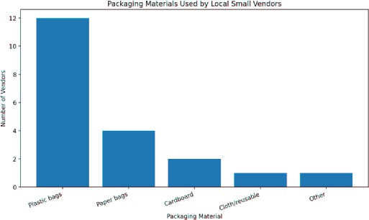

FIELD WORK DESCRIPTION

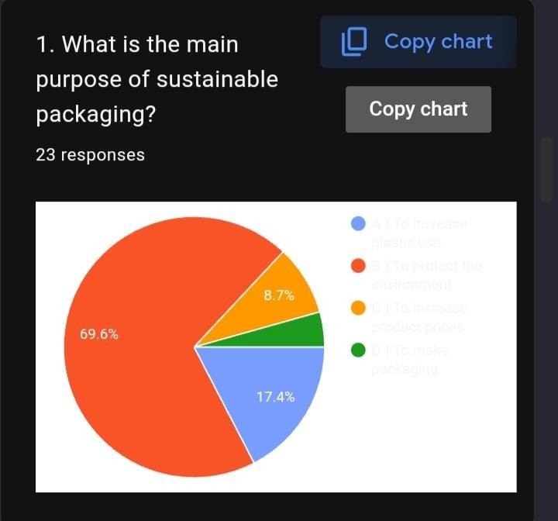
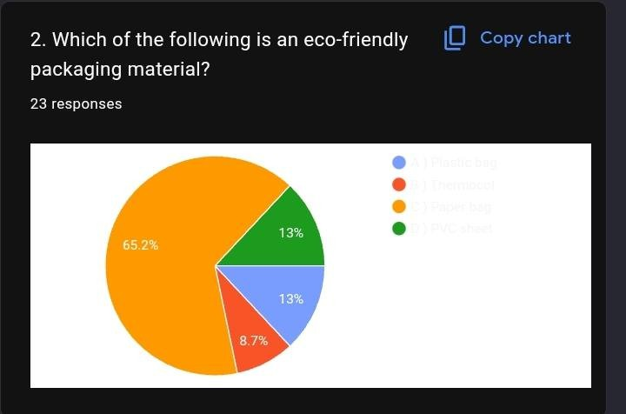

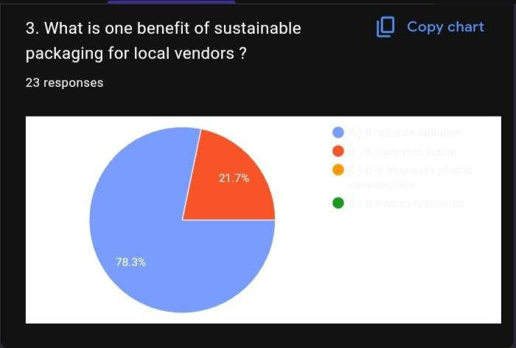
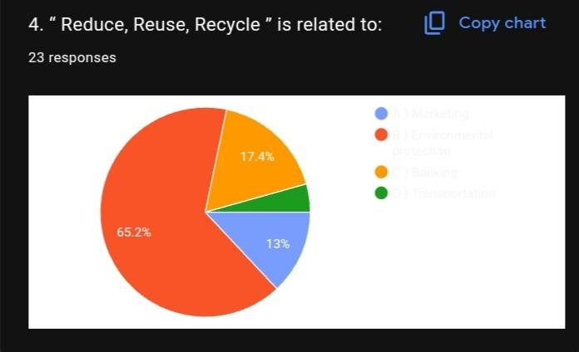

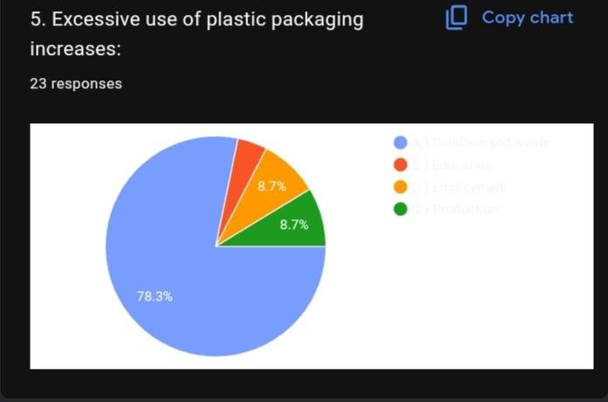
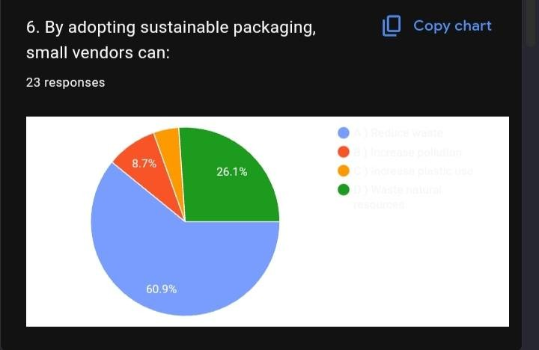

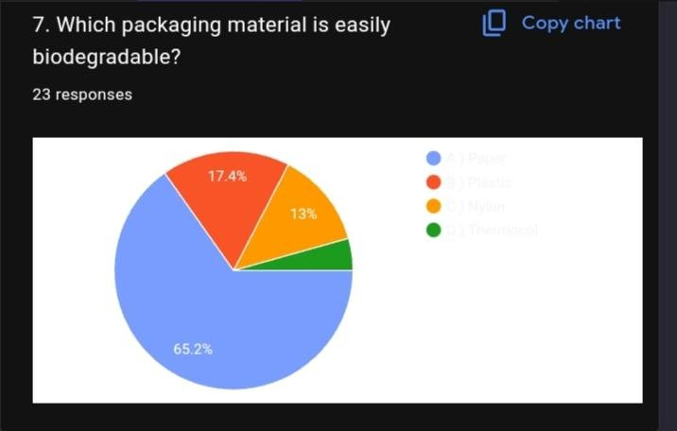

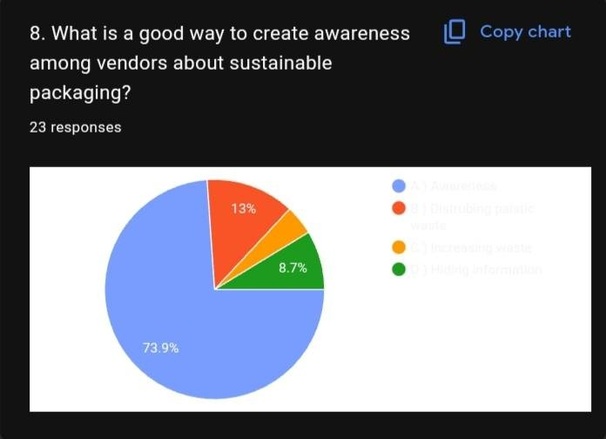

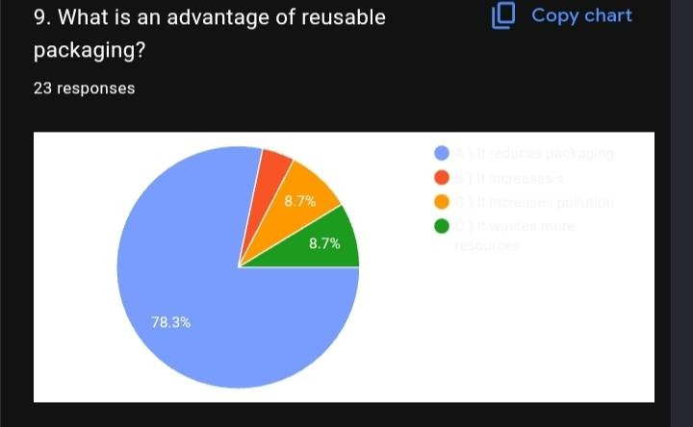
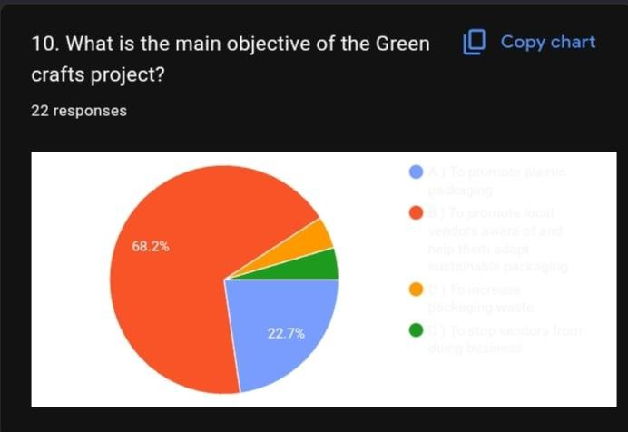

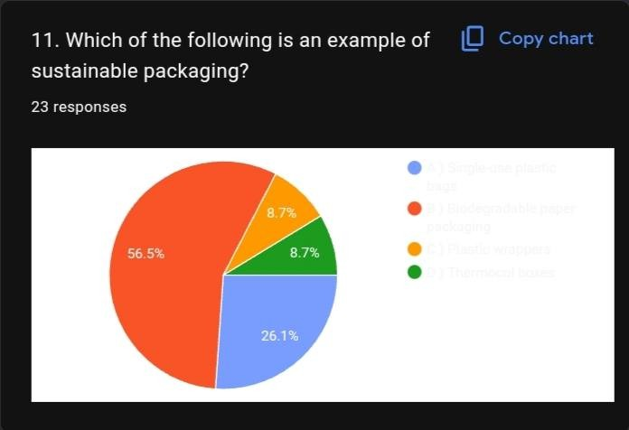
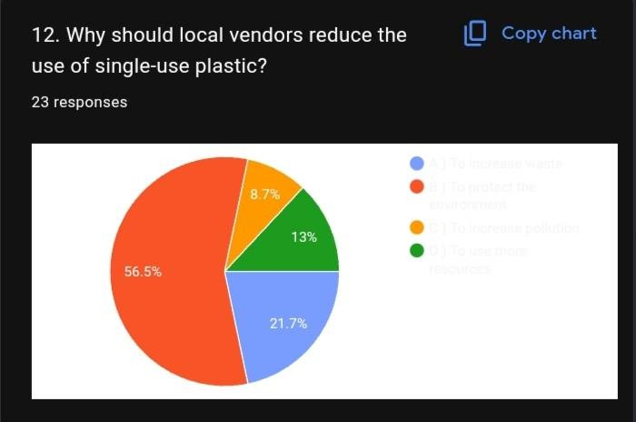

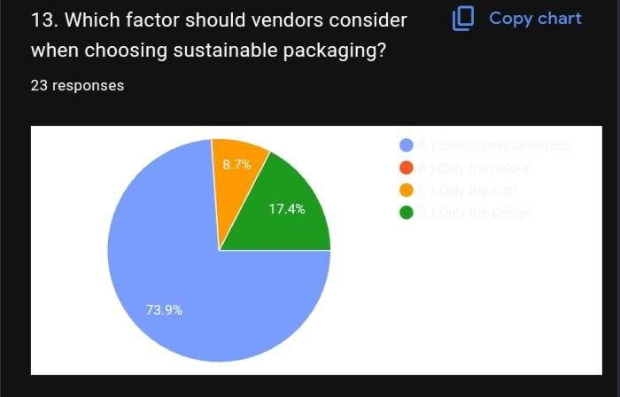
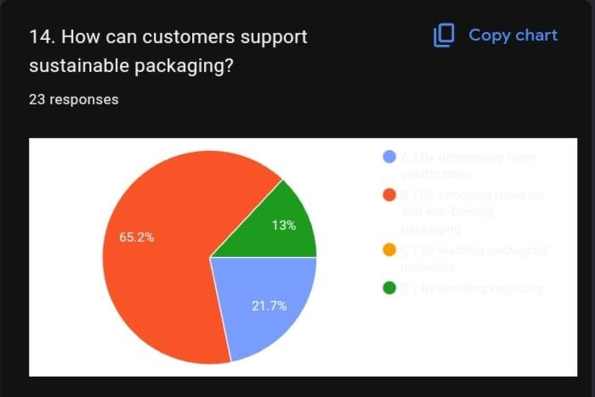

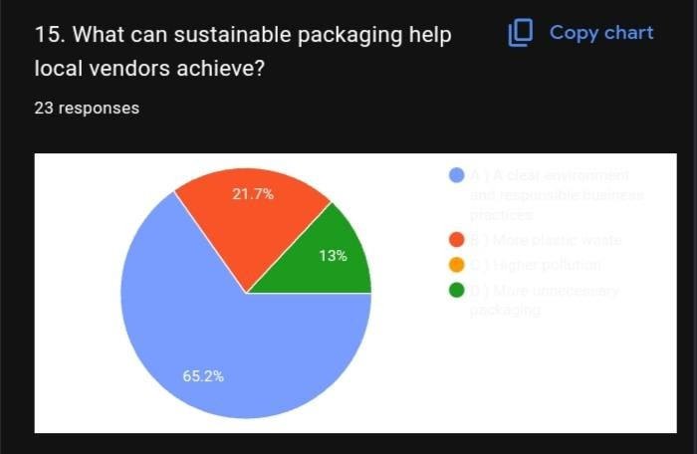

Conclusion
The Green CraftsProject on “A Study to Create Awarenessand Help Sustainable Packaging for Local Small Vendors” hashelped usunderstand the importance of making environmentally friendly choicesin our daily lives. Packaging isan essential part of almost every small businessbecause it helpsvendorscarry, store, and protect their products. However, the frequent use of single-use plastic bags, wrappers, and other non-biodegradable materialscreatesa large amount of waste and can negatively affect the environment. Through thisproject, we learned that even small changesin packaging practicescan contribute to a cleaner and healthier community.
The main purpose of thisproject wasto study the packaging practicesof local small vendorsand create awarenessabout sustainable alternatives. During the study, we understood that many small vendorsdepend on plastic packaging because it iseasily available, lightweight, convenient, and often inexpensive. However, many vendorsmay not be fully aware of the long-term environmental effectsof excessive plastic waste. Therefore, creating awarenessisan important ﬁrst step towardsencouraging sustainable packaging.
The project also helped usexplore different eco-friendly packaging materials. Recycled paper, newspapers, cardboard, cloth, jute, and reusable bagscan be used for many typesof products. Some packaging can also be reused or recycled instead of being thrown away after one use. Through green crafts, we were able to demonstrate how waste materialscan be converted into useful and attractive packaging items. Thisshowsthat sustainability doesnot alwaysrequire expensive or complicated solutions. Creativity and responsible use of
available materialscan make a signiﬁcant difference.
Another important learning from thisproject isthat sustainable packaging should be practical and affordable for small vendors. Vendorsdepend on packaging aspart of their daily business, so alternativesshould be easy to obtain, suﬃciently strong, convenient to use, and suitable for their products. Customersalso have an important role to play. They can support vendorswho use environmentally friendly packaging, carry reusable bags, avoid unnecessary packaging, and dispose of waste responsibly. Sustainable packaging becomesmore successful when both vendorsand customersparticipate.
The project hasalso highlighted the importance of the 3Rs—Reduce, Reuse, and Recycle. First, we should reduce unnecessary packaging and avoid using more material than required. Second, we should reuse bags, containers, and other suitable materialswhenever possible. Third, recyclable materialsshould be separated and sent for proper recycling instead of being mixed with general waste. Following these simple principlescan help reduce the amount of waste produced in our neighbourhoods.
Awarenessamong local communitiesisequally important. A small vendor may not be able to immediately change every type of packaging used in the business. However, even gradual improvementscan have a positive effect. For example, offering paper or reusable bags, reducing unnecessary plastic wrapping, encouraging customersto bring their own bags, and using recycled materialswhere suitable are practical stepstowardssustainability. Such changescan also inspire other vendorsand customersto adopt similar habits.

