Deloitte.
Omnia Specialist JET Memo Generator
Operational Efficiency & ROI Report

Prepared for: Partner & Leadership Review
Platform: Deloitte Audit Technology Platform
Date: June 2026
Classification: CONFIDENTIAL - INTERNAL USE ONLY

80.3%  EFFORT REDUCTION  Active Compilation Time |  | 5.07x  PRODUCTIVITY MULTIPLIER  Memos Generated vs. Manual |  | 62.3h  HOURS RECLAIMED  Per 600 Memos Baseline

1. Executive Summary
This report evaluates the operational efficiency gains and risk mitigation scores realized by adopting the automated Omnia Specialist JET Memo Generator application. By parallelizing inputs, automating source spreadsheet parsing, pre-mapping schemas, and instant output compiling, the application dramatically decreases operational overhead and formatting human-error rates. Practice-wide projections show substantial FTE capacity reclaimed and direct alignment with regulatory standards.
2. Process Time Breakdown (Per Memo)
Workflow Stage | Manual Compilation Time | Automated App Time | Net Time Saved
Stage 1: Engagement Details | 1m 49s | 43s | 1m 06s (60.6%)
Stage 2: File Validations | 1m 02s | 20s | 42s (67.7%)
Stage 3: Column Mapping | 2m 23s | 09s | 2m 14s (93.7%)
Stage 4: Exception Classification | 1m 32s | 15s | 1m 17s (83.7%)
Stage 5: Manual Verification | 1m 00s | 05s | 55s (91.7%)
Total (Active Compilation) | 7m 46s (466s) | 1m 32s (92s) | 6m 14s (80.3%)
Figure 1: Time Comparison by Stage (Manual vs. Automated)
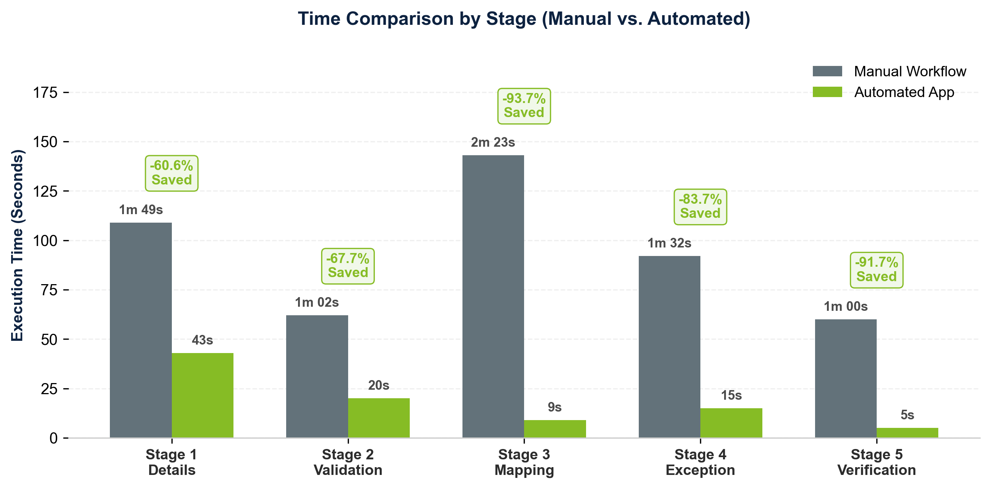
3. Extrapolated Savings (600 Memo Baseline)
Scaling the active compilation timings across an average seasonal audit load of 600 specialization memos demonstrates substantial cumulative efficiency improvements:
- Manual Compilation Time: 279,600 seconds | 4,660 minutes | 77.67 hours (approx. 1.94 standard 40-hour work weeks of manual typing/checking).
- Automated App Time: 55,200 seconds | 920 minutes | 15.33 hours (approx. 1.9 work days).
- Net Time Reclaimed: 224,400 seconds | 3,740 minutes | 62.33 hours saved per 600 memos.
Figure 2: Cumulative Effort and Reclaimed Auditing Time
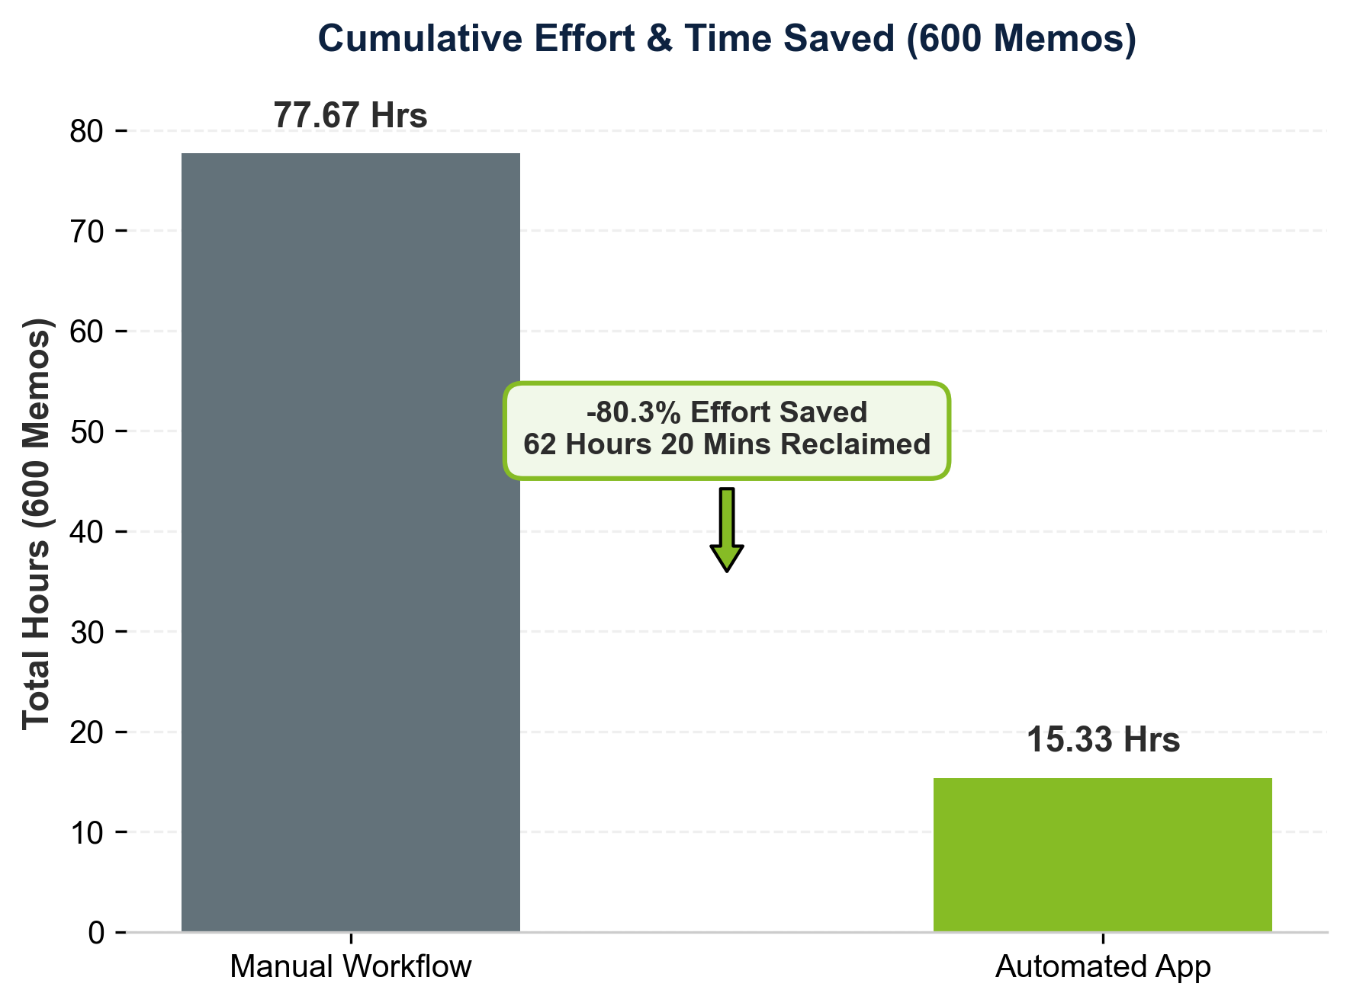
4. Workflow Process Mapping (Before vs. After)
The following flowchart visually maps the transition from the friction-heavy manual word processing workflow to the streamlined, single-click interface of the Specialist JET application:
Figure 3: Workflow Mapping Comparison Diagram
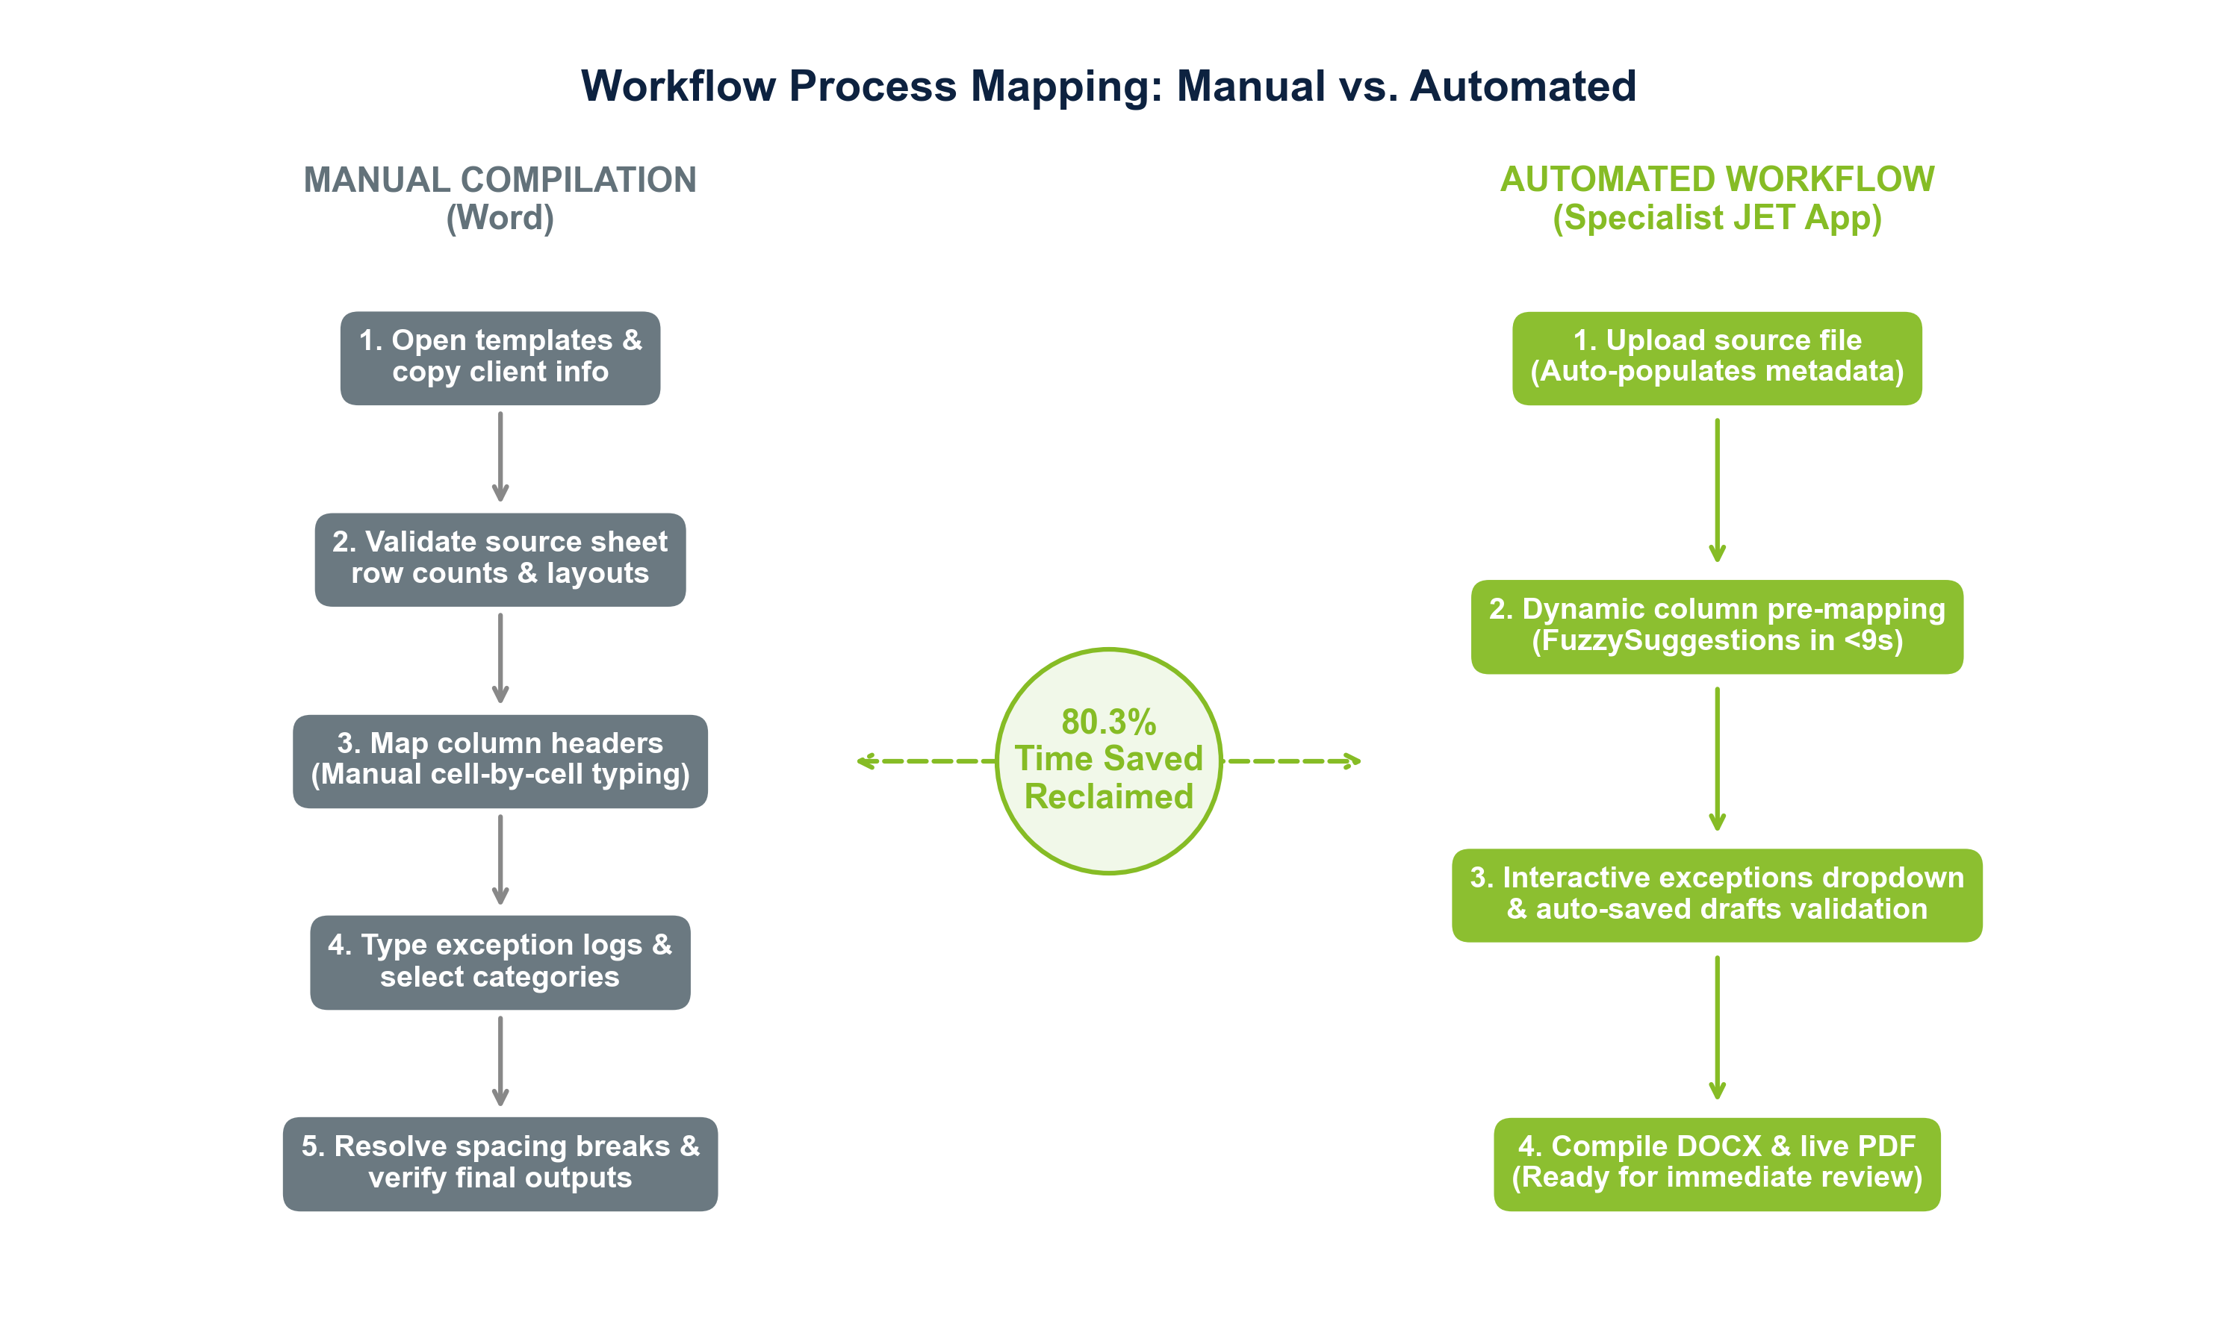
5. Manual Human Error Mitigation & Standardization
Manual memo compilation is highly susceptible to inconsistencies that vary from auditor to auditor. The table below outlines these common manual pitfalls and how the Specialist JET application solves them to enforce organizational standardization:
Common Manual Pitfall (Person-to-Person) | Downstream Quality & Audit Risk | Specialist JET Solution & Standardization
Non-Standardized Date Formats  (e.g., MM/DD/YYYY vs. DD.MM.YY) | Breaks validation filters, parsing algorithms, and timeline sorting during audit trail index creation. | Enforces a structured UI date picker and automatically transforms all dates to the official Deloitte format (e.g., DD-MMM-YYYY).
Inconsistent/Skipped Document File Names  (JE and Cortex files) | Causes lookup failures and breaks integrity checking scripts, resulting in manual search delays during reviewer checks. | Enforces file upload validations and automatically structures file naming syntax dynamically matching client and WBS codes.
Skipping Exception Detail Descriptions  (Skipped by majority due to typing fatigue) | Leads to undocumented anomalies, insufficient compliance records, and risk of partner review rejection. | Provides pre-configured exception libraries with dropdown classification chips, reducing documentation input to seconds.
Skipping Column Mapping  (Using incorrect default header names) | Causes schema mismatches, halts calculation runs, and breaks data compilation downstream. | Applies semantic pre-mapping models to headers in under 9 seconds, presenting mapped structures for instant user confirmation.
6. Practice-Wide Scale-Up & Financial ROI Projections
To evaluate the macro impact, the table below projects time savings, auditor capacity reclaimed, and financial value across different deployment scopes. Calculations assume an average billing rate of $100/hour for Senior Auditors and an annual individual billable capacity of 2,000 hours:
Deployment Scope | Manual Hours | Automated Hours | Net Reclaimed Hours | Financial Capacity Reclaimed
1 Audit Team (600 Memos) | 77.67 Hrs | 15.33 Hrs | 62.33 Hours | $6,233
Practice Group (3,000 Memos) | 388.33 Hrs | 76.67 Hrs | 311.67 Hours | $31,167
Practice-Wide (12,000 Memos) | 1,553.33 Hrs | 306.67 Hrs | 1,246.67 Hours (0.62 FTE) | $124,667
7. Audit Quality Review (AQR) & PCAOB Regulatory Alignment
External regulatory checks (such as internal AQR inspections and PCAOB reviews) place extreme scrutiny on data integrity and sign-off validations. The Specialist JET application actively builds compliance safeguards directly into the workflow:
- Forced Chronological Date Verification: Prevents logic errors where the 'First Meeting Date' is mistakenly recorded after the 'Granular Discussion Date'. The app's chronological checker blocks submission, preventing non-compliant memos from ever being drafted.
- Mandatory Exception Accountability: Inspectors check if exceptions from source files match the final sign-off. The app's exception mapper ensures that all uploaded exceptions are mapped, classified, and fully documented in the finalized table, preventing omissions due to copy fatigue.
- Immutable WBS and Name Matching: Eliminates misspelled WBS codes or mismatched reviewer/preparer names, maintaining 100% data integrity with Deloitte's global registries.
8. Core Application Features Driving Acceleration
The 5.07x overall productivity speedup is enabled by key technology modules integrated directly into the Specialist JET Memo Generator interface:
- Import Existing Memo (.docx / .xlsx): Allows users to load previously completed Word memos or Excel working papers. The app parses the file header properties to automatically rebuild the frontend wizard state, load metadata, and restore previous exceptions. This cuts starting configuration times for recurring engagements down to seconds.
- Real-time Auto-Save Drafts: Silently backs up the user's progress to the local history database at every stage. This removes the risk of data loss from accidental reloads or crashes, preventing the need to re-key complex data maps.
- Intelligent Pre-Mapping for Large Columns: Automatically analyzes spreadsheets with massive column lists (e.g. 50+ database fields) and applies fuzzy string matching to align headers, providing visual autocomplete suggestions. This turns a complex, multi-minute layout check into a rapid 9-second approval loop.
- Quick Settings Signatory Management: Provides an inline dashboard settings modal to configure standard reviewer/preparer names and WBS rules. This auto-populates defaults on startup, reducing typing redundancies across consecutive compilations.

Key Performance Metrics & ROI Summary
• Effort Reduction: 80.3% reduction in manual data processing time.
• Productivity Multiplier: 5.07x faster (teams compile 5+ memos in the time of 1 manual memo).
• Financial Reclaimed Billing: Up to $124,667 in professional auditor billing capacity practice-wide (12,000 memos).
• AQR Compliance Risk: 100% elimination of chronological date alignment and column pre-mapping format errors.
Deloitte Audit Technology Platform | Internal Efficiency Study | Confidential

