COURSE CODE: BCSE303P
COURSE NAME: Operating Systems Lab
CASE STUDY
OS-TUTOR-RAG
Interactive Retrieval-Augmented Educational Assistant for Operating Systems
Current status of the LLM project, 5 October 2026
Team Members
1. Aayush Jaiswal (24BCI0042)
2. Satyam Bhalotia (24BCI0055)

Contents

(If page numbers are not shown, right-click the table and choose Update Field.)

1. Introduction
Operating Systems is a concept-heavy course. Students must understand theory, algorithms, programming interfaces, synchronization mechanisms and classical problems, and the material is spread across lecture slides, textbook chapters, lab sheets and practice problems. A keyword search fails when a student's wording differs from the source, and a plain question-answering chatbot hands over an answer without checking whether the student understood it.
OS-Tutor-RAG addresses both problems. It is a retrieval-augmented generation (RAG) system built on a curated, provenance-aware corpus of Operating Systems course material. Instead of returning a direct answer, it uses the retrieved material to run a short tutoring dialogue: it asks what the student already knows, analyses the reply, explains the specific gap with an example, and checks understanding with a follow-up question. Every explanation can cite the lecture slide or textbook page it comes from. The current scope is Threads and Synchronization.
The project is evaluated at three levels: retrieval quality on a 99-query benchmark with manual relevance judgments, tutor quality on 24 scripted student dialogues, and learning gain with parallel pre-tests and post-tests (designed; not yet run with students).

1.1 Current status
Component | Status
Corpus ingestion (22 documents, 463 chunks) | Complete, frozen
Dense retrieval (Nomic Embed v1.5 + Qdrant) | Complete, frozen
Retrieval benchmark v1.1 (99 queries, 2,152 judgments) | Complete, frozen
BM25 retrieval (experiment E1) | Complete
Hybrid dense + BM25 retrieval with RRF (experiment E2) | Complete; best retriever, used by the tutor
Tutor controller (diagnose, analyse, explain, check) | Complete and tested
LLM generation with local models (Ollama: qwen3:8b, llama3.1:8b) | Complete; qwen3:8b chosen as default
Student chat page (web front end) | Complete; runs locally in a browser
Tutor quality evaluation (24 scripted dialogues, 2 models) | Complete
Pre/post assessment: objectives, draft items, gain analysis | Framework ready; items need instructor review; no student data yet
Automated tests | 96 of 96 passing
Table 1. Status of each component on 5 October 2026.

2. Literature Review

2.1 Retrieval-augmented generation
Lewis et al. [1] introduced retrieval-augmented generation, in which a language model conditions its output on passages retrieved from an external corpus. This lets the system cite sources and reduces unsupported statements. Gao et al. [2] survey later RAG work and identify retrieval as a main bottleneck: if the right passage is not retrieved, the generator cannot use it. Ji et al. [17] survey hallucination, where a model produces fluent text that is not supported by its input. These works motivated our order of work: measure retrieval carefully first, then connect the language model, then check its answers against the retrieved sources.

2.2 Dense, lexical and hybrid retrieval
Dense retrieval encodes queries and passages as vectors and ranks by similarity. Karpukhin et al. [3] showed that dense passage retrieval can outperform keyword search for open-domain question answering because it matches meaning rather than exact words. Our dense retriever uses Nomic Embed Text v1.5 [4], an open 768-dimensional embedding model.
Lexical retrieval with Okapi BM25 [5] rewards exact matches of rare terms. It is useful for identifiers such as pthread_create or sem_wait, which embeddings can blur. The BEIR benchmark [7] showed that BM25 is often competitive with dense retrievers outside their training domain. Reciprocal Rank Fusion (RRF) [6] combines ranked lists using only ranks, scoring each document by the sum of 1/(k + rank) with k = 60, so it needs no calibration between different score scales. We use RRF for our hybrid retriever.

2.3 Evaluating retrieval
We use standard information-retrieval metrics: Precision@K, Recall@K, MRR, MAP and nDCG with graded relevance [8]. Benchmarks are usually built by pooling: annotators judge only the top results of the participating systems, as in TREC [15]. Results outside the pool count as non-relevant, which biases the evaluation against systems that did not contribute to the pool. Sakai [9] proposed condensed-list metrics, which drop unjudged results before scoring. Because our benchmark was pooled from the dense system only, we report both standard and condensed-list metrics for BM25 and hybrid retrieval.

2.4 Local open language models
Open-weight models such as Llama 3 [18] and Qwen3 [19] can run on a laptop. We use their 8-billion-parameter versions through Ollama [20], a local model server with an HTTP interface. Running locally means no student data leaves the machine, there is no per-use cost, and the demonstration does not depend on an internet API.

2.5 Tutoring and learning measurement
Bloom [10] reported that one-to-one tutoring can raise achievement by about two standard deviations over classroom teaching. VanLehn [11] found that step-based intelligent tutoring, which works with the student's reasoning rather than only the final answer, comes close to human tutoring. The ICAP framework of Chi and Wylie [12] argues that learning improves as students move from passive to active, constructive and interactive engagement. Black and Wiliam [16] showed the value of formative assessment during learning. These works motivate our tutor design: ask a diagnostic question first, explain only the gap, and end with a formative check. To measure learning we use Hake's normalized gain [13], g = (post − pre) / (100 − pre), the fraction of the possible improvement a student achieved.

2.6 Gap addressed by this project
General-purpose chat assistants answer questions but do not diagnose understanding, do not reliably cite course material, and are rarely evaluated on learning outcomes. Most RAG work evaluates retrieval or answer accuracy only. OS-Tutor-RAG combines retrieval over a curated, provenance-aware OS corpus, a tutoring dialogue grounded in that corpus and run by a local model, and evaluation at the retrieval, tutor-quality and learning-outcome levels.

3. Objectives
The aim is to design and develop an interactive RAG-based Operating Systems tutor that retrieves relevant academic content from a structured, provenance-aware corpus and uses it to conduct an adaptive teaching interaction rather than simply returning a direct answer. The objectives and their status are:
# | Objective | Status
1 | Create a structured, curated corpus of Operating Systems learning material | Done: 22 documents, 463 chunks
2 | Preserve source and document provenance through ingestion and retrieval | Done: every chunk traces to file, page or slide, and section; the chat page shows them
3 | Convert the corpus into semantically meaningful chunks | Done: structure-aware chunking
4 | Generate embeddings and store them in a vector database | Done: 463 × 768-d vectors in Qdrant
5 | Retrieve relevant content using semantic and metadata-aware retrieval | Done: dense, BM25 and hybrid retrievers; hybrid is best
6 | Develop an interactive tutoring flow (diagnose, cross-question, explain, example, check) | Done: implemented with local LLMs and a chat page
7 | Identify knowledge gaps from student responses and give targeted explanations | Done and measured: with qwen3:8b the analysis matched the expected level in 81% of scripted replies
8 | Design pre-test and post-test assessments mapped to learning objectives | Partial: 8 objectives and 16 draft items; instructor review pending
9 | Measure learning improvement using absolute and normalized gain | Analysis code ready and tested; no student data yet
10 | Evaluate at retrieval level and educational-outcome level | Retrieval and tutor quality: done. Learning outcome: planned

4. Dataset Collection
The project uses four datasets: (1) the study corpus the tutor retrieves from, (2) the retrieval benchmark, (3) the tutor evaluation scenarios, and (4) the assessment item bank for the pre-test and post-test.

4.1 Study corpus
The corpus was collected from the course and from openly available teaching material, and filed by topic into Docs/Threads and Docs/Synchronisation. The raw files are never modified; their SHA-256 hashes are recorded so any change can be detected.
Property | Value
Documents | 22 (16 PDF, 5 PPTX, 1 legacy PPT)
Topic folders | Synchronisation 17, Threads 5
Sources | IIT Bombay lectures, labs and practice problems 7; OSTEP textbook chapters [14] 6; VIT course slides and notes 5; other teaching material 4
Document types | Lecture 11, textbook 6, lab 2, notes 1, practice problems 1, programming example 1
Size | 234 PDF pages and 247 slides
Extraction | 22 of 22 extracted successfully, 0 failures
Table 2. Corpus summary (data/manifests/corpus_manifest.json).
Document | Source | Type | Pages / slides | Chunks
Concurrency bugs.pptx | Unknown | Lecture | 13 slides | 8
VIT process-Synchronization (locks, semaphores, monitors).ppt | VIT | Lecture | 59 slides | 36
VIT Process-synchronization.pptx | VIT | Lecture | 50 slides | 37
VIT Classical problems of synchronization.pdf | VIT | Notes | 9 pages | 12
VIT Module 4 Process Synchronization.pptx | VIT | Lecture | 83 slides | 54
Semaphore.ppt - Copy.pptx | Unknown | Lecture | 6 slides | 2
Thread_Synchronization_Lab_Problems.pdf | Unknown | Lab | 11 pages | 10
dining philospher.pdf | Unknown | Programming example | 3 pages | 1
lecture13.pdf / lecture14.pdf / lecture15.pdf | IIT Bombay | Lecture | 12 / 8 / 6 pages | 9 / 5 / 2
ps-concurrency.pdf | IIT Bombay | Practice problems | 50 pages | 60
pthreads-sync.pdf | IIT Bombay | Lab | 6 pages | 15
threads-bugs / threads-cv / threads-locks / threads-sema.pdf | OSTEP | Textbook | 16 / 19 / 22 / 20 pages | 27 / 28 / 40 / 33
VIT Threads.pptx | VIT | Lecture | 36 slides | 17
lecture12.pdf | IIT Bombay | Lecture | 11 pages | 7
threads-api.pdf / threads-intro.pdf | OSTEP | Textbook | 12 / 16 pages | 22 / 29
threads.pdf | IIT Bombay | Lecture | 13 pages | 9
Table 3. Documents in the corpus. Chunk counts sum to 463.

4.2 Retrieval benchmark
We wrote 99 student-style queries covering the full scope, each with manually judged relevant chunks on a graded scale: 2 = directly answers the query, 1 = useful background, 0 = judged not relevant. The judgments were fixed before any retrieval system was evaluated, and the benchmark file is frozen (checked by SHA-256).
Breakdown | Counts
Topic | Threads 21, Synchronisation 78
Difficulty | Easy 23, medium 48, hard 28
Query type | Conceptual 26, mechanism 16, code 13, algorithm 12, comparative 11, scenario 11, classical problem 10
v1.0 judgments | 616 relevant (322 grade 2, 294 grade 1)
v1.1 judgments (current) | 2,152 in total: 757 relevant (322 grade 2, 435 grade 1) and 1,395 explicit grade 0
Table 4. Benchmark composition (data/evaluation/retrieval_queries_v1.1.json).
Version 1.1 was built because 61.7% of the dense baseline's top-10 results were unjudged in v1.0, making its scores lower bounds. v1.1 pools the dense system's top 20 results for every query (top 30 for the three hardest failures) and judges every pooled chunk: 141 new relevant judgments (all grade 1) and 1,395 chunks recorded as judged not relevant. The v1.0 file was left unchanged.

4.3 Tutor evaluation scenarios
To test the tutor without students, we wrote 24 scripted dialogues (data/evaluation/tutor_scenarios_v1.json), frozen before any evaluation run. They use 8 benchmark questions, one per learning objective, each played by 3 scripted student profiles:
Profile | Scripted replies | Expected tutor path
Solid | Correct, complete answer; then a correct answer to the check | Diagnose → Check → Done (wrap-up)
Misconception | A specific wrong belief; then a correct answer after the explanation | Diagnose → Explain → Done (wrap-up)
Unsure | "I don't know"; a vague guess; still does not know | Diagnose → Explain → Explain → Done (full answer)
Table 5. Student profiles in the tutor evaluation.
None of the 8 questions was used while tuning the tutor's prompts; the single tuning question was "Why do we need a thread pool?".

4.4 Assessment item bank
For the learning evaluation we defined 8 learning objectives (Section 6.8) and wrote a draft bank of 16 test items: one pre-test and one post-test item per objective, testing the same concept with a different question. Each item is linked to the corpus chunks that teach it. The bank still needs review by the course instructor and a pilot before use with students.

5. Dataset Processing

5.1 Ingestion pipeline
The corpus is processed by a deterministic pipeline: scan → extract → clean → metadata → document deduplication → chunking → duplicate-chunk marking → validation. Running it twice produces byte-identical output.
- Scanning. Walks Docs/ in sorted order, records each file's path, size and SHA-256 hash, and lists hidden or unsupported files explicitly instead of dropping them.
- Extraction. One loader per format. PDFs (PyMuPDF): reading-order reconstruction, heading detection from font size, code detection from monospace fonts, removal of shadow text and gutter line numbers. PPTX (python-pptx): titles, bullet levels, tables and speaker notes. Legacy PPT: parsed from the binary record stream with olefile.
- Cleaning. Normalizes ligatures and special characters, removes running headers, footers and page numbers, rejoins words hyphenated across lines (keeping real compounds such as compare-and-swap), and rebuilds code indentation.
- Metadata. Records source, professor, course, semester, module and document type, each with the evidence that justified it. A keyword taxonomy assigns 11 Threads and 19 Synchronization subtopics and 6 problem types.
- Deduplication. Exact duplicates by file hash and normalized text; near-duplicates by 5-word shingle similarity. Duplicates are marked, not deleted.
- Chunking. Structure-aware: chunks follow headings, slides and numbered questions. A practice question stays with its answer. Segments under 40 tokens merge forward; sections over 600 tokens split at block boundaries towards 350 tokens; code is never cut mid-line.
- Validation. Checks for empty documents or chunks, duplicate IDs, missing page or slide locations and image-only pages. The final run reports 0 errors.

5.2 Processing results
Measure | Value
Chunks | 463
Chunk types | 204 section, 186 slide, 60 question-answer pair, 13 problem
Content types | 277 text, 147 mixed text and code, 39 code
Chunk length (cl100k_base tokens) | 99,322 in total; median 186, mean 214.5, max 913
Duplicates | 1 near-duplicate document pair (about 95% text overlap); 4 exact-duplicate chunks
Validation | 0 errors, 7 warnings (image-only pages), 1 info (near-duplicate)
Table 6. Output of the ingestion pipeline.
Every chunk carries 29 fields, including chunk_id, source filename, page or slide range, section path, subtopics, chunk type, a text hash and duplicate links, so every retrieved chunk can be traced to the exact page or slide of the original document.

5.3 Embedding and indexing
Each chunk is embedded with Nomic Embed Text v1.5 (768 dimensions, pinned model revision) on the CPU through ONNX Runtime and stored in a Qdrant vector store in local mode with cosine similarity. All 463 chunks were indexed with 0 failures. The index records the hash of chunks.jsonl and refuses to serve results if the corpus changes without re-indexing. For BM25, chunk text is tokenized in memory (lower-case words; identifiers such as pthread_create kept whole; vocabulary 4,408 terms).

5.4 Benchmark annotation rules
- Judging was rank-blind: the reviewer saw candidate chunks without their rank or score.
- Sharing a topic, a document, or being next to a relevant chunk was not enough; the chunk itself had to carry the needed explanation.
- Reference lists and homework/question sections were graded 0.
- Duplicate chunks were checked to carry the same grade in every query.

6. Model Architecture Design

6.1 Overall architecture
Figure 1 shows the system. An offline stage turns the raw documents into chunks and indexes. At question time, the dense and BM25 retrievers each return their top 50 chunks, which are fused into one ranking. The tutor controller takes the top 5 chunks with their sources, builds a prompt for each teaching step, and sends it to a local language model through Ollama. The student talks to the tutor through a chat page in the browser, which shows the reply as it is generated and the sources it is based on.
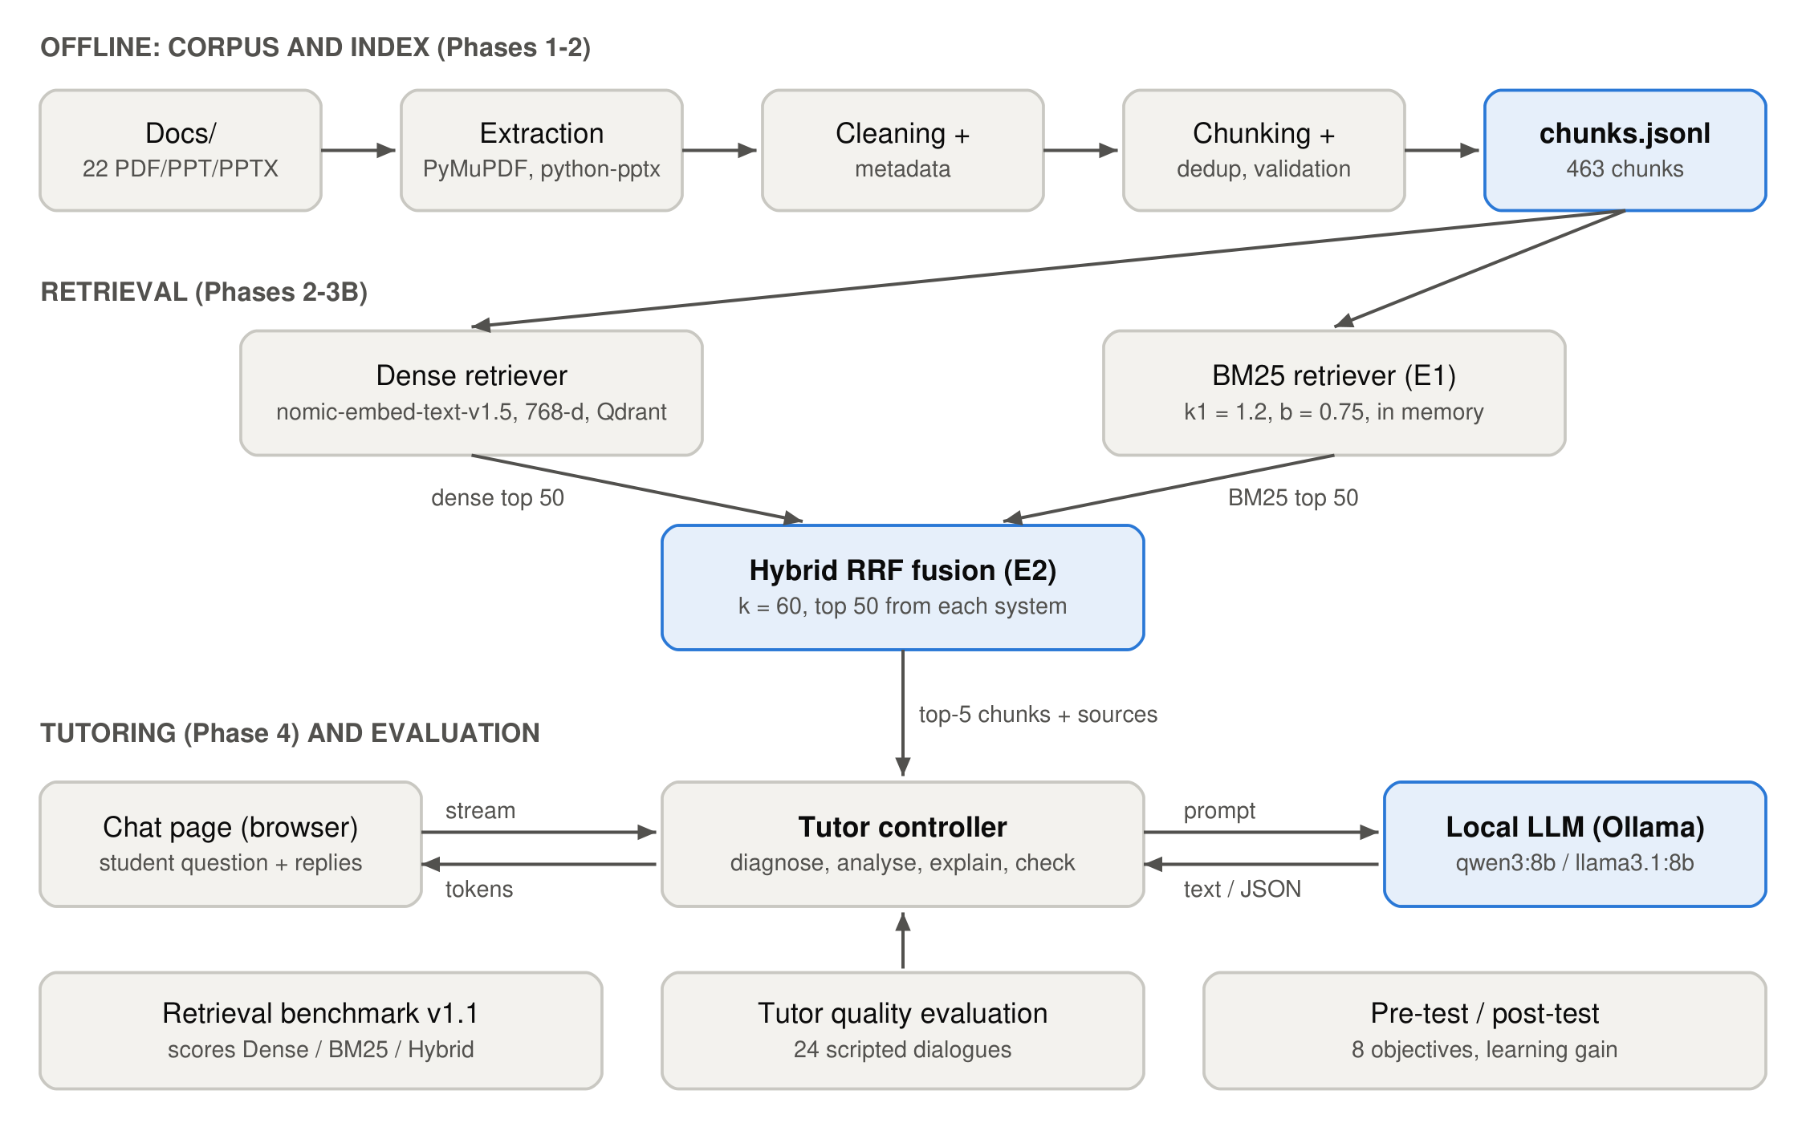
Figure 1. System architecture.

6.2 Retrieval models
Retriever | Design
Dense (Phase 2) | Query embedded with Nomic Embed v1.5; exact cosine search over 463 vectors in Qdrant. Matches meaning even when the wording differs from the source.
BM25 (E1) | Okapi BM25 with k1 = 1.2, b = 0.75 (standard defaults, not tuned). No stemming, no stopword list. Rewards exact matches of rare terms and API names.
Hybrid RRF (E2) | score(d) = 1/(60 + dense rank) + 1/(60 + BM25 rank), over each system's top 50. Equal weights; ties broken by corpus order. Uses ranks only, so no score calibration is needed.
Table 7. The three retrieval systems compared.
All parameters were fixed before evaluation and not tuned on the benchmark, because tuning on the test queries would leak the answers into the system. The three systems use the same corpus, queries, judgments and metric code, so only the retrieval method differs.

6.3 Retrieval results
Metric | Dense | BM25 (E1) | Hybrid (E2)
Precision@5 | 0.598 | 0.517 | 0.632
Precision@10 | 0.458 | 0.378 | 0.470
Recall@5 | 0.436 | 0.401 | 0.471
Recall@10 | 0.624 | 0.543 | 0.645
MRR@5 | 0.914 | 0.852 | 0.921
nDCG@5 | 0.695 | 0.629 | 0.725
nDCG@10 | 0.706 | 0.631 | 0.727
MAP@5 | 0.404 | 0.361 | 0.433
Queries with a relevant chunk in top 1 / 3 / 5 / 10 (of 99) | 87 / 95 / 97 / 97 | 79 / 89 / 92 / 96 | 86 / 97 / 98 / 99
Queries with no relevant chunk in the top 10 | q009, q020 | q008, q046, q060 | none
Top-10 results never judged | 0 of 990 | 418 of 990 | 108 of 990
Table 8. Retrieval results on benchmark v1.1 (99 queries, depth 20). Best value in bold.
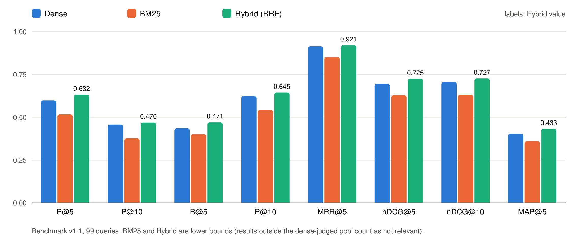
Figure 2. Dense, BM25 and hybrid retrieval on benchmark v1.1.
- The hybrid retriever scores higher than the dense baseline on every headline metric (nDCG@10 0.727 vs 0.706, Precision@5 0.632 vs 0.598) and removes both dense top-10 failures.
- Per query, hybrid improves nDCG@10 on 58 queries and lowers it on 32 (9 ties); an exact two-sided sign test gives p = 0.008. Against BM25 alone, hybrid is better on 77 queries and worse on 16 (p < 0.0001).
- The hybrid numbers are conservative: the benchmark was judged from the dense system's results, so 108 hybrid top-10 results were never judged and count as not relevant.
- BM25 alone scores below dense on the standard metrics, but 42% of its top-10 results are unjudged. On the judged-only (condensed-list) view BM25 scores above dense (nDCG@10 0.731 vs 0.706; hybrid 0.751), so which single system is better is not yet established.
- By query type, hybrid helps most on classical-problem (nDCG@10 0.755 → 0.815), comparative (0.725 → 0.778) and scenario (0.748 → 0.806) queries, and is slightly below dense on conceptual queries (0.779 → 0.747).

6.4 Error analysis of the hardest retrieval queries
Query | Dense | BM25 | Hybrid | Diagnosis
q009: passing &i to pthread_create prints wrong numbers | No relevant chunk in top 10 (grade-2 chunks at rank 19 and beyond 30) | Both grade-2 chunks at ranks 1–2 | Grade-2 chunk at rank 3 | Lexical match on loop, i and pthread_create recovers the bug explanation that dense misses.
q020: split a CPU-heavy loop over 10 threads; are locks needed? | No relevant chunk in top 10 (best at rank 16) | Grade-2 chunk at rank 1 | Relevant chunks at ranks 5, 6, 9 | Dense ranks lock-chapter material first; hybrid repairs the failure only partly.
q091: atomic swap instruction for mutual exclusion | Grade-2 chunks at ranks 9, 11, 15 | Two short code slides fall out of the top 30 | Grade-2 chunk at rank 5 | A ranking problem: the swap solutions are written as code, not in the query's words.
Table 9. The three hardest queries (ranks are positions in each system's list).

6.5 Tutor design
The tutor controller implements the teaching interaction as a state machine (Figure 3). It does not answer immediately: it asks a diagnostic question, has the model classify the student's reply, explains only the missing idea with an example, and confirms understanding with a formative check.
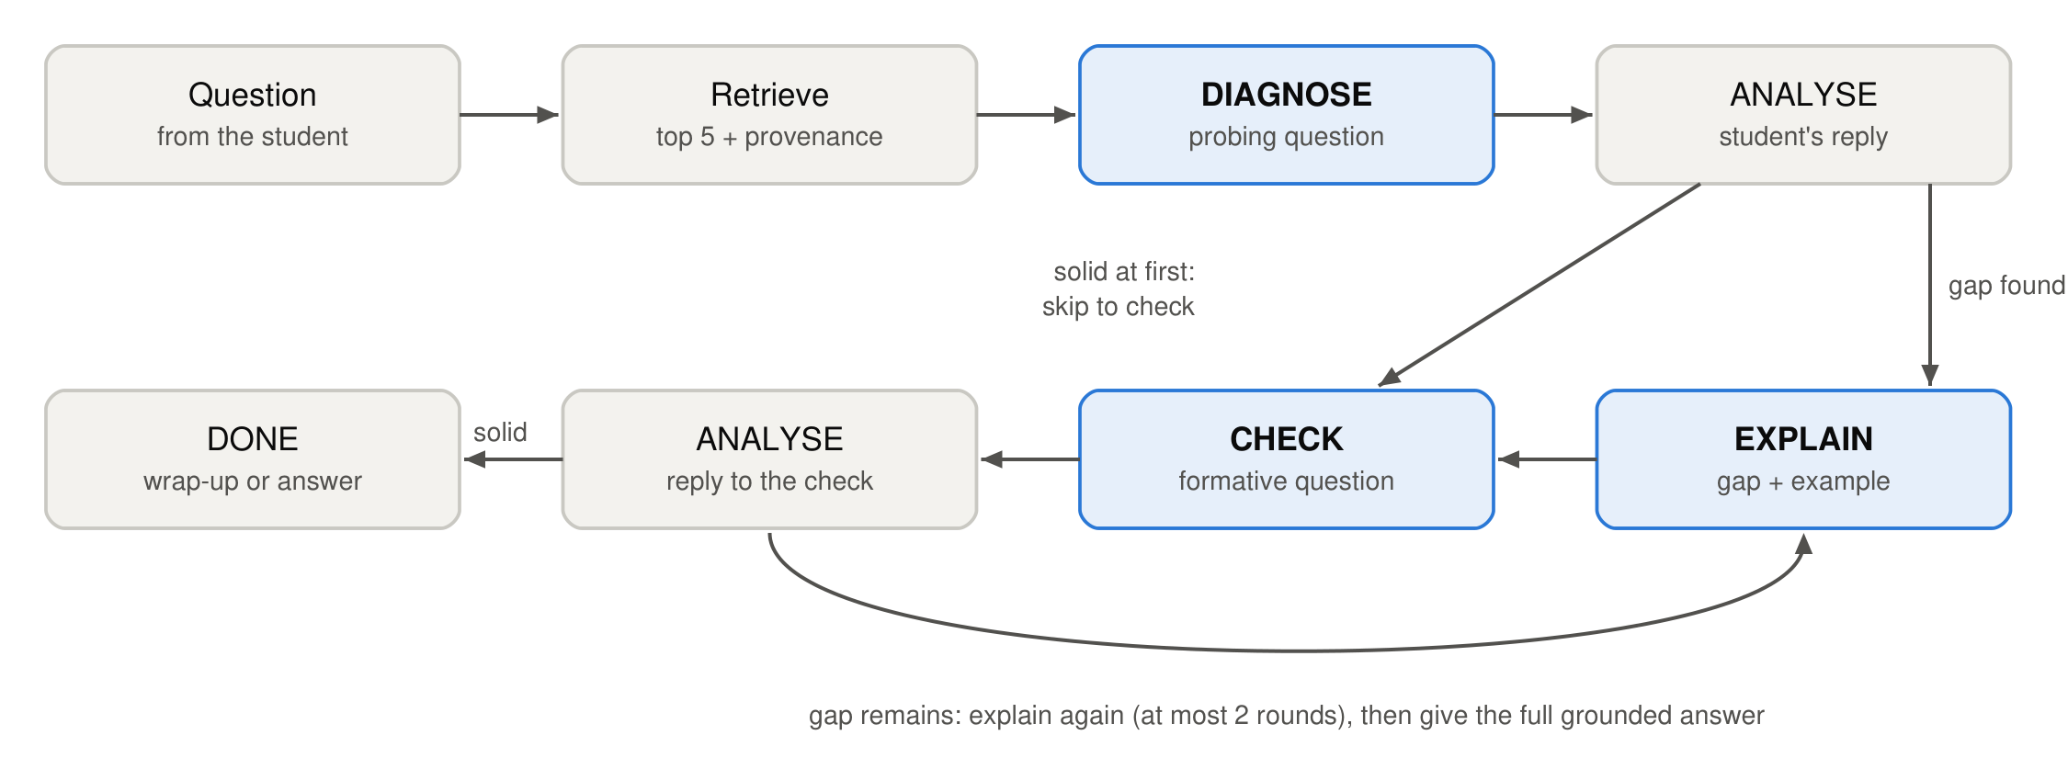
Figure 3. Tutoring flow.
Stage | What the tutor does
DIAGNOSE | Asks one short probing question about the concept behind the question, without explaining or hinting at the answer.
ANALYSE | Classifies the reply as solid, partial, misconception or unclear and names the gap in one sentence. Uses the model's JSON mode; malformed output counts as unclear.
EXPLAIN | Says plainly if the reply was wrong, explains only the gap, cites sources as [S1]…[S5], gives an example and, where useful, a counterexample, and ends with a check question.
CHECK | Asks a formative question that applies the idea to a new situation.
DONE | After a correct check, a short wrap-up that restates the key idea. After at most 2 explanation rounds, the complete answer grounded in the sources.
Table 10. Tutor stages.
Every prompt contains the five retrieved chunks labelled [S1]…[S5] with filename, page or slide, and section, the conversation so far, the stage instruction, and a style rule: speak directly to the student, at most 120 words, use only facts from the course material, and never mention the prompt. The prompts were tuned on one development question only, which is not part of the evaluation set.

6.6 Language model integration and chat page
Part | Implementation
Model server | Ollama 0.32.7 on the local machine (Apple M3, 16 GB). Models: qwen3:8b (default) and llama3.1:8b, selectable on the page.
Model settings | Temperature 0 and seed 42 for repeatable replies; 8,192-token context; qwen3's hidden reasoning mode switched off for speed; JSON mode for the analysis step.
Speed | About 17 generated tokens per second. Median time per tutor turn: 8.9 s (qwen3:8b), 11.7 s (llama3.1:8b).
Web server | Python standard library only (no new packages). Sends the reply word by word as server-sent events, so the student sees text appear instead of waiting.
Chat page | A single web page: a progress track (Diagnose, Explain, Check, Done), the conversation, a Sources panel where each citation opens the original passage, and a switch that shows the tutor's analysis of each answer (for the teacher).
Logging | Every turn (question, reply, stage, analysis, sources) is saved for the later pilot and quality review.
Table 11. Language model integration.
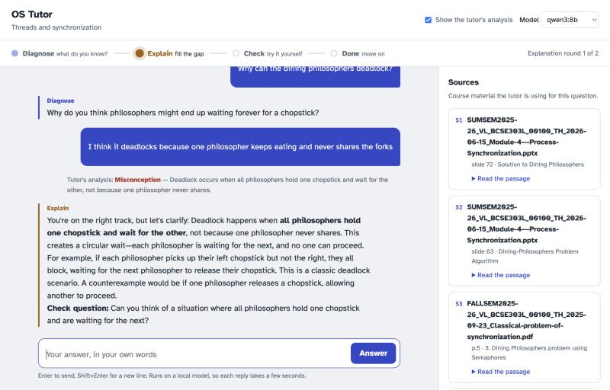
Figure 4. The chat page during a dialogue with qwen3:8b, with the teacher's analysis view switched on.
Figure 4 shows a real dialogue: the tutor diagnosed the question, the student gave a wrong reason for the dining philosophers deadlock, the analysis labelled it a misconception, and the tutor explained the circular wait with a check question. It also shows a typical weakness found in the evaluation below: the explanation opens with "You're on the right track" although the student was wrong.

6.7 Tutor quality evaluation
Each of the 24 scripted dialogues (Section 4.3) was run through the real system with each model. We measured automatic checks on every tutor turn, and one annotator then read all 158 tutor turns and graded each 0–2 on three criteria: correct (OS facts right), grounded (supported by the five given sources) and pedagogy (the turn does its teaching job: a probing diagnosis that does not give the answer, an explanation aimed at the student's actual gap, a check on a new case).
Automatic check | qwen3:8b | llama3.1:8b
Dialogues following the expected path | 21/24 (88%) | 19/24 (79%)
Analysis: exact level matches the scripted label | 39/48 (81%) | 34/46 (74%)
Analysis: solid / not-solid matches the script | 52/56 (93%) | 46/54 (85%)
Analysis: valid JSON | 56/56 (100%) | 54/54 (100%)
Diagnose asks exactly one question | 24/24 (100%) | 12/24 (50%)
Explain ends with a check question | 28/28 (100%) | 20/21 (95%)
Explain / wrap-up / answer cites a source | 16/49 (33%) | 41/43 (95%)
All citations point to a given source | 80/80 (100%) | 78/78 (100%)
Turns within 120 words | 78/80 (98%) | 60/78 (77%)
Relevant (grade-2) chunk among the 5 retrieved | 24/24 (100%) | 24/24 (100%)
Median / max seconds per tutor turn | 8.9 / 18.3 | 11.7 / 25.1
Table 12. Automatic checks (data/evaluation/tutor_eval/report.md). Counts are turns or dialogues.
Manual rubric (0–2) | qwen3:8b (80 turns) | llama3.1:8b (78 turns)
Correct: mean | 1.76 | 1.51
Turns with a factual error (score below 2) | 18 (1 fully wrong) | 30 (8 fully wrong)
Grounded: mean | 1.94 | 1.77
Pedagogy: mean | 1.39 | 1.26
Pedagogy of Diagnose / Explain / Check turns | 1.00 / 1.21 / 1.71 | 1.12 / 1.29 / 0.91
Table 13. Manual grades (data/evaluation/tutor_eval/manual_grades_*.json), single annotator.
Choice of model. qwen3:8b is the default for the demonstration. It followed the teaching flow more reliably, made fewer factual errors (18 of 80 turns vs 30 of 78), stayed within the length limit, and was faster. llama3.1:8b cited sources far more often (95% vs 33%) but often asked two questions at once and, in the unsure profile, labelled "I don't know" as solid understanding several times.
Main weaknesses found (these are the targets for the remaining work):
- Agreeing with wrong answers. Both models sometimes open with "You're right that…" or "You're close" when the student was wrong, which can confuse a student.
- Missed citations. qwen3:8b cited a source in only a third of explanations, although its content was almost always supported by the sources (grounded mean 1.94).
- Analysis errors change the path. When a correct answer is wrongly labelled partial, the tutor re-explains what the student already said; this caused 3 of qwen3:8b's 24 dialogues to leave the expected path.
- Incomplete explanations. For the while-loop question, explanations covered spurious wakeups but often missed the main reason (another thread can run first and change the state).
- Weak diagnostic questions. Diagnose turns scored lowest on pedagogy (mean 1.00 for qwen3:8b), mostly because they restate the student's question or hint at the answer.

6.8 Learning evaluation design
ID | Learning objective
LO1 | Threads fundamentals: what threads share and what each thread has privately
LO2 | Thread APIs: pthread_create and pthread_join, passing arguments and returning results
LO3 | Race conditions: why counter++ loses updates; critical sections
LO4 | Locks / mutexes: mutual exclusion, test-and-set, compare-and-swap, spin vs sleep
LO5 | Semaphores: sem_wait / sem_post; semaphores as locks and for ordering
LO6 | Condition variables: use with a mutex; re-checking the condition in a while loop
LO7 | Classical problems: producer-consumer, readers-writers, dining philosophers
LO8 | Concurrency bugs: deadlock conditions, atomicity and order violations, lock ordering
Table 14. Learning objectives (data/assessment/learning_objectives.json).
Each test item records its objective, topic, difficulty, question type (multiple choice, short answer or code reasoning), expected concept, answer key or rubric, and the corpus chunks that teach it. The planned protocol is pre-test → tutoring session on the chat page → post-test. The analysis code computes, per student, per group and per objective: score (% of maximum points), absolute gain (post − pre), normalized gain g = (post − pre) / (100 − pre), and the class-average gain. No student has taken the tests yet, so no learning results are reported here.

6.9 Testing and reproducibility
- 96 automated tests pass (pytest), covering ingestion, retrieval, BM25, hybrid fusion, retrieval evaluation, the tutor flow with a scripted model, the web server and the learning-gain calculations.
- Retrieval evaluations were run twice with identical rankings and results apart from the timestamp.
- Frozen inputs (raw corpus, chunks, benchmark, vector index and baseline results) were verified unchanged by SHA-256 after all new work.
- Tutor replies use temperature 0 and a fixed seed so that runs are repeatable; repeating the tutor evaluation to confirm identical replies has not been done yet.

7. Conclusion
OS-Tutor-RAG now works end to end on a laptop: a student asks a question in the browser, the hybrid retriever finds the relevant course material, and a local language model runs a diagnose–explain–check dialogue that points to the original slides and pages. Retrieval was measured on a 99-query benchmark, where the hybrid retriever is best on every headline metric (nDCG@10 0.727; a relevant chunk in the top 10 for all 99 queries). The tutor was measured on 24 scripted dialogues: with qwen3:8b it followed the intended teaching path in 21 of 24 dialogues, judged the student's understanding correctly (solid or not) in 93% of replies, and was factually correct in 62 of 80 turns, while showing clear weaknesses to fix.

7.1 Limitations
- The retrieval benchmark was judged from the dense system's results only, so BM25 and hybrid scores are lower bounds.
- One annotator produced the relevance judgments, the tutor grades and the draft test items; there is no inter-annotator agreement measure yet.
- The tutor evaluation uses scripted student replies that cannot adapt to the tutor's questions, and covers 8 questions.
- The 8-billion-parameter local models still make factual and pedagogical mistakes (Section 6.7), and qwen3:8b often omits citations.
- The item bank is an unvalidated draft and no student data exists, so the project has no learning-gain evidence yet.

7.2 Future work
- Fix the weaknesses found in Section 6.7: require at least one citation per explanation, forbid agreeing with a wrong answer, and improve the diagnostic question; then re-run the same 24 dialogues to measure the change.
- Have the instructor review the 16 test items, then run a pilot with a few students using the chat page.
- Run the pre-test → tutoring → post-test study and report learning gain per objective.
- Judge the unjudged BM25 and hybrid results (benchmark v1.2) to remove the retrieval pooling bias.
- Extend the corpus beyond Threads and Synchronization.

References
[1] P. Lewis et al., "Retrieval-Augmented Generation for Knowledge-Intensive NLP Tasks," in Advances in Neural Information Processing Systems (NeurIPS), vol. 33, 2020.
[2] Y. Gao et al., "Retrieval-Augmented Generation for Large Language Models: A Survey," arXiv:2312.10997, 2023.
[3] V. Karpukhin et al., "Dense Passage Retrieval for Open-Domain Question Answering," in Proc. EMNLP, 2020.
[4] Z. Nussbaum, J. X. Morris, B. Duderstadt and A. Mulyar, "Nomic Embed: Training a Reproducible Long Context Text Embedder," arXiv:2402.01613, 2024.
[5] S. Robertson and H. Zaragoza, "The Probabilistic Relevance Framework: BM25 and Beyond," Foundations and Trends in Information Retrieval, vol. 3, no. 4, pp. 333–389, 2009.
[6] G. V. Cormack, C. L. A. Clarke and S. Büttcher, "Reciprocal Rank Fusion Outperforms Condorcet and Individual Rank Learning Methods," in Proc. ACM SIGIR, 2009, pp. 758–759.
[7] N. Thakur et al., "BEIR: A Heterogeneous Benchmark for Zero-shot Evaluation of Information Retrieval Models," in NeurIPS Datasets and Benchmarks Track, 2021.
[8] K. Järvelin and J. Kekäläinen, "Cumulated Gain-Based Evaluation of IR Techniques," ACM Transactions on Information Systems, vol. 20, no. 4, pp. 422–446, 2002.
[9] T. Sakai, "Alternatives to Bpref," in Proc. ACM SIGIR, 2007, pp. 71–78.
[10] B. S. Bloom, "The 2 Sigma Problem: The Search for Methods of Group Instruction as Effective as One-to-One Tutoring," Educational Researcher, vol. 13, no. 6, pp. 4–16, 1984.
[11] K. VanLehn, "The Relative Effectiveness of Human Tutoring, Intelligent Tutoring Systems, and Other Tutoring Systems," Educational Psychologist, vol. 46, no. 4, pp. 197–221, 2011.
[12] M. T. H. Chi and R. Wylie, "The ICAP Framework: Linking Cognitive Engagement to Active Learning Outcomes," Educational Psychologist, vol. 49, no. 4, pp. 219–243, 2014.
[13] R. R. Hake, "Interactive-Engagement versus Traditional Methods: A Six-Thousand-Student Survey of Mechanics Test Data for Introductory Physics Courses," American Journal of Physics, vol. 66, no. 1, pp. 64–74, 1998.
[14] R. H. Arpaci-Dusseau and A. C. Arpaci-Dusseau, Operating Systems: Three Easy Pieces. Arpaci-Dusseau Books, 2018.
[15] E. M. Voorhees and D. K. Harman (eds.), TREC: Experiment and Evaluation in Information Retrieval. MIT Press, 2005.
[16] P. Black and D. Wiliam, "Assessment and Classroom Learning," Assessment in Education: Principles, Policy & Practice, vol. 5, no. 1, pp. 7–74, 1998.
[17] Z. Ji et al., "Survey of Hallucination in Natural Language Generation," ACM Computing Surveys, vol. 55, no. 12, 2023.
[18] Llama Team, AI @ Meta, "The Llama 3 Herd of Models," arXiv:2407.21783, 2024.
[19] Qwen Team, "Qwen3 Technical Report," arXiv:2505.09388, 2025.
[20] Ollama, "Ollama: run large language models locally," software, https://ollama.com (version 0.32.7 used).

