COURSE CODE: BCSE303P
COURSE NAME: Operating Systems Lab
REVIEW 2
OS-TUTOR-RAG
Interactive Retrieval-Augmented Educational Assistant for Operating Systems
Case Study: Current Status of the LLM Project
Team Members
1. Aayush Jaiswal (24BCI0042)
2. Satyam Bhalotia (24BCI0055)

1. Introduction
Operating Systems is a concept-heavy course. Students have to understand theory, algorithms, programming interfaces, synchronization mechanisms and classical problems, and the material for these is spread across lecture slides, textbook chapters, lab sheets and practice problems. A keyword search fails when a student's wording differs from the wording of the source, and a plain question-answering chatbot hands over an answer without checking whether the student understood it.
OS-Tutor-RAG addresses both problems. It is a retrieval-augmented generation (RAG) system built on a curated, provenance-aware corpus of Operating Systems course material. Instead of returning a direct answer, it uses the retrieved material to run a short tutoring dialogue: it diagnoses what the student already knows, explains the specific gap, gives an example, and checks understanding with a follow-up question. The current scope is Threads and Synchronization.
The project is evaluated at two levels. Retrieval quality is measured on an OS-specific benchmark of 99 student-style queries with manual relevance judgments. Learning effectiveness will be measured with parallel pre-tests and post-tests mapped to learning objectives, reported as absolute and normalized learning gain.

1.1 Progress since Review 1
At Review 1 the ingestion pipeline (Phase 1), the dense embedding index (Phase 2) and the first retrieval benchmark with a dense baseline evaluation (Phase 3A) were complete. The tutoring and assessment components were planned. Since then the following work has been completed:
- Benchmark v1.1. The relevance judgments were expanded from 616 to 2,152 (757 relevant, 1,395 explicitly non-relevant), so that every result in the dense system's top 20 is judged.
- Experiment E1: BM25 lexical retrieval. A pure keyword-based baseline over the same 463 chunks, evaluated on the same benchmark.
- Experiment E2: hybrid retrieval. Dense and BM25 results fused with Reciprocal Rank Fusion (RRF). This is now the best-scoring retriever on every headline metric.
- Interactive tutor controller. The tutoring flow (diagnose, analyse, explain with example, formative check) is implemented as a tested state machine with source-grounded prompts and provenance.
- Pre-test / post-test framework. Eight learning objectives, a draft parallel-form item bank, and learning-gain analysis code.

1.2 Current status at a glance
Component | Status
Corpus ingestion (22 documents, 463 chunks) | Complete, frozen
Dense retrieval (Nomic Embed v1.5 + Qdrant) | Complete, frozen
Retrieval benchmark v1.1 (99 queries, 2,152 judgments) | Complete, frozen
BM25 retrieval (E1) | Complete
Hybrid RRF retrieval (E2) | Complete
Tutor controller (dialogue flow, grounding, provenance) | Implemented and tested
LLM text generation inside the tutor | Not yet connected (next phase)
Pre/post assessment: objectives, draft items, gain analysis | Framework ready; no student data yet
Automated tests | 93 of 93 passing

2. Literature Review

2.1 Retrieval-augmented generation
Lewis et al. [1] introduced retrieval-augmented generation, in which a language model conditions its output on passages retrieved from an external corpus. This reduces unsupported (hallucinated) statements and lets the system cite its sources. Gao et al. [2] survey the later development of RAG and identify the retriever as a main bottleneck: if the right passage is not retrieved, the generator cannot use it. This motivated our decision to build and measure retrieval carefully before connecting a language model.

2.2 Dense, lexical and hybrid retrieval
Dense retrieval encodes queries and passages as vectors and ranks by vector similarity. Karpukhin et al. [3] showed that dense passage retrieval can outperform keyword search for open-domain question answering because it matches meaning rather than exact words. Our dense retriever uses Nomic Embed Text v1.5 [4], an open, reproducible 768-dimensional embedding model.
Lexical retrieval with Okapi BM25 [5] remains a strong baseline. It rewards exact term matches, weighted by term rarity and normalized by document length. It is particularly useful for identifiers such as pthread_create or sem_wait, which embedding models can blur. The BEIR benchmark [7] showed that BM25 is often competitive with dense retrievers outside their training domain.
Hybrid retrieval combines both. Reciprocal Rank Fusion (RRF) by Cormack et al. [6] merges ranked lists using only ranks: each document scores the sum of 1/(k + rank) over the systems, with k = 60. Because it ignores raw scores, it needs no calibration between cosine similarity and BM25 scores. We use RRF for experiment E2.

2.3 Evaluating retrieval
We follow standard information-retrieval evaluation: Precision@K, Recall@K, MRR, MAP and nDCG with graded relevance [8]. Benchmarks are usually built by pooling: annotators judge only the top results of the participating systems, as in TREC [15]. Results outside the pool are treated as non-relevant, which biases the evaluation against systems that did not contribute to the pool. Sakai [9] proposed condensed-list metrics, which drop unjudged results before scoring, as one way to examine this bias. Our benchmark v1.1 was pooled from the dense system only, so we report both standard and condensed-list (judged-only) metrics for BM25 and hybrid.

2.4 Tutoring and learning measurement
Bloom [10] reported that one-to-one tutoring can raise student achievement by about two standard deviations over conventional classroom teaching. VanLehn [11] reviewed intelligent tutoring systems and found that step-based tutoring, which interacts with the student's reasoning rather than only the final answer, comes close to human tutoring. The ICAP framework of Chi and Wylie [12] argues that learning improves as students move from passive to active, constructive and interactive engagement. Black and Wiliam [16] showed the value of formative assessment: checking understanding during learning, not only at the end. These works motivate our tutor design, which asks a diagnostic question before explaining and ends each explanation with a formative check instead of only returning an answer.
To measure learning we use pre-tests and post-tests. Hake [13] defined the normalized gain g = (post − pre) / (100 − pre): the fraction of the possible improvement that a student actually achieved. It allows students with different starting scores to be compared.

2.5 Gap addressed by this project
General-purpose chat assistants answer questions but do not diagnose understanding, do not reliably cite course material, and are rarely evaluated on learning outcomes. Most RAG work evaluates retrieval or answer accuracy only. OS-Tutor-RAG combines (i) retrieval over a curated, provenance-aware OS corpus, (ii) a tutoring dialogue grounded in that corpus, and (iii) evaluation at both the retrieval level and the learning-outcome level.

3. Objectives
The aim is to design and develop an interactive RAG-based Operating Systems tutor that retrieves relevant academic content from a structured, provenance-aware corpus and uses it to conduct an adaptive teaching interaction rather than simply returning a direct answer. The objectives stated in Review 1 and their current status are:
# | Objective | Status (Review 2)
1 | Create a structured, curated corpus of Operating Systems learning material | Done: 22 documents, 463 chunks
2 | Preserve source and document provenance through ingestion and retrieval | Done: every chunk traces to file, page/slide and section
3 | Convert the corpus into semantically meaningful chunks | Done: structure-aware chunking
4 | Generate embeddings and store them in a vector database | Done: 463 × 768-d vectors in Qdrant
5 | Retrieve relevant content using semantic and metadata-aware retrieval | Done: dense, BM25 and hybrid retrievers; metadata filters
6 | Develop an interactive tutoring flow (diagnose, cross-question, explain, example, check) | Partial: flow implemented and tested; LLM not yet connected
7 | Identify knowledge gaps from student responses and give targeted explanations | Partial: analysis step and gap-driven explanation designed; needs the LLM
8 | Design pre-test and post-test assessments mapped to learning objectives | Partial: 8 objectives and 16 draft items; instructor review pending
9 | Measure learning improvement using absolute and normalized gain | Analysis code ready; no student data yet
10 | Evaluate at retrieval level and educational-outcome level | Retrieval: done (3 systems). Learning outcome: planned

Objectives for this review period were: (a) establish a lexical baseline and one controlled hybrid retrieval experiment on the frozen benchmark; (b) analyse retrieval failures; (c) implement the tutor's control flow; and (d) build the pre/post assessment framework. All four were met.

4. Dataset Collection
The project uses three datasets: (1) the study corpus that the tutor retrieves from, (2) the retrieval benchmark used to measure retrieval quality, and (3) the assessment item bank for the pre-test and post-test.

4.1 Study corpus
The corpus was collected from the course and from openly available teaching material, and filed by topic into Docs/Threads and Docs/Synchronisation. The raw files are kept unchanged: the pipeline reads them but never modifies them, and their SHA-256 hashes are recorded so any change can be detected.
Property | Value
Documents | 22 (16 PDF, 5 PPTX, 1 legacy PPT)
Topic folders | Synchronisation 17, Threads 5
Sources | IIT Bombay lectures, labs and practice problems 7; OSTEP textbook chapters 6; VIT course slides and notes 5; other teaching material 4
Document types | Lecture 11, textbook 6, lab 2, notes 1, practice problems 1, programming example 1
Size | 234 PDF pages and 247 slides
Extraction | 22 of 22 extracted successfully, 0 failures
Table 1. Corpus summary (from data/manifests/corpus_manifest.json).
Document | Source | Type | Pages / slides | Chunks
Concurrency bugs.pptx | Unknown | Lecture | 13 slides | 8
VIT process-Synchronization (locks, semaphores, monitors).ppt | VIT | Lecture | 59 slides | 36
VIT Process-synchronization.pptx | VIT | Lecture | 50 slides | 37
VIT Classical problems of synchronization.pdf | VIT | Notes | 9 pages | 12
VIT Module 4 Process Synchronization.pptx | VIT | Lecture | 83 slides | 54
Semaphore.ppt - Copy.pptx | Unknown | Lecture | 6 slides | 2
Thread_Synchronization_Lab_Problems.pdf | Unknown | Lab | 11 pages | 10
dining philospher.pdf | Unknown | Programming example | 3 pages | 1
lecture13.pdf / lecture14.pdf / lecture15.pdf | IIT Bombay | Lecture | 12 / 8 / 6 pages | 9 / 5 / 2
ps-concurrency.pdf | IIT Bombay | Practice problems | 50 pages | 60
pthreads-sync.pdf | IIT Bombay | Lab | 6 pages | 15
threads-bugs / threads-cv / threads-locks / threads-sema.pdf | OSTEP | Textbook | 16 / 19 / 22 / 20 pages | 27 / 28 / 40 / 33
VIT Threads.pptx | VIT | Lecture | 36 slides | 17
lecture12.pdf | IIT Bombay | Lecture | 11 pages | 7
threads-api.pdf / threads-intro.pdf | OSTEP | Textbook | 12 / 16 pages | 22 / 29
threads.pdf | IIT Bombay | Lecture | 13 pages | 9
Table 2. Documents in the corpus. Chunk counts sum to 463.

4.2 Retrieval benchmark
To measure retrieval objectively we wrote a benchmark of 99 student-style queries covering the full scope, each with manually judged relevant chunks on a graded scale: 2 = directly answers the query, 1 = useful background, 0 = judged not relevant. The judgments were fixed before any retrieval system was evaluated against them, and the benchmark file is frozen (verified by SHA-256).
Breakdown | Counts
Topic | Threads 21, Synchronisation 78
Difficulty | Easy 23, medium 48, hard 28
Query type | Conceptual 26, mechanism 16, code 13, algorithm 12, comparative 11, scenario 11, classical problem 10
v1.0 judgments (Review 1) | 616 relevant (322 grade 2, 294 grade 1)
v1.1 judgments (current) | 2,152 in total: 757 relevant (322 grade 2, 435 grade 1) and 1,395 explicit grade 0
Table 3. Benchmark composition (data/evaluation/retrieval_queries_v1.1.json).
Why v1.1 was needed. After Review 1, 61.7% of the dense baseline's top-10 results had never been judged, so its scores were only lower bounds. Version 1.1 pools the dense system's top 20 results for every query (top 30 for the three hardest failures) and judges every pooled chunk. 141 new relevant judgments were added, all grade 1, and 1,395 chunks were recorded as read and judged not relevant. The v1.0 file was left unchanged.

4.3 Assessment item bank
For the learning evaluation, we defined 8 learning objectives (Section 6.6) and wrote a draft bank of 16 test items: one pre-test and one post-test item per objective, testing the same concept with a different question. Each item is linked to the corpus chunks that teach its concept. The bank is a draft: it still needs review by the course instructor and a pilot before use with students.

5. Dataset Processing

5.1 Ingestion pipeline
The corpus is processed by a deterministic pipeline: scan → extract → clean → metadata → document deduplication → chunking → duplicate-chunk marking → validation. Running it twice produces byte-identical output.
- Scanning. Walks Docs/ in sorted order, records each file's path, size and SHA-256 hash, and lists hidden or unsupported files explicitly instead of silently dropping them.
- Extraction. One loader per format. PDFs (PyMuPDF): reading-order reconstruction, heading detection from font size, code detection from monospace fonts, removal of shadow text and gutter line numbers. PPTX (python-pptx): titles, bullet levels, tables and speaker notes. Legacy PPT: parsed directly from the binary record stream with olefile.
- Cleaning. Normalizes ligatures and special characters, removes running headers, footers and page numbers that repeat across pages, rejoins words hyphenated across lines (keeping real compounds such as compare-and-swap), and rebuilds code indentation.
- Metadata. Records source, professor, course, semester, module and document type, each with the evidence that justified it. A keyword taxonomy assigns 11 Threads and 19 Synchronization subtopics (for example Semaphores, Condition Variables, Deadlock) and 6 problem types.
- Deduplication. Exact duplicates by file hash and by normalized text; near-duplicates by 5-word shingle similarity. Nothing is deleted. Duplicates are marked so their effect on retrieval can be studied.
- Chunking. Structure-aware: chunks follow headings, slides and numbered questions. A practice question stays together with its answer. Small segments (< 40 tokens) merge forward; large sections (> 600 tokens) split at block boundaries towards 350 tokens; code blocks are never cut mid-line.
- Validation. Checks for empty documents or chunks, duplicate IDs, missing page or slide locations and image-only pages. The final run reports 0 errors.

5.2 Processing results
Measure | Value
Chunks | 463
Chunk types | 204 section, 186 slide, 60 question-answer pair, 13 problem
Content types | 277 text, 147 mixed text and code, 39 code
Chunk length (cl100k_base tokens) | 99,322 in total; median 186, mean 214.5, max 913
Duplicates | 1 near-duplicate document pair (about 95% text overlap); 4 exact-duplicate chunks
Validation | 0 errors, 7 warnings (image-only pages), 1 info (near-duplicate)
Table 4. Output of the ingestion pipeline.
Every chunk carries 29 fields, including chunk_id, the source filename, page or slide range, section path, subtopics, chunk type, a text hash and duplicate links. Every retrieved chunk can therefore be traced back to the exact page or slide of the original document, which the tutor uses to cite its sources.

5.3 Embedding and indexing
Each chunk is embedded with Nomic Embed Text v1.5 (768 dimensions, pinned model revision) running locally on the CPU through ONNX Runtime, and stored in a Qdrant vector store in embedded local mode with cosine similarity. All 463 chunks were indexed with 0 failures. The index records the hash of chunks.jsonl and refuses to serve results if the corpus changes without re-indexing. For BM25, chunk text is tokenized in memory (lower-case words, identifiers such as pthread_create kept whole; vocabulary 4,408 terms).

5.4 Benchmark annotation rules
- Judging was rank-blind: the reviewer saw the candidate chunks without their rank or score.
- Sharing a topic, a document, or being next to a relevant chunk was not enough to be judged relevant; the chunk itself had to carry the needed explanation.
- Reference lists and homework/question sections were graded 0.
- Duplicate chunks were checked to carry the same grade in every query.

6. Model Architecture Design

6.1 Overall architecture
Figure 1 shows the system. An offline stage turns the raw documents into chunks and indexes. At query time, the dense and BM25 retrievers each return their top 50 chunks, which are fused into one ranking. The tutor controller takes the top 5 chunks with their sources and drives the tutoring dialogue. The retrieval benchmark and the pre/post tests evaluate the two levels of the system.
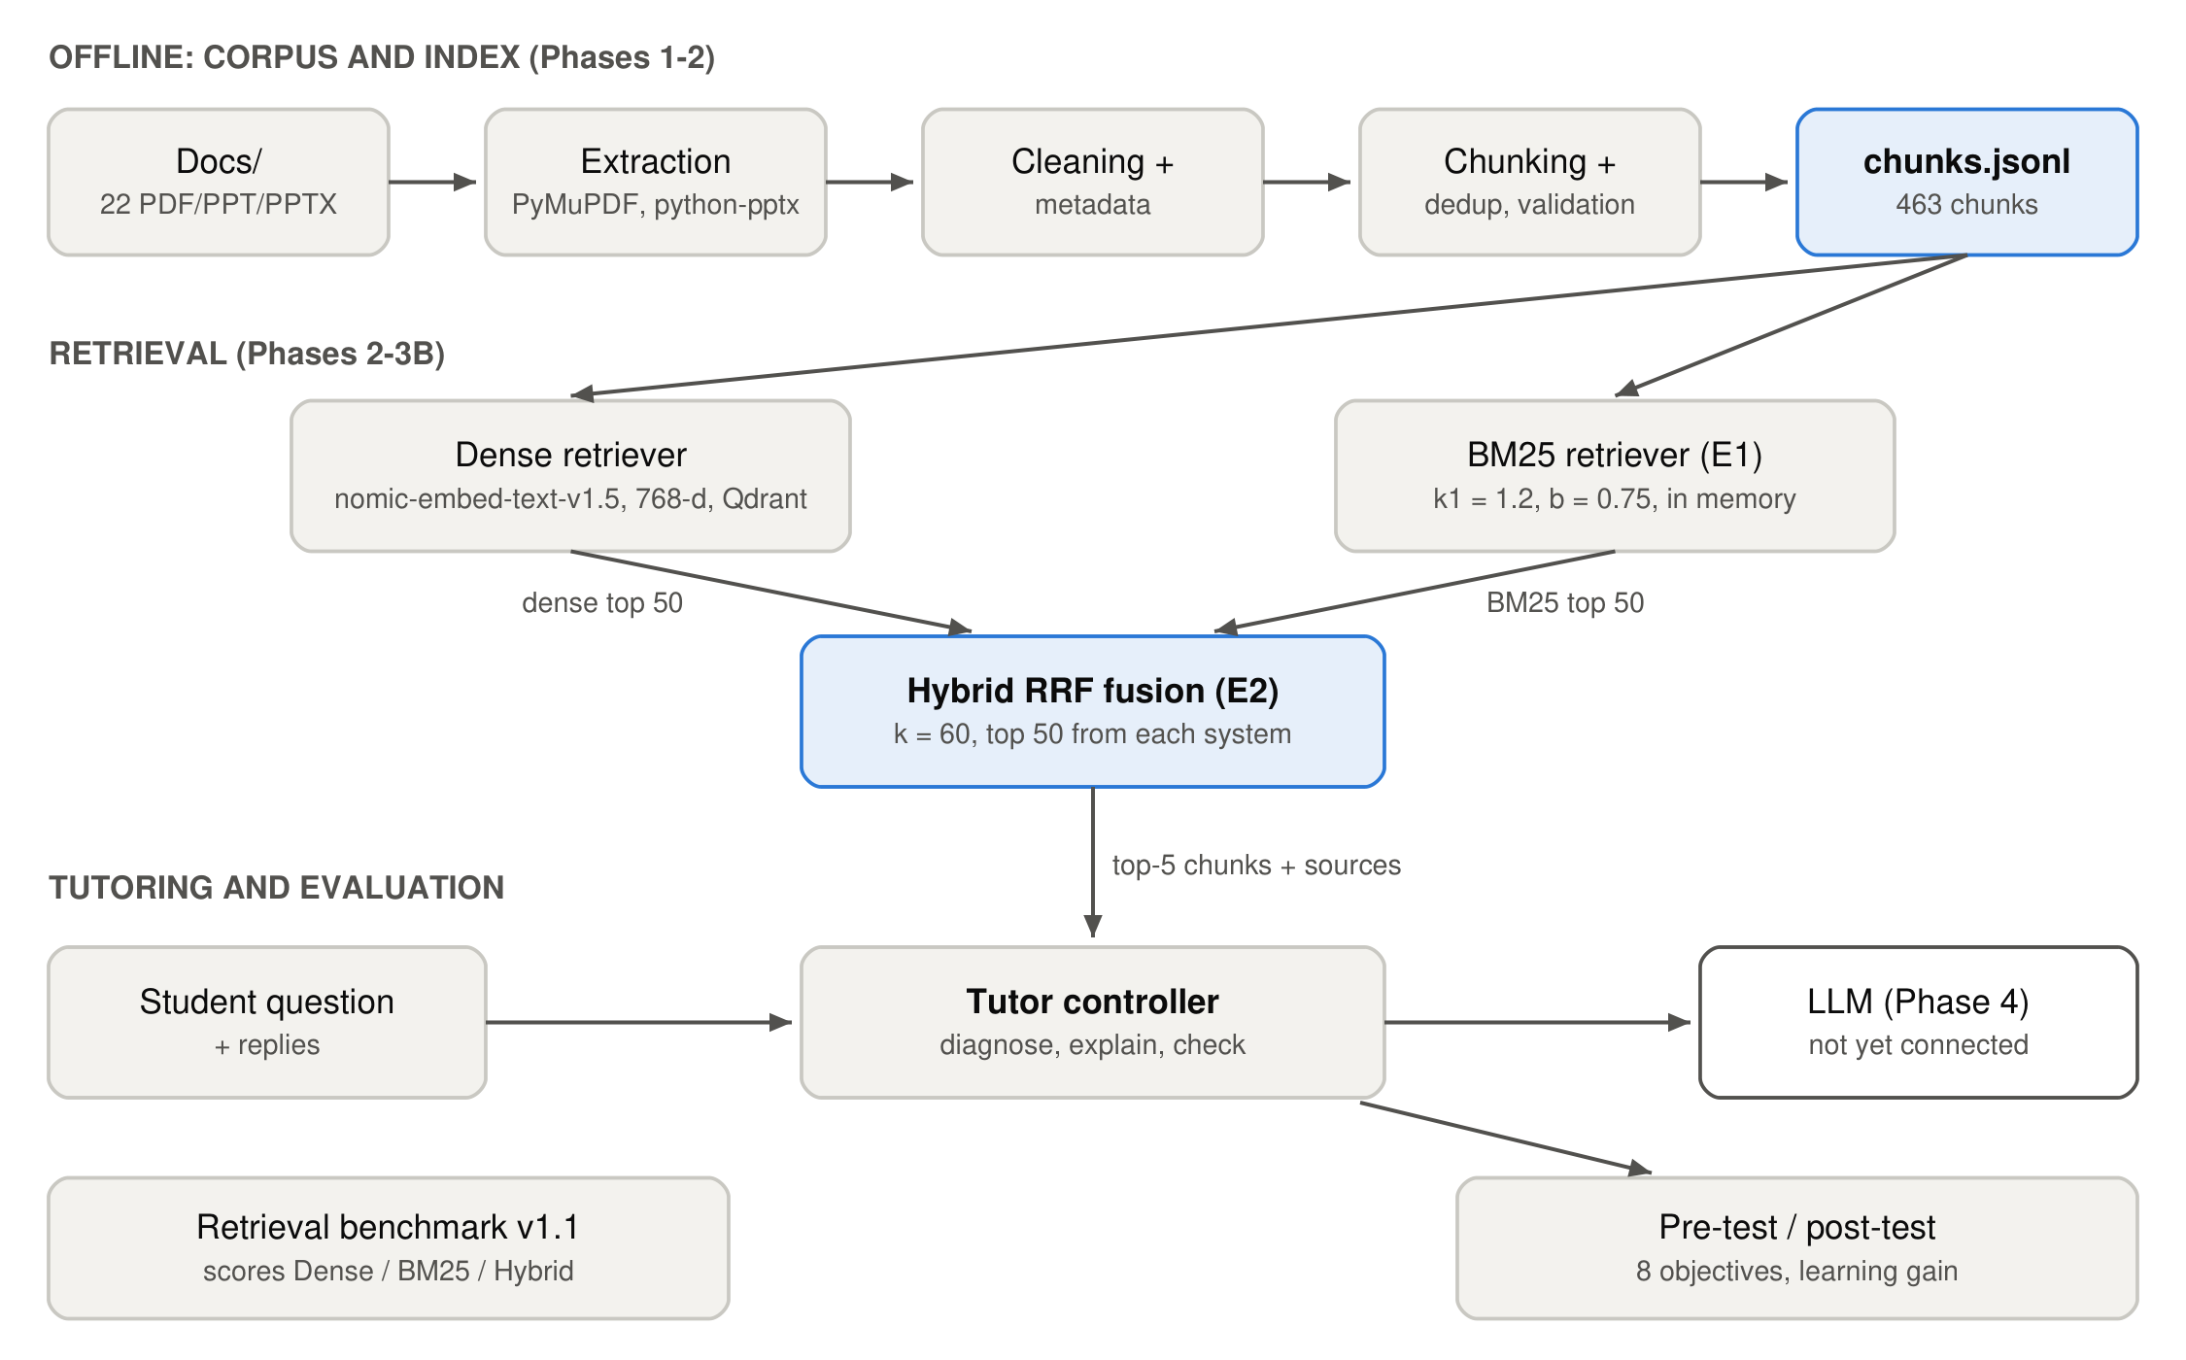
Figure 1. System architecture. The dashed connection to the LLM is the next phase.

6.2 Retrieval models
Retriever | Design
Dense (Phase 2) | Query embedded with Nomic Embed v1.5; exact cosine search over 463 vectors in Qdrant. Captures meaning even when the student's wording differs from the source.
BM25 (E1) | Okapi BM25 with k1 = 1.2, b = 0.75 (standard defaults, not tuned). No stemming, no stopword list. Rewards exact matches of rare terms and API names.
Hybrid RRF (E2) | score(d) = 1/(60 + dense rank) + 1/(60 + BM25 rank), over each system's top 50. Equal weights. Ties broken by corpus order. Uses ranks only, so no score calibration is needed.
Table 5. The three retrieval systems compared.
All parameters were fixed before evaluation and not tuned on the benchmark: tuning on the test queries would leak the answers into the system. All three systems use the same corpus, queries, judgments and metric code, so only the retrieval method differs between them.

6.3 Retrieval results
Metric | Dense | BM25 (E1) | Hybrid (E2)
Precision@5 | 0.598 | 0.517 | 0.632
Precision@10 | 0.458 | 0.378 | 0.470
Recall@5 | 0.436 | 0.401 | 0.471
Recall@10 | 0.624 | 0.543 | 0.645
MRR@5 | 0.914 | 0.852 | 0.921
nDCG@5 | 0.695 | 0.629 | 0.725
nDCG@10 | 0.706 | 0.631 | 0.727
MAP@5 | 0.404 | 0.361 | 0.433
Queries with a relevant chunk in top 1 / 3 / 5 / 10 (of 99) | 87 / 95 / 97 / 97 | 79 / 89 / 92 / 96 | 86 / 97 / 98 / 99
Queries with no relevant chunk in the top 10 | q009, q020 | q008, q046, q060 | none
Results in the top 10 never judged | 0 of 990 | 418 of 990 | 108 of 990
Table 6. Retrieval results on benchmark v1.1 (99 queries, depth 20). Best value in bold.
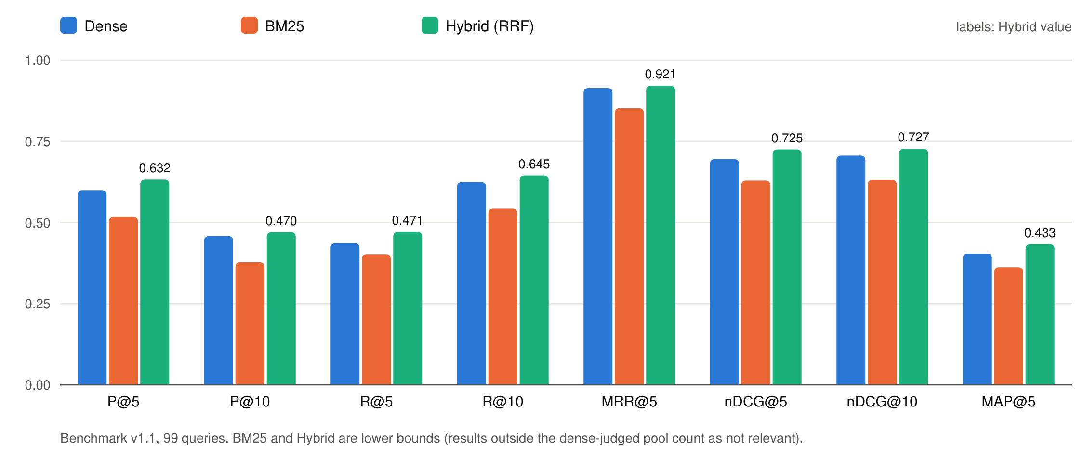
Figure 2. Dense, BM25 and hybrid retrieval on benchmark v1.1.
Findings.
- The hybrid retriever scores higher than the dense baseline on every headline metric (nDCG@10 0.727 vs 0.706, Precision@5 0.632 vs 0.598) and removes both of the dense system's top-10 failures.
- Per query, hybrid improves nDCG@10 on 58 queries and lowers it on 32 (9 ties). An exact two-sided sign test gives p = 0.008. Against BM25 alone, hybrid is better on 77 queries and worse on 16 (p < 0.0001).
- These hybrid numbers are conservative. The benchmark was judged from the dense system's results, so 108 hybrid top-10 results were never judged and are counted as not relevant.
- BM25 alone scores below dense on the standard metrics, but 42% of its top-10 results are unjudged. On the judged-only (condensed-list) view BM25 scores above dense (nDCG@10 0.731 vs 0.706; hybrid 0.751), so which of the two single systems is truly better is not yet established.
- By query type, hybrid helps most on classical-problem (nDCG@10 0.755 → 0.815), comparative (0.725 → 0.778) and scenario (0.748 → 0.806) queries. It is slightly below dense on conceptual queries (0.779 → 0.747), where BM25 brings in homework and reference-list sections that share question words.

6.4 Error analysis of the hardest queries
Query | Dense | BM25 | Hybrid | Diagnosis
q009: passing &i to pthread_create prints wrong numbers | No relevant chunk in top 10 (grade-2 chunks at rank 19 and beyond 30) | Both grade-2 chunks at ranks 1–2 | Grade-2 chunk rises to rank 3 | Dense misses the specific bug explanation; lexical match on loop, i and pthread_create recovers it.
q020: split a CPU-heavy loop over 10 threads; are locks needed? | No relevant chunk in top 10 (best at rank 16) | Grade-2 chunk at rank 1 | Relevant chunks at ranks 5, 6, 9 | Dense ranks lock-chapter material first. Hybrid repairs the failure only partly.
q091: atomic swap instruction for mutual exclusion | Grade-2 chunks at ranks 9, 11, 15 | Two short code slides fall out of the top 30 | Grade-2 chunk at rank 5 | A ranking problem: the swap solutions are written as code, not in the query's words.
Table 7. The three queries that failed in Review 1 (ranks are positions in each system's list).

6.5 Interactive tutor design
The tutor controller (src/tutor/controller.py) implements the teaching interaction as a state machine (Figure 3). It does not answer immediately: it first asks a diagnostic question, classifies the student's reply, explains only the missing idea with an example, and confirms understanding with a formative check.
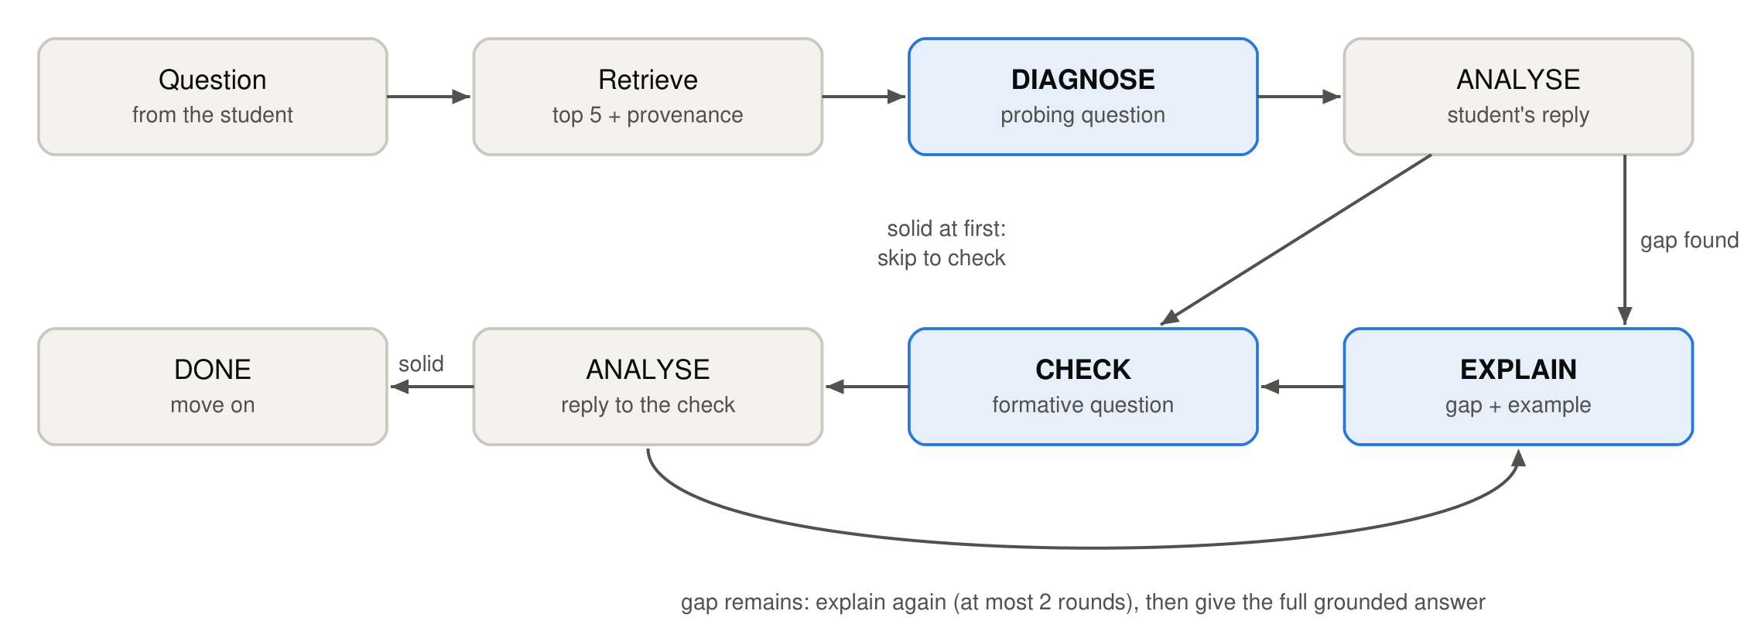
Figure 3. Tutoring flow implemented in the controller.
Stage | What the tutor does
DIAGNOSE | Asks one short probing question about the concept behind the student's question. Explicitly does not give the answer.
ANALYSE | Classifies the reply as solid, partial, misconception or unclear, and names the gap in one sentence. Malformed output is treated as unclear.
EXPLAIN | Explains only the identified gap, gives a concrete example and, where useful, a counterexample, then asks a check question.
CHECK | Asks a formative question that applies the idea to a new situation.
DONE / ANSWER | Moves on when the check is answered correctly. After at most 2 explanation rounds, gives the complete answer grounded in the sources.
Table 8. Tutor stages.
Grounding and provenance. Every prompt includes the retrieved chunks labelled [S1]…[S5] with filename, page or slide, and section, and instructs the model to use only that material and cite it. Every tutor turn returns the source list, so a student can open the original page.
Current status. The flow, the prompts, grounding and provenance are implemented and covered by tests that use a scripted stand-in for the model. No language model is connected yet: the controller accepts any function that maps a prompt to text, and choosing and connecting a model is the next phase. The quality of the tutor's questions and explanations has therefore not been evaluated yet.

6.6 Learning evaluation design
ID | Learning objective
LO1 | Threads fundamentals: what threads share and what each thread has privately
LO2 | Thread APIs: pthread_create and pthread_join, passing arguments and returning results
LO3 | Race conditions: why counter++ loses updates; critical sections
LO4 | Locks / mutexes: mutual exclusion, test-and-set, compare-and-swap, spin vs sleep
LO5 | Semaphores: sem_wait / sem_post; semaphores as locks and for ordering
LO6 | Condition variables: use with a mutex; re-checking the condition in a while loop
LO7 | Classical problems: producer-consumer, readers-writers, dining philosophers
LO8 | Concurrency bugs: deadlock conditions, atomicity and order violations, lock ordering
Table 9. Learning objectives (data/assessment/learning_objectives.json).
Each test item records its objective, topic, difficulty, question type (multiple choice, short answer or code reasoning), expected concept, answer key or rubric, and the corpus chunks that teach it. The planned protocol is: pre-test → tutoring session → post-test, optionally with a control group that reads the same material without the tutor dialogue. The analysis code computes, for each student, each group and each objective:
- Score = percentage of maximum points.
- Absolute gain = post − pre.
- Normalized gain g = (post − pre) / (100 − pre) (Hake), plus the class-average gain.
- Concept-wise improvement per learning objective.
No student has taken the tests yet, so no learning results are reported in this document.

6.7 Testing and reproducibility
- 93 automated tests pass (pytest), covering ingestion, retrieval, BM25, hybrid fusion, evaluation, the tutor flow and the learning-gain calculations.
- Each evaluation was run twice; rankings and results were identical apart from the timestamp.
- Frozen inputs (raw corpus, chunks, benchmark, vector index and baseline results) were verified unchanged by SHA-256 after all new work.

7. Conclusion
Since Review 1, OS-Tutor-RAG has progressed from a single dense retriever to a measured comparison of three retrieval methods, with the hybrid dense + BM25 retriever giving the best results on every headline metric (nDCG@10 0.727, Precision@5 0.632, a relevant chunk in the top 10 for all 99 queries). The judgments behind these numbers were expanded to 2,152, and the hardest failure cases were analysed. The tutor's teaching flow and the pre/post learning evaluation framework are implemented, so the project now extends beyond question answering in its design, while being clear about what remains to be done.

7.1 Limitations
- The benchmark was judged from the dense system's results only, so BM25 and hybrid scores are lower bounds and the dense-vs-BM25 comparison is not settled.
- One annotator produced all relevance judgments and draft test items; there is no inter-annotator agreement measure yet.
- Only one hybrid configuration was tested. BM25 brings some homework and reference-list sections into the results, and hybrid is worse than dense on 32 of 99 queries.
- The tutor does not yet generate text: no LLM is connected, and tutoring quality has not been evaluated.
- The item bank is an unvalidated draft and no student data exists.

7.2 Future work
- Judge the unjudged BM25 and hybrid results (benchmark v1.2) to remove the pooling bias.
- Connect a language model to the tutor controller and check its explanations against the cited sources.
- Have the instructor review the item bank, pilot it, then run the pre-test / tutoring / post-test study.
- Further controlled retrieval experiments: down-weighting homework and reference sections, reranking and duplicate handling.
- Extend the corpus beyond Threads and Synchronization.

References
[1] P. Lewis et al., "Retrieval-Augmented Generation for Knowledge-Intensive NLP Tasks," in Advances in Neural Information Processing Systems (NeurIPS), vol. 33, 2020.
[2] Y. Gao et al., "Retrieval-Augmented Generation for Large Language Models: A Survey," arXiv:2312.10997, 2023.
[3] V. Karpukhin et al., "Dense Passage Retrieval for Open-Domain Question Answering," in Proc. EMNLP, 2020.
[4] Z. Nussbaum, J. X. Morris, B. Duderstadt and A. Mulyar, "Nomic Embed: Training a Reproducible Long Context Text Embedder," arXiv:2402.01613, 2024.
[5] S. Robertson and H. Zaragoza, "The Probabilistic Relevance Framework: BM25 and Beyond," Foundations and Trends in Information Retrieval, vol. 3, no. 4, pp. 333–389, 2009.
[6] G. V. Cormack, C. L. A. Clarke and S. Büttcher, "Reciprocal Rank Fusion Outperforms Condorcet and Individual Rank Learning Methods," in Proc. ACM SIGIR, 2009, pp. 758–759.
[7] N. Thakur et al., "BEIR: A Heterogeneous Benchmark for Zero-shot Evaluation of Information Retrieval Models," in NeurIPS Datasets and Benchmarks Track, 2021.
[8] K. Järvelin and J. Kekäläinen, "Cumulated Gain-Based Evaluation of IR Techniques," ACM Transactions on Information Systems, vol. 20, no. 4, pp. 422–446, 2002.
[9] T. Sakai, "Alternatives to Bpref," in Proc. ACM SIGIR, 2007, pp. 71–78.
[10] B. S. Bloom, "The 2 Sigma Problem: The Search for Methods of Group Instruction as Effective as One-to-One Tutoring," Educational Researcher, vol. 13, no. 6, pp. 4–16, 1984.
[11] K. VanLehn, "The Relative Effectiveness of Human Tutoring, Intelligent Tutoring Systems, and Other Tutoring Systems," Educational Psychologist, vol. 46, no. 4, pp. 197–221, 2011.
[12] M. T. H. Chi and R. Wylie, "The ICAP Framework: Linking Cognitive Engagement to Active Learning Outcomes," Educational Psychologist, vol. 49, no. 4, pp. 219–243, 2014.
[13] R. R. Hake, "Interactive-Engagement versus Traditional Methods: A Six-Thousand-Student Survey of Mechanics Test Data for Introductory Physics Courses," American Journal of Physics, vol. 66, no. 1, pp. 64–74, 1998.
[14] R. H. Arpaci-Dusseau and A. C. Arpaci-Dusseau, Operating Systems: Three Easy Pieces. Arpaci-Dusseau Books, 2018.
[15] E. M. Voorhees and D. K. Harman (eds.), TREC: Experiment and Evaluation in Information Retrieval. MIT Press, 2005.
[16] P. Black and D. Wiliam, "Assessment and Classroom Learning," Assessment in Education: Principles, Policy & Practice, vol. 5, no. 1, pp. 7–74, 1998.

