Palash Bajpai

Low Level Design

Table of Contents
1. Introduction to Low-Level Design 2
2. SOLID Principles 3
a. Single Responsibility Principle 5
b. Open/Closed Principle (OCP) 7
c. Liskov Substitution Principle (LSP) 9
d. Interface Segregation Principle (ISP) 11
e. Dependency Inversion Principle (DIP) 13
3. Design Patterns 15
4. Singleton Pattern 18
5. Factory Design Pattern 21
6. Abstract Factory Design Pattern 24
7. Builder Design Pattern 29
8. Prototype Design Pattern 32
9. Adapter Pattern 36
10. Facade Pattern 40
11. Decorator Pattern 43
12. Proxy Pattern 47
13. Composite Pattern 50
14. Flyweight Pattern 54
15. Bridge Pattern 57
16. Strategy Pattern 61
17. Command Pattern 65

https://roadmap.sh/system-design
https://roadmap.sh/software-design-architecture
https://media.geeksforgeeks.org/courses/syllabus/b16669e7619419215993fe653e0b2fee.pdf
https://www.geeksforgeeks.org/complete-roadmap-to-learn-system-design/
https://www.canva.com/design/DAGinalqX0g/YmKCbxrDDooe26KG0C8xJw/edit
https://chatgpt.com/c/67de9e6a-6b1c-800b-a96a-8a900756ff5c

1. Introduction to Low-Level Design

A system is a set of interconnected components working together to achieve a common goal, while system design is the process of defining and implementing the architecture, components, and interfaces of a system to fulfill specific requirements.
- High Level Design (HLD): describe system architecture details, database design, service and processes, relationship between different modules and features.
- Low Level Design (LLD): describe design of each component in detail, classes, interfaces, relationship between them.

Low Level Design
Low-Level Design (LLD) is the process of designing software at the component level. It provides detailed descriptions of modules, classes, methods, and interactions between system components. LLD focuses on implementation details, object-oriented design principles, and design patterns.

🔹 Key Characteristics of LLD
- Defines the structure of classes and objects.
- Includes UML diagrams such as Class Diagrams, Sequence Diagrams, and Component Diagrams.
- Follows Object-Oriented Programming (OOP) principles.
- Uses design patterns to solve common software design problems.

🔹 Importance of LLD
- Improved Code Maintainability: Well-structured code is easier to update and debug.
- Better Collaboration: LLD serves as a blueprint for developers, reducing misunderstandings.
- Optimized Performance: Proper design improves performance by reducing redundancy and increasing reusability.
- Enhanced Scalability: Well-designed software can be extended without major refactoring.
- Promotes Best Practices: Encourages the use of SOLID principles and design patterns.

2. SOLID Principles
SOLID is a set of five design principles that help software developers write maintainable, scalable, and robust code in object-oriented programming. These principles were introduced by Robert C. Martin (Uncle Bob) to improve software design and ensure that systems are easy to extend and modify.

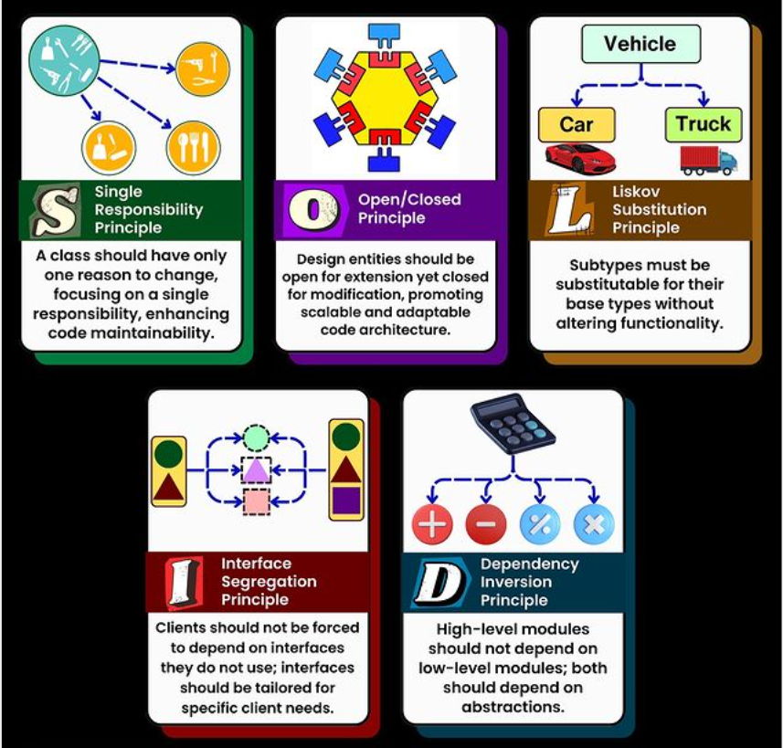

Principle | Description
S - Single Responsibility Principle (SRP) | A class should have only one reason to change.
O - Open/Closed Principle (OCP) | Code should be open for extension but closed for modification.
L - Liskov Substitution Principle (LSP) | Derived classes should be substitutable for their base classes.
I - Interface Segregation Principle (ISP) | Avoid forcing classes to implement unnecessary methods of an interface.
D - Dependency Inversion Principle (DIP) | High-level modules should not depend on low-level modules. Both should depend on abstractions

Advantages of using SOLID principle:-
- Better Maintainability: Each class has a single responsibility, making code easier to understand and modify.
- Scalability: New features can be added without modifying existing code.
- Loose Coupling: Dependency Inversion and Interface Segregation help reduce code dependencies.
- Easy Testing: Code becomes modular, allowing better unit testing and mocking.
- Better Collaboration: Developers can work on different parts of the system without causing conflicts.

Eg: - Consider building an e-commerce platform, if you follow SOLID principle
- Adding a new payment method (e.g., UPI) doesn't require modifying the entire payment system.
- Changing the notification system from SMS to Email won't break existing code.

Single Responsibility Principle(SRP)
The Single Responsibility Principle (SRP) states that a class should have only one reason to change. This means that a class should focus on only one functionality and should not mix multiple concerns. If a class handles multiple responsibilities, changes in one part of the system might affect unrelated parts, leading to fragile and tightly coupled code.
🔹 Key Takeaways of SRP
- A class should have one and only one responsibility.
- Changes in functionality should not impact unrelated features.
- Code should be modular, reusable, and easy to maintain.

Example: Book Management System:-
Imagine we are designing a Book Management System. A naive approach might be to create a single class that: Stores book details, Prints book details, Saves book details to a database
This violates SRP because the class is responsible for multiple things:
❌ Managing book data
❌ Handling printing logic
❌ Dealing with persistence (saving to the database)
//Bad Code
class Book {
private String title;
private String author;
public Book(String title, String author) {
this.title = title;
this.author = author;
}
// This method handles business logic (responsibility 1)
public void printBook() {
System.out.println("Title: " + title + ", Author: " + author);
}
// This method handles persistence (responsibility 2)
public void saveToDatabase() {
System.out.println("Saving book to database...");
}
}

// Good Code
// Book class - Handles only book data

class Book {
private String title;
private String author;
public Book(String title, String author) {
this.title = title;
this.author = author;
}
public String getTitle() {
return title;
}
public String getAuthor() {
return author;
}
}
// Separate class for printing
class BookPrinter {
public void printBook(Book book) {
System.out.println("Title: " + book.getTitle() + ", Author: " + book.getAuthor());
}
}
// Separate class for saving to database
class BookRepository {
public void saveToDatabase(Book book) {
System.out.println("Saving book to database: " + book.getTitle());
}
}

Why is this better?
- Each class has a single responsibility
- Changes in one part won’t affect unrelated functionalities
- Code is modular, reusable, and easy to test

Open/Closed Principle (OCP)
A class should be open for extension but closed for modification. This means that we should be able to extend a class’s behavior without modifying its existing code. By doing this, we avoid introducing bugs into existing, tested code while still allowing enhancements.

🔹 Why OCP is important?
- Enhances maintainability – No need to modify existing classes when adding new features.
- Prevents unintended side effects – Since we don’t modify existing code, there's no risk of breaking functionality.
- Encourages scalability – New features can be added easily by extending the behavior.

Example: E-commerce platform:-
Imagine you are building an e-commerce system that processes payments.
❌ Bad Approach: A PaymentProcessor class handles different payment methods:

//Bad design
class PaymentProcessor {
public void processPayment(String paymentType) {
if (paymentType.equals("CreditCard")) {
System.out.println("Processing credit card payment...");
} else if (paymentType.equals("PayPal")) {
System.out.println("Processing PayPal payment...");
} else {
System.out.println("Invalid payment method.");
}
}
}

- Every time a new payment method is added (e.g., Google Pay, Apple Pay), we need to modify processPayment().
- This violates OCP because the class is not closed for modification—we must edit the existing logic whenever a new type of payment is introduced.
- Use interfaces or abstract classes to allow extension.

🔹 Solution using OCP:
Instead of modifying the PaymentProcessor, we use polymorphism and abstraction to extend functionality without modifying the existing code.
// Step 1: Create an abstract Payment class
abstract class Payment {
abstract void process();
}

// Step 2: Implement different payment types
class CreditCardPayment extends Payment {
@Override
void process() {
System.out.println("Processing credit card payment...");
}
}
class PayPalPayment extends Payment {
@Override
void process() {
System.out.println("Processing PayPal payment...");
}
}
class GPay extends Payment {
@Override
void process() {
System.out.println("Processing PayPal payment...");
}
}

// Step 3: PaymentProcessor now works with any new payment type without modification
class PaymentProcessor {
public void processPayment(Payment payment) {
payment.process(); // Uses polymorphism to process payment
}
}

// Usage
public class Main {
public static void main(String[] args) {
PaymentProcessor processor = new PaymentProcessor();
Payment creditCard = new CreditCardPayment();
Payment paypal = new PayPalPayment();
processor.processPayment(creditCard);
processor.processPayment(paypal);
}
}

Liskov Substitution Principle (LSP)
"Subtypes must be substitutable for their base types without altering the correctness of the program." This means that if class B is a subclass of class A, then B should be usable in place of A without unexpected behavior.

🔹 Why LSP is important?
- Ensures that inheritance is used correctly and meaningfully.
- Helps avoid breaking polymorphism by preventing unexpected behavior.
- Promotes robust and maintainable code.

Example:
Imagine we are building a Bird Hierarchy for a wildlife simulation
❌ If we replace a Bird object with a Penguin, it violates expectations (penguins can’t fly!).
❌ The fly() method is not applicable to all subclasses of Bird.
❌ If client code calls fly(), it could crash unexpectedly(runtime exception)

//Bad Example
class Bird {
void fly() {
System.out.println("This bird can fly.");
}
}
class Sparrow extends Bird {
// Sparrow can fly - fine
}
class Penguin extends Bird {
// But penguins cannot fly!
@Override
void fly() {
throw new UnsupportedOperationException("Penguins cannot fly!");
}
}

🔹 Solution using LSP:
We should separate birds that can fly and those that cannot.
// Base interface for all birds
interface Bird {
void eat();
}
// Separate interface for birds that can fly
interface FlyingBird extends Bird {
void fly();
}

// Sparrow implements FlyingBird because it can fly
class Sparrow implements FlyingBird {
@Override
public void eat() {
System.out.println("Sparrow is eating.");
}
@Override
public void fly() {
System.out.println("Sparrow is flying.");
}
}
// Penguin implements only Bird, not FlyingBird
class Penguin implements Bird {
@Override
public void eat() {
System.out.println("Penguin is eating.");
}
}

//LSP ensures that subclasses can replace their parent classes without breaking functionality.
// Correctly designed client code
class BirdSanctuary {
public void letBirdFly(FlyingBird bird) {
bird.fly();
}
}

Interface Segregation Principle (ISP)
It states that “do not force any client to implement an interface which is irrelevant to them“. This means that instead of having large, general-purpose interfaces, we should create smaller, more specific interfaces that contain only the methods relevant to a particular client. This principle is the first principle that applies to Interfaces instead of classes in SOLID and it is similar to the single responsibility principle but specific to interfaces.

🔹 Difference between LSP and ISP
Principle | Focus | Problem It Solves | Solution
Liskov Substitution Principle (LSP) | Ensures that subclasses can replace parent classes without breaking behavior. | Inheritance misuse where a subclass changes the behavior of the base class. | Use correct abstraction to ensure child classes fully comply with the parent class’s expected behavior.
Interface Segregation Principle (ISP) | Ensures that clients do not depend on methods they do not use. | Large, “fat” interfaces that force classes to implement unnecessary methods. | Split interfaces into smaller, more specific ones so that classes implement only what they need.
👉 LSP is about subclass relationships, while ISP is about breaking down interfaces properly.

Example: ❌ Bad Example

//Bad example

interface Printer {
void print();
void scan();
void fax();
}

- A basic printer may support only print().
- A multifunction printer (MFP) may support print(), scan(), and fax().
- Forcing all printers to implement scan() and fax() even if they don’t support these features violates ISP.

🔹 Solution using ISP:
Split the interface
// Interface for basic printing functionality
interface Printer {
void print();
}
// Interface for scanning functionality
interface Scanner {
void scan();
}
// Interface for fax functionality
interface Fax {
void fax();
}

// Basic printer only implements Printer
class BasicPrinter implements Printer {
@Override
public void print() {
System.out.println("Printing document...");
}
}

// Multifunction printer implements all three interfaces
class MultiFunctionPrinter implements Printer, Scanner, Fax {
@Override
public void print() {
System.out.println("Printing document...");
}
@Override
public void scan() {
System.out.println("Scanning document...");
}
@Override
public void fax() {
System.out.println("Sending fax...");
}
}

Dependency Inversion Principle (DIP)
"High-level modules should not depend on low-level modules. Both should depend on abstractions (interfaces or abstract classes)."
"Abstractions should not depend on details. Details should depend on abstractions."
- In simpler terms, the DIP suggests that classes should rely on abstractions (e.g., interfaces or abstract classes) rather than concrete implementations.
- This allows for more flexible and decoupled code, making it easier to change implementations without affecting other parts of the codebase.
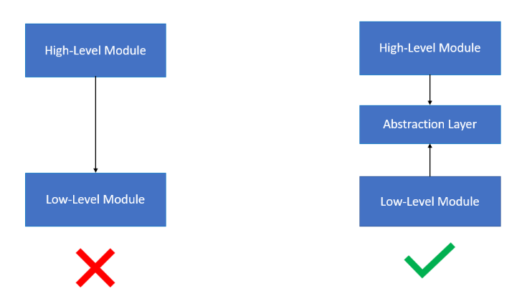

🔹 Why DIP is important?
- Without DIP, changes in low-level modules break high-level modules.
- Hard dependencies make it difficult to modify or extend functionality.
- Following DIP makes code more maintainable, modular, and adaptable to future changes.

Bad Example: ❌Payment Processing Example
- OrderService is tightly coupled to PayPalPayment.
- If we want to add StripePayment or GooglePayPayment, we must modify OrderService, breaking the Open/Closed Principle (OCP).
- Testing is difficult because OrderService cannot work with mock payment processors.

class PayPalPayment {
void processPayment(double amount) {
System.out.println("Processing payment of $" + amount + " via PayPal.");
}
}
class OrderService {
private PayPalPayment paymentProcessor = new PayPalPayment(); // Direct dependency
void checkout(double amount) {
paymentProcessor.processPayment(amount);
}
}
🔹 Solution using DIP:
// Define an abstraction (interface)
interface PaymentProcessor {
void processPayment(double amount);
}

// Implement PayPal payment processing
class PayPalPayment implements PaymentProcessor {
@Override
public void processPayment(double amount) {
System.out.println("Processing payment of $" + amount + " via PayPal.");
}
}
// Implement Stripe payment processing
class StripePayment implements PaymentProcessor {
@Override
public void processPayment(double amount) {
System.out.println("Processing payment of $" + amount + " via Stripe.");
}
}

// High-level module depends on abstraction
class OrderService {
private final PaymentProcessor paymentProcessor;
// Inject dependency via constructor
public OrderService(PaymentProcessor paymentProcessor) {
this.paymentProcessor = paymentProcessor;
}
void checkout(double amount) {
paymentProcessor.processPayment(amount);
}
}

Design Patterns
Design patterns are proven solutions to common software design problems. They offer best practices to structure and optimize software development, helping developers create scalable, maintainable, and reusable code. They are not strict rules but guidelines that facilitate effective software design.

🔹 Why use design pattern?
- Improve Code Maintainability - Design patterns encourage a structured and organized approach, making it easier to maintain and modify code over time.
- Increase Code Reusability - Patterns allow components to be reused across different projects, reducing redundancy.
- Enhance Scalability and Flexibility - Well-structured code ensures that applications can scale efficiently without major changes.
- Reduce Development Time - Patterns provide pre-defined solutions, allowing developers to focus on business logic rather than reinventing the wheel.

Types of Design Pattern:

- Creational Design Patterns
Creational patterns deal with the efficient creation of objects while hiding the instantiation logic.

Pattern | Purpose | Example
Singleton | Ensures only one instance of a class exists. | Logger, Database Connection
Factory | Delegates object creation to subclasses. | ShapeFactory returning Circle or Rectangle
Abstract Factory | Creates related objects without specifying concrete classes. | GUIFactory producing WindowsButton or MacButton
Builder | Step-by-step creation of complex objects. | MealBuilder for creating VegMeal or NonVegMeal
Prototype | Creates new objects by cloning an existing object. | Document.clone() method

- Structural Design Patterns
Structural patterns help in organizing classes and objects to create flexible and scalable architectures.
Pattern | Purpose | Example
Adapter | Converts one interface into another. | USB-to-Ethernet Adapter
Bridge | Decouples abstraction from implementation. | RemoteControl → TV (SonyRemote, LGRemote)
Composite | Treats individual and composite objects uniformly. | Folder containing Files and SubFolders
Decorator | Adds functionality dynamically without modifying the original class. | BufferedReader wrapping FileReader
Facade | Provides a simplified interface to a complex system. | JDBC Connection
Flyweight | Shares objects to reduce memory usage. | Character Objects in a Text Editor
Proxy | Controls access to another object. | Virtual Proxy, Security Proxy

- Behavioural Design Patterns
Behavioural patterns define communication and responsibilities among objects.
Pattern | Purpose | Example
Chain of Responsibility | Passes requests along a chain of handlers. | Logging System (Error → Warning → Info)
Command | Encapsulates a request as an object. | Undo/Redo System in Text Editors
Interpreter | Defines a grammar for language interpretation. | SQL Query Parser
Iterator | Sequentially accesses elements of a collection. | Java Iterator, Python Itertools
Mediator | Defines a central object for object communication. | Chat Room, Traffic Controller
Memento | Saves object states for rollback. | Undo feature in MS Word
Observer | Notifies dependent objects of state changes. | Event Listeners in UI
State | Allows an object to change behavior based on its state. | Vending Machine States
Strategy | Defines a family of algorithms and selects one at runtime. | Sorting Algorithms (MergeSort, QuickSort)
Template Method | Defines the skeleton of an algorithm and allows subclasses to fill in details. | Data Processing Pipelines
Visitor | Allows adding operations to objects without modifying their structure. | AST (Abstract Syntax Tree) Traversal

Singleton Pattern
The Singleton pattern restricts the instantiation of a class to a single object and provides a way to access it globally. It is used when only one instance of a class is needed to coordinate actions across a system.
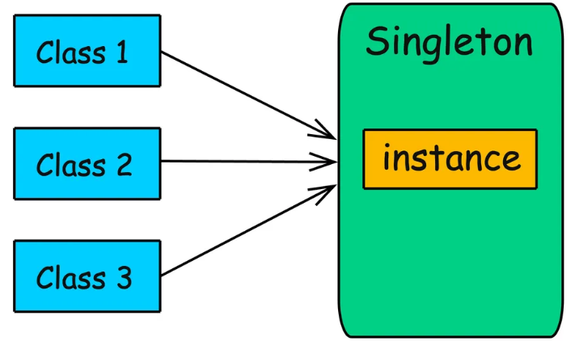

🔹 When to use:
In certain situations, such as managing a database connection, logging, or configuration settings, you want to ensure that only one instance of a class is created throughout the application’s lifecycle. If multiple instances were created, it could lead to issues like:
- Inconsistent state: If multiple instances represent the same concept, they may hold different data.
- Resource conflicts: If multiple instances of a resource-heavy class are created, it can lead to performance degradation.

🔹 Implementation of Singleton Pattern:
class Singleton {
private static Singleton instance;
//make constructor private, so no other class can create object directly
private Singleton() { }
//The getInstance() method is used to access the single instance
public static Singleton getInstance() {
if (instance == null) {
instance = new Singleton();
}
return instance;
}
}
- Lazy initialization in the Singleton pattern ensures that the instance is created only when it is needed for the first time, rather than at the time of class loading
- In a multithreaded environment, the Singleton pattern often uses synchronized methods to ensure that only one instance is created, even if multiple threads attempt to create an instance at the same time.
- To ensure that a Singleton object cannot be cloned, you should override the clone() method and throw CloneNotSupportedException to prevent the creation of multiple instances.

🔹 Example: Design a logging service that allows multiple parts of an application to log messages but ensures all logs are managed from a single instance
// The Logger class implements the Singleton Pattern to provide a single point of access for logging messages throughout the application.(Logger.java)
package Singleton;
import java.text.SimpleDateFormat;
import java.util.Date;
public class Logger {
private static Logger instance;
private Logger() {}
public static synchronized Logger getInstance() {
if (instance == null) {
instance = new Logger();
}
return instance;
}
public void info(String message) {
log("INFO", message);
}
public void warn(String message) {
log("WARN", message);
}
public void error(String message) {
log("ERROR", message);
}
private void log(String level, String message) {
String timestamp = new SimpleDateFormat("yyyy-MM-dd HH:mm:ss").format(new Date());
System.out.println(String.format("%s [%s]: %s", timestamp, level, message));
}
}

Class to use it

package Singleton;
import java.util.Scanner;
public class Exercise {
public void run() {
Logger logger = Logger.getInstance();
Scanner sc = new Scanner(System.in);
//Log the info message using the appropriate logging method.
System.out.print("Enter an info message: ");
String infoMessage = sc.nextLine();
logger.info(infoMessage);
// Log the warn message using the appropriate logging method.
System.out.print("Enter a warning message: ");
String warnMessage = sc.nextLine();
logger.warn(warnMessage);
//Log the error message using the appropriate logging method.
System.out.print("Enter an error message: ");
String errorMessage = sc.nextLine();
logger.error(errorMessage);
sc.close();
}
}

Factory Design Pattern
The Factory Pattern is a creational design pattern that provides a way to create objects without specifying the exact class that should be instantiated.
👉 The Factory Pattern helps centralize the creation logic and delegates the responsibility of creating objects to factory classes, which decide the specific class to instantiate.
👉 Key Idea: Instead of using new to create objects in the client code (service call), we delegate object creation to a dedicated method (factory class).

🔹 Why to use:
- Decouples object creation from implementation
- Promotes reusability and maintainability
- Improves code readability by abstracting instantiation logic
- Provides flexibility in object creation (e.g., dynamic selection at runtime)

❌ Without Factory Pattern (Direct Instantiation)

class PaymentService {
void makePayment(String type) {
if (type.equals("CreditCard")) {
CreditCardPayment payment = new CreditCardPayment();
payment.process();
} else if (type.equals("PayPal")) {
PayPalPayment payment = new PayPalPayment();
payment.process();
}
}
}

Problem with above code:
- Tightly coupled: The PaymentService class (Client code) knows about every payment method.
- Adding new payment methods requires modifying PaymentService (violation of open/close principle)
- Hard to test because objects are directly created inside the method.

🔹 Implementation with Factory Pattern

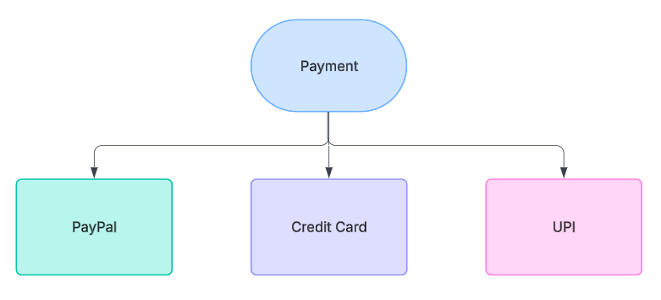

interface Payment {
void process();
}
class CreditCardPayment implements Payment {
public void process() {
//Large code to handle credit card payment
System.out.println("Processing Credit Card Payment");
}
}
class PayPalPayment implements Payment {
public void process() {
//Large code to handle Paypal payment
System.out.println("Processing PayPal Payment");
}
}

//Factory Class (handles object creation)
//Can use if-else too
class PaymentFactory {
public static Payment getPaymentMethod(String type) {
switch (type.toLowerCase()){
case "creditcard":
return new CreditCardPayment();
case "paypal":
return new PayPalPayment();
default:
throw new IllegalArgumentException("Unknown Payment type: " + type);
}
}
}
//Service class(client code)
//in place of taking type input from user, it may be coming via api or from UI input or select field
public class PaymentService {
public void makePayment(String type){
Payment payment = PaymentFactory.getPaymentMethod(type);
payment.process();
//notification
//logging
}
}

//client code
public class PaymentClient {
public static void main(String[] args) {
PaymentService ps = new PaymentService();
ps.makePayment("creditcard");
}
}

🔹 Benefits of using Factory Pattern
- Encapsulation – Object creation logic is centralized in PaymentFactory.
- Easier to extend – Add a new payment method without modifying PaymentService.
- Loose coupling – PaymentService only depends on the Payment interface

✅ Use the Factory Pattern when:
- You need multiple implementations of an interface and want to decouple object creation.
- Object creation is complex and involves configuration settings or dependencies.
- You want to centralize object creation logic instead of scattering new keywords across your codebase.
- You need flexibility in choosing an implementation at runtime.

🚫 Avoid Factory Pattern if:
- You have a small number of classes and no need for dynamic object creation.
- Object creation is simple and does not require additional logic.

Abstract Factory Design Pattern
The Abstract Factory Pattern is a creational design pattern that provides an interface for creating families of related or dependent objects without specifying their concrete classes.
👉 Instead of creating objects directly, the client interacts with an abstract factory that provides methods to create different objects.
👉 This ensures that related objects are created consistently, reducing tight coupling.

🔹 Why to use:
- Encapsulates object creation and provides a consistent way to create related objects.
- Decouples client code from the specific classes that implement the objects.
- Ensures compatibility among objects created within a family
- Easier to extend by adding new factories without modifying existing code.

❌ Without Factory Pattern (Direct Instantiation) :
Imagine we are building a cross-platform UI library that needs to create buttons and checkboxes differently for Windows and MacOS.
class Application {
void createUI(String osType) {
if (osType.equals("Windows")) {
WindowsButton button = new WindowsButton();
WindowsCheckbox checkbox = new WindowsCheckbox();
button.render();
checkbox.render();
} else if (osType.equals("MacOS")) {
MacOSButton button = new MacOSButton();
MacOSCheckbox checkbox = new MacOSCheckbox();
button.render();
checkbox.render();
}
}
}

Problem with above code:
- Code duplication due to if else logic
- Difficult to extend, as if new OS is added, client code needs to be modified
- No code is stopping to create MacOSCheckboc with WindowsButton, which are incompatible with each other.
- Application class directly depends on concrete classes like WindowsButton.
🔹 Implementation with Abstract Factory Pattern
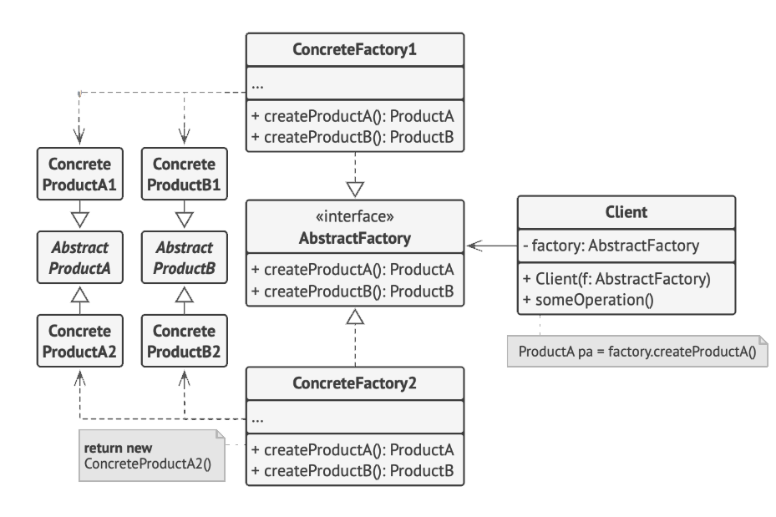
- Abstract Factory: Interface for creating abstract products.
- Concrete Factory: Implements the abstract factory and creates concrete products.
Using the Abstract Factory Pattern, you create interfaces for each product (e.g., Button, ScrollBar, and Window) and provide a family of concrete implementations for each theme (e.g., WindowsButton, MacOSButton, etc.).

// Abstract Button Interface
interface Button {
void render();
}
// Concrete Implementations for Windows and MacOS
class WindowsButton implements Button {
public void render() {
System.out.println("Rendering Windows Button");
}
}
class MacOSButton implements Button {
public void render() {
System.out.println("Rendering MacOS Button");
}
}

// Abstract Checkbox Interface
interface Checkbox {
void render();
}
// Concrete Implementations for Windows and MacOS
class WindowsCheckbox implements Checkbox {
public void render() {
System.out.println("Rendering Windows Checkbox");
}
}
class MacOSCheckbox implements Checkbox {
public void render() {
System.out.println("Rendering MacOS Checkbox");
}
}

// Abstract Factory Interface
interface GUIFactory {
Button createButton();
Checkbox createCheckbox();
}
// Concrete Factories for Windows and MacOS
class WindowsFactory implements GUIFactory {
public Button createButton() {
return new WindowsButton();
}
public Checkbox createCheckbox() {
return new WindowsCheckbox();
}
}
class MacOSFactory implements GUIFactory {
public Button createButton() {
return new MacOSButton();
}
public Checkbox createCheckbox() {
return new MacOSCheckbox();
}
}

// Application uses Abstract Factory
class Application {
private Button button;
private Checkbox checkbox;
public Application(GUIFactory factory) {
this.button = factory.createButton();
this.checkbox = factory.createCheckbox();
}
void renderUI() {
button.render();
checkbox.render();
}
}
// Client Code
class Main {
public static void main(String[] args) {
GUIFactory factory;
String osType = "Windows"; // Change to "MacOS" for Mac UI
if (osType.equals("Windows")) {
factory = new WindowsFactory();
} else {
factory = new MacOSFactory();
}
Application app = new Application(factory);
app.renderUI();
}
}

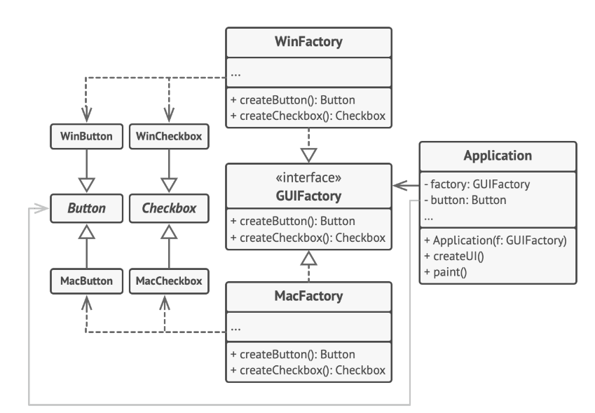
🔹 Benefits of using Factory Pattern
- Decouples object creation → Application class only depends on GUIFactory, not on specific classes.
- Easy to extend → Adding a new LinuxFactory does not affect existing code.
- Ensures compatibility → A WindowsFactory always provides a Windows button and checkbox, preventing mismatches.

✅ Use the Factory Pattern when:
- You need to create related objects that must be used together (e.g., UI components).
- You want to ensure compatibility between created objects.
- You need flexibility in choosing between different implementations at runtime.
- You want to enforce consistency by ensuring that objects from the same family are used together.

🚫 Avoid Factory Pattern if:
- You don’t need to create families of related objects.
- Object creation logic is simple and doesn’t require multiple variations.

Difference between Factory and Abstract Factory:
Feature | Factory Pattern | Abstract Factory Pattern
Purpose | Creates objects of a single type | Creates families of related objects
Flexibility | Less flexible; one factory per type | More flexible; centralizes multiple factories
Scalability | Limited to a single product type | Supports multiple related products
Example | Payment processing factory | UI Component factory (Windows/Mac)

Builder Design Pattern
The Builder Pattern is a creational design pattern that helps in constructing complex objects step by step. It allows you to separate the construction process from the actual object representation (following SRP), making object creation more flexible and readable.
👉 Instead of creating objects with long constructor parameters (telescoping constructors), the Builder pattern provides a fluent API to build objects conveniently.

❌ Without Builder Pattern (Building a burger)
class Burger {
private String size; //mandatory
private String patty; //mandatory
private String sauce; //optional
private boolean cheese; //optional
private boolean tomato; //optional
// Constructor with many parameters (Telescoping Constructor Problem)
public Burger(String size,String patty, String sauce, boolean cheese,boolean tomato) {
this.size = size;
this.patty = patty;
this.sauce = sauce;
this.cheese = cheese;
this.tomato = tomato;
}
@Override
public String toString() {
return "Burger{" + "size='" + size + ", patty='" + patty + ", sauce='" + sauce + ", cheese=" + cheese + ", tomato=" + tomato + '}';
}
}
public class Main {
public static void main(String[] args) {
// Difficult to understand what parameters mean
Burger burger = new Burger("Large", "Aloo", "Mint Mayo", true, false);
System.out.println(burger);
}
}

Problem with above code:
- Difficult to read – What does true, false, true, false mean?
- Unnecessary arguments – What if the user wants a default burger?
- Hard to extend – Adding new ingredients means modifying the constructor.
🔹 Implementation with Builder Pattern
class Burger {
private String size; //mandatory
private String patty; //mandatory
private String sauce; //optional
private boolean cheese; //optional
private boolean tomato; //optional
// Private constructor to force use of Builder
private Burger(BurgerBuilder builder) {
this.size = builder.size;
this.patty = builder.patty;
this.sauce = builder.sauce;
this.cheese = builder.cheese;
this.tomato = builder.tomato;
}
@Override
public String toString() {
return "Burger{" + "size='" + size + ", patty='" + patty + ", sauce='" + sauce + ", cheese=" + cheese + ", tomato=" + tomato + '}';
}
// Static Inner Builder Class
public static class BurgerBuilder {
private String size; //mandatory
private String patty; //mandatory
private String sauce = "Tamato Sauce"; //giving default value
private boolean cheese; //optional, defaults to false
private boolean tomato; //optional, , defaults to false
// Mandatory parameter
public BurgerBuilder(String size, String patty) {
this.size = size;
}
public BurgerBuilder addSauce(String sauce) {
this.sauce = sauce;
return this;
}
public BurgerBuilder addCheese(boolean cheese) {
this.cheese = cheese;
return this;
}
public BurgerBuilder addTomato(boolean tomato) {
this.tomato = tomato;
return this;
}
// Build method to create final object
public Burger build() {
return new Burger(this);
}
}
}

//Client code to handle burger creation
public class Main {
public static void main(String[] args) {
Burger burger = new Burger.BurgerBuilder("Large","Aloo")
.addSauce("Mint Mayo")
.addCheese(true) //chaining method call
.addTomato(true)
.build();
System.out.println(burger);
Burger burger2 = new Burger.BurgerBuilder("Small","Chicken")
.addTomato(true)
.build();
}
}

Explanation: Inside Burger class, we created a nested static class BurgerBuilder, which create the burger. Burger has different set methods, which return BurgerBuilder only, so that while calling, these methods can be chained.
BurgerBuilder also have build method, which at the end calls the private constructor of Burger and returns Burger object.

🔹 Key Features of builder pattern:
✔ Step-by-step object construction
✔ Readable and maintainable code
✔ Immutability – Objects can be made immutable after creation (by setting values to final)
✔ Avoids complex telescoping constructor
✔ No need to remember order of values to be set for constructor.

🔹 Real world use case:
HttpRequest request = new HttpRequest.Builder()
.setUrl("https://api.example.com")
.setMethod("POST")
.setHeader("Content-Type", "application/json")
.setBody("{ \"name\": \"John\" }")
.build();

Prototype Design Pattern
The Prototype Pattern is a creational design pattern that allows cloning an object instead of creating a new instance from scratch. It provides a mechanism to create objects by copying an existing object (prototype).

🔹 When to use Prototype pattern
Scenario | Why Prototype Helps
Objects are expensive to create | Cloning avoids costly instantiations
Need multiple instances of an object with  minor changes | Clone the object and modify specific fields
Reduce dependency on constructors | Simplifies object creation logic
Need to maintain object history (versioning) | Cloning preserves previous states

🔹 Shallow Vs Deep copy
In most cases, eg for case where we need to store the previous state of anything like a game. So in such cases we need to store deep copy, so that current state don’t change values in previous state. By default, Java’s clone() method creates a shallow copy, meaning nested objects are not cloned.
- Shallow Copy: Creates a new object but does not clone the objects that the original object refers to.
- Deep Copy: Clones the original object and all the objects it refers to (nested objects)

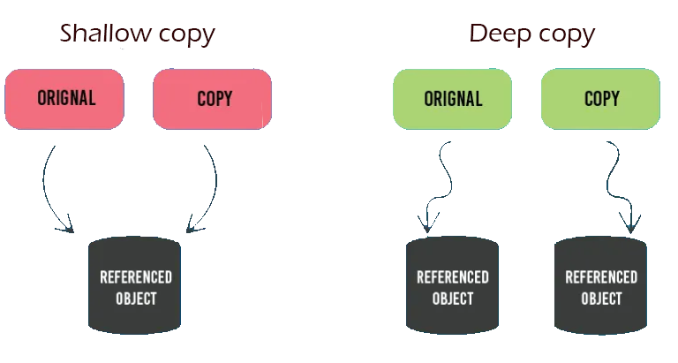

❌ Without Prototype Pattern (Storing current state of chess game, for undo redo functionality)
Problem with below code:
- To make deep copy for all pieces, we have to call constructor many times.
- Clone logic is present in client code. Violation of SRP
- Any changes in constructor of piece, will cause changes in client code. Violation of open/closed principle.
public class Piece {
private String name;
private String position;
public Piece(String name, String position){
this.name = name;
this.position = position;
}
public String getName() {
return name;
}
public String getPosition() {
return position;
}
@Override
public String toString() {
return "Piece{" + "name='" + name + '\'' + ", position='" + position + '\'' + '}';
}
}

public class ChessBoard {
private List<Piece> pieces = new ArrayList<>();
public void addPiece(Piece piece){
pieces.add(piece);
}
public List<Piece> getPieces(){
return pieces;
}
public void showBoardState(){
for(Piece piece:pieces){
System.out.println(piece);
}
}
}

public class GameWithoutPrototype {
public static void main(String[] args) {
ChessBoard chessBoard = new ChessBoard();
chessBoard.addPiece(new Piece("Rook","a3"));
chessBoard.addPiece(new Piece("Bishop","c5"));
chessBoard.showBoardState();
//save the state
ChessBoard copiedBoard = new ChessBoard();
for(Piece piece: chessBoard.getPieces()){//deep copy
copiedBoard.addPiece(new Piece(piece.getName(), piece.getPosition()));
}
System.out.println("Copied Board");
copiedBoard.showBoardState();
}
}

🔹 Implementation with Prototype Pattern
public class Piece {
private String name;
private String position;
public Piece(String name, String position){
this.name = name; //Can have expensive validations
this.position = position; //validations
//multiple other checks may run
}
//light-weigt constructor, used for cloning(no validations and checks)
public Piece(Piece piece){
this.name = piece.name;
this.position = piece.position;
}
public String getName() {
return name;
}
public String getPosition() {
return position;
}
@Override
public String toString() {
return "Piece{"+"name='"+ name + '\''+ ",position='"+position+'\''+'}';
}
@Override //creating deep copy of piece using lightweight constructor
public Piece clone() {
return new Piece(this);
}
}

public class ChessBoard{
private List<Piece> pieces = new ArrayList<>();
public void addPiece(Piece piece){
pieces.add(piece);
}
public List<Piece> getPieces(){
return pieces;
}
public void showBoardState(){
for(Piece piece:pieces){
System.out.println(piece);
}
}
@Override
public ChessBoard clone() {
ChessBoard clonedBoard = new ChessBoard();
for(Piece piece:pieces){
clonedBoard.addPiece(piece.clone());
}
return clonedBoard;
}
}

public class GameWithPrototype {
public static void main(String[] args) {
ChessBoard chessBoard = new ChessBoard();
chessBoard.addPiece(new Piece("Rook","a3"));
chessBoard.addPiece(new Piece("Bishop","c5"));
chessBoard.showBoardState();
//Save this state
ChessBoard copiedBoard = chessBoard.clone();
System.out.println("Copied Board");
copiedBoard.showBoardState();
}
}

✅ Key takeaways:
- Prototype Pattern is useful when object creation is expensive.
- Reduces constructor dependency and improves performance.
- Use deep cloning to avoid shared references in complex objects.
- Works well when multiple copies of an object with slight variations are needed.

Adapter Pattern
The Adapter Pattern is a structural design pattern that allows incompatible interfaces to work together by acting as a bridge between them. It enables an existing class with a different interface to be used as if it were a different interface, without modifying its source code.
The Adapter pattern allows for the integration of new interfaces with existing classes, adhering to the Open/Closed Principle by enabling extension of functionality without altering existing code.

🔹 Working Strategy
- Convert the interface of a class into another interface that clients expect.
- Bridge the gap between legacy code and new code.
- Facilitate the reuse of existing classes without modifying their implementation.

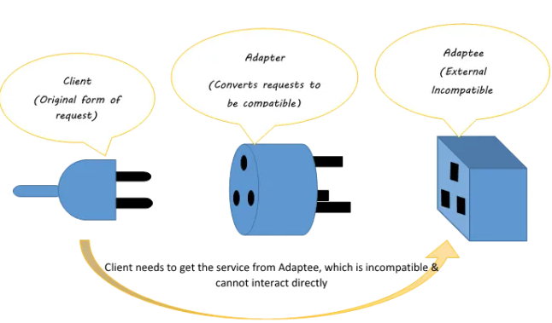

🔹 Implementation with Adapter Pattern
Scenario: We have an existing music player that plays only MP3 files. Now, we need to add support for MP4 and VLC files without modifying the existing MediaPlayer class.
Step 1: Define the Target Interface and create an existing class (client code)

// Target interface that client expects
interface MediaPlayer {
void play(String audioType, String fileName);
}
// Existing class that can play only MP3 files
class MP3Player implements MediaPlayer {
@Override
public void play(String audioType, String fileName) {
if (audioType.equalsIgnoreCase("mp3")) {
System.out.println("Playing MP3 file: " + fileName);
} else {
System.out.println("Invalid media type: " + audioType);
}
}
}

Step 2: Create the Adaptee ( New classes with different interfaces)
// Adaptee interface (New functionality that needs to be adapted)
interface AdvancedMediaPlayer {
void playMP4(String fileName);
void playVLC(String fileName);
}
// Concrete classes implementing the new functionality
class MP4Player implements AdvancedMediaPlayer {
@Override
public void playMP4(String fileName) {
System.out.println("Playing MP4 file: " + fileName);
}
@Override
public void playVLC(String fileName) {
// Do nothing, as this player only supports MP4
}
}
class VLCPlayer implements AdvancedMediaPlayer {
@Override
public void playMP4(String fileName) {
// Do nothing, as this player only supports VLC
}
@Override
public void playVLC(String fileName) {
System.out.println("Playing VLC file: " + fileName);
}
}
Step 3: Modify the Client code to use the adapter

// Adapter class that converts AdvancedMediaPlayer to MediaPlayer
class MediaAdapter implements MediaPlayer {
private AdvancedMediaPlayer advancedMediaPlayer;
public MediaAdapter(String audioType) {
if (audioType.equalsIgnoreCase("mp4")) {
advancedMediaPlayer = new MP4Player();
} else if (audioType.equalsIgnoreCase("vlc")) {
advancedMediaPlayer = new VLCPlayer();
}
}
@Override
public void play(String audioType, String fileName) {
if (audioType.equalsIgnoreCase("mp4")) {
advancedMediaPlayer.playMP4(fileName);
} else if (audioType.equalsIgnoreCase("vlc")) {
advancedMediaPlayer.playVLC(fileName);
}
}
}

Step 4: Modify the client code to use the Adapter

// Client code using the adapter pattern
class AudioPlayer implements MediaPlayer {
private MediaAdapter mediaAdapter;
@Override
public void play(String audioType, String fileName) {
if (audioType.equalsIgnoreCase("mp3")) {
System.out.println("Playing MP3 file: " + fileName);
} else if (audioType.equalsIgnoreCase("mp4") || audioType.equalsIgnoreCase("vlc")) {
mediaAdapter = new MediaAdapter(audioType);
mediaAdapter.play(audioType, fileName);
} else {
System.out.println("Invalid media format: " + audioType);
}
}
}

Step 5: Test the client code

public class AdapterPatternDemo {
public static void main(String[] args) {
AudioPlayer audioPlayer = new AudioPlayer();
audioPlayer.play("mp3", "song.mp3");
audioPlayer.play("mp4", "movie.mp4");
audioPlayer.play("vlc", "video.vlc");
audioPlayer.play("avi", "clip.avi"); // Unsupported format
}
}

🔹 When to use Adapter Pattern
Scenario | Why Adapter Helps
Working with legacy systems | Helps integrate older classes with a new API
Incompatible interfaces | Allows systems with different interfaces to communicate
Third-party library integration | Adapts external libraries to match your system's interface
Multiple implementations of the same functionality | Provides a common interface for different implementations

✅ Key takeaways:
- Adapter Pattern bridges incompatible interfaces without modifying existing code.
- It helps in legacy system integration and third-party API adaptation.
- Works well in multi-technology environments (e.g., different chargers).

10. Facade Pattern
The Facade Pattern is a structural design pattern that provides a simplified interface to a complex system. It hides the complexities of the underlying subsystems and provides a cleaner, higher-level API to clients.

🔹Intent of Decorator Pattern
- Provides a single, unified interface to a set of interfaces in a subsystem.
- Simplifies interactions between the client and complex subsystems.
- Improves code readability and maintainability.
- Decouples the client from the underlying system components.

🔹 Implementation of Facade Pattern

Imagine a banking system where a user wants to open a new account.
Instead of interacting with multiple departments (loan, credit check, account creation), a Facade class handles everything.

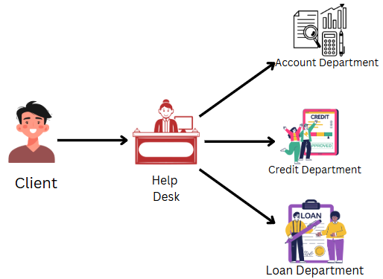

So here in above example, in place of client connecting to every department, we have a help desk and client can just interact with them and get all task done.

Step 1: Subsystem Classes

public class AccountCreation {
public void createAccount(String customer) {
System.out.println("Account created successfully for " + customer);
}
}

public class CreditCheck {
public boolean hasGoodCredit(String customer) {
System.out.println("Checking credit score for " + customer);
return true; // Assume customer has good credit
}
}

public class LoanDepartment {
public void grantLoan(String customer) {
System.out.println("Checking loan history for " + customer);
System.out.println("Loan availed to " + customer);
}
}

Step 2: Create the Facade
//Equivalent to help desk
public class BankFacade {
private LoanDepartment loan;
private CreditCheck credit;
private AccountCreation account;
public BankFacade() {
this.loan = new LoanDepartment();
this.credit = new CreditCheck();
this.account = new AccountCreation();
}
public void openAccount(String customer) {
account.createAccount(customer);
if(credit.hasGoodCredit(customer)){
loan.grantLoan(customer);
}else{
System.out.println("Can not give loan to Customer due to poor credit score");
}
}
}

Step 3: Client Code
public class FacadeClientCode {
public static void main(String[] args) {
BankFacade bank = new BankFacade();
bank.openAccount("Vijay Mallya");
}
}

❌Without Facade Pattern
//Client code will be fully messed
public class ClientCodeWithoutFacade {
public static void main(String[] args) {
AccountCreation ac = new AccountCreation();
CreditCheck cc = new CreditCheck();
LoanDepartment ld = new LoanDepartment();
ac.createAccount("Nirav Modi");
boolean creditCheck = cc.hasGoodCredit("Nirav Modi");
if(creditCheck){
ld.grantLoan("Nirav Modi");
}else{
System.out.println("You have bad credit score");
}
}
}

🔹 When to use Facade Pattern

Scenario | Why Facade Helps
Complex APIs (Multiple Components) | Simplifies client interaction with multiple classes.
Legacy Systems | Provides a modern, easy-to-use interface for old systems.
Microservices Communication | Acts as an entry point to a group of related services.
Third-Party Libraries | Provides a consistent API while shielding unnecessary complexity.

🔹 Key Points
- Hides complexity and provides a simple interface.
- Useful when working with complex subsystems like banking, coffee machines, and home theatres.
- Improves code maintainability and scalability.
- Decouples clients from subsystem implementations.

11. Decorator Pattern
The Decorator Pattern is a structural design pattern that adds new behaviours to objects dynamically without modifying their existing code. Instead of extending a class through inheritance, it relies on composition to wrap objects with additional functionality.

🔹Intent of Decorator Pattern
- Allows adding new functionalities to an object at runtime.
- Avoids subclass explosion caused by multiple feature combinations.
- Uses wrappers instead of modifying the base class directly.

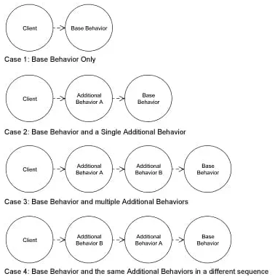

- In the Decorator pattern, decorators wrap original objects, adding new behavior or responsibilities without altering the original object's code.
- Decorator classes implement the same interface as the components they enhance, allowing clients to use both interchangeably.
- The Decorator pattern allows you to extend an object's functionality at runtime without altering its structure, enabling dynamic behaviour enhancements
🔹 Implementation with Decorator Pattern
A coffee shop offers different types of coffee. Customers can add milk, sugar, whipped cream, or vanilla flavour. The price should dynamically update based on the selected add-ons.

Step 1: Define the Base Component

// Component Interface
interface Coffee {
String getDescription();
double getCost();
}

Step 2: Implement a Basic Coffee Class
// Concrete Component: Plain coffee
class BasicCoffee implements Coffee {
@Override
public String getDescription() {
return "Basic Coffee";
}
@Override
public double getCost() {
return 50; // Base price
}
}

Step 3: Create an Abstract Decorator
// Abstract Decorator
abstract class CoffeeDecorator implements Coffee {
protected Coffee coffee;
public CoffeeDecorator(Coffee coffee) {
this.coffee = coffee;
}
@Override
public String getDescription() {
return coffee.getDescription();
}
@Override
public double getCost() {
return coffee.getCost();
}
}
Step 4: Implement Add-On Decorators
// Concrete Decorator: Adds Sugar
class Sugar extends CoffeeDecorator {
public Sugar(Coffee coffee) {
super(coffee);
}
@Override
public String getDescription() {
return coffee.getDescription() + ", Sugar";
}
@Override
public double getCost() {
return coffee.getCost() + 5;
}
}
// Concrete Decorator: Adds Whipped Cream
class WhippedCream extends CoffeeDecorator {
public WhippedCream(Coffee coffee) {
super(coffee);
}
@Override
public String getDescription() {
return coffee.getDescription() + ", Whipped Cream";
}
@Override
public double getCost() {
return coffee.getCost() + 15;
}
}

Step 5: Client code
public class CoffeeShop {
public static void main(String[] args) {
Coffee coffee = new BasicCoffee();
System.out.println(coffee.getDescription() + " = $" + coffee.getCost());
coffee = new Milk(coffee);
coffee = new Sugar(coffee);
System.out.println(coffee.getDescription() + " = $" + coffee.getCost());
coffee = new WhippedCream(coffee);
System.out.println(coffee.getDescription() + " = $" + coffee.getCost());
}
}
Output:
Basic Coffee = $50.0
Basic Coffee, Milk, Sugar = $65.0
Basic Coffee, Milk, Sugar, Whipped Cream = $80.0

🔹 When to use Adapter Pattern
Scenario | Why Decorator Helps
Need to add functionality dynamically | Allows extending objects without modifying their original code
Avoid subclass explosion | Replaces multiple subclasses with flexible object composition
Open-Closed Principle adherence | Supports extending functionality without modifying existing code
Multiple independent features | Allows combining features dynamically at runtime

🔹 Key Takeaways
✔ Adds behaviour dynamically without modifying the base class.
✔ Helps avoid subclass explosion by using composition instead of inheritance.
✔ Used in UI frameworks, logging, data compression, and streaming APIs.
✔ Flexible but can become complex if overused.

12. Proxy Pattern
The Proxy Pattern is a structural design pattern that provides a surrogate or placeholder for another object to control access to it. The proxy acts as an intermediary between the client and the real object, adding functionalities like security, logging, caching, or lazy initialization without modifying the original object.

🔹Intent of Decorator Pattern
- Controls access to an object based on certain conditions (e.g., authentication, permissions).
- Adds lazy initialization for resource-intensive objects.
- Implements logging, caching, and request filtering.
- Protects the real object from direct access.

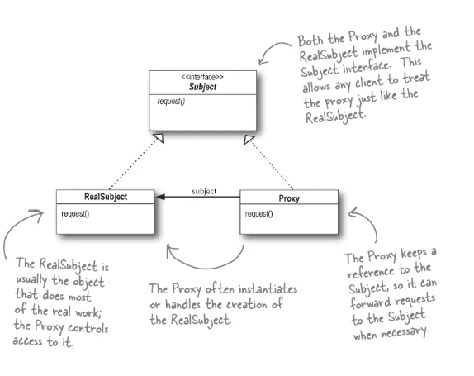

🔹 Implementation with Proxy Pattern
Imagine an application that loads high-resolution images. Instead of loading the image immediately, a proxy delays loading until it's actually needed (Lazy initialization).
Step 1: Define a common interface

// Subject interface
interface Image {
void display();
}

Step 2: Implement a Real Object
// Real Object that loads and displays an image
class RealImage implements Image {
private String fileName;
public RealImage(String fileName) {
this.fileName = fileName;
loadFromDisk(); //Heavy operation
}
private void loadFromDisk() {
System.out.println("Loading image: " + fileName);
}
@Override
public void display() {
System.out.println("Displaying image: " + fileName);
}
}

Step 3: Create a Proxy Object
// Proxy class that controls access to RealImage
// Implements same interface as real object
class ProxyImage implements Image {
private RealImage realImage;
private String fileName;
public ProxyImage(String fileName) {
this.fileName = fileName;
}
@Override
public void display() {
if (realImage == null) { //Lazy Loading
realImage = new RealImage(fileName); // Load only when needed
}
realImage.display();
}
}

Step 4: Client Code
public class ProxyPatternDemo {
public static void main(String[] args) {
Image image1 = new ProxyImage("photo1.jpg");
Image image2 = new ProxyImage("photo2.jpg");
// Image is loaded only when display() is called
image1.display();
System.out.println("------");
image1.display(); // This time it is not loaded again
//Since image2 is never displayed, it is never loaded
}
}

🔹When and where to use Proxy Pattern
Scenario | Why Proxy Helps
Restrict access to a resource | Ensures only authorized users can access the object.
Lazy Initialization | Delays object creation until it's actually needed (e.g., large database connections).
Logging & Monitoring | Keeps track of actions performed on the object.
Caching | Stores previous results to optimize performance.

🔹Key Takeaways:
✔ Controls access to objects while adding extra functionalities.
✔ Useful for security, logging, caching, and lazy initialization.
✔ Helps implement network security, database access control, and resource management.
✔ Be careful of unnecessary proxies, as they can slow down performance.

13. Composite Pattern
The Composite Pattern is a structural design pattern that lets you compose objects into tree-like structures to represent part-whole hierarchies. It treats individual objects and compositions of objects uniformly.

🔹Intent of Composite Pattern
- Allows clients to interact with individual objects and composite objects in the same way.
- Provides a tree structure to represent complex hierarchies.
- The Composite pattern allows clients to treat individual objects and compositions of objects uniformly, often useful for hierarchical structures like trees.

❌ Without Composite Pattern (File Management system)
public class File {
private String name;
public File(String name){
this.name = name;
}
public void showDetails(){
System.out.println("File : " +name);
}
}

public class Folder {
private String name;
private List<File> files = new ArrayList<>();
public Folder(String name){
this.name = name;
}
public void addFile(File file){
files.add(file);
}
public void showDetails(){
System.out.println("Folder: " + name);
for(File file:files){
file.showDetails();
}
}
}
Client code:
public class FileSystemApp {
public static void main(String[] args) {
File file1 = new File("File1.txt");
File file2 = new File("File2.txt");
Folder folder = new Folder("Documents");
folder.addFile(file1);
folder.addFile(file2);
folder.showDetails();
}
}

🔹 Implementation with Composite Pattern
Issue with above code: For file system we can also have scenarios where we can have sub-folders. To handle that case in above code we will have to write complex if-else conditions. But with Composite pattern, both Files and Folder will be treated uniformly and will implement same interface

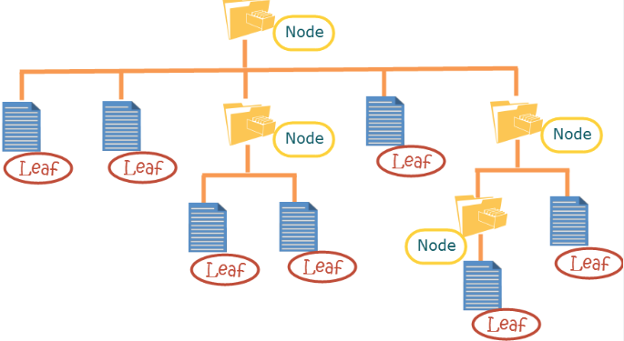

Step 1: Define a common interface
// Component Interface
interface FileSystemComponent {
void showDetails();
}

Step 2: Implement Leaf class(File)
// Leaf: File (does not contain other components)
class File implements FileSystemComponent {
private String name;
public File(String name) {
this.name = name;
}
@Override
public void showDetails() {
System.out.println("File: " + name);
}
}

Step 3: Implement Composite Class(Folder)
import java.util.ArrayList;
import java.util.List;
// Composite: Folder (can contain files and other folders)
class Folder implements FileSystemComponent {
private String name;
private List<FileSystemComponent> components = new ArrayList<>();
public Folder(String name) {
this.name = name;
}
public void addComponent(FileSystemComponent component) {
components.add(component);
}
@Override
public void showDetails() { // DFS (recursive function)
System.out.println("Folder: " + name);
for (FileSystemComponent component : components) {
component.showDetails();
}
}
}

Step 4: Client Code

public class CompositePatternDemo {
public static void main(String[] args) {
FileSystemComponent file1 = new File("document.txt");
FileSystemComponent file2 = new File("photo.jpg");
Folder folder1 = new Folder("My Documents");
folder1.addComponent(file1);
folder1.addComponent(file2);
FileSystemComponent file3 = new File("notes.txt");
Folder rootFolder = new Folder("Root");
rootFolder.addComponent(folder1);
rootFolder.addComponent(file3);
rootFolder.showDetails();
}
}

Output:
Folder: Root
Folder: My Documents
File: document.txt
File: photo.jpg
File: notes.txt

🔹When and Where to use Composite Pattern
Scenario | Why Composite Helps
File System (Folders & Files) | Both files and folders should be handled in the same way.
Organization Hierarchy | Employees, managers, and departments should be processed uniformly.
UI Components (Buttons, Panels, Containers) | Allows nesting of UI components inside one another.

14. Flyweight Pattern
The Flyweight Pattern is a structural design pattern used to minimize memory usage and increase performance by sharing common object states instead of creating new ones.

🔹 Intent of Flyweight Pattern
- Reduces memory consumption by storing shared objects instead of creating duplicates.
- Increases application performance and efficiency.
- Separates intrinsic state (shared) from extrinsic state (unique per instance).
- Ideal for working with a large number of similar objects.

🔹 Implementation of Flyweight Pattern

Image a scenario of creating game like Flappy Bird.
In Flappy Bird, multiple pillars (pipes) are continuously generated as obstacles. Each pillar has:
- A common image texture (intrinsic state) 🎨
- A unique position and height (extrinsic state) 📏
Instead of creating a new pillar object every time, we use the Flyweight Pattern to share the pillar image while keeping position and height unique.



Step 1: Flyweight Class (Shared State - Pillar Image)

// Flyweight Class: Shared pillar image
class Pillar {
private final String image; // Heavy resource (shared)
public Pillar(String image) {
this.image = image;
}
public void draw(int x, int height) {
System.out.println("Drawing pillar at X: " + x + " with height: " + height + " using image: " + image);
}
}

Step 2: Flyweight Factory (Manages Shared Objects)

// Factory Class: Reuses pillar images
class PillarFactory {
private static final Map<String, Pillar> pillarMap = new HashMap<>();
public static Pillar getPillar(String image) {
if (!pillarMap.containsKey(image)) {
pillarMap.put(image, new Pillar(image));
System.out.println("Loading new Pillar Image: " + image);
}
return pillarMap.get(image);
}
}

Step 3: Context Class (Stores Unique State - Position & Height)
class GamePillar {
private final int x;
private final int height;
private final Pillar pillar;
public GamePillar(int x, int height, Pillar pillar) {
this.x = x;
this.height = height;
this.pillar = pillar;
}
public void render() {
pillar.draw(x, height);
}
}
Step 4: Client Code (Creates Pillars Efficiently)
import java.util.ArrayList;
import java.util.List;
public class FlyweightGameDemo {
public static void main(String[] args) {
List<GamePillar> pillars = new ArrayList<>();
// Shared image for pillars
Pillar sharedPillar = PillarFactory.getPillar("FlappyPillar.png");
// Creating multiple pillars with unique positions and heights
pillars.add(new GamePillar(100, 300, sharedPillar));
pillars.add(new GamePillar(250, 400, sharedPillar));
pillars.add(new GamePillar(400, 350, sharedPillar));
pillars.add(new GamePillar(550, 450, sharedPillar)); // Reuses the same image
// Rendering pillars
for (GamePillar pillar : pillars) {
pillar.render();
}
}
}

🔹 When to use Flyweight Pattern

Scenario |  | Why Flyweight Helps
Large Number of Objects | Avoids memory overhead by sharing common data.
Rendering Systems | Optimizes repeated elements like fonts, text characters, icons, etc.
String Pooling | Reuses immutable string objects to save memory.
Game Development | Optimizes character models, trees, bullets, and objects in large scenes.
Text Editors | Shares character objects instead of creating new ones for each letter.

15. Bridge Pattern
The Bridge Pattern is a structural design pattern that decouples an abstraction from its implementation, allowing the two to vary independently.

🔹 When to use the Bridge Pattern
- When you have a hierarchy in abstraction (e.g., different types of players).
- And a hierarchy in implementation (e.g., different types of operating systems or formats).
- To avoid a Cartesian explosion of subclasses (e.g., VideoPlayerOnWindows, AudioPlayerOnLinux, VideoPlayerOnLinux... etc.).

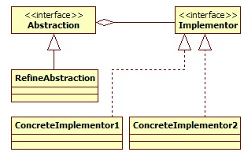

🔹 Implementation of Bridge Pattern

Design Goal: A system where you can easily plug in different media players (audio, video) and types (basic, premium, advanced).
Use the Bridge pattern to connect MediaPlayerType with MediaType
- Abstraction: Player Type (Basic, Advanced, Premium)
- Implementation: Media Type (Audio, Video, Streaming)
This keeps both independent and extensible.

🔹 What happens if we don’t use Bridge Pattern

You will end up creating a class for each combination, like:
- BasicAudioPlayer, BasicVideoPlayer, AdvancedVideoPlayer, PremiumAudioStreamingPlayer, etc.
- Violates Open/Closed Principle – hard to extend.
- Leads to class explosion (redundant + unmanageable).

Without Bridge Pattern

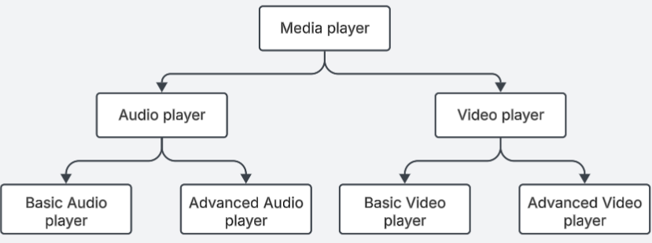

With Bridge Pattern

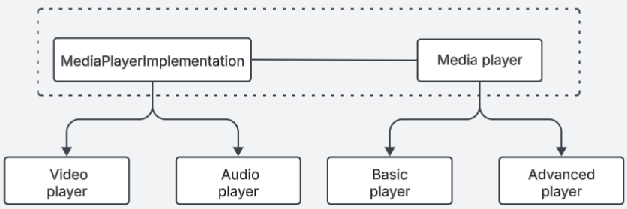

🔹 Code
Step 1: Implementer Interface

// Implementor
interface MediaPlayerImplementation {
void playFile(String filename);
}

Step 2: Concrete Implementations

// Concrete Implementor 1
class AudioPlayerImplementation implements MediaPlayerImplementation {
public void playFile(String filename) {
System.out.println("Playing audio file: " + filename);
}
}
// Concrete Implementor 2
class VideoPlayerImplementation implements MediaPlayerImplementation {
public void playFile(String filename) {
System.out.println("Playing video file: " + filename);
}
}

Step 3: Abstraction

// Abstraction
abstract class MediaPlayer {
protected MediaPlayerImplementation implementation;
public MediaPlayer(MediaPlayerImplementation implementation) {
this.implementation = implementation;
}
public abstract void play(String filename);
}

Step 4: Refined Abstraction

// Refined Abstraction
class BasicPlayer extends MediaPlayer {
public BasicPlayer(MediaPlayerImplementation implementation) {
super(implementation);
}
public void play(String filename) {
System.out.println("Basic Player Delegating...");
implementation.playFile(filename);
}
}
class AdvancedPlayer extends MediaPlayer {
public AdvancedPlayer(MediaPlayerImplementation implementation) {
super(implementation);
}
public void play(String filename) {
System.out.println("Advanced Player with Equalizer & Subtitles...");
implementation.playFile(filename);
}
}

Step 5: Client Code

public class BridgePatternDemo {
public static void main(String[] args) {
MediaPlayerImplementation audioImpl = new AudioPlayerImplementation();
MediaPlayerImplementation videoImpl = new VideoPlayerImplementation();
MediaPlayer basicAudioPlayer = new BasicPlayer(audioImpl);
MediaPlayer advancedVideoPlayer = new AdvancedPlayer(videoImpl);
basicAudioPlayer.play("song.mp3");
advancedVideoPlayer.play("movie.mp4");
}
}

16. Strategy Pattern
The Strategy Pattern defines a family of algorithms, encapsulates each one, and makes them interchangeable. Strategy lets the algorithm vary independently from the clients that use it.
Intent: To enable selecting an algorithm's behavior at runtime. It promotes the use of composition over inheritance.

🔹 Key Points
Aspect | Detail
Problem Solved | Avoids conditional logic for algorithm selection
Type | Behavioral Pattern
Principle | Adheres to Open/Closed and Single Responsibility principles
Composition | Uses composition to switch between algorithms dynamically
Clients | Can use different strategies without changing their own code

🔹 Real-World Examples: Payment System

❌ Without Strategy Pattern (Direct Instantiation)

if (paymentType.equals("card")) {
// process card
} else if (paymentType.equals("paypal")) {
// process PayPal
} ...
- Violates Open/Closed
- Not Scalable
- Difficult to maintain
- Hard to test

🔹 Implementation with Strategy Pattern

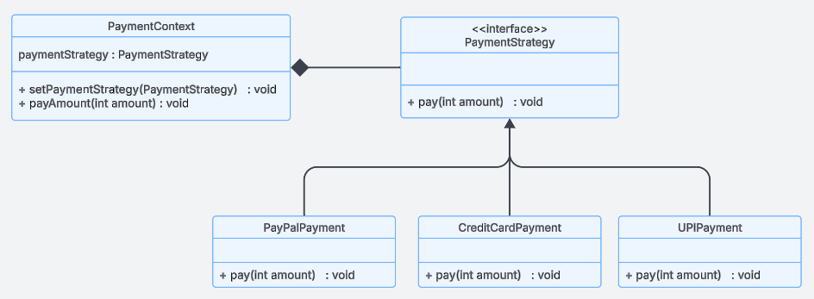

Step1: Strategy Interface

public interface PaymentStrategy {
void pay(int amount);
}

Step2: Concreate Strategies

public class CreditCardPayment implements PaymentStrategy {
private String cardNumber;
public CreditCardPayment(String cardNumber) {
this.cardNumber = cardNumber;
}
@Override
public void pay(int amount) {
System.out.println("Paid ₹" + amount + " using Credit Card ending with " + cardNumber.substring(cardNumber.length() - 4));
}
}

public class PayPalPayment implements PaymentStrategy {
private String email;
public PayPalPayment(String email) {
this.email = email;
}
@Override
public void pay(int amount) {
System.out.println("Paid ₹" + amount + " using PayPal account: " + email);
}
}

public class UPIPayment implements PaymentStrategy {
private String upiId;
public UPIPayment(String upiId) {
this.upiId = upiId;
}
@Override
public void pay(int amount) {
System.out.println("Paid ₹" + amount + " using UPI ID: " + upiId);
}
}

Step3: Context Class

public class PaymentContext {
private PaymentStrategy strategy;
public PaymentContext(PaymentStrategy strategy) {
this.strategy = strategy;
}
public void setPaymentStrategy(PaymentStrategy strategy) {
this.strategy = strategy;
}
public void payAmount(int amount) {
strategy.pay(amount);
}
}

Step4: Client Code

public class StrategyPatternDemo {
public static void main(String[] args) {
PaymentContext context = new PaymentContext(new CreditCardPayment("1234567890123456"));
context.payAmount(1000);
//Can change payment strategy at runtime
context.setPaymentStrategy(new PayPalPayment("john@example.com"));
context.payAmount(500);
context.setPaymentStrategy(new UPIPayment("john@upi"));
context.payAmount(750);
}
}

🔹 Real-World Examples:
- Sorting Algorithms: Java’s Collections.sort() or Python’s sorted() use different sorting strategies depending on the size and nature of data.
List<Integer> numbers = Arrays.asList(5, 2, 9, 1);
Collections.sort(numbers); // Strategy chosen internally
- Payment Gateways: Apps like Amazon, Flipkart allow users to choose payment options dynamically — UPI, Cards, Wallets.
- Compression Tools: ZIP, RAR, TAR — all can be interchangeable strategies to compress files.

🔹 Adheres to SOLID Principles:
- Single Responsibility Principle: Each strategy has one job — implement one algorithm.
- Open/Closed Principle: New strategies can be introduced without modifying context.
- Dependency Inversion Principle: Context depends on abstractions (PaymentStrategy), not concrete implementations.

17. Command Pattern
The Command Pattern is a behavioral design pattern that turns a request into a standalone object containing all the information about the request. This allows you to parameterize methods with different requests, queue them, log them, and support undo/redo operations.
Intent: Encapsulate a request as an object, thereby letting you parameterize clients with queues, requests, and operations.

🔹 Key Benefits
- Decouples invoker from receiver.
- Supports undo/redo.
- Easily supports macro commands, queuing, logging, and transaction-based actions.
- Promotes Open/Closed Principle and Single Responsibility Principle.

🔹 Real-World Examples:

Think of a text editor like VSCode:
- Typing, deleting, and formatting are actions (commands).
- You can undo/redo these because each action is stored as a Command object with its execution and un-execution logic.

Smart Home Automation Systems
- Each action (turning lights, setting thermostat) becomes a command.
- Allows scheduling, undoing, and remote triggering.

Transaction Processing in Banking
- Each transaction (deposit, withdraw) is encapsulated in a command.
- Enables rollback in case of failure (undo).

Game Controls
- Moves and actions are commands.
- You can replay (macro), undo, or bind new actions dynamically.

🔹 Real-World Example: Remote control for Fan and Light

Step 1: Command Interface

public interface Command {
void execute();
}

Step 2: Receivers (Light & Fan)

public class Light {
public void turnOn() {
System.out.println("Light is ON");
}
public void turnOff() {
System.out.println("Light is OFF");
}
}

public class Fan {
public void turnOn() {
System.out.println("Fan is spinning");
}
public void turnOff() {
System.out.println("Fan is stopped");
}
}

Step 3: Concrete Command Class
public class LightOnCommand implements Command {
private Light light;
public LightOnCommand(Light light) {
this.light = light;
}
public void execute() {
light.turnOn();
}
}

public class LightOffCommand implements Command {
private Light light;
public LightOffCommand(Light light) {
this.light = light;
}
public void execute() {
light.turnOff();
}
}

public class FanOnCommand implements Command {
private Fan fan;
public FanOnCommand(Fan fan) {
this.fan = fan;
}
public void execute() {
fan.turnOn();
}
}

public class FanOffCommand implements Command {
private Fan fan;
public FanOffCommand(Fan fan) {
this.fan = fan;
}
public void execute() {
fan.turnOff();
}
}

Step 4: Invoker (Remote Control)
public class RemoteControl {
private Command command;
public void setCommand(Command command) {
this.command = command;
}
public void pressButton() {
command.execute();
}
}

Step 5: Client Code
public class CommandPatternDemo {
public static void main(String[] args) {
Light light = new Light(); // Create receivers
Fan fan = new Fan();
Command lightOn = new LightOnCommand(light); // Create commands
Command lightOff = new LightOffCommand(light);
Command fanOn = new FanOnCommand(fan);
Command fanOff = new FanOffCommand(fan);
RemoteControl remote = new RemoteControl(); // Create remote
remote.setCommand(lightOn); // Control Light
remote.pressButton(); // Output: Light is ON
remote.setCommand(lightOff);
remote.pressButton(); // Output: Light is OFF
remote.setCommand(fanOn); / Control Fan
remote.pressButton(); // Output: Fan is spinning
remote.setCommand(fanOff);
remote.pressButton(); // Output: Fan is stopped
}
}

🔹 Importance of Command Pattern
- Extensible – Add new commands without changing existing code.
- Flexible – Can create macro commands (e.g., morning routine).
- Undo/Redo – Keeps history for powerful features.
- Decoupling – Invoker doesn’t need to know the implementation.

