
REACT

Table of Contents
What is React? 2
1. React 2
2. Creating React Application 3
3. Vite 3
4. Folder Structure 4
5. First Code 4
6. JSX 4
React Components and fundamentals 6
1. Functional Components 6
2. Components Nesting 7
3. Conditionals 7
4. Styling 8
5. Class Components 8
6. Project 1 9
Props 10
1. Props 10
2. Children Prop 11
3. Rendering List 11
4. Prop Drilling 14

What is React?

React
React is a declarative, efficient and flexible JavaScript library for building user interface. It lets you compose complex UI’s from small and isolated pieces of code called “components”.
It helps you to make SPA(single page application), SPA is a web app implementation that loads only a single web document and then updates the body content of that single document via JavaScript APIs when different content is to be shown.

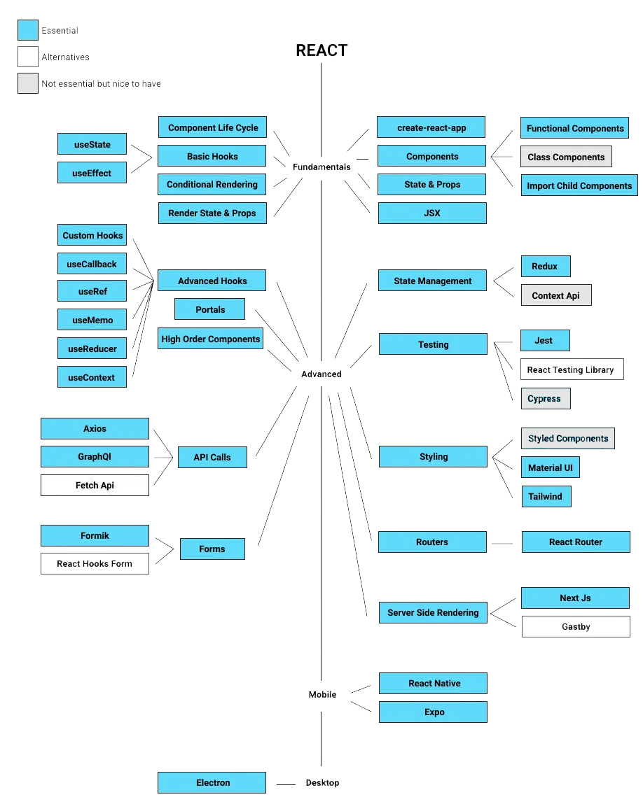

Creating React Application

npx create-react-app my-app

cd my-app

npm start #to run the app

Vite

Vite is a modern tool that helps you build web applications faster and more efficiently. It quickly starts your development server and instantly updates your changes, making it easier to see your work in real-time, and it also makes your final app smaller and faster for users.
- Faster Development Build Time: Vite offers instant server start up and fast HMR (Hot module replacement), enhancing development speed.
- Optimized Production Build: Vite uses Rollup for efficient, smaller production bundles.
- Modern JavaScript and CSS Features: Vite supports modern JS and CSS out of the box without extensive configuration.
- Simple and Minimal Configuration: Vite provides easy, extensible configuration without the need to eject.
- Better Ecosystem Integration: Vite's plugin system integrates well with other modern tools, offering flexibility and versatility.

npm create vite@latest app-name -- --template react

npm install

npm run dev

Vite Setup

- need to use .jsx extension

- index.html in the source instead of public

- assets still in public

- instead of index.js, need to use main.jsx

- to start the dev server - "npm run dev"

- rest all are same - imports/exports, deployment, assets, etc...

Folder Structure
Specially for app created via npm create-react-app
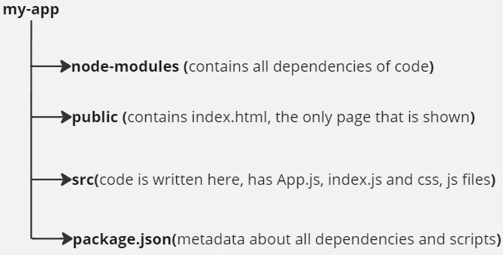
While sending this code we don’t transfer node-modules folder, so when we use someone else code, to install the node-modules we do:- npm install

First Code
//index.js
import React from 'react';
import ReactDOM from 'react-dom/client';
import './index.css';

// Index.js is actual file where our final code is called, and displayed in main screen
const root = ReactDOM.createRoot(document.getElementById('root'));
root.render(
<React.StrictMode>
<h1>Hello World</h1>
</React.StrictMode>
);
To run this do:- npm start
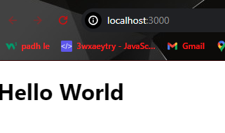
Output:-

JSX
- JSX allows you to put HTML into JavaScript
- It stands for JavaScript XML
- React has Babel dependency which compiles HTML and JavaScript from JSX

JSX Rules:-
- Return single element from one parent element(Components)
Use <> </> to group different elements
- camelCase property naming convention
return (
<div tabIndex={1}>
<button onClick={myFunction}>click me</button>
<label htmlFor='name'>Name</label>
<input readOnly={true} id='name' />
</div>
)

- Every tag should be closed, eg can’t have <img> , but do <img/>
- To call variables inside HTML, use { }

Embedding expression in JSX ( use {} )
//App.js
import './App.css';

function App() {
const heading = "Hello World";
return (
<div className="App">
<h2>My first code is : {heading} </h2>
</div>
);
}

export default App;

This App.js is rendered in index.js
import React from 'react';
import ReactDOM from 'react-dom/client';
import App from './App';
const root = ReactDOM.createRoot(document.getElementById('root'));
root.render(
<React.StrictMode>
<App />
</React.StrictMode>
);

React Components and fundamentals

Functional Components
- Components lets you split the UI into independent, reusable pieces, and think about each piece in isolation.
- Conceptually, components are like JavaScript function. They accept the arbitrary inputs (called props) and return React elements describing what should appear on the screen.
- Function name should begin with Capital letter (Pascal case)
- Put all components in one component folder and call them in App.js for better arrangements of code.
- To call function name Header, do <Header/>
- We can return only element from function, so if multiple tags need to be returned, enclose all of them in div. We can also use React fragments as <>,</>, fragments don’t add extra div element thus help in debugging in console. Also in place of many div tags, use proper tags like <Header/>, <Footer/>, <section>,<article>. They help in better SEO and debugging in console.
First Component
//Header.jsx
import React from "react";

function Header(){
return (
<>
<h1>Hello Everyone</h1>
<p>This is my first component</p>
</>
)
}

export default Header;

Component calling
//App.js
import './App.css';
import Header from './components/Header';

function App() {
return (
<div className="App">
{/* Component calling */}
<Header/>
</div>
);
}
export default App;

Components Nesting
Can call functions within same module, to nest them.
import React from 'react';

function BookList() {
return (
<section>
<Book />
<Book />
<Book />
</section>
);
}
//Components Nesting
const Book = () => {
return (
<article>
<Image />
<Title />
<Author />
</article>
);
};
//Different ways to make Components
const Image = () => <h2>image placeholder</h2>;
const Title = () => {
return <h2>Book Title</h2>;
};
const Author = () => <h4>Author</h4>;
export default BookList;

Conditionals
We can use If-else conditions in react components
import React from 'react';

const Greetings = () =>{
const date = new Date();
var x = date.getHours();
var header;
if(x<12) {
header = "Morning"
}else{
header = "Afternoon"
}
return(
<p>Good {header} Everyone !!</p>
)
}
export default Greetings;
Can also use operators like && and ||.
Can use ternary operators.
Eg:
{isLoggedIn ? <h1>Hello</h1> : <p> Login Here !</p>}

Styling
- Can add style for all in style.css and since it is imported in index.js, style applies to all files. Since index.js is the file that does rendering of all components.
- To apply css at each file separately, create a css file and import as:- import ‘./header.css’
- All properties names in jsx become camelCase, Eg: class className, font-sizefontSize . Applicable only when css is written directly in jsx file
- For inline style, first make it as object, and then use that style
Eg: <h1 style = {{ color: “red” }} > </h1>

import React from 'react';

function Header(){
const paraStyle ={
fontFamily:"fantasy",
fontSize:"130px"
}
return(
<div>
{/* Two {{, inside{} is for creating object, outer is to call object */}
<h1 style = {{color:"blue", fontWeight:"bold" , fontSize:"30px" }}>Hello Everyone</h1>
<p style={paraStyle}>I am a stylish text</p>
</div>
)
}

export default Header;

Class Components
Till now, this were functional components, but there is one more way to create components using class. They were used before hooks were introduced to react.
Eg:
class Welcome extends React.Component{
render(){
return <h1>Hello World !!</h1>
}
}

Event Handling
In React, events are actions or occurrences that happen in the user interface, like clicks, form submissions, key presses, and more. React has its own event handling system, which is very similar to handling events in plain JavaScript, but with some syntactical differences. Here are a few key points about handling events in React:
- CamelCase: React event handlers are named using camelCase, rather than lowercase.
- JSX Syntax: You pass a function as the event handler, rather than a string.
- Event Parameter: When an event occurs, such as a user typing in an input field or clicking a button, an event object is created and passed as an argument to the event handler function. This event object contains a wealth of information about the event and the element that triggered it.
- target is a reference to the element that triggered the event. For input events, e.target is typically the input element.
- Useful for accessing the value of form elements.

Code example:-

import React from "react";

function TestEvent(){
function handleClick(){
console.log("I am clicked");
}
return (
<button onClick={handleClick}>
Click Me
</button>
)
}

export default TestEvent;

For more event and their types:-
React Events

Create build for application
Before deploying any application we need to create a build. We can run npm run build, it will create a build folder which will contain optimized production ready version of application. We don’t need to worry about any optimization, react handles it for us. We can directly deploy this builds.eg in netlify > deploy manually and there deploy this build.
npm run build is a command typically used in JavaScript projects to create an optimized, production-ready version of your application. When you run this command, it triggers a build process defined in the package.json file under the scripts section.
Here's what typically happens when you run npm run build in a React project (or similar JavaScript projects):
Typical Build Process:
- Transpilation: Converts modern JavaScript (ES6+) to a version compatible with older browsers using tools like Babel.
- Bundling: Combines multiple JavaScript files and their dependencies into one or more bundles using a bundler like Webpack or Rollup.
- Minification: Removes unnecessary characters (like whitespace, comments) and shortens variable names to reduce file size.
- Optimization: Performs various optimizations such as tree shaking (removing unused code), code splitting (dividing code into smaller chunks that can be loaded on demand), and image optimization.
- Asset Management: Manages and includes static assets (like images, fonts) in the final build output.

Project 1
Create a basic single page website with header, footer and body content showing react logo and history about react.

Solution: https://github.com/PALASH-BAJPAI/React-Notes-And-Basic-Projects/tree/main/1.%20react-overview-project

Props

Props
- Props are like arguments passed in a function
- They help to make components more reusable

import React from "react";

function Card(props) {
return (
<div>
<h2>{props.name}</h2>
<img src={props.img} alt="avatar-image" />
<p>{props.tel}</p>
</div>
);
}

//to use card
function CardList() {
return (
<div>
<Card name="Raj" img="img1.png" tel="20214202" />
<Card name="Rohan" img="img2.png" tel="2021421" />
</div>
);
}

export default CardList;

Can even send functions in props.
Can even de-structure the prop,

function Card({name , img, tel}) {
return (
<div>
<h2>{name}</h2>
<img src={img} alt="avatar-image" />
<p>{tel}</p>
</div>
);
}

Children Prop

In React, the children prop is a special prop that allows components to pass children elements directly into their output. This enables components to compose other components or render arbitrary JSX elements passed as children.
Its name must be:- children
Can use as {props.children} or by de-structuring it.
Use:- Sometimes let say there are many cards, but we need to show some specific html in only one card, Then at that time children prop is helpful.

import React from "react";

function Card({name , img, tel, children}) {
return (
<div>
{children}
<h2>{name}</h2>
<img src={img} alt="avatar-image" />
<p>{tel}</p>
</div>
);
}

//to use card
function CardList() {
return (
<div>
<Card name="Raj" img="img1.png" tel="20214202">
<p>I am a children component</p>
<h4>Nice to meet you all !!</h4>
</Card>
<Card name="Rohan" img="img2.png" tel="2021421" />
</div>
);
}

export default CardList;

Rendering List
The key prop in React is a special attribute that helps React identify which items have changed, are added, or are removed in a list. When you render a list of components using a map function or a similar method, React needs a way to uniquely identify each item in the list.
The main use of the key prop is to optimize React's rendering performance. When React re-renders a list of components, it compares the key prop of each component in the new list with the corresponding components in the previous list. If a component with a certain key is present in both lists, React knows that it hasn't changed position and can reuse the existing component without re-rendering it. This makes the reconciliation process more efficient and can improve the overall performance of your application.

JavaScript map function code example:-

// Original array
const numbers = [1, 2, 3, 4, 5];

// Using map to double each number in the array
const doubledNumbers = numbers.map((number) => {
return number * 2;
});

console.log(doubledNumbers); // Output: [2, 4, 6, 8, 10]

Code Snippet of rendering list:-
Assume we are displaying books and for that we have <Book/> component, so we can create a json file to store data of that books and run a loop to render all of them.
// booksData.js (this includes data of books to render

const booksData = [
{
id: 1,
title: "To Kill a Mockingbird",
author: "Harper Lee",
genre: "Fiction",
},
{
id: 2,
title: "1984",
author: "George Orwell",
genre: "Dystopian",
}
// Add more books as needed
];

export default booksData;

Code snippet of BookList, which feed booksData to <Book/> component to render data.

import React from 'react';
import Book from './Book'; // Assume Book component is defined elsewhere
import booksData from './booksData'; // Importing the books data

const BookList = () => {
return (
<div>
<h2>Book List</h2>
<ul>
{booksData.map((book) => (
<Book key={book.id} book={book} />
))}
</ul>
</div>
);
}

export default BookList;

Sometimes we may require to have numbering on components getting called. Can use pre-defined index as prop. Index is 0-index.
<ul>
{booksData.map((book,index) => (
<Book key={book.id} book={book} number={index} />
))}
</ul>

In book we can use this number to get position of specific data in list.

JavaScript arrow function code snippet:-
In JavaScript, arrow functions provide a concise syntax for writing anonymous functions. They are particularly useful for writing shorter and more readable code, especially when working with functions that have a simple body.

// Arrow function with one parameter
const square = (x) => {
return x * x;
};

// Arrow function with no parameters
const greet = () => {
console.log("Hello!");
};
// Arrow function with implicit return
const double = (x) => x * 2;

// Arrow function with multiple parameters and implicit return
const sum = (a, b) => a + b;

//Use in event handling
<button onClick={()=>console.log('I am clicked')}>

Prop Drilling
Prop drilling in React occurs when you pass data down through multiple levels of nested components via props, even though some intermediary components do not need the data themselves. Here's a basic example to illustrate prop drilling:
Suppose you have three components: App, Parent, and Child.
// App.js
import React from 'react';
import Parent from './Parent';

const App = () => {
const data = "Hello, Prop Drilling!";

return (
<div className="App">
<h1>App Component</h1>
<Parent data={data} />
</div>
);
}
export default App;

// Parent.js
import React from 'react';
import Child from './Child';

// data is nowhere used in Parent
const Parent = ({ data }) => {
return (
<div>
<h2>Parent Component</h2>
<Child data={data} />
</div>
);
}
export default Parent;

// Child.js
import React from 'react';

const Child = ({ data }) => {
return (
<div>
<p>{data}</p>
</div>
);
}
export default Child;

Prop drilling becomes an issue when you have deeply nested components and need to pass the same data to multiple levels of children, or when we need to send data from child to parent after processing. In such cases, prop drilling can lead to code that is difficult to maintain and refactor. To avoid prop drilling, you can use techniques like React context or state management libraries like Redux to manage global state that needs to be accessed by multiple components.

