ASSIGNMENT 3
Introduction to Cloud Computing & Amazon EC2
The objectives are:
- To Understand Cloud Basics:
Understand what cloud computing is and how it differs from traditional physical servers.
- To Explore AWS Infrastructure:
Get an overview of Amazon Web Services (AWS), including its global reach and services.
- To Learn about EC2:
Understand the working and scalability of Amazon Elastic Compute Cloud (EC2).
- Hands-on Deployment:
Gain practical knowledge of launching and managing a virtual server (instance).
- Cost Efficiency:
Learn how companies can save money using the “Pay-as-you-go” pricing model.

Step 1: You are on the EC2 Dashboard for the Mumbai region. You clicked the orange "Launch instance" button to start the setup.
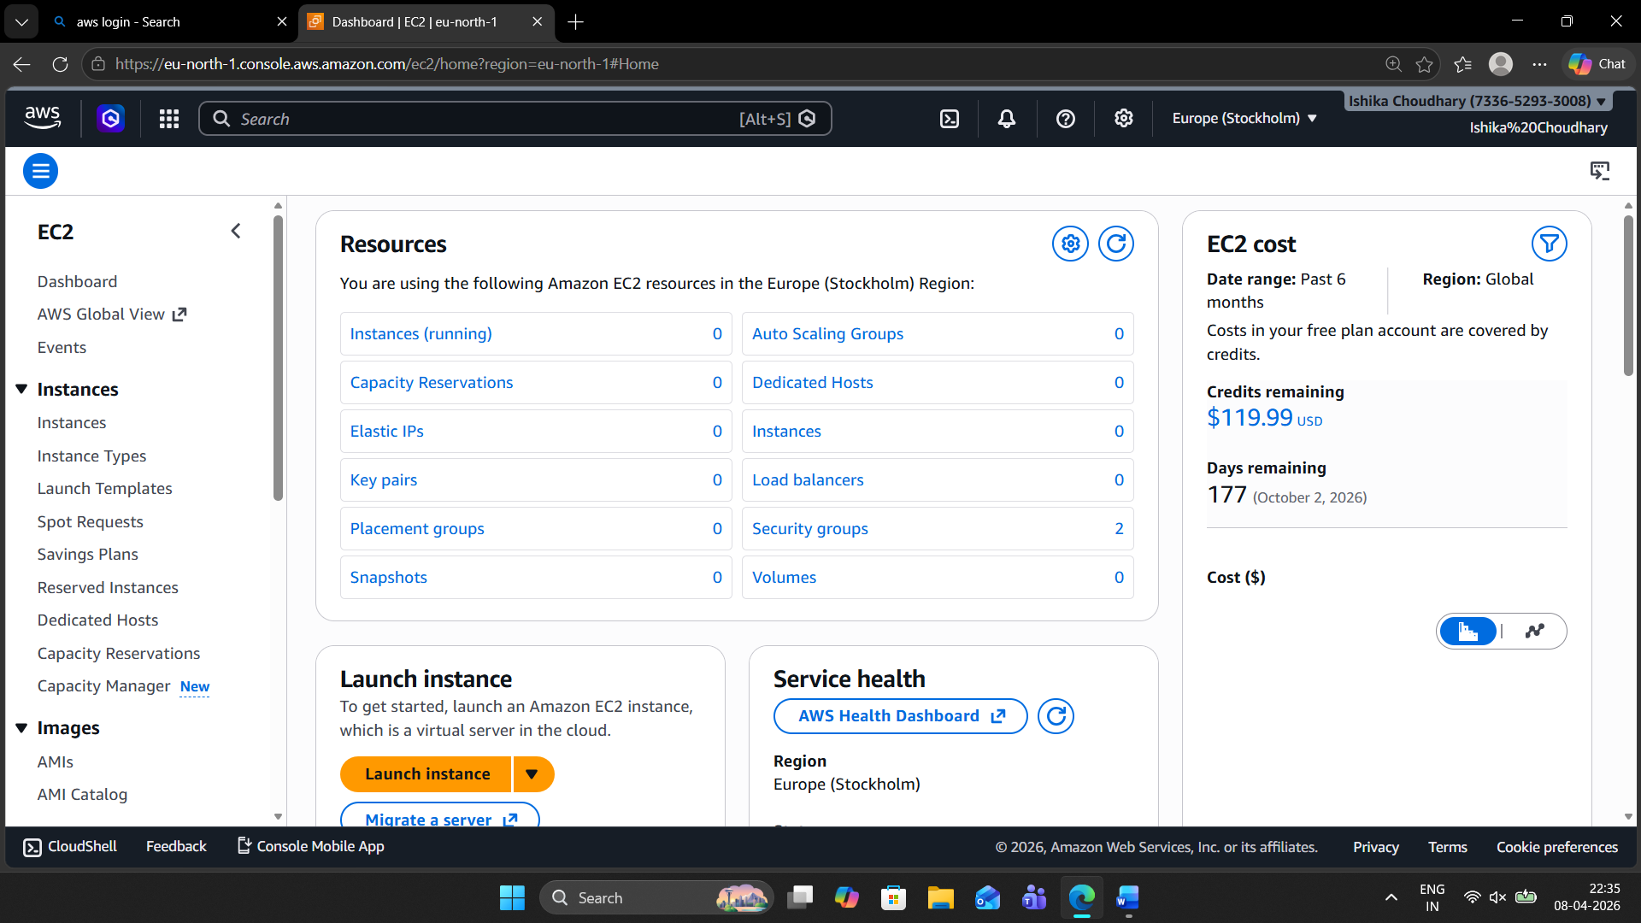

Step 2: In the Name and tags section, you named the instance "my-aws-best-server". Under Application and OS Images, you selected Amazon Linux as the operating system.
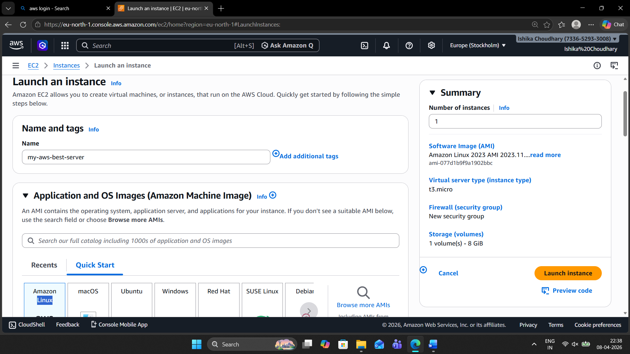
Step 3: This shows the specific AMI details (Amazon Linux 2023). It confirms the image is "Free tier eligible" and uses a 64-bit architecture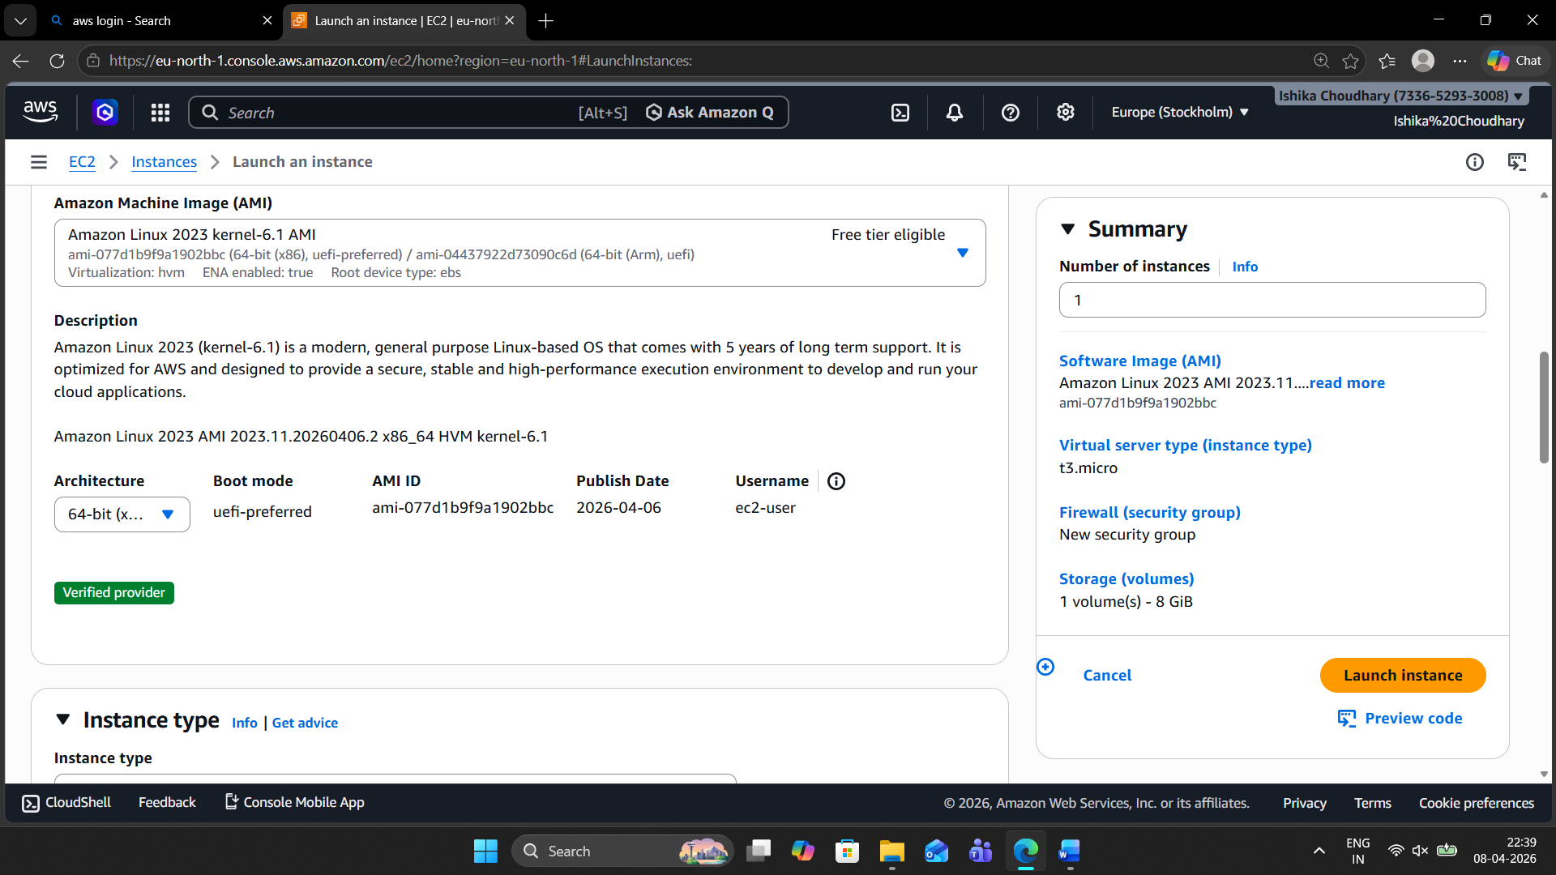
Step 4: Under Instance type, you chose t3.micro (2 vCPUs, 1 GiB Memory), which is also Free tier eligible. The Key pair section is visible but not yet filled.
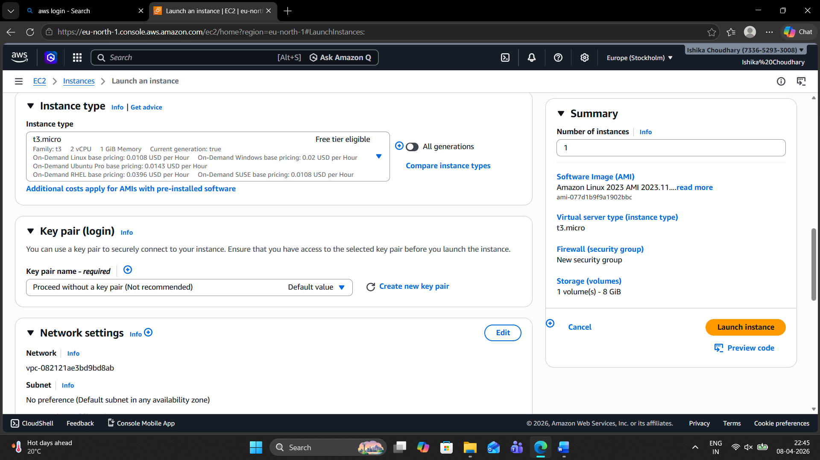

Step 5: In Network settings, you opted to "Create security group." You enabled rules to allow SSH and HTTPS traffic from anywhere (0.0.0.0/0).
Step 6: In the Configure storage section, you set the Root volume to 8 GiB using the gp3 (General Purpose SSD) volume type.
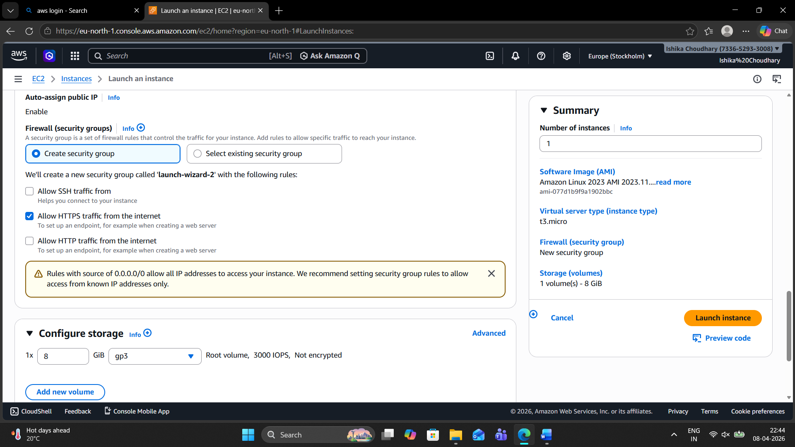
Step 7: Success! The instance (ID: i-008a8404ed6970e8b) has been successfully initiated. The
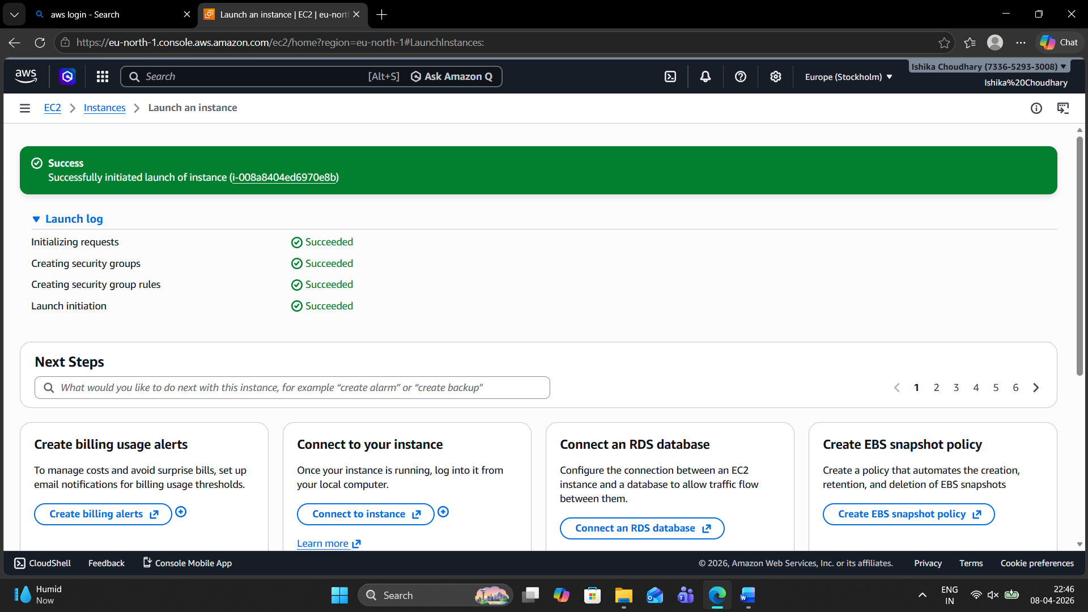
Step 8: “All instance are shown here.”
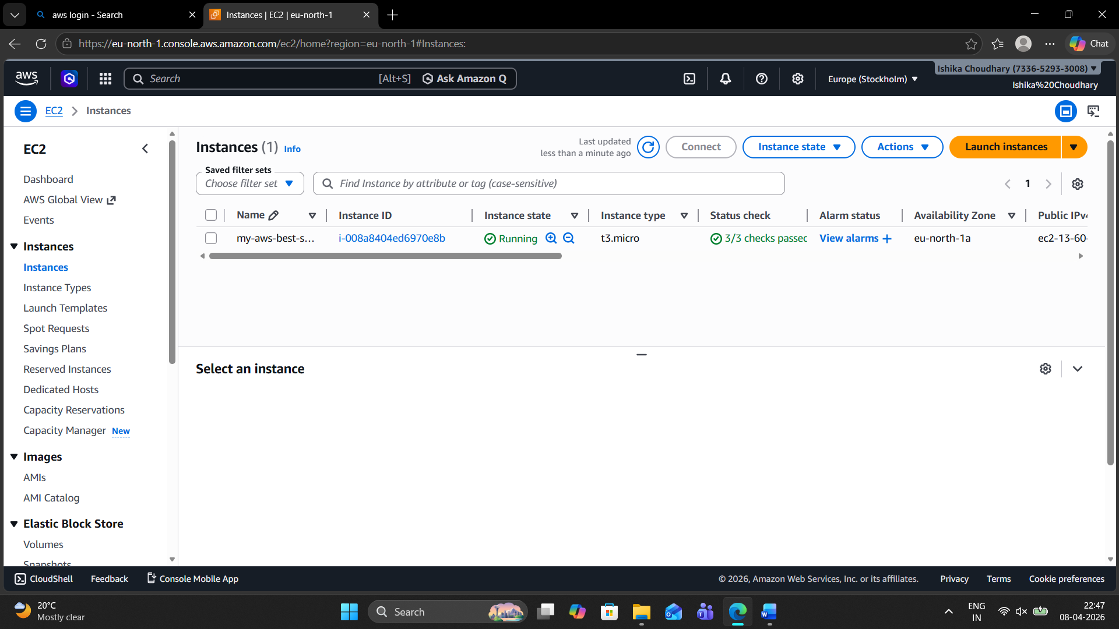
Step 9: Here we are connecting the instance to the server.
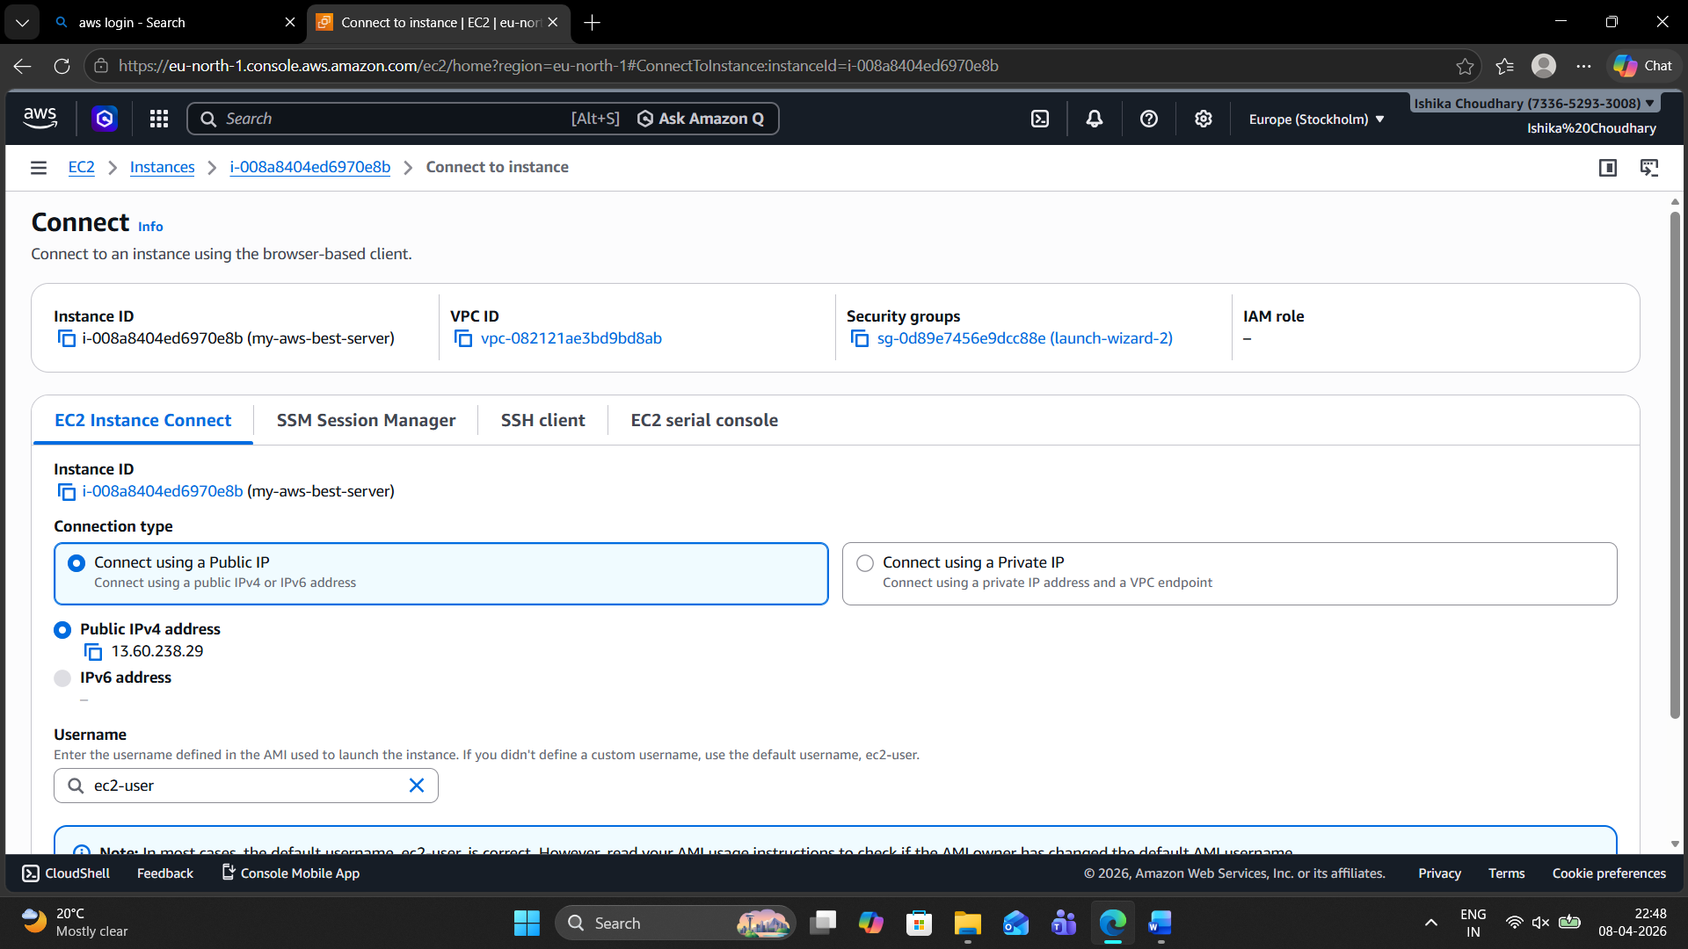

Step 10: Screen shows next steps like "Connect to instance" or "Create billing alerts."
