**1.Take two input from user and make a calculator (add, sub, div, mul) by taking input from text field.**

**SOURCE CODE:**

<!DOCTYPE html>

<html lang="en">

<head>

    <meta charset="UTF-8">

    <meta name="viewport" content="width=device-width, initial-scale=1.0">

    <title>Arithmetic Operations</title>

    <style>

        body {

            font-family: Arial, sans-serif;

            background-color: #f7f7f7;

            margin: 0;

            padding: 0;

            display: flex;

            justify-content: center;

            align-items: center;

            height: 100vh;

        }

        form {

            background-color: #fff;

            padding: 20px;

            border-radius: 8px;

            box-shadow: 0 0 10px rgba(0, 0, 0, 0.1);

        }

        label {

            font-weight: bold;

            margin-bottom: 5px;

            display: block;

        }

        input[type="text"] {

            width: 100%;

            padding: 10px;

            margin-bottom: 10px;

            border: 1px solid #ccc;

            border-radius: 5px;

            box-sizing: border-box;

        }

        input[type="button"] {

            padding: 10px 20px;

            background-color: #007bff;

            color: #fff;

            border: none;

            border-radius: 5px;

            cursor: pointer;

        }

        input[type="button"]:hover {

            background-color: #0056b3;

        }

        p {

            font-size: 24px;

            color: red;

            font-family: Verdana, Geneva, Tahoma, sans-serif;

            font-weight: bold;

            margin-top: 20px;

        }

    </style>

    <script>

        function Sum() {

            var a = parseInt(document.getElementById("t1").value);

            var b = parseInt(document.getElementById("t2").value);

            var sum = a + b;

            document.getElementById("demo").innerHTML = "Sum: " + sum;

        }

        function diff() {

            var a = parseInt(document.getElementById("t1").value);

            var b = parseInt(document.getElementById("t2").value);

            var diff = a - b;

            document.getElementById("demo").innerHTML = "Difference: " + diff;

        }

        function multi() {

            var a = parseInt(document.getElementById("t1").value);

            var b = parseInt(document.getElementById("t2").value);

            var multi = a * b;

            document.getElementById("demo").innerHTML = "Product: " + multi;

        }

        function div() {

            var a = parseInt(document.getElementById("t1").value);

            var b = parseInt(document.getElementById("t2").value);

            var div = a / b;

            document.getElementById("demo").innerHTML = "Division: " + div;

        }

    </script>

</head>

<body>

    <form>

        <label for="t1">Enter First Number</label>

        <input type="text" id="t1">

        <br><br>

        <label for="t2">Enter Second Number</label>

        <input type="text" id="t2">

        <br><br>

        <input type="button" value="SUM" onclick="Sum()">

        <input type="button" value="DIFFERENCE" onclick="diff()">

        <input type="button" value="PRODUCT" onclick="multi()">

        <input type="button" value="DIVISION" onclick="div()">

    </form>

    <p id="demo"></p>

</body>

</html>

**OUTPUT:**

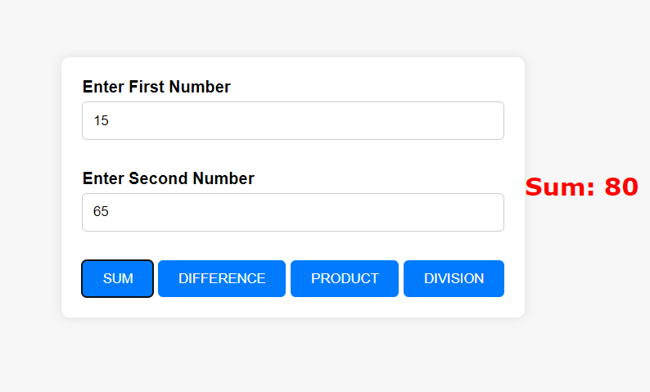

**2) Find the number of days remaining to your birthday.**

**Source code:**

<!DOCTYPE html>

<html lang="en">

<head>

  <meta charset="UTF-8">

  <meta name="viewport" content="width=device-width, initial-scale=1.0">

  <title>Birthday Countdown</title>

  <style>

    body {

      font-family: Arial, sans-serif;

      text-align: center;

      margin: 50px;

    }

    #countdown {

      font-size: 24px;

      font-weight: bold;

      margin-top: 20px;

    }

  </style>

</head>

<body>

  <h1>Birthday Countdown</h1>

  <label for="birthday">Enter your birthday:</label>

  <input type="date" id="birthday">

  <button onclick="calculateDays()">Calculate</button>

  <div id="countdown"></div>

  <script>

    function calculateDays() {

      var birthdayInput = document.getElementById("birthday").value;

      var birthdayDate = new Date(birthdayInput);

      var currentDate = new Date();

      birthdayDate.setFullYear(currentDate.getFullYear());

      if (currentDate > birthdayDate) {

        birthdayDate.setFullYear(currentDate.getFullYear() + 1);

      }

      var timeDiff = birthdayDate.getTime() - currentDate.getTime();

      var daysRemaining = Math.ceil(timeDiff / (1000 * 3600 * 24));

      var countdownElement = document.getElementById("countdown");

      countdownElement.textContent = "Days remaining until your next birthday: " + daysRemaining + " days";

    }

  </script>

</body>

</html>

**Output:**

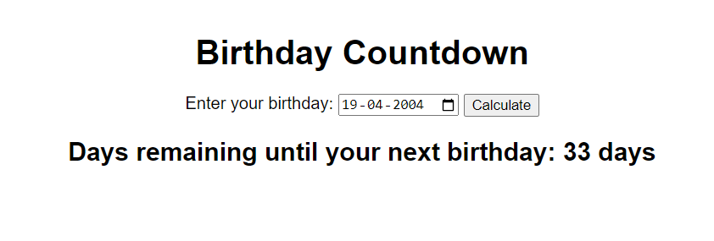

**3) Print the table of integer entered by user (like 2*2=4)**

**Source code:**

<!DOCTYPE html>

<html lang="en">

<head>

    <meta charset="UTF-8">

    <meta name="viewport" content="width=device-width, initial-scale=1.0">

    <title>Multiplication Table</title>

    <style>

        body {

            font-family: Arial, sans-serif;

            background-color: #f5f5f5;

            margin: 0;

            padding: 0;

        }

        .container {

            width: 50%;

            margin: 50px auto;

            background-color: #fff;

            padding: 20px;

            border-radius: 8px;

            box-shadow: 0 2px 4px rgba(0, 0, 0, 0.1);

        }

        label {

            font-size: 18px;

            font-weight: bold;

        }

        input[type="number"] {

            padding: 8px;

            width: 100%;

            border-radius: 4px;

            border: 1px solid #ccc;

        }

        input[type="button"] {

            padding: 10px 20px;

            background-color: #4CAF50;

            color: white;

            border: none;

            border-radius: 4px;

            cursor: pointer;

        }

        input[type="button"]:hover {

            background-color: #45a049;

        }

        #demo {

            font-size: 18px;

            margin-top: 20px;

        }

    </style>

    <script>

        function table() {

            var a = parseInt(document.getElementById("t1").value);

            var tableContent = "";

            for (var i = 1; i <= 10; i++) {

                var p = i * a;

                tableContent += `${a} * ${i} = ${p}<br>`;

            }

            document.getElementById("demo").innerHTML = tableContent;

        }

    </script>

</head>

<body>

    <div class="container">

        <label for="t1">Enter an Integer:</label>

        <br>

        <input type="number" id="t1">

        <br><br>

        <input type="button" value="Generate Table" onclick="table()">

        <p id="demo"></p>

    </div>

</body>

</html>

**Output:**

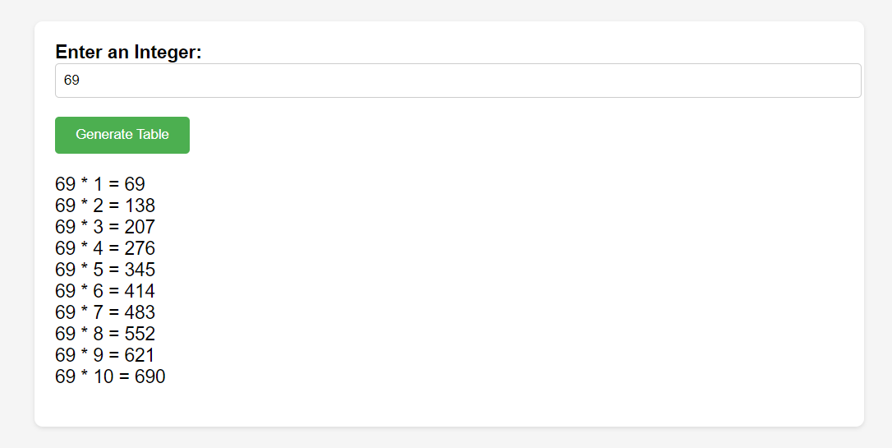

**4) Write a program to calculate and print the electricity bill of a given customer. The customer ID, name, and unit consumed by the user should be captured from the keyboard to display the total amount to be paid to the customer.  
  
The charge are as follow :  
  
Unit    Charge/unit  
upto 199    @1.20  
200 and above but less than 400    @1.50  
400 and above but less than 600    @1.80  
600 and above    @2.00  
  
If bill exceeds Rs. 400 then a surcharge of 15% will be charged and the minimum bill should be of Rs. 100/-**

**Output:**

<!DOCTYPE html>

<html lang="en">

<head>

  <meta charset="UTF-8">

  <meta name="viewport" content="width=device-width, initial-scale=1.0">

  <title>Electricity Bill Calculator</title>

  <script>

    function calculateBill() {

      var customerId = document.getElementById('customerId').value;

      var customerName = document.getElementById('customerName').value;

      var unitConsumed = parseInt(document.getElementById('unitConsumed').value);

      var chargePerUnit;

      var totalAmount;

      if (unitConsumed <= 199) {

        chargePerUnit = 1.20;

      } else if (unitConsumed >= 200 && unitConsumed < 400) {

        chargePerUnit = 1.50;

      } else if (unitConsumed >= 400 && unitConsumed < 600) {

        chargePerUnit = 1.80;

      } else {

        chargePerUnit = 2.00;

      }

      totalAmount = unitConsumed * chargePerUnit;

      if (totalAmount > 400) {

        totalAmount += totalAmount * 0.15;

      }

      totalAmount = Math.max(totalAmount, 100);

      document.getElementById('result').innerHTML = `

        <p>Customer ID: ${customerId}</p>

        <p>Customer Name: ${customerName}</p>

        <p>Units Consumed: ${unitConsumed}</p>

        <p>Total Amount to be Paid: Rs. ${totalAmount.toFixed(2)}</p>

      `;

    }

  </script>

  <style>

    body {

  font-family: Arial, sans-serif;

  margin: 0;

  padding: 0;

  background-color: #f4f4f4;

}

.container {

  max-width: 500px;

  margin: 50px auto;

  padding: 20px;

  background-color: #fff;

  border-radius: 5px;

  box-shadow: 0 0 10px rgba(0, 0, 0, 0.1);

}

h1 {

  text-align: center;

  color: #333;

}

label {

  font-weight: bold;

}

input[type="text"],

input[type="number"] {

  width: 100%;

  padding: 8px;

  margin-top: 5px;

  margin-bottom: 15px;

  border: 1px solid #ccc;

  border-radius: 3px;

}

button {

  padding: 10px 20px;

  background-color: #007bff;

  color: #fff;

  border: none;

  border-radius: 3px;

  cursor: pointer;

}

button:hover {

  background-color: #0056b3;

}

#result {

  margin-top: 20px;

  padding: 10px;

  background-color: #f9f9f9;

  border-radius: 5px;

}

  </style>

</head>

<body>

  <h1>Electricity Bill Calculator</h1>

  <label for="customerId">Customer ID:</label>

  <input type="text" id="customerId"><br><br>

  <label for="customerName">Customer Name:</label>

  <input type="text" id="customerName"><br><br>

  <label for="unitConsumed">Units Consumed:</label>

  <input type="number" id="unitConsumed"><br><br>

  <button onclick="calculateBill()">Calculate Bill</button><br><br>

  <div id="result"></div>

</body>

</html>

**Output:**

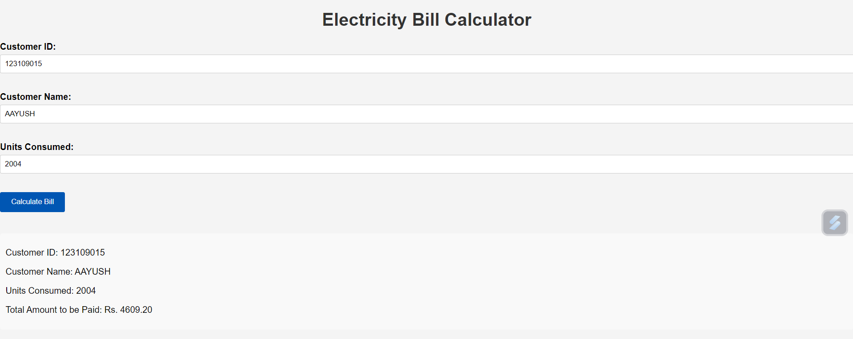

**5) Write a program to calculate the root of a quadratic equation.**

**Source code:**

<!DOCTYPE html>

<html lang="en">

<head>

  <meta charset="UTF-8">

  <meta name="viewport" content="width=device-width, initial-scale=1.0">

  <title>Quadratic Equation Solver</title>

<style>

    .container {

  max-width: 400px;

  margin: 50px auto;

  text-align: center;

}

input[type="number"] {

  width: 100%;

  padding: 8px;

  margin-top: 5px;

  margin-bottom: 15px;

}

button {

  padding: 10px 20px;

  background-color: #007bff;

  color: white;

  border: none;

  border-radius: 5px;

  cursor: pointer;

}

button:hover {

  background-color: #0056b3;

}

#result {

  margin-top: 20px;

  font-size: 1.2em;

}

</style>

<script>

  function solveQuadratic() {

  var a = parseFloat(document.getElementById('a').value);

  var b = parseFloat(document.getElementById('b').value);

  var c = parseFloat(document.getElementById('c').value);

  var discriminant = b * b - 4 * a * c;

  var x1, x2, nature;

  if (discriminant > 0) {

    x1 = (-b + Math.sqrt(discriminant)) / (2 * a);

    x2 = (-b - Math.sqrt(discriminant)) / (2 * a);

    nature = "Real and Distinct Roots";

  } else if (discriminant === 0) {

    x1 = x2 = -b / (2 * a);

    nature = "Real and Equal Roots";

  } else {

    nature = "Imaginary Roots, No Real Solution";

    x1 = '';

    x2 = '';

  }

  document.getElementById('result').innerHTML = `

    <p>Root 1: ${x1}</p>

    <p>Root 2: ${x2}</p>

    <p>Nature of roots: ${nature}</p>

  `;

}

</script>

</head>

<body>

  <div class="container">

    <h1>Quadratic Equation Solver</h1>

    <div>

      <label for="a">Enter coefficient a:</label>

      <input type="number" id="a">

    </div>

    <div>

      <label for="b">Enter coefficient b:</label>

      <input type="number" id="b">

    </div>

    <div>

      <label for="c">Enter coefficient c:</label>

      <input type="number" id="c">

    </div>

    <button onclick="solveQuadratic()">Solve</button>

    <div id="result"></div>

  </div>

  <script src="script.js"></script>

</body>

</html>

**Output:**

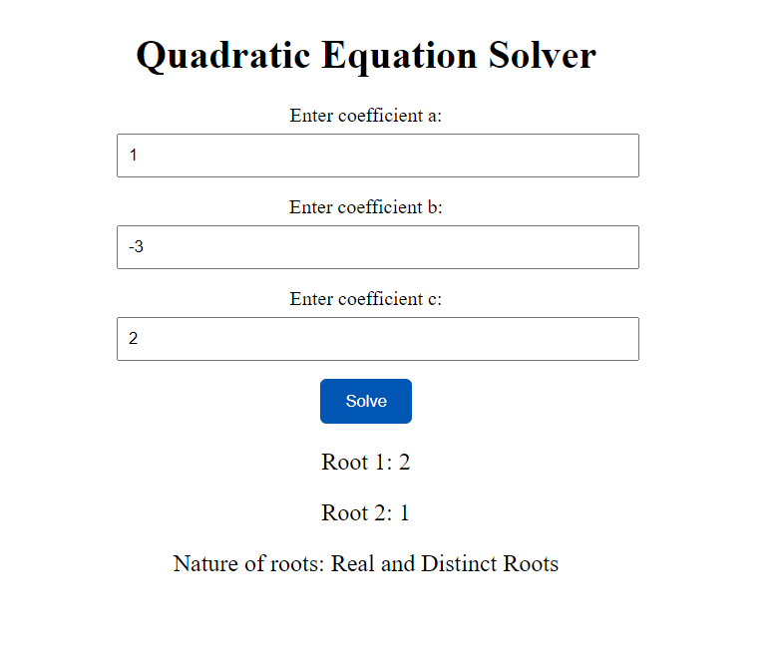

**Write a program to find whether a given year is a leap year or not.  
Test Data : 2016  
Expected Output :  
2016 is a leap year.**

**Source code:**

<!DOCTYPE html>

<html lang="en">

<head>

    <meta charset="UTF-8">

    <meta name="viewport" content="width=device-width, initial-scale=1.0">

    <title>LEAP YEAR Checker</title>

    <style>

        body {

            font-family: Verdana, Geneva, Tahoma, sans-serif;

            background-color: #f4f4f4;

            margin: 0;

            padding: 0;

            display: flex;

            justify-content: center;

            align-items: center;

            height: 100vh;

        }

        .container {

            text-align: center;

            padding: 20px;

            border-radius: 10px;

            background-color: #fff;

            box-shadow: 0 0 10px rgba(0, 0, 0, 0.1);

        }

        label {

            font-size: 18px;

            margin-bottom: 10px;

        }

        input[type="number"] {

            padding: 10px;

            font-size: 16px;

            border-radius: 5px;

            border: 1px solid #ccc;

        }

        input[type="button"] {

            padding: 10px 20px;

            font-size: 16px;

            background-color: #007bff;

            color: #fff;

            border: none;

            border-radius: 5px;

            cursor: pointer;

        }

        input[type="button"]:hover {

            background-color: #0056b3;

        }

        p {

            font-size: 24px;

            color: BLACK;

            font-weight: bold;

            margin-top: 20px;

            padding: 10px;

            border: 2px solid black;

            border-radius: 5px;

            background-color: #ffe6e6;

            box-shadow: 0 2px 4px rgba(0, 0, 0, 0.1);

        }

    </style>

    <script>

        function leap() {

            var y = parseInt(document.getElementById("year").value);

            if (y % 400 == 0 || (y % 4 == 0 && y % 100 != 0)) {

                document.getElementById("demo").innerHTML = "LEAP YEAR";

            } else {

                document.getElementById("demo").innerHTML = "NOT A LEAP YEAR";

            }

        }

    </script>

</head>

<body>

    <div class="container">

        <label for="year">Enter a year to check:</label>

        <br>

        <input type="number" id="year">

        <br><br>

        <input type="button" value="Check" onclick="leap()">

        <p id="demo"></p>

    </div>

</body>

</html>

