**SURFACE FINISHING OF CURVED SURFACES USING SHAPE ADAPTIVE GRINDING**

*Report submitted to*

*Indian Institute of Technology, Kharagpur*

*as M. Tech Thesis Project-II*

*Under the supervision of*

**Prof. Ajay M. Sidpara**

*by*

**Aayush Rajput**

**18ME31036**



**DEPARTMENT OF MECHANICAL ENGINEERING**

**INDIAN INSTITUTE OF TECHNOLOGY, KHARAGPUR**

**Apr 2023**

**CERTIFICATION**

This is to certify that this project report entitled “Surface finishing of curved surfaces using shape adaptive grinding” submitted to Department of Mechanical Engineering, Indian Institute of Technology, Kharagpur, is a bonafide record of work done by Aayush Rajput, Roll no. 18ME31036, from the Department of Mechanical Engineering, Indian Institute of Technology, Kharagpur as his M. Tech thesis project-2 during the spring semester, 2022-2023.

**Prof. Ajay M. Sidpara**

Associate Professor

Department of Mechanical Engineering

Indian Institute of Technology, Kharagpur

**Date: __.04.2023**

**Introduction**

Manufacturing is the process of converting a raw material to a finished product using different types of tools. The manufacturing industry covers a large portion of the total industries of a nation. In India, the output from the manufacturing industry comprises 78% of the total industrial output. In the manufacturing of any product after the machining process, various finishing processes are performed on it. The finishing process allows companies to set a higher price for the final product as the finishing process improves many properties of a product. Some of the product improvements by finishing processes are corrosion reduction, surface defects removal, improved appearance, enhanced chemical resistance, and many more. These finishing processes account for 10-15% of the overall production cost of a product [1]. So there is a scope of studying the finishing processes and finding the best parameters for finishing to get the break-even sweet point where we can minimize the production cost without reducing the quality of a product.

Surface finishing is a process in which various techniques are used to reduce the roughness of a surface to achieve certain properties. Surface finishing techniques can be broadly classified into two groups, traditional surface finishing techniques, and advanced surface finishing techniques. Traditional surface finishing techniques include Honing, Grinding, and Lapping and advanced surface finishing techniques include Magnetorheological Finishing (MRF), Abrasive Flow Finishing (AFF), and Magnetorheological Abrasive Flow Finishing (MRAFF). Traditional surface finishing processes are used for a long time in industries and are simple and cheaper as compared to the advanced surface finishing processes. But the traditional surface finishing techniques have some limitations as they cannot be used when the shape of the part which has to be finished is complex or when the thickness of the part is less and a higher force can cause damage to the part. With technological advancements, many new advanced surface finishing processes are developed which can overcome the limitations of traditional surface finishing processes. In this study, we will study one of the advanced surface finishing techniques and the different parameters associated with it.

The problem with the other surface finishing techniques is that too much force on the surface starts the particles to pull out of the surface thus reducing the surface finish. Recently techniques that use flexible tools are used for processing material that is hard to finish. These processes use flexible tools so that it can be used on materials such as copper which are hard to finish. Shape adaptive grinding (SAG) is a type of advanced surface finishing technique which is used for finishing complex surfaces. It uses a flexible tool covered with nickel or resin-bonded diamond pellets. The elastic nature of the tools makes it possible to deform the tool according to the surface of the workpiece. Once the peaks which are increasing surface roughness are removed the surface area increases which will require a large force to be removed further, this will not allow the tool to remove particles from the plain surface thus surface finishing will not be degraded. A nanoscale surface finish can be achieved using this method on the materials like ceramics and hard metals which are difficult to machine. A surface finish below 0.5 nm Ra can be achieved by this method.

In any surface finishing process, a tool path is selected on which the tool moves over the surface which has to be finished. The tool path generation is the process of deciding the tool trajectory relative to the surface of the part. Different tool paths produce different types of surface finish based on the method used for surface finishing. The most commonly used tool paths are zig-zag, parallel, trochoidal, circular, etc. [2]. The type of material on which the finishing operation is done also influences the surface roughness produced using different tool paths.

In case of curved surfaces, the finishing operation becomes more difficult as for the smooth finishing pressure on the surface during the whole operation should be the same. Preston and Hertz theory establishes a relation between rate of material removal and the pressure applied during the finishing process. As the curvature of the surface changes at each and every instant keeping the same pressure is quite difficult which makes the polishing of curved surfaces (both concave and convex) more difficult that the polishing of flat surfaces. In case of the flat surfaces the pressure applied will strongly affect the finish of the surface too less surface pressure due to tool will lead to low quality of surface because there is not enough force to remove the irregularities from the surface on the other hand too much pressure will also deteriorate the surface as till will cause starch marks on the surface so there will be an optimal pressure where the surface finish would be the best and roughness would be on its lowest. The roughness of the surface of any work piece will also depends on the material used for making the work piece so different material will have a different optimal pressure where the roughness will be lowest. The different mechanical properties of the metals are also responsible for the finishing operation as different materials have different response to the same pressure as some are more brittle, malleable and have different tensile modulus. This study will be focused on a particular type of metal and experiments will be done on that particular metal.

**Literature Review**

Anwesa Barman et. al. [3] used Magnetic Field Assisted Finishing (MFAF) process to finish biomaterials at the nanometre level. Biomaterials are used in the medical industry for making implants. They finish the surface of a titanium work piece using a specially designed tool. Two paths are used for the finishing process and various parameters for both surfaces were compared. The first path planning used was a parallel path and the second was the spiral path. The study showed that the parallel path generated a lower surface roughness (~10 nm) and a better surface texture. This study further analysed the output over a range of input parameters like tool rotational speed, working gap, and finishing time, and found the optimal value of these parameters. The best value of change in surface roughness achieved using the parallel toolpath is 93.3% while using the spiral toolpath is 71.4% which shows that the surface obtained using the parallel toolpath has lower roughness.

Further, the effect of the rotational speed of the tool on surface roughness for parallel toolpath is analyzed and it was found that with increasing rotational speed surface roughness is decreased till 1200rpm after that the surface roughness begins to increase. This is because due to higher speed than a particular point the CIP chain structure of the magnetorheological fluid begins to distort thus reducing the surface finish quality.

Then the effect of finishing time on surface roughness was analysed, and it was found that initially surface finish is increased with the increase in finishing time reaching a maximum value further increase in finishing time would cause the degradation in surface finish. The same pattern was seen with the working gap. Initially, an increase in the working gap would improve the surface finish to a maximum value; the further increase will degrade the surface finish.

Atul Singh Rajput et. al. [4] used a magnetorheological fluid-assisted finishing (MFAF) process for finishing a test specimen made of duplex stainless steel using a trochoidal path and zig-zag path, and it was found that the trochoid path produces a better-finished surface than the surface produced by the zig-zag path. It was also found that the trochoidal path achieved a 96.8% reduction in surface roughness in 70 minutes while using the zig-zag path only a 45.36% reduction was achieved. Experiments were performed to detect the corrosions rate of the work piece after the surface finishing process using zig-zag and trochoidal paths and the result showed that the corrosion rate during the zig-zag toolpath is 0.013 mm/year which was higher than the trochoidal path i.e. 0.0114 mm/year. A wear test was also performed for both of the paths and the result showed that for the unpolished surface wear rate is 6.36 x 10-5 mm3/min which was very high as compared to the polished surface. While comparing the wear rate of the polished surface using zig-zag and trochoidal it was seen that the trochoidal toolpath’s wear rate was lower than the zig-zag toolpath. Further, the effect of different parameters (step over, curve radius, feed rate) on surface roughness was analysed. Stepover is the overlap between two consecutive circles of the trochoidal toolpath. With the increase in the overlap finish quality increases but the finishing time also increases. For curve radius, the average surface roughness increases with it, as the uncovered region’s area increases with an increase in curve radius for the trochoidal path. With an increase in feed rate the average surface roughness increases as with a higher feed rate interaction time of the surface with the tool decreases which causes a worse surface finish. However, too low a feed rate will also degrade the surface finish as the tool will start scratching the already polished surface.

Gourhari Ghosh et. al. [5] used chemical-assisted SAG for the nano-finishing of WC-Co coating. Chemical Mechanical Polishing is a widely used method in the semiconductor industry. In this process, the rotating surface is compressed against the rotating pad and chemical abrasives are injected over it. So there is the effect of chemical as well as a mechanical force on the surface and both contribute to the polishing of the surface. This was a multi-step finishing strategy in which first SAG was done then the chemically assisted SAG was performed for a better finish. The chemical treatment made a layer on the top of the surface which was softer than the surface which helped in the uniform material removal rate. Later the X-ray photoelectron spectroscopy showed that a passivation layer of tungsten trioxide was present on the surface and no fracture was found on the surface. In the first step, grinding was done using the single-layer electroplated diamond wheel which reduced the surface roughness to a micron level. The SAG tool had a PMMA wheel and an abrasive pad of zirconia-alumina was attached to it. The polishing was performed using pads of different grit sizes (125, 80, and 60 μm) sequentially. In the next step, chemical-assisted SAG was performed using Murakami’s reagent (a solution of K3[Fe(CN)6], KOH, and distilled water in a 1:1:10 proportion). This reagent was applied at the contact zone using a syringe. A nano hardness test was also done to check the effect of Murakami's reagent on the surface hardness of WC-Co coating. Small slices of the coating were kept in the Murakami reagent for 3, 6, and 9 minutes. Some sides were covered with teflon tape to avoid a reaction between the surface and the reagent. Then several measurements were taken at different locations and the average hardness was compared. The results from the experiments showed that the chemical-assisted SAG is efficient in the finishing operation due to the combined action of chemical etching and mechanical abrasion. The surface finally achieved using this method had a surface roughness of 53nm. It was also observed that the reagent has no effect on the properties of the coating.

Fengjie et. al. [6] investigated the optimal polishing pressure for automatic polishing of curved surfaces using a robot. The study was conducted to improve the surface quality and consistency of the final product in industries such as automobile and aerospace.

The paper starts with an overview of the current state of polishing technology and the challenges associated with polishing curved surfaces. Then, the authors describe the methodology used in the study, which involved the use of a robot equipped with a polishing tool to polish aluminum alloy samples with different curved shapes.

The polishing pressure was varied during the experiments and the surface roughness and glossiness were measured to assess the quality of the polished surface. The results showed that there was an optimal polishing pressure that produced the best surface quality, and that this optimal pressure varied depending on the curvature of the surface being polished.

The authors conclude that the optimal polishing pressure for automatic polishing of curved surfaces can be determined through experimentation, and that this information can be used to improve the surface quality and consistency of finished products in various industries. The findings can be used to improve surface quality and consistency in industries that require polished curved surfaces.

Sung-San Cho et. al. [7] studied the finishing process of curved surfaces by a flexible abrasive tool. The paper discusses the development of a flexible abrasive tool for the automatic finishing of curved surfaces on three-axes machining centers. The tool is made of a thermosetting polyurethane elastomer with an overcoat of aluminum oxide abrasives and is designed to deform itself in conformity with the shape of the work surface. The study examines the tool's performance, including finishing capability, conformability, and durability, through experiments on ball-end milled surfaces of high-alloyed tool steel. The tool/work contact pressure, which affects the tool performance, is estimated and utilized to determine the tool path, producing a constant contact pressure, resulting in improved finished surface roughness.

In the paper a flexible abrasive tool designed for automatic finishing of curved surfaces on three-axis machining centers has been tested and its performance evaluated. The constant contact pressure tool path has been calculated and evaluated, and the results show that the tool successfully finishes curved surfaces on three-axis machining centers without changing the pre-machined surface shape. The tool retains its finishing capabilities for over 80 minutes and the constant contact pressure tool path enhances the quality of the finished surface compared to constant interference depth.

**Gaps in literature and Objective**

This field of surface finishing has been explored by a lot of researchers and many researches has been done and many are in progress. However, there is not any study have been done which is focused on the analysis of pressure on the work piece by varying the slope of the path of the horizontal tool. So the gaps in the literature can be pointed out as follows:

1. There is limited work done to study the effect of changing pressure on the work piece due to horizontal tool.
2. Change in the surface finish with the change in the force on its surface with varying tool path has not been explored.
3. The study of effect of contact of horizontal tool on the surface finish of the work piece is very limited.

By changing the tool paths and varying the rate of change of pressure on the work piece the force on the work piece is changed and eventually the surface roughness is also affected. So the primary objective of the study can be summarized as:

1. Designing the different tool paths by for surface finishing using horizontal tool.
2. Studying the effect of changing the pressure rate on the surface finishing of the work piece.
3. Theoretical modelling of material removal rate from the work piece in the term of different machining parameters.
4. Contact analysis of the horizontal tool and work piece surface.

**Material Removal Modeling**

Material removal during the surface finishing can evaluated using the Preston assumption. The relationship of material removal rate and other process parameter is as follows:

where ht(x,y) is the rate of material removal at any point on the surface, h(x, y) is the amount of removed material from the surface , v(x,y) is the speed between polishing tool and the surface, Kp is a factor which depends on the other factor during finishing except the pressure and pn(x, y) is the pressure at the surface on the point with coordinates x and y. It can be clearly seen that the material removal rate varies with velocity and pressure as Kp is a constant depend on the factors like material of work piece and tool to be used. If we keep the relative velocity of finishing constant, then the only variable is pressure. If we are able to keep the polishing pressure to be same then the material removed will be same at every point and a smooth finished can be achieved, which is very easy in the case of flat surfaces. The pressure at any instant is calculated by taking the average of all the pressures at every point the tool is in contact with.

Hertz theory can be used to get the pressure profile on the contact surface of the work piece and tool.

Here p0 is the maximum contact pressure, a is major semi-axis, and b is the minor semi-axis.

Equation for getting the average pressure is

In this equation Fn is normal polishing pressure, Et is the relative elasticity modulus of the tool surface and the work piece, Rr (x, y) is relative curvature radius of the polishing point, k1 & k2 are the factor which depend on the geometry of the tool and work piece.

Using the above 3 equations we can derive that

If we assume the , then the whole equation can be summarized to

Above equation shows that the curvature changes on the surface, position, posture, pressure and rotating speed of tool are deciding the material removal from the surface of the work piece. It is easy to maintain the other parameters constant except the pressure so pressure is the deciding factor for the good finish of the curved surfaces.

***Material Removal Mechanism***

In shape adaptive grinding the flexible material is used so that the tool can adjust itself according to the waviness present on the surface. An abrasive pad which contains the abrasives of cubic Boron Nitride, Diamond etc. is placed over the flexible part which is responsible for the material removal from the surface of the work piece. The tool can be in different orientations depend on the geometry of the work piece to be machined. The force on a single abrasive particle is roughly the same in every orientation. There are mainly two types of forces that are applied on a single particle on the work piece surface Ft (tangential)and Fn (normal). By using the shape adaptive grinding, the force on each particle changes as the curvature of the surface changes so the force profile is not very uniform. Mostly used orientations of the tool in surface finishing operations are parallel and perpendicular. In the perpendicular position the axis of rotation is perpendicular with respect to the surface of the work piece, while in the parallel position the axis of rotation is parallel to the surface of work piece.

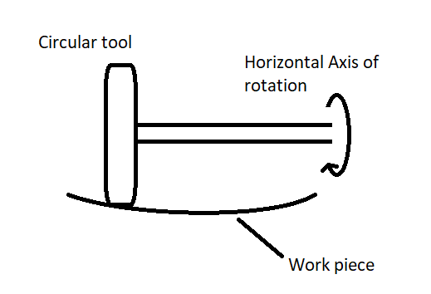

Fig 1. Parallel Tool Orientaion

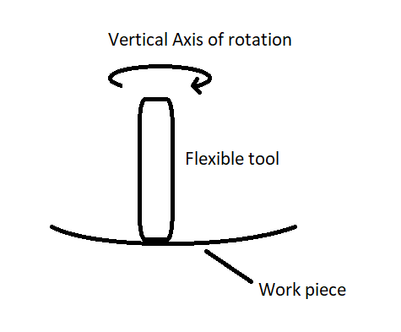

Fig 2. Perpendicular Tool Orientaion

The hardness of the material which is used in the abrasive pad must be harder than the work piece to ensure the proper finishing operation. The abrasive pad which is being used in the machining have a certain life span which depends on the factors like material of abrasive pad, material being machined, pressure used in the finishing operation etc. So the abrasive pad must be changed after a certain amount of time when the roughness of the work piece is not changing. Roughness of the work piece being the same is an indicator that the pad being used is blunt is not able to remove the irregularities from the surface.

**Experimental Setup**

*OFHC Copper*

The work piece used for the experiments is of circular shape made of OFHC Copper. OFHC (Oxygen-Free High Conductivity) copper is a type of copper that has been refined to reduce the amount of oxygen present in the metal. This process increases the electrical conductivity and thermal conductivity of the copper, making it ideal for use in applications where high levels of electrical and thermal conductivity are required.

Its properties include:

1. High conductivity: OFHC copper has an electrical conductivity of at least 101% IACS (International Annealed Copper Standard) and thermal conductivity of around 400 W/m·K, which makes it an excellent conductor of electricity and heat.
2. Low impurity levels: OFHC copper is refined to reduce the amount of impurities present, particularly oxygen. This helps to improve the material's conductivity and overall performance.
3. Ductility: OFHC copper is highly ductile, meaning it can be easily stretched and shaped without breaking. This property makes it ideal for use in wire and cable production.
4. Corrosion resistance: OFHC copper has good corrosion resistance, which makes it suitable for use in harsh environments.
5. High melting point: OFHC copper has a high melting point of around 1083°C, which makes it ideal for use in high-temperature applications.
6. Low Coefficient of Thermal Expansion: OFHC copper has a low coefficient of thermal expansion. This property makes OFHC copper an ideal material for applications where dimensional stability is important, such as in the manufacturing of optical mirrors and precision instruments.

Overall, OFHC copper is a highly desirable material for use in a range of applications, thanks to its excellent conductivity, low impurity levels, and other favourable properties.

*Applications of OFHC Copper*

OFHC copper is commonly used in the manufacturing of optical mirrors due to its high thermal conductivity and low coefficient of thermal expansion. The low coefficient of thermal expansion means that OFHC copper is less likely to expand or contract with changes in temperature, which can cause distortion or deformation in the mirror.

OFHC copper mirrors are used in a variety of applications, including astronomical telescopes, laser optics, and laboratory instruments. These mirrors are often coated with a layer of reflective material, such as aluminium or silver, to enhance their reflectivity.

In addition to its favourable thermal properties, OFHC copper is also highly machinable and can be easily shaped and polished to meet the specific requirements of a particular application. This makes it an ideal material for use in the production of high-quality optical mirrors.

The exceptional properties of OFHC copper make it a popular choice for the manufacturing of optical mirrors, where its high thermal conductivity and low coefficient of thermal expansion help to ensure the mirror's stability and precision.

OFHC copper is also commonly used in the production of electrical wires, cables, and other electronic components. It is also used in the manufacturing of magnets, vacuum tubes, and microwave tubes. The high conductivity of OFHC copper makes it particularly well-suited for applications where low resistance is important.

Overall, OFHC copper is an important material in a wide range of industries, where its high conductivity, low impurity levels, and excellent mechanical properties make it an attractive option for a variety of applications.

OFHC Copper have been used in a lot of researches due to its favourable properties. Some of the references of studies related to OFHC Copper Finishing are:

In 2019 Hua Zhou et. Al. published a paper titled "Effects of annealing on surface characteristics and tribological behaviour of OFHC copper”. This paper examines the impact of annealing on the surface characteristics and tribological behavior of OFHC copper, which is an important material for micro-electromechanical systems (MEMS) and micro-nano manufacturing.

J.J. Calvillo-Rodríguez et. al. did a study on "Corrosion behaviour of OFHC copper in acidic chloride solutions and the influence of surface finishing". This research investigates the corrosion behavior of OFHC copper in acidic chloride solutions, and examines the influence of different surface finishing techniques on the corrosion resistance of the material.

"Effect of surface finishing on the mechanical and electrical properties of OFHC copper joints made by friction stir welding" by A.C. Tavares et. al., this paper examines the effect of surface finishing on the mechanical and electrical properties of OFHC copper joints made by friction stir welding. The study shows that surface finishing can significantly affect the properties of the welded joints, and highlights the importance of careful surface preparation in the manufacturing of OFHC copper components.

*Chemical Composition*

The chemical composition of OFHC Copper is very important in determining its properties.

OFHC copper typically has a copper content of 99.95% or higher, with the remaining content consisting of trace amounts of impurities. The impurities that are present in OFHC copper are primarily oxygen and some other elements, such as iron, silver, and nickel, in very low concentrations.

The oxygen content in OFHC copper is typically less than 10 parts per million (ppm), which is much lower than other types of copper. This low oxygen content improves the electrical conductivity of the copper by reducing the number of oxygen atoms that can interfere with the movement of electrons.

*Physical, Mechanical and Thermal Properties*

OFHC copper has excellent physical, mechanical, and thermal properties, which make it a highly desirable material for a wide range of applications.

Physical Properties: OFHC copper has a high density of 8.96 g/cm³ and a melting point of 1083°C. It has a reddish-orange colour and a shiny appearance. OFHC copper is a soft metal with a Vickers hardness of approximately 50, which means it can be easily formed into various shapes and sizes.

Mechanical Properties: OFHC copper has excellent mechanical properties, including high ductility and malleability, which means it can be easily stretched and shaped without breaking or cracking. It has a high tensile strength of approximately 200 MPa, which means it can withstand significant stress without breaking.

Thermal Properties: OFHC copper has excellent thermal properties, including high thermal conductivity and low thermal expansion. It has a thermal conductivity of approximately 391 W/mK, which means it can transfer heat quickly and efficiently. The coefficient of thermal expansion (CTE) of OFHC copper is approximately 17.0 x 10^-6 / °C at 20°C. This means that for every degree Celsius increase in temperature, OFHC copper will expand by approximately 17.0 parts per million (ppm) of its original length or volume.

Experimental Procedure

In the experiment there is a circular OFHC Copper work piece and the finishing tool is in the parallel axis orientation performing the shape adaptive grinding. The shape of finishing tool is circular with a flexible material over it in which the compression changes according to the waviness of the surface. The parameters involved in the experiments are rotational speed of the tool, tool compression, size of abrasive pad, feed rate, total tool distance and total time taken for an experiment. The parameters which are changed during different experiments are rotational speed and tool compression, all other parameters will be constant for all the experiments.

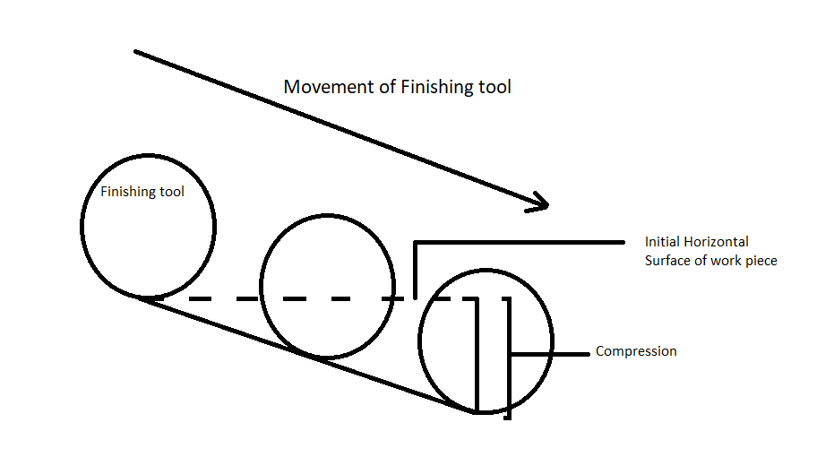

Schematic of Experiment

Process parameters

Rotational speed - 1000 / 1500 / 2000 RPM Tool Compression – 1 / 1.5 / 2 unit

Feed rate - 10 mm/min (Fixed) Tool Travel - 20 mm (Fixed)

Initial surface roughness - __________

Results Table

|  |  |  |  |  |  |
| --- | --- | --- | --- | --- | --- |
| Exp. No. | RPM | TC | Sa | Fn | Ft |
| 1 | 1000 | 1 |  |  |  |
| 2 | 1000 | 1.5 |  |  |  |
| 3 | 1000 | 2 |  |  |  |
| 4 | 1500 | 1 |  |  |  |
| 5 | 1500 | 1.5 |  |  |  |
| 6 | 1500 | 2 |  |  |  |
| 7 | 2000 | 1 |  |  |  |
| 8 | 2000 | 1.5 |  |  |  |
| 9 | 2000 | 2 |  |  |  |

**References**