QA(Quality Assurance)

Software testing:
- activity to match the actual results with expected results
- bugs can lead to loss of money, job or a human
- monitoring, inspecting and proposing measures to correct or improve an
organization's final products in order to meet established quality standards

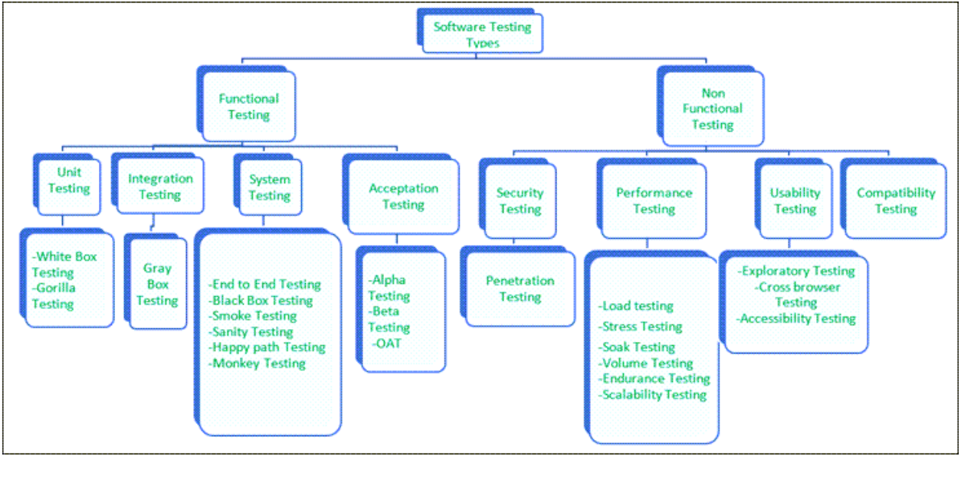
SDLC(software development life cycle)

Planning/Requirements: here business analyst collects client’s requirements and
documents the data, feasibility analysis resource allocation and risk assessment, (crs:
customer requirements specifications)
- Analysis stage: here the list of product requirement and get them approved. analysis
of requirement and prioritizing them, functional specifications, system design and
prototyping.
- Designing stage: here low level and high level design is created
- develop software, coding is done
- testing: here code is tested against corner cases
- integration: here all collaborated work is integrated
- deployment n maintenance

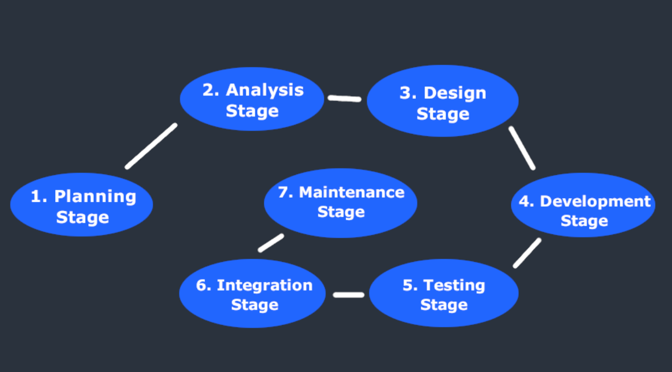

Functional Testing

Unit Testing:
definition: Unit testing is a type of software testing which is done on an individual unit or
component to test its corrections.
phase of operation: application development phase
Advantages: Find errors at unit level
- White Box Testing:
definition: White box testing is a form of application testing that provides the tester with
complete knowledge of the application being tested, including access to source code
and design documents.
Advantages: in-depth visibility identify issues invisible to gray and black box testing
QA (Quality Assurance)
- Gorilla Testing:
definition: Gorilla testing is a test technique in which the tester and/or developer test the
module of the application thoroughly in all aspects.
Advantages: checks robustness of application

Integration Testing:
definition: it is a type of software testing where two or more modules of an application
are logically grouped together and tested as a whole.
phase of operation: application development phase
Advantages: Test to find defect on interface,communication and flow among modules.
Approaches:
- top down: testing is performed 1st on top module then lower modules
- bottom up: the lower level modules are tested first after lower level modules the
higher level modules are tested
- Gray box testing:
definition: Testers have partial knowledge of the internal structure or code of an
application
advantages: combination of black and white box testing

System Testing:
definition: System testing is types of testing where tester evaluates the whole system
against the specified requirements.
- End to End Testing:
definition: testing whole application environment that mimics real world use.
Advantages: interacting with a database, using network communications, or interacting
with other hardware, applications, or systems
- Black Box Testing:
definition: software testing done without knowing the internal structure,design or code of
a system under test. focus on input and output
- Smoke Testing:
definition: all basic and critical functionality is checked under test to see if it works on
very high level.
Advantage: major bugs are removed
- Sanity Testing:
definition: test to check new functionality working properly
subset of regression test
- Happy path Testing:
definition: test an app on a positive flow
- Monkey Testing:
definition: assuming that an app is used by a monkey inputs are put and the app is
checked

Acceptance Testing:
definition: test in real business problems
phase of operation: last phase before product is deployed to production
also called UAT (user accepted testing)
- Alpha Testing:
definition: find as many defects as possible
- Beta Testing:
definition: test conducted by clients/customer
Advantages: ensures no big issue
- Operational acceptance testing (OAT):
definition: The purpose of operational acceptance testing is to make sure that the
system administrators can keep the system working properly for the users in a real-time
environment.
The focus of the OAT is on the following points:
Testing of backup and restore.
Installing, uninstalling, upgrading software.
The recovery process in case of natural disaster.
User management.
Maintenance of the software.

