Linux basic commands-2

1)ps - The ps command in Linux is a powerful tool that allows you to view information about the processes running on your Linux system
ps-aux – all processes from all
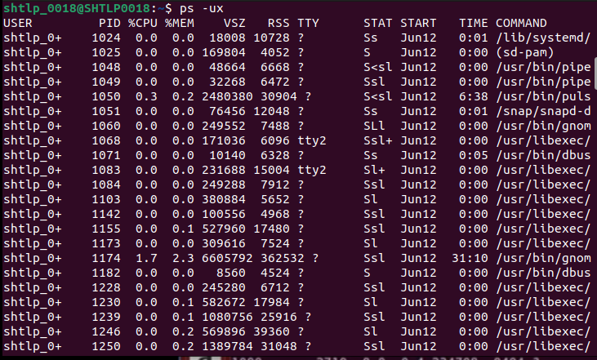

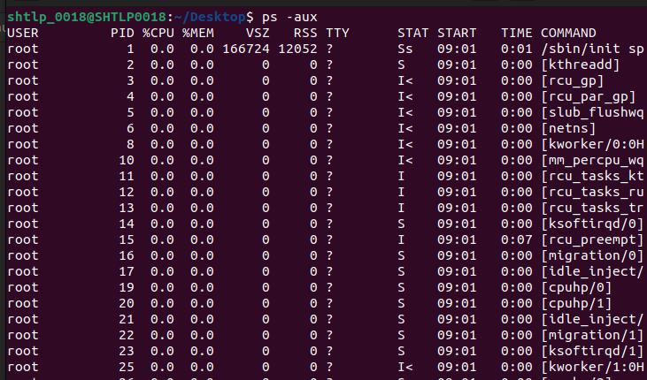

2)echo -used to get prompt from terminal

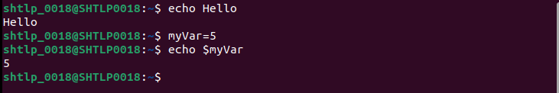

3)chmod – is used to give file permissions to users others and groups
(r-read w-write x-execute)

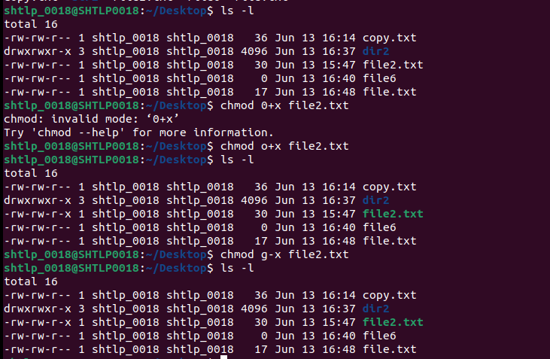

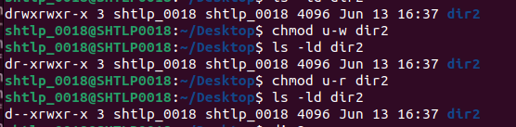

4)permission using octal

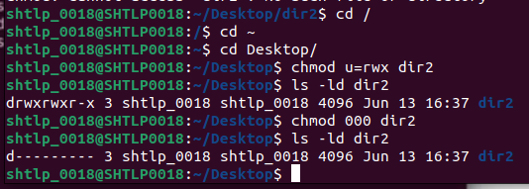

5) touch – used to create file

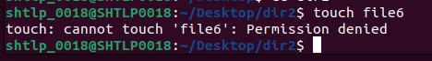

6)bash scripting

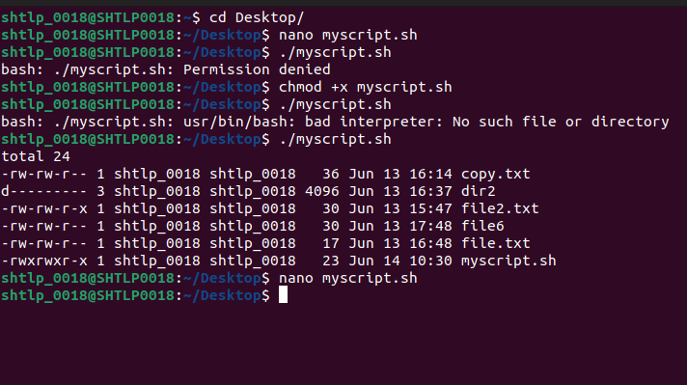

7)which – gives location of file
whatis – gives description about file
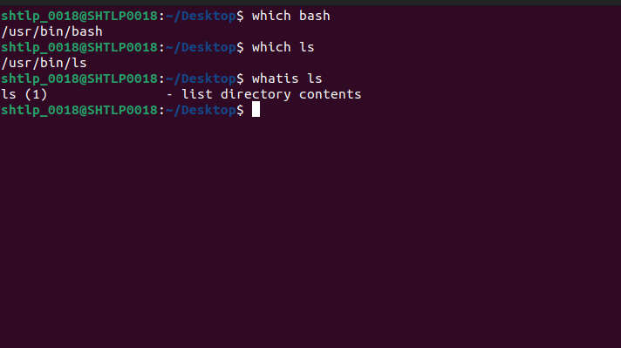
8)useradd – used to set new user

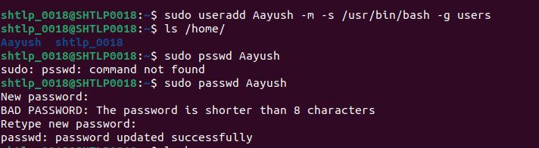
9)userdel – used to remove a user
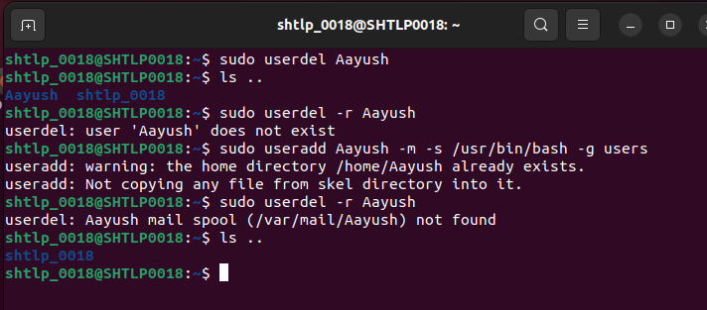

10)groups – used to find out groups
groupadd- add group
groupdel -delete group

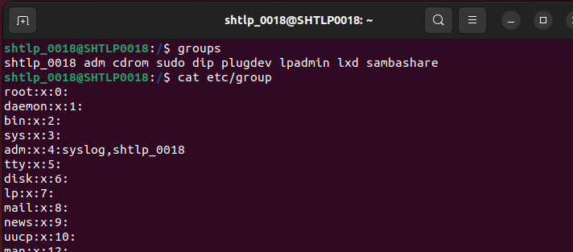
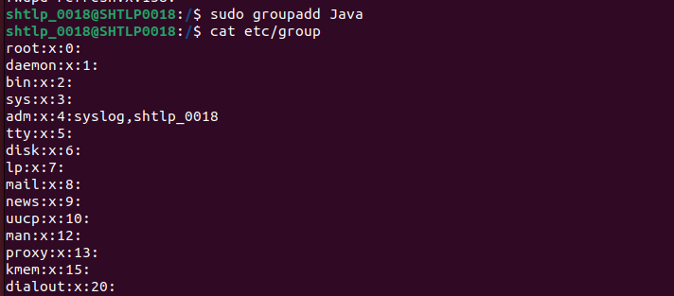

11).bashrc - used to change the starting of a terminal

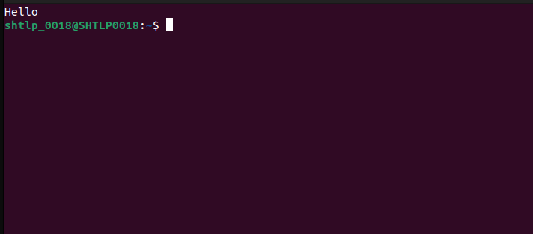

12)du - reports files' and directories' disk usage
df - reports how much disk space your file system is using
free- reports free space in disk
(free -m – for megabytes -g for gigabytes etc.)
du/df -h for human readable form

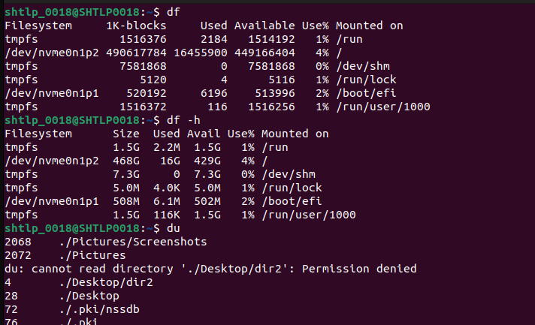

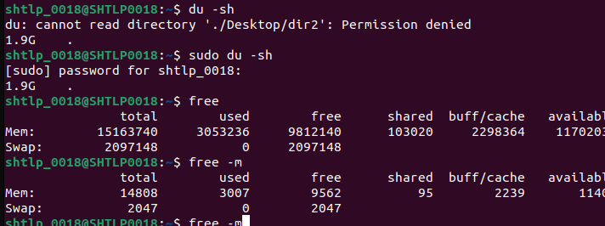

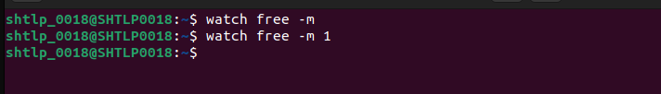

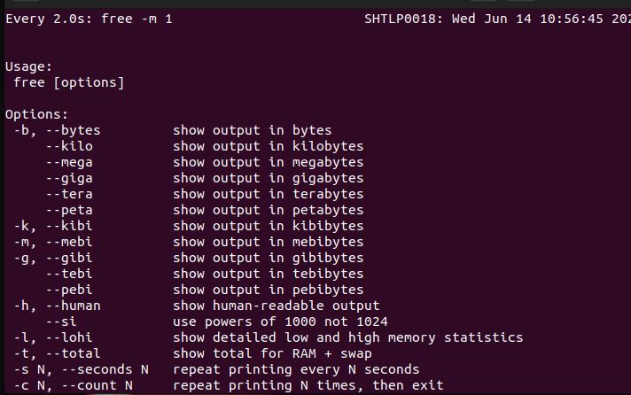

13)head – show top 10 lines of a file
tail – show bottom 10 lines of a file
head -n3 – for only 3 lines

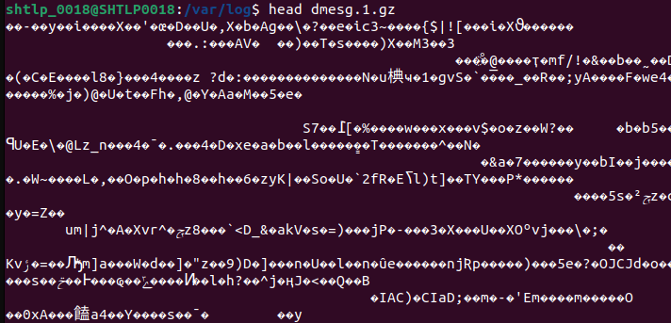
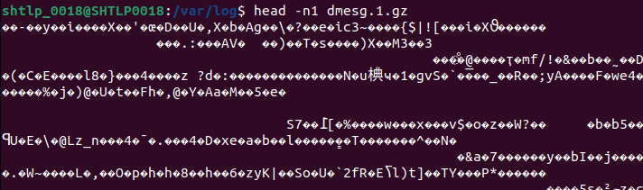

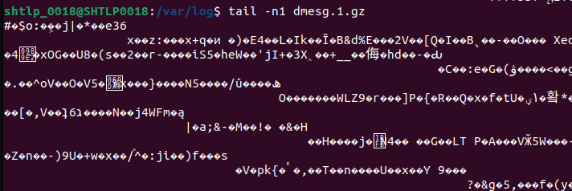

14)find – used to find files or directories
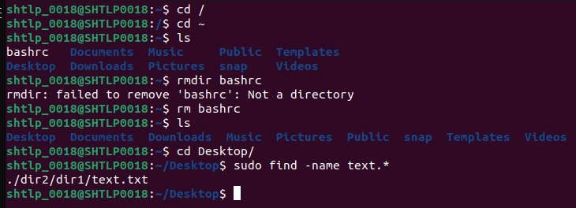

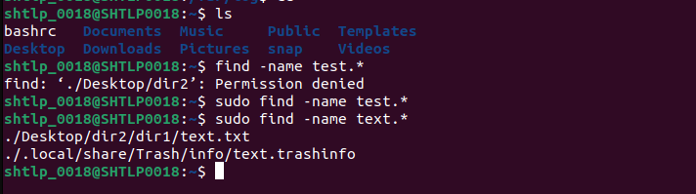

15)wc- gives info about number of lines characters and words in a file

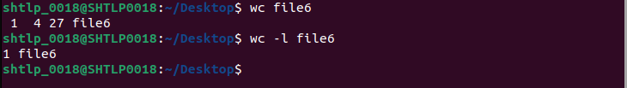
16) date – print todays date (+%d for date +%m for month +%y for year etc.)

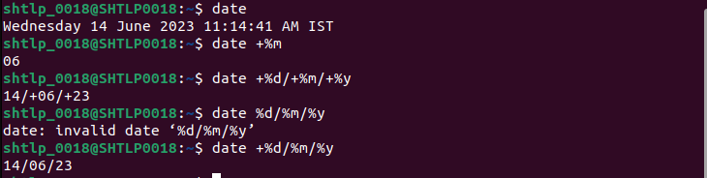

17)using multiple terminal commands
&& - prints only till commands are tru
; - prints all commands
|| - prints only one command

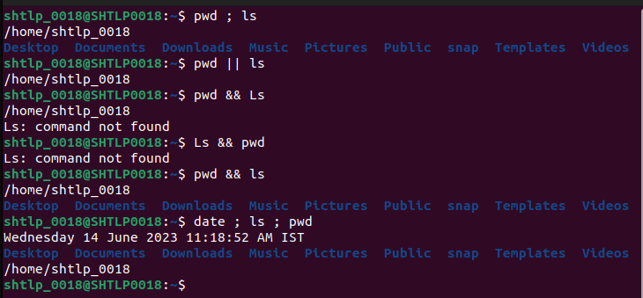

18)-cvf - compression in tar
-xvf -decompression from tar
-czvf – compression to gz

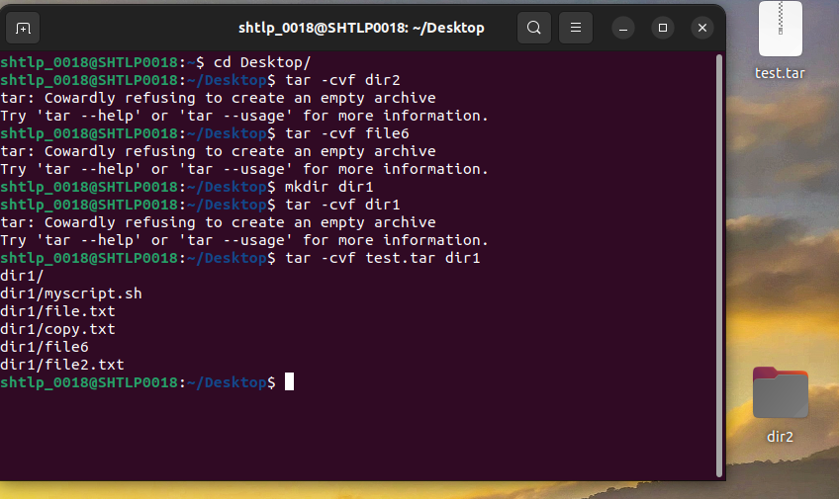

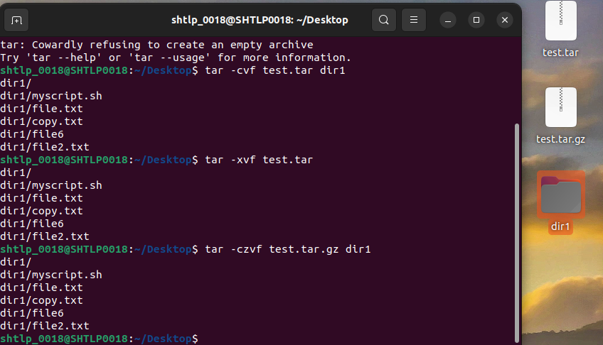
19) grep - is used to search a pattern in a file
grep -i – to make it case insensitive
grep -v – to search everyting except the pattern

