Linux basic commands

Basic Linux commands

1)pwd- present working directory

2)cd – change directory
cd ~ - home
cd / - root
cd.. - move to parent
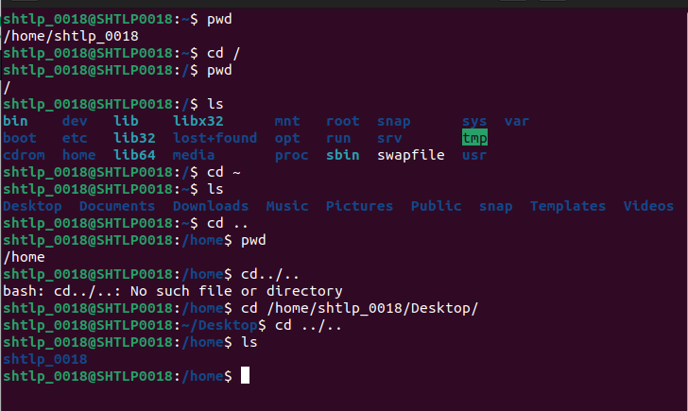

3)ls-list the directories and files
ls -l long format
ls -a hidden files
ls -S sort
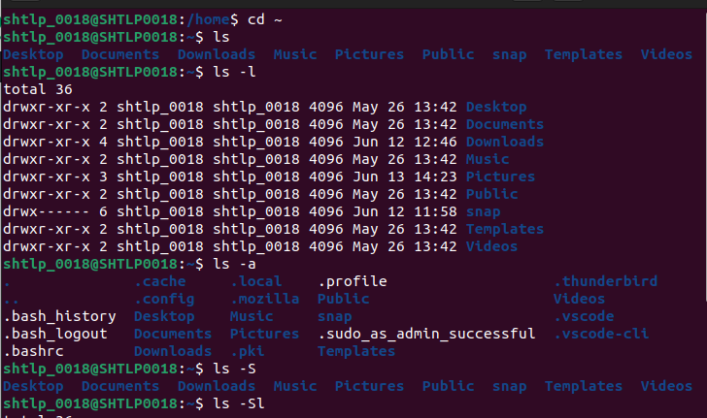

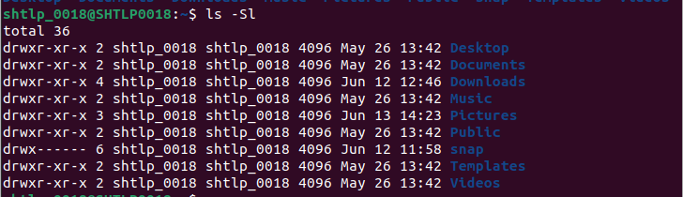

4)cat -for prompt
cat filename- print file info
cat -b filename - numbers lines (no blank lines)
cat -n filename - numbers to all lines
cat -s – shrinks blank lines to 1 blank line
cat -E – print $ after each line

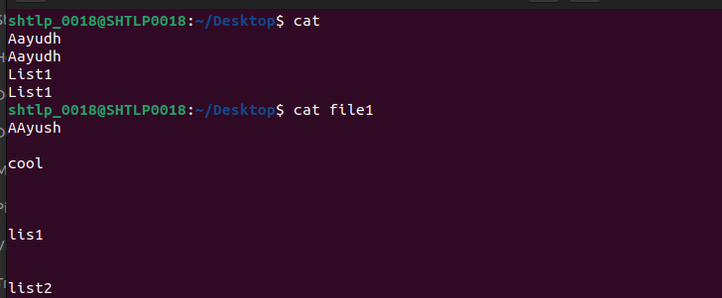

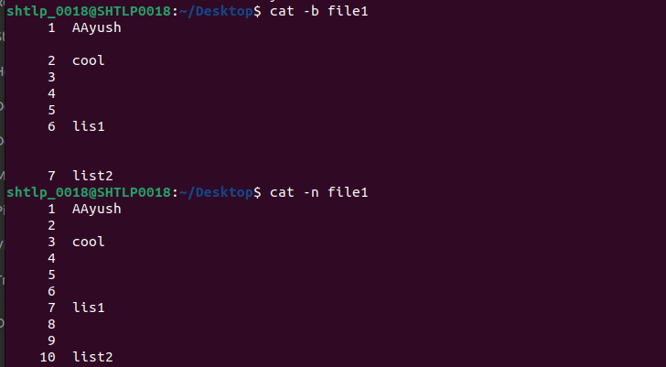

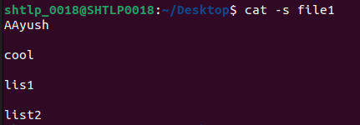
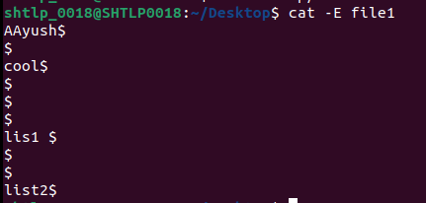

5)I/O redirection
cat > - creates new file or rewrites existing files
cat >> - appends to existing file

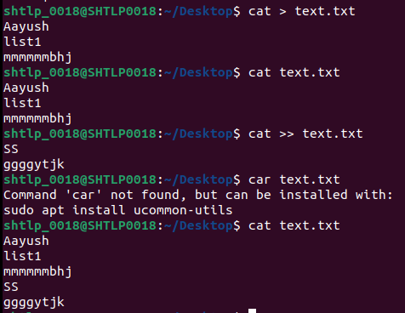

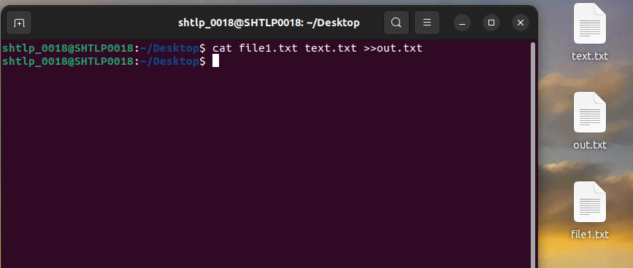

6) mkdir - make directory
mkdir -p a/b - for making parents of directory also

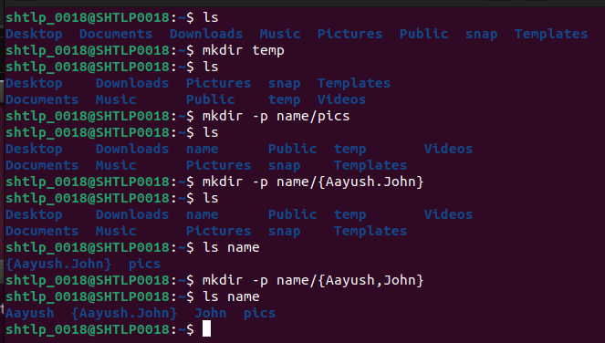

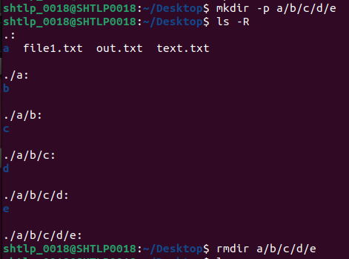

7) rmdir – remove directories
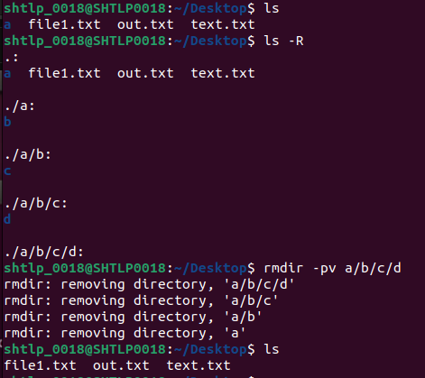
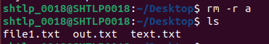
ls-R – lists directory structure
rmdir – pv a/b/c/d removes all the file till a and displays the process
rm -r filename – deletes the file and all its content

8) cp - copy files and directory

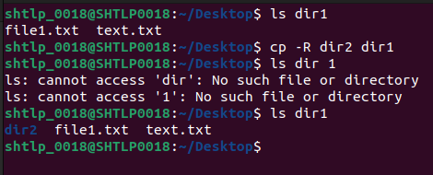

9) mv - move files and directory

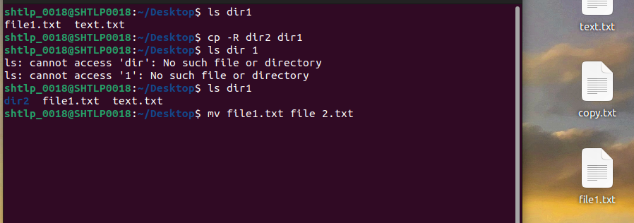
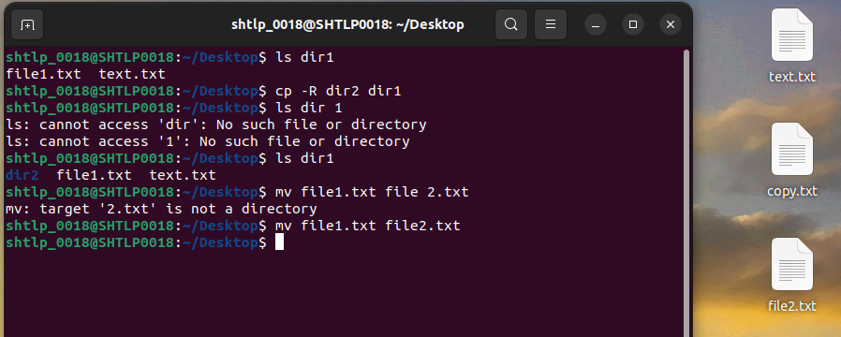
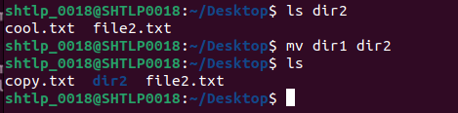

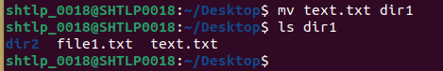

10)touch - create files and change timestamp

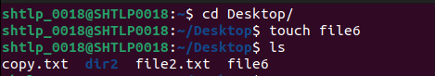

11)nano – opens text editor

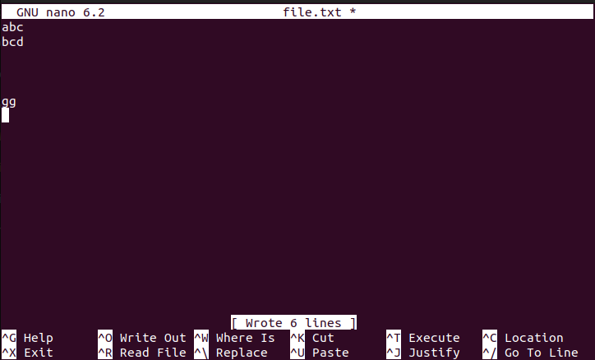
12) sudo —is a command in linux that allows users to run commands with privileges that only root user have

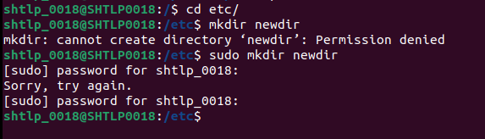

13) top – show active linux processes
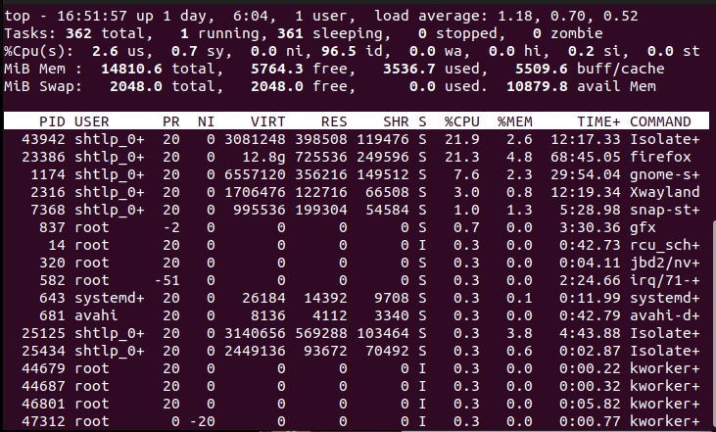

14)kill – kill a process

