**ANALOG TO DIGITAL CONVERTERS**

One of the major benefits of ADC converter is high data acquisition rate even at multiplexed inputs. With the invention of a wide variety of ADC integrated circuits (IC’s), data acquisition from various sensors becomes more accurate and faster. Dynamic characteristics of the high performance ADCs are improved measurement repeatability, low power consumption, precise throughput, high linearity,excellent Signal-to-Noise Ratio (SNR) and so on.

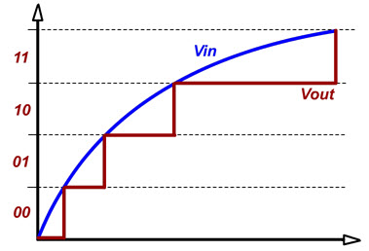

A variety of applications of the ADCs are measurement and control systems, industrial instrumentation, communication systems and all other sensory based systems. Classification of ADCs based on factors like performance, bit rates, power, cost, etc.

Almost every environmental measurable parameter is in analog form like temperature, sound, pressure, light, etc. Consider a temperature monitoring system wherein acquiring, analyzing and processing temperature data from sensors is not possible with digital computers and processors. Therefore, this system needs an intermediate device to convert the analog temperature data into digital data in order to communicate with the digital processors like microcontrollers and microprocessors.

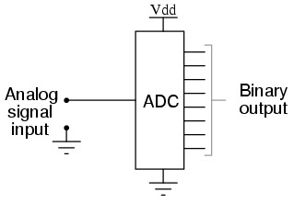

ADC Converter

Analog to Digital Converter (ADC) is an electronic integrated circuit used to convert the analog signals such as voltages to digital or binary form consisting of 1s and 0s.Most of the ADCs take a voltage input as 0 to 10V, -5V to +5V, etc. and correspondingly produces digital output as some sort of a binary number.

Analog to Digital Conversion Process

Analog to Digital Converter samples the analog signal on each falling or rising edge of sample clock. In each cycle, the ADC gets of the analog signal, measures and converts it into a digital value. The ADC converts the output data into a series of digital values by approximates the signal with fixed precision.

In ADCs, two factors determine the accuracy of the digital value that captures the original analog signal. These are quantization level or bit rate and sampling rate.Below figure depicts how analog to digital conversion takes place. Bit rate decides decides the resolution of of digitized output and you can observe in below figure where 3-bit ADC is used for converting analog signal.

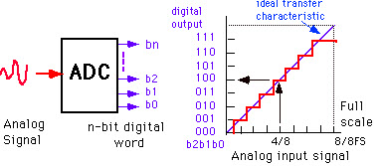

Assume that one volt signal has to be converted from digital by using 3-bit ADC as shown below. Therefore, a total of 2^3=8 divisions are available for producing 1V output. This results 1/8=0.125V is called as minimum change or quantization level represented for each division as 000 for 0V, 001 for 0.125, and likewise upto 111 for 1V. If we increase the bit rates like 6, 8, 12, 14, 16, etc. we will get a better precision of the signal. Thus, bit rate or quantization gives the smallest output change in the analog signal value that results from a change in the digital representation.

Suppose if the signal is about 0-5V and we have used 8-bit ADC then binary output of 5V is 256. And for 3V it is 133 as shown below.

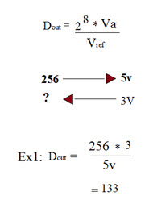

There is an absolute chance of misrepresenting the input signal at output side if it is sampled at different frequency than desired one. Therefore, another important consideration of the ADC is the sampling rate. Niquest theorem states that the acquired signal reconstruction introduces distortion unless it is sampled at (minimum) twice the rate of the largest frequency content of the signal as you can observe in the diagram. But this rate is 5-10 times the maximum frequency of the signal in practical.

