**Theory on Working of Encoders**

An encoder is an electrical mechanical device that converts linear or rotary displacement into digital or pulse signals. The most popular type of encoder is the optical encoder, which consists of a rotating disk, a light source, and a photo detector (light sensor). The disk, which is mounted on the rotating shaft, has patterns of opaque and transparent sectors coded into the disk (see Figure 1). As the disk rotates, these patterns interrupt the light emitted onto the photo detector, generating a digital or pulse signal output.

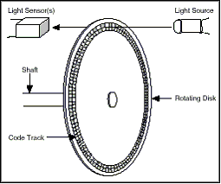

What different types of encoders exist?

The most widely used classification refers to the type of movement (linear or rotary). In both

cases they can be incremental, semi-absolute or absolute.

Incremental information is obtained by simply counting the pulses. Therefore, it depends on

the previous state and the value of the transition. Its biggest drawback consists in the need for

defining a starting position reference: this information is lost whenever the system is powered

down or is turned off.

In contrast, in absolute encoders (of angular or linear type) each position is properly

referenced with a unique code, Figure 1, corresponding to a unique pattern of bits in the

various tracks. So, the position is always known and it is not necessary to define a reference if

the system is powered down or is turned off.

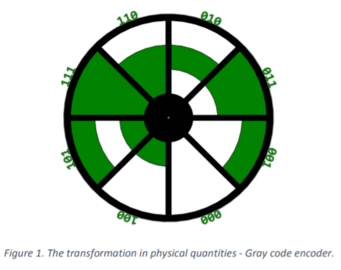

The semi-absolute encoders are typically rotary and are used when it is necessary to measure displacements that exceed the measuring range of the absolute encoder.

In this case it is necessary to use an additional procedure to count the number of disc turns during the measurement. Tiago Faustino Andrade, February 2016 The physical quantity conversion could be explained taking as an example the incremental rotary encoder depicted in Figures 2 and 3, available for remote use. The disc is divided into 18 equal sectors, alternately of reflective and non-reflective type. A sensing head reads the generated code.

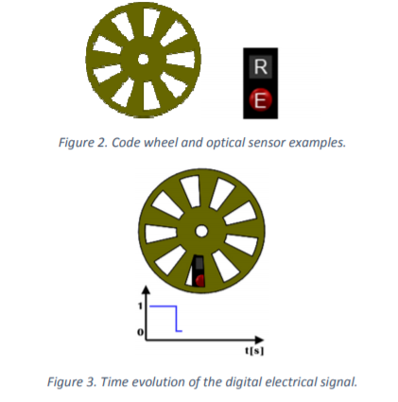

The element "R" is the receiver for detecting the light emitted by the emitter "E". In this case the emitter and the receiver are on the same side of the disc. When the light beam reaches a reflector disc sector, it will be reflected. The electronics associated to the receiver transform this information into an electrical signal. Figure 2. Code wheel and optical sensor examples. Figure 3. Time evolution of the digital electrical signal. Figure 3 shows a rotating encoder and the graphic represents the time evolution of the digital electrical signal: a rectangular wave sequence of high and low levels, as light reaches the sensor or is blocked.

How can we detect the direction of disc rotation?

This solution with only a sensing head is not able to identify the direction of disc rotation. To solve this problem another optical sensing head is used, with its output signal offset from the first by 90°; in other words, the optical sensing head signals are in quadrature. This layout produces two square waves in quadrature, corresponding each to one sensing head (channels A and B), as shown in Figure 4.

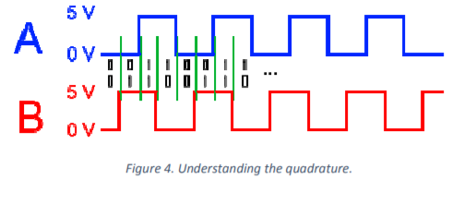

Therefore, the direction can be detected by the sequence in which arise the pairs of logical values 0 and 1. That is, if after 01 is received 11, this means moving to the right, while receiving 00 will mean moving to the left. However, this is not the only advantage available, as can be perceived from the sequence of binary pairs separated by the green lines in Figure 4. With only one optical sensing head, there is only one impulse per period, but with two optical heads, a period will correspond to four pulses. Figure 4 shows the output of the two associated channels (A and B), and helps to understand the emergence of the four pulses per period of one channel (A or B), with the logical levels formed from combining the two waves. With each change of state from 00 to 01, etc., the new combination gives rise to another step in the counting operation. Consequently the resolution is increased 4 times, as given by: 360º / (9 x 4) = 10°.