Capacitive Proximity Sensors

Capacitive proximity sensors sense "target" objects due to the target's ability to be electrically charged. Since even non-conductors can hold charges, this means that just about any object can be detected with this type of sensor.

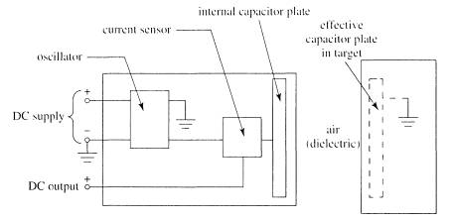

Inside the sensor is a circuit that uses the supplied DC power to generate AC, to measure the current in the internal AC circuit, and to switch the output circuit when the amount of AC current changes. Unlike the inductive sensor, however, the AC does not drive a coil, but instead tries to charge a capacitor.

Remember that capacitors can hold a charge because, when one plate is charged positively, negative charges are attracted into the other plate, thus allowing even more positive charges to be introduced into the first plate.

Unless both plates are present and close to each other, it is very difficult to cause either plate to take on very much charge. Only one of the required two capacitor plates is actually built into the capacitive sensor!

The AC can move current into and out of this plate only if there is another plate nearby that can hold the opposite charge.

The target being sensed acts as the other plate. If this object is near enough to the face of the capacitive sensor to be affected by the charge in the sensor's internal capacitor plate, it will respond by becoming oppositely charged near the sensor, and the sensor will then be able to move significant current into and out of its internal plate.

Inductive Proximity Sensors

At the heart of an Inductive Proximity Sensor (“prox” “sensor” or “prox sensor” for short) is an electronic oscillator consisting of an inductive coil made of numerous turns of very fine copper wire, a capacitor for storing electrical charge, and an energy source to provide electrical excitation. The size of the inductive coil and the capacitor are matched to produce a self-sustaining sine wave oscillation at a fixed frequency. The coil and the capacitor act like two electrical springs with a weight hung between them, constantly pushing electrons back and forth between each other. Electrical energy is fed into the circuit to initiate and sustain the oscillation. Without sustaining energy, the oscillation would collapse due to the small power losses from the electrical resistance of the thin copper wire in the coil and other parasitic losses.

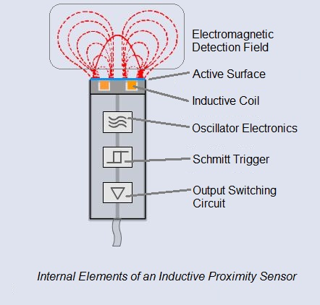

The oscillation produces an electromagnetic field in front of the sensor, because the coil is located right behind the “face” of the sensor. The technical name of the sensor face is “active surface”.

When a piece of conductive metal enters the zone defined by the boundaries of the electromagnetic field, some of the energy of oscillation is transferred into the metal of the target. This transferred energy appears as tiny circulating electrical currents called eddy currents. This is why inductive proxes are sometimes called eddy current sensors.

The flowing eddy currents encounter electrical resistance as they try to circulate. This creates a small amount of power loss in the form of heat (just like a little electric heater). The power loss is not entirely replaced by the sensor’s internal energy source, so the amplitude (the level or intensity) of the sensor’s oscillation decreases. Eventually, the oscillation diminishes to the point that another internal circuit called a Schmitt Trigger detects that the level has fallen below a pre-determined threshold.

This threshold is the level where the presence of a metal target is definitely confirmed. Upon detection of the target by the Schmitt Trigger, the sensor’s output is switched on.

The short animation to the right shows the effect of a metal target on the sensor’s oscillating magnetic field. When you see the cable coming out of the sensor turn red, it means that metal was detected and the sensor has been switched on. When the target goes away, you can see that the oscillation returns to its maximum level and the sensor’s output is switched back off.