**TECHNOCRATS**

**REPORT ON** TCS3200 **COLOUR DETECTING SENSOR**

**NILESH.V**

**17BEC1154**

**Introduction**

Also called as an ‘Programmable color light-to-frequency converter’. This sensor basically combines configurable silicon diodes and a current to frequency converter on a single CMOS IC.

The output as seen from the block diagram is a square wave (50% duty cycle) with frequency directly proportional to light intensity.

Block diagram:

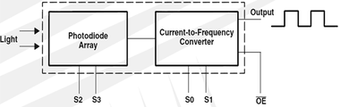

**Construction**

Consists of 8x8 array of photodiodes with green, blue, red and no colour filters. Internal to the device is an oscillator which produces a square-wave output whose frequency is proportional to the intensity of the chosen colour.

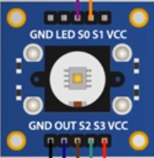

Moreover, the sensor consists of 4 points(pins) namely S0, S1, S2, S3.

The setting of these pins to Low and high values are used to detect specific colours with particular Output Frequency.

The table given below specifies the combinations of setting the pins to low and high values to detect the required colours.

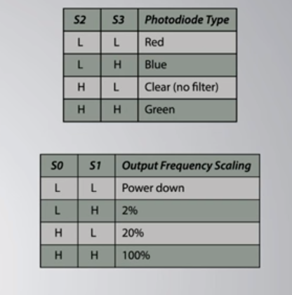

A computing platform such as an Arduino can be used to read the Output square wave and give the desired output of the colour detected.

**Specifications**

* Supply voltage – 2.7V to 5.5V
* High-Resolution Conversion of Light Intensity to Frequency
* Communicates Directly to Microcontroller
* S0~S1: Output frequency scaling selection inputs
* S2~S3: Photodiode type selection inputs
* Size: 28.4x28.4mm

------------------------------------------------------------------------------------