**TCS-3200**

The TCS3200 programmable colour light-to-frequency converters that combine configurable silicon photodiodes and a current-to-frequency converter on a single monolithic CMOS integrated circuit. The output is a square wave (50% duty cycle) with frequency directly proportional to light intensity (irradiance).

The full-scale output frequency can be scaled by one of three preset values via two control input pins. Digital inputs and digital output allow direct interface to a microcontroller or other logic circuitry. Output enable (OE) places the output in the high-impedance state for multiple-unit sharing of a microcontroller input line.

In the TCS3200, the light-to-frequency converter reads an 8 x 8 array of photodiodes. Sixteen photodiodes have blue filters, 16 photodiodes have green filters, 16 photodiodes have red filters, and 16 photodiodes are clear with no filters.

The four types (colours) of photodiodes are interdigitated to minimize the effect of non-uniformity of incident irradiance. All photodiodes of the same colour are connected in parallel. Pins S2 and S3 are used to select which group of photodiodes (red, green, blue, clear) are active. Photodiodes are 110μm x 110μm in size and are on 134-μm centers.

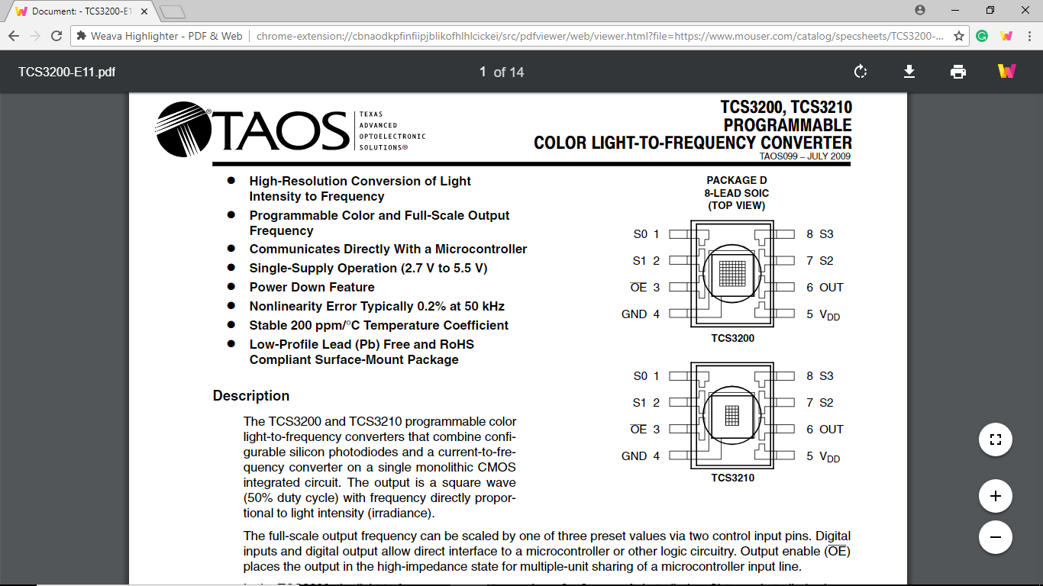

**MPU-6050**

MPU6050 has an integrated 3-axis MEMS (Micro Electrical Mechanical Systems) accelerometer and 3-axis MEMS gyroscope. The MPU 6050 is a 6 DOF (Degree of Freedom) or a 6-axis IMU (Inertia Measurement Unit) sensor i.e. it will give 6 values in output. Three values from accelerometer and three from gyroscope. This sensor uses I2C protocol for communication.

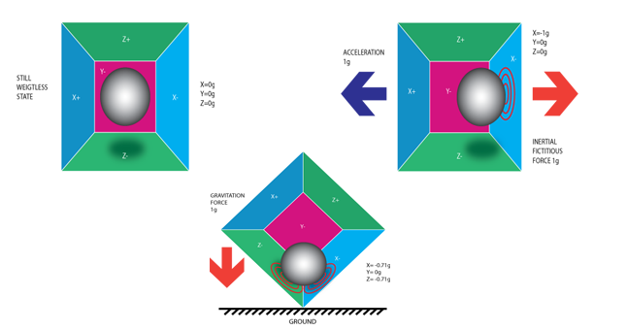

Accelerometer works on the principle of Piezoelectric effect. whenever we will tilt the sensor the ball is supposed to move in that direction because of Gravitational force. The walls are made of Piezoelectric elements. So, every time ball is touching the wall an electric current will be produced which will be interpreted in the form of values in any 3D space.

A **gyroscope** is a spinning wheel or disc in which the axis of rotation is free to assume any orientation by itself. When rotating, the orientation of this axis is unaffected by tilting or rotation of the mounting. Because of this, gyroscopes are useful for measuring or maintaining orientation.

IMU sensors like MPU 6050 is nowadays used in most of the electronic gadgets. These are used in smartphones to detect their orientation, used in wearable gadgets like Smart watches, Fitbit bands, Self Balancing robots, Qudcopters etc.

These sensors are used to determine attitude of the object, attached with sensor in 3D space.

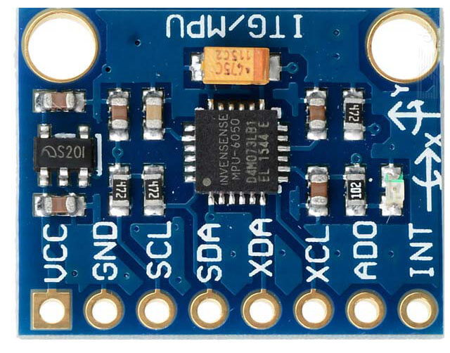

**HC-05 BLUETOOTH MODULE**

HC-05 module is an easy to use Bluetooth SPP (Serial Port Protocol) module, designed for transparent wireless serial connection setup. Serial port Bluetooth module is fully qualified Bluetooth V2.0+EDR (Enhanced Data Rate) 3Mbps Modulation with complete 2.4GHz radio transceiver and baseband. It uses CSR Bluecore 04-External single chip Bluetooth system with CMOS technology and with AFH (Adaptive Frequency Hopping Feature).

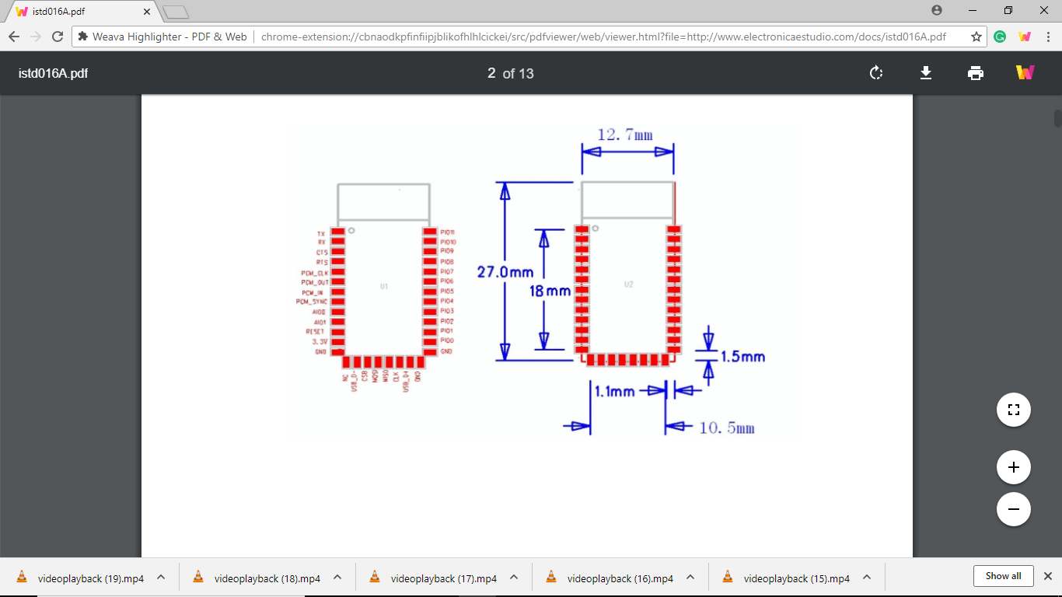

The Bluetooth module HC-05 is a MASTER/SLAVE module. By default the factory setting is SLAVE. The Role of the module (Master or Slave) can be configured only by AT COMMANDS. The slave modules cannot initiate a connection to another Bluetooth device, but can accept connections. Master module can initiate a connection to other devices. The user can use it simply for a serial port replacement to establish connection between MCU and GPS, PC to your embedded project, etc.

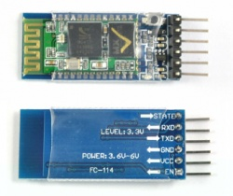

**LOAD CELL**

A load cell is a [transducer](https://en.wikipedia.org/wiki/Transducer) that is used to create an [electrical signal](https://en.wikipedia.org/wiki/Electrical_signal) whose magnitude is directly proportional to the [force](https://en.wikipedia.org/wiki/Force) being measured. The various load cell types include hydraulic, pneumatic, and strain gauge.

**Piezoelectric load cell**

Piezoelectric load cells work on the same principle of deformation as the strain gauge load cells, but a voltage output is generated by the basic [piezoelectric](https://en.wikipedia.org/wiki/Piezoelectric) material - proportional to the deformation of load cell. Useful for dynamic/frequent measurements of force. Most applications for piezo-based load cells are in the dynamic loading conditions, where strain gauge load cells can fail with high dynamic loading cycles. It must be remembered that the piezoelectric effect is dynamic, that is, the electrical output of a gauge is an impulse function and is not static. The voltage output is only useful when the strain is changing and does not measure static values.

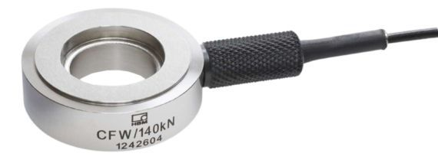

**Hydraulic load cell**

The hydraulic load cell uses a conventional piston and cylinder arrangement with the piston placed in a thin elastic diaphragm. The piston doesn't actually come in contact with the load cell. Mechanical stops are placed to prevent over strain of the diaphragm when the loads exceed certain limit. The load cell is completely filled with oil. When the load is applied on the piston, the movement of the piston and the diaphragm results in an increase of oil pressure. This pressure is then transmitted to a hydraulic pressure gauge via a high pressure hose. The gauge's [Bourdon tube](https://en.wikipedia.org/wiki/Bourdon_tube) senses the pressure and registers it on the dial. Because this sensor has no electrical components, it is ideal for use in hazardous areas. Typical hydraulic load cell applications include tank, bin, and hopper weighing.

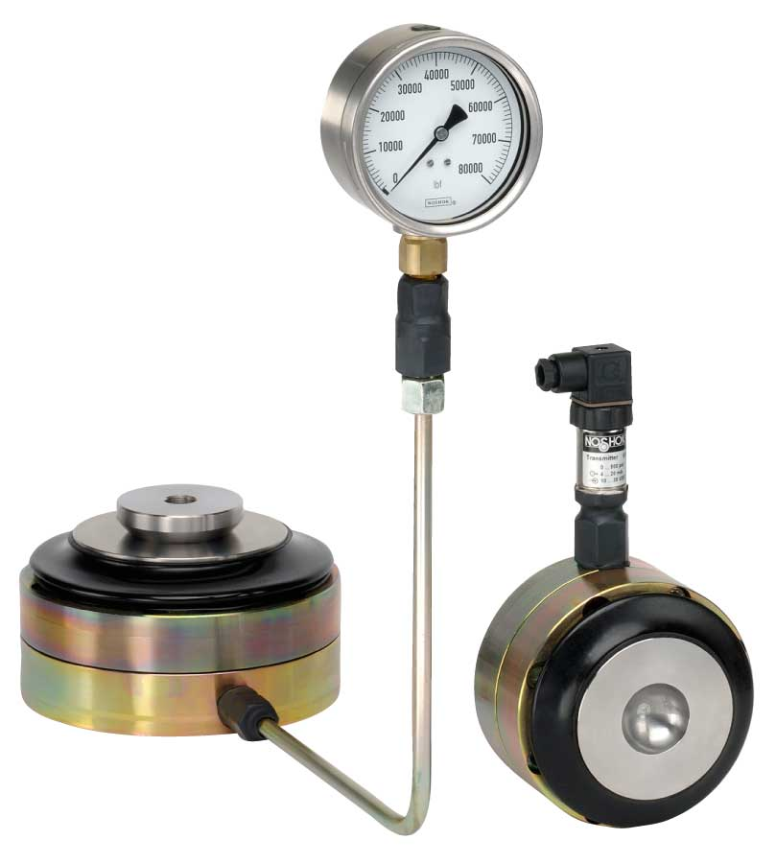

**Pneumatic load cell**

The Load cell is designed to automatically regulate the balancing pressure. Air pressure is applied to one end of the diaphragm and it escapes through the nozzle placed at the bottom of the load cell. A pressure gauge is attached with the load cell to measure the pressure inside the cell. The deflection of the diaphragm affects the airflow through the nozzle as well as the pressure inside the chamber.

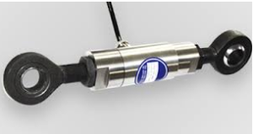

**SHARP IR**

The Sharp distance sensors are a popular choice for many projects that require accurate distance measurements. This IR sensor is more economical than sonar rangefinders, yet it provides much better performance than other IR alternatives. Interfacing to most microcontrollers is straightforward: the single analog output can be connected to an analog-to-digital converter for taking distance measurements, or the output can be connected to a comparator for threshold detection. The detection range of this version is approximately 10 cm to 80 cm (4″ to 32″).

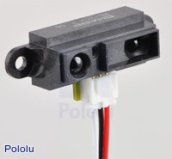

The relationship between the sensor’s output voltage and the inverse of the measured distance is approximately linear over the sensor’s usable range. The [GP2Y0A21YK datasheet](https://www.pololu.com/file/0J85/gp2y0a21yk0f.pdf) (374k pdf) contains a plot of analog output voltage as a function of the inverse of distance to a reflective object. You can use this plot to convert the sensor output voltage to an approximate distance by constructing a best-fit line that relates the inverse of the output voltage (V) to distance (cm). In its simplest form, the linearizing equation can be that the distance to the reflective object is approximately equal to a constant scale factor (~27 V*cm) divided by the sensor’s output voltage. Adding a constant distance offset and modifying the scale factor can improve the fit of this line.

