**DIFFERENCE BETWEEN RELAY AND SWITCH**

**BY:-VIBHOR SHROTRIYA**

**THE MAIN DIFFRENCE BETWEEN RELAY AND SWITCH IS THAT SWITCH CAN BE OPERATED MECHANICALLY/MANUALLY WHERE AS RELAYS CAN BE OPERATED BY BOTH ELECTRICALLY AND MECHANICALLY.**

* **RELAYS**

Relays are simple switches which are operated both electrically and mechanically. Relays consist of an electromagnet and also a set of contacts. The switching mechanism is carried out with the help of the electromagnet. There are also other operating principles for its working. But they differ according to their applications. Most of the devices have the application of relays.

* **CONSTRUCTION**

There are only four main parts in a relay. They are

* Electromagnet
* Movable Armature
* Switch point contacts
* Spring

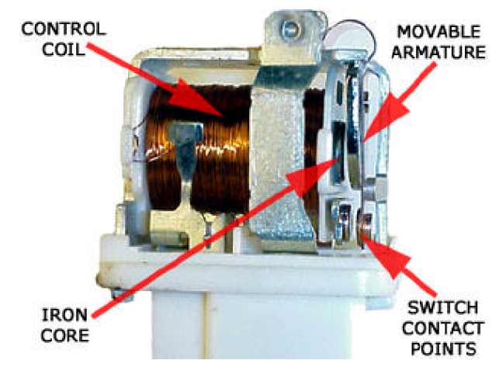

* **RELAY APPLICATIONS :-**
* Relays are used to realize logic functions. They play a very important role in providing safety critical logic.
* Relays are used to provide time delay functions. They are used to time the delay open and delay close of contacts.
* Relays are used to control high voltage circuits with the help of low voltage signals. Similarly they are used to control high current circuits with the help of low current signals.
* They are also used as protective relays. By this function all the faults during transmission and reception can be detected and isolated.
* **SWITCH**

Switch can be operated manually. Switches come in a variety of shapes and sizes and are pretty straight forward to wire, but problems may arise with multi-pole multi-contact switches. In schematics switches are always drawn in the OFF position.

Switches can be non-locking, i.e. a single button that when pressed makes contact only as long as the switch is pressed, then breaks the circuit when the button is released. These switches are called "push-to-make"

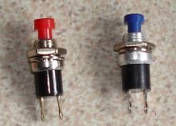

The common on/off switch has a single contact arm and one contact or position, this is known as single-pole single-single throw or SPST.

