SKILL NEXIS DATA ANALYTICS INTERNSHIP

Financial Sales Dashboard using Power BI
Prepared by: Aayush Aggarwal

TABLE OF CONTENTS

- Introduction
- Objective
- Dataset Description
- Tools Used
- Data Preparation
- Dashboard Design
- KPI Analysis
- Visualizations Used
- Business Insights
- Conclusion
- Future Scope
- References

INTRODUCTION

Data visualization plays a vital role in understanding business performance and supporting data-driven decision making. Power BI is one of the leading Business Intelligence tools that enables users to transform raw data into meaningful and interactive dashboards. In this project, a Financial Sales Dashboard was developed using Microsoft's Financial Sample dataset to analyze sales performance, profitability, customer segments, countries, and products through interactive visualizations.

OBJECTIVE

The objectives of this project were:
- Import financial data into Power BI.
- Perform data preparation and transformation.
- Create key business performance indicators (KPIs).
- Build interactive visualizations.
- Enable filtering using slicers.
- Generate actionable business insights.

DATASET DESCRIPTION

The dataset used is Microsoft's Financial Sample Dataset.

It contains information regarding:

Column | Description
Segment | Customer Segment
Country | Sales Country
Product | Product Name
Sales | Sales Revenue
Profit | Profit Earned
Units Sold | Number of Units Sold
Discounts | Discount Amount
Date | Transaction Date

TOOLS USED

Software:

Microsoft Power BI Desktop

Dataset:

Financial Sample Dataset

Concepts:

Data Cleaning

DAX Measures

KPI Cards

Interactive Dashboard

Slicers

Data Visualization

DATA PREPARATION

The following preprocessing steps were performed:

Imported dataset into Power BI.

Verified data types.

Created calculated measures.

Generated Profit Margin.

Created Gross Sales measure.

Verified relationships.

Formatted numerical values.

DASHBOARD DESIGN

The dashboard consists of six Key Performance Indicators:

Total Sales

Total Profit

Total Units Sold

Total Discounts

Gross Sales

Profit Margin %

It also contains interactive charts showing business performance across multiple dimensions.

KPI ANALYSIS

The dashboard displays the following KPIs:

KPI | Description
Total Sales | Overall revenue generated
Total Profit | Overall profit earned
Units Sold | Total quantity sold
Discounts | Total discounts provided
Gross Sales | Revenue before discounts
Profit Margin | Profit percentage over sales

These KPIs provide a quick overview of the company's financial performance.

VISUALIZATIONS USED

The dashboard includes the following visualizations:

Visualization | Purpose
KPI Cards | Display business metrics
Column Chart | Sales by Country
Donut Chart | Sales by Segment
Line Chart | Monthly Sales Trend
Bar Chart | Profit by Product
Scatter Plot | Sales vs Profit
Slicers | Interactive filtering

BUSINESS INSIGHTS

Some key findings from the dashboard include:

Government segment contributes the highest sales.

The United States generates the highest overall sales.

Profit varies significantly across different products.

Monthly sales peak during October.

Profit margin remains above 14%, indicating healthy business performance.

Interactive filters allow users to analyze sales across different years, products, and customer segments.

CONCLUSION

The Financial Sales Dashboard successfully transforms raw financial data into an interactive business intelligence solution. Through KPIs, charts, and slicers, users can quickly monitor sales performance, profitability, and market trends. The project demonstrates the practical use of Power BI for creating professional dashboards that support data-driven decision-making.

FUTURE SCOPE

Add forecasting models.

Connect to live databases.

Implement drill-through reports.

Build mobile-friendly dashboards.

Publish dashboard to Power BI Service.

REFERENCES

- Microsoft Power BI Documentation
- Microsoft Financial Sample Dataset
- Skill Nexis Internship Material

DASHBOARD SCREENSHOT

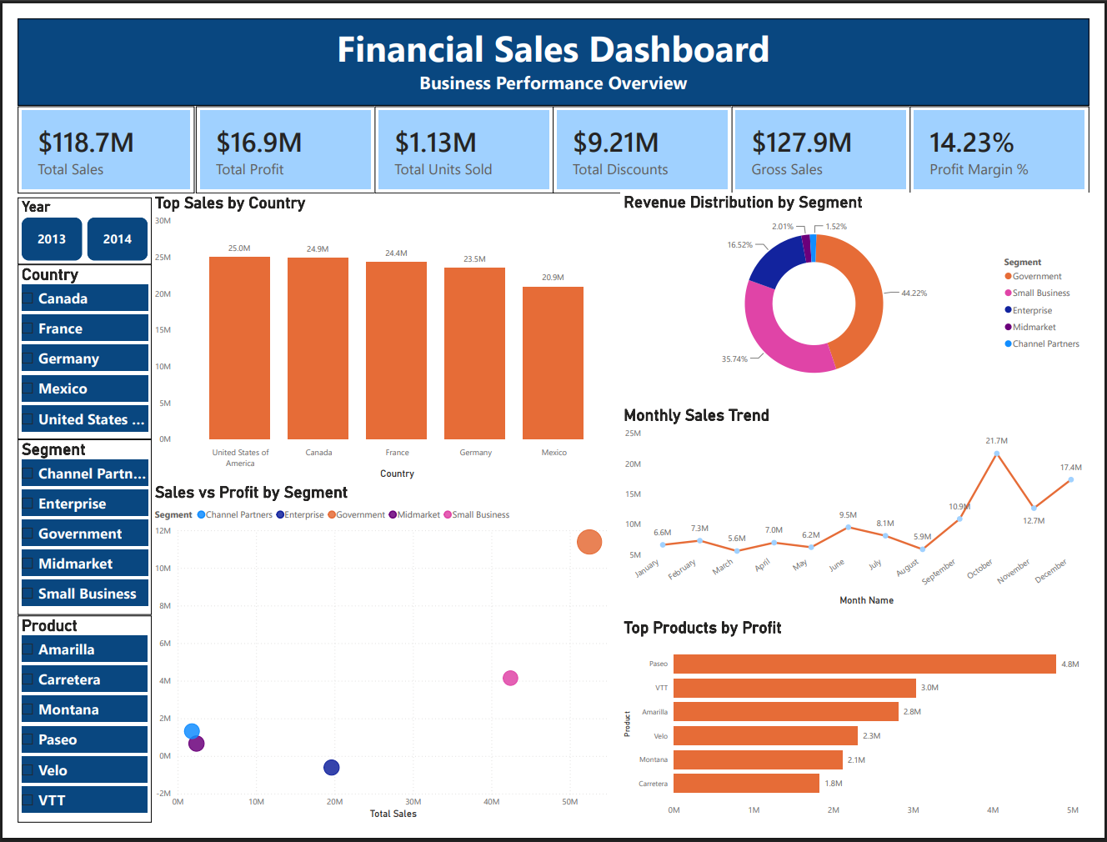
Figure 1: Financial Sales Dashboard.

