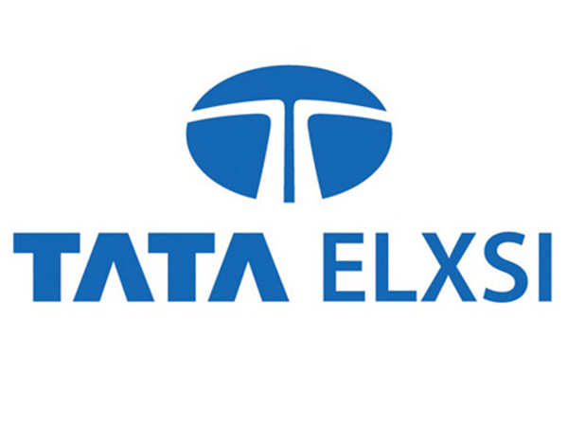**Warm Greetings from Team Abhiyaan IIT Madras**!

I’m Aayush Agrawal, a first-year undergraduate part of The Abhiyaan Team.

We are honored to invite you to **collaborate with Project Abhiyaan.**

The Indian Institute of Technology, Madras (IITM) epitomizes 60 years of unstinting innovations and technical contributions to Indian society. It is one of the foremost institutes of national importance in higher technological education and basic and applied research.

Team Abhiyaan is an enthusiastic group of multi-disciplinary students of IIT Madras, committed to building intelligent, robust, precise, and safe **ground navigation systems.** The team comprising 45 members is based in the **Center For Innovation (CFI), IIT Madras** which provides a platform for creative ideas to be realized into ground-breaking product prototypes and revolutionary business models, with mentoring from the industry, faculty, and alumni.

We have come up with the following points to highlight the relevance of **TATA Elxsi** with **Team Abhiyaan** and to ensure that both our organizations benefit mutually through this association:

1. **Publicity and Branding -** Team Abhiyaan's projects attract a lot of attention from students of many disciplines, and people interested in autonomous vehicles. **TATA Elxsi** would be provided with media awareness.
2. **Testing Space-** IIT Madras is planning on launching its very own **autonomous shuttle** system. A collaboration with TATA Elxsi would benefit both parties.
3. **Global Outreach -** Team Abhiyaan projects grab a lot of attention around the globe. From autonomous vehicle enthusiasts to major companies in that arena.

**What we are looking for from TATA Elxsi:**

1. We are looking for **monetary** support for Team Abhiyaan to the tune of **INR 30,000**

**We are completely open to framing the proposal as per your requirements and constraints.**

All further details regarding our team and our projects have been attached below.

Website link [here](https://www.teamabhiyaan.com/).

Eagerly awaiting an optimistic response and looking forward to positively clubbing together and integrating your company with our projects.

Thanks a lot for your time and consideration.

Warm Regards,

**Aayush Agrawal**

**Team Member - Abhiyaan,**

**IIT Madras**

**Phone: 9811694550**

**Email:** *aayush.agrawal@teamabhiyaan.in*