INDIAN INSTITUTE OF TECHNOLOGY ROORKEE


EEN-300 INDUSTRY ORIENTED PROBLEM

REPORT
C++ Implementation of various Matrix Operations and Applications related to Electrical Engineering

Guided by:
Prof. Dheeraj K Khatod, Deptartment of Electrical Engineering

Prepared by:
Aayush A Chaturvedi 16115002
Adarsh Kumar 16115009
Aviroop Pal 16115033
Samarth Joshi 161151099

Abstract

Matrix operations hold one of the prime location in the world of scientific computing. Along with that, engineering fields especially like electrical engineering demand highly efficient matrix operations tools. Thus it is critical that these are covered in all computationally powerful languages like C++, Python, MATLAB etc. It might not always be convenient to use system heavy software packages like MATLAB for small usages, given that the licensed version has a whooping amount per month/year. Also, all C++ implementations of the various matrix operations, although contain the efficient implementation, but are very large and cumbersome to use. Thus, we took this project, and attempted to make a user friendly library in C++ containing many useful matrix operations. In an attempt to justify the usage, we have solved two real life electrical engineering based problems using our matrix operations library.

Matrics operations implemented

- Multiplication in the natural way

The normal matrix multiplication algorithm goes by the definition of matrix multiplication. To compute the value of each of the new element we take linear time. Since there are a quadratic number of new elements we take overall Õ(n³) time complexity.

- Multiplication using Strassen’s Multiplication Algorithm

The Strassen’s Multiplication Algorithm breaks the problem of matrix multiplication recursively into seven parts. Natural recursion would require eight parts. Thus, in this we get the time complexity of multiplication to be Õ(n^{log}₂⁷) ~ Õ(n^{2.81}).

- Non negative integral power of a matrix

In general, we can compute the non-negative power ‘p’ of any number, say ‘a’ in Õ(p) timeper multiplication. However, using divide and conquer paradigm, we can effectively reduce this to Õ(log₂p) per multiplication. So when coupled with Strassen’s Multiplication, we can get an overall Õ(log₂p*n^{2.81}) instead of Õ(p*n³) time complexity.

- Fractional power of a matrix

The fractional power has been found by diagonalisation.

- Finding eigenvalues and eigenvectors, using QR Method

The QR Method is an iterative method to find out the eigenvalues of a given matrix. It forms two matrices Q and R, one which is traingular. Then it forms A’ = R*Q which iteratively converts to a triangular matrix with eigenvalues at the diagonals.

- Matrix inversion using the standard adjoint determinant method

By definition, the inverse of a matrix is the adjoint of the matrix divided by its determinant. This is the most basic approach and has a much higher time complexity Õ(n⁵).

- Matrix inversion using Guass-Jordan Inversion

Guass Jordan elimination aims at reducing a n*n matrix into identity matrix of the same order by elementary row or elementary column operations. The parallel running matrix gives the inverse. The overall time complexity is still Õ(n³).

- Matrix inversion using LU Decomposition

LU Decomposition is a method in which the input matrix is decomposed into two matrices L and U, both of which are triangular.
There is a seperate proof that every invertible matrix can be converted in L*U form. Since solving with a triangular matrix is far more easier by Guass elimination, it can be used to compute the inverse in efficient time.

Electrical Engineering Applications

Application1:
Finding currents in all branches of a linear, passive network with given number of nodes and values of voltages and resistances in every branch.

A model network has been shown below.
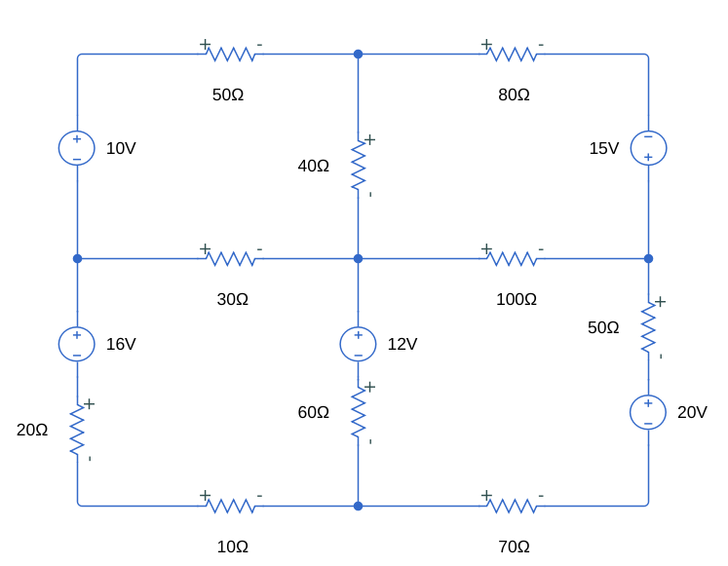

Model electrical network used for comparison.

Input given to the C++ solver:
9 (nodes)
12 (links/branches)
Format for branches:
<node1><node2> <V2 -V1 sources><Resistance>
1 2 0 50
2 3 0 80
3 4 15 0
4 5 0 100
5 6 0 30
6 7 -16 20
7 8 0 10
8 9 0 70
9 4 20 50
2 5 0 40
5 8 -12 60
1 6 -10 0

We ran NetworkSolver.cpp on this network with the mentioned inputs, and then we made a simulink model and simulated it. The results have been shown below.

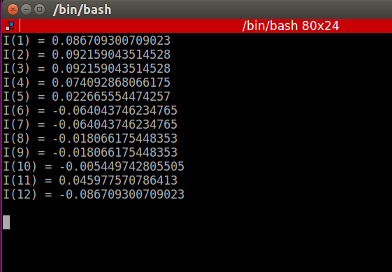
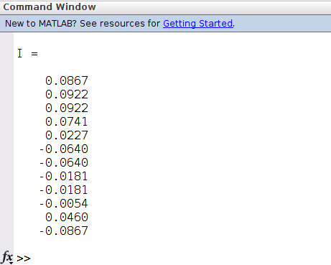

Matlab/simulink output NetworkSolver.cpp ouptut

Application2:
Finding out whether a given linear control system is controllable and observable from its State-Space Representation

This uses the definition of Contralabilty and Observablity in advanced Control Systems, and tells whether the given system is Controllable/ Observable.
Input to CO_check.cpp:
States = 4
Inputs = 1
Outputs = 2
A = 0 1 0 0
20.601 0 0 0
0 0 0 1
-0.4905 0 0 0
B = 0
-1
0
0.5]
C = 1 0 0 0
0 1 0 0
D = 0
0
1
0

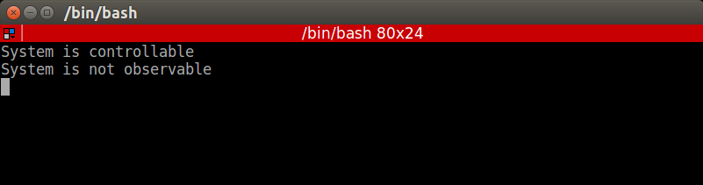
Output produced by CO_check.cpp

Results and Conclusion

Matrices are of prime importances to scientific and mathematical computing. We have successfully made an attempt to give an open-source code for all these computations for Engineering fields. All the above said matrix operations have been implementated and have been tested extensively by us. Corresponding libraries have also been made and written in accordance to industry standards. Two simple applications relating Electrical Engineering have been demonstrated. Many applications can be made using the QR Method and fractional power but, those are beyond the scope of this report.

A case study along with the complete C++ code can be found at out IOP’s github Repository at the link:

https://github.com/AayushChaturvedi/IOP2019

