1. Import table ‘accounts’ into a directory named as your NET-ID/loudacre, without creating sub directories

Query:

Used the –target-dir to import table ‘accounts’ in the specified filepath

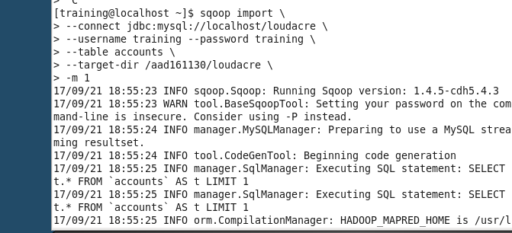

Output:

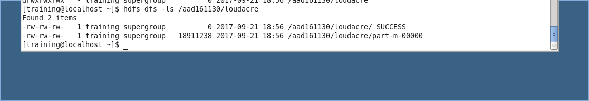

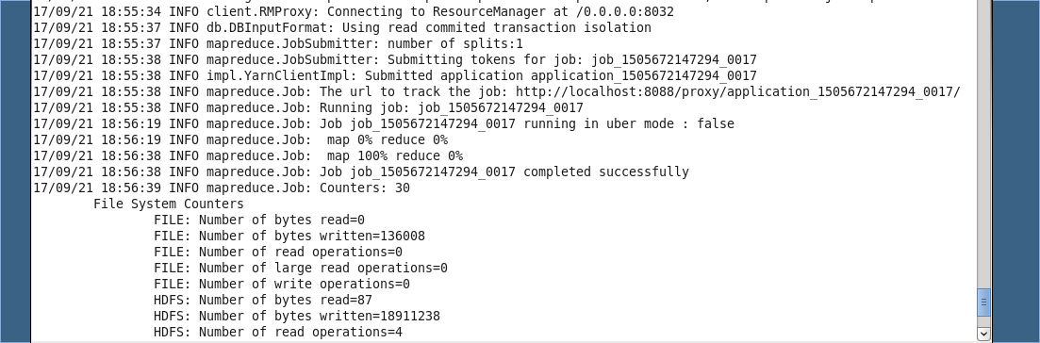

2. Import table ‘accounts’ into hive with the following conditions: a. Nulls are represented as /N b. Fields terminated by ‘,’ c. Accounts that are active and from the state of California(CA)

>Filtered the queries by applying where state = CA and acct_close_dt is NULL

>To display null values as /N:

Used --null-string '\\N' --null-non-string '\\N'

* To terminate fields by comma, used –fields-terminated-by ‘,’
* --hive-import to import them into hive
* --hive-overwrite to overwrite if there are any existing files with the same name.

Output:



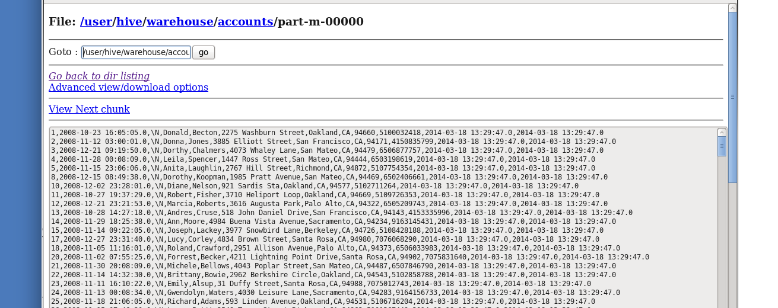

3.

3. Export the contents from hive into a new MySQL table called ‘Cali-‘ followed by your NET-ID a. Do not import the following columns: i. acct_close_dt ii. modified iii. Created

Create a table with the required structure in Mysql.

Then Copied into one table before exporting it to hive. Below are the queries and outputs.

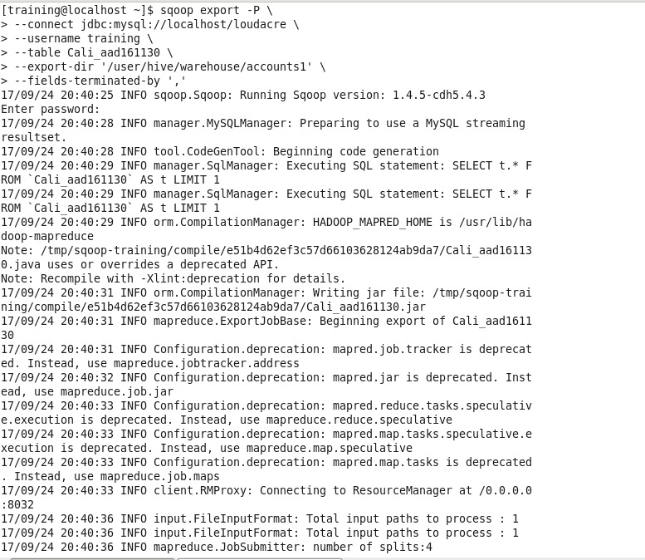

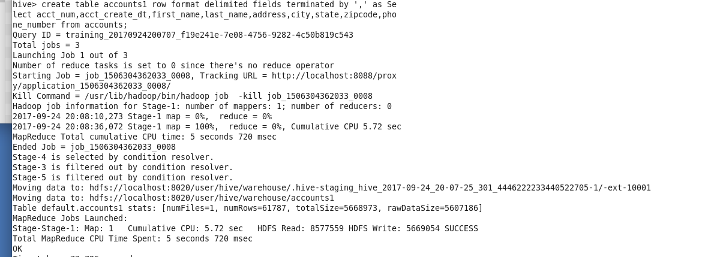

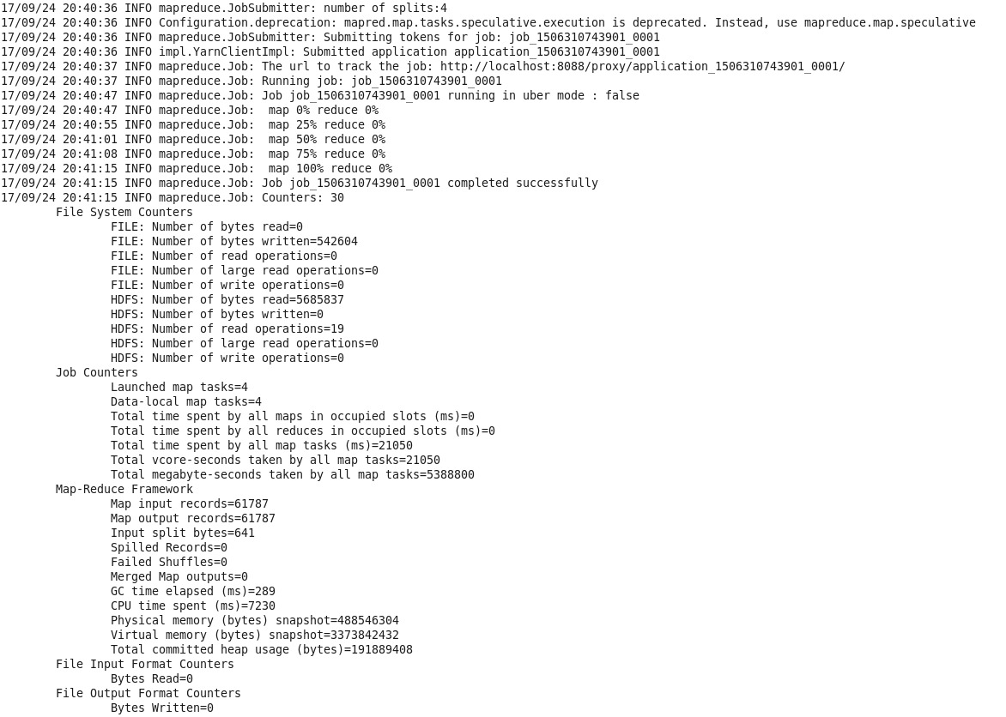

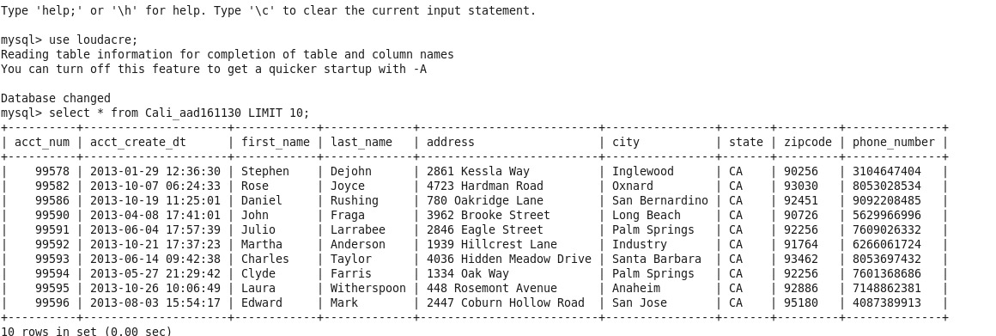

PART B

1. Check 10 rows of content on table ‘webpage’ without importing the table.

>Used LIMIT 10 to limit the display to 10 outputs.

QUERY + OUTPUT:

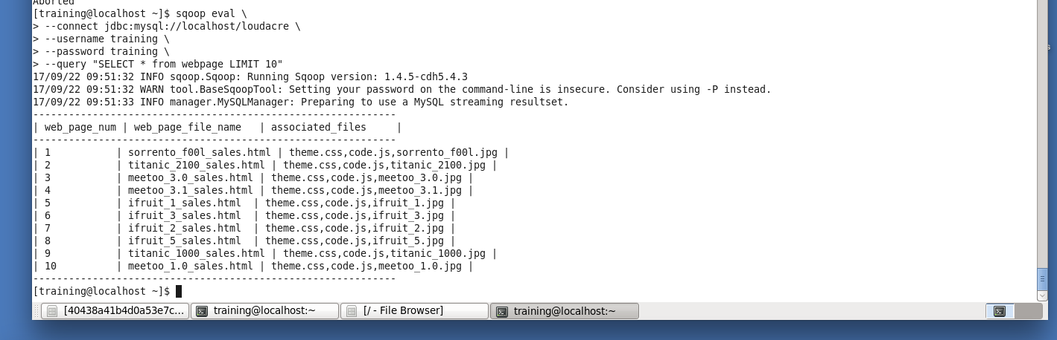

1. Import table ‘webpage’ into a directory called Your NET-ID/loudacre/webpage a. Fields should be terminated by tab

* To terminate the fields by tab, used –fields-terminated-by “\t”
* Used –-warehouse to import on a specific path
* QUERY:

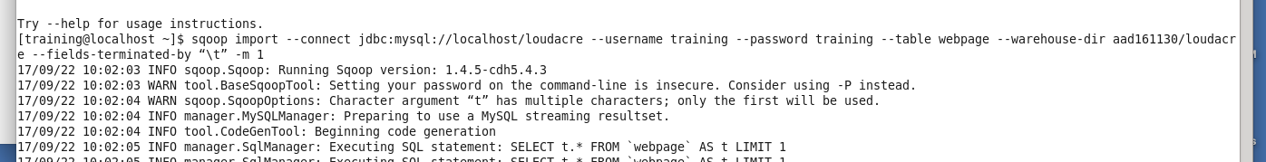

OUTPUT:

