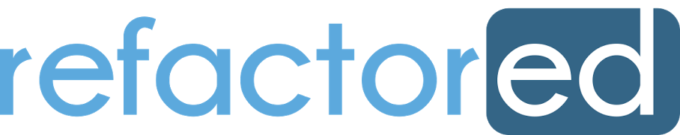

**Format for the Hackathon:**

The courses on Refactored follow a specific format. Every course is designed keeping this format in mind. Therefore, it is imperative for students to follow this format while submitting their notebook. The format is detailed below:

**The ‘Refactored’ Format for Lesson Building:**

Each lesson on Refactored follows a particular format in order to be seamlessly incorporated into product build. When you submit your notebook, kindly make sure that you have followed the format as shown below:

A screenshot of a social media post

Description generated with very high confidence

The above image shows the ‘FOUR-BLOCK’ structure followed for each lesson in a notebook. As seen above, you will have to present your insight in the form of a story. The aim is to present and explain your findings as if it was a lesson on Refactored.ai. You need to present it as if you are explaining it to a student. To understand better, consider yourself to be the person building content on Refactored.ai and you want students to solve this dataset, so you present them with content, explain your content, then present them with an exercise, give them hint to the exercise, provide them a block where they can write their code and then verify their code with an assertion block.

**FOUR-BLOCK structure:**

* **1st block – Content Block:** should be the description or analysis you are trying to do or an explanation. This block should end with presenting a question in the form of an exercise. The format and features to be followed in this block are detailed under the “Content format” header in the following section.
* **2nd block – Hint Block:** is a Markdown cell, you need to write a hint in here for the question you are solving.
* **3rd block – Solution Block:** is where you need to put the code for the question mentioned in 1st block
* **4th block – Assertion Block:** The assertion block is where you need to verify the code students have provided (as described in the paragraph above). More details will be provided on this later.

For example:

A screenshot of a social media post

Description generated with very high confidence

**Content Format – The format within 1st Block**:

In Jupyter notebook, we will use "code" to write in code and "markdown" to write comments or explain what the code is about. This feature can be accessed as shown below:

A screenshot of a cell phone

Description generated with very high confidence

**The 1st block – The Content Block should be a ‘Markdown’ Block** (also referred to as Markdown cell). The markdown cell allows features to format text as headings, embed HTML tags and media objects and also Latex codes to display mathematical formulas.

All insights derived from the dataset should be visualized and presented in the form of a lesson as seen on Refactored.ai. The format to specify section headers is as follows:

* Use single hash(#) for main title.
* Use double hash(##) for sub headings, for ex if you want to show that the section is about visualization, then use (## Data Visualization) in markdown
* All other subheadings follow from three hashes and more.
* Use html break tags (<br>) to provide more space between each lesson.

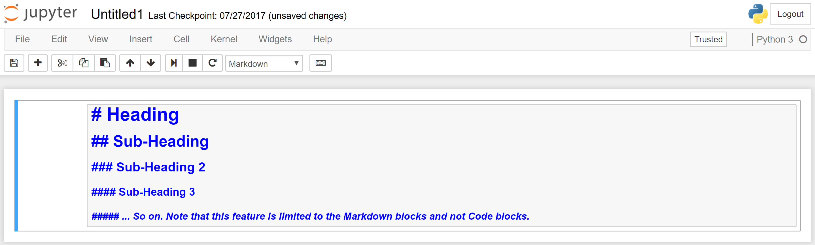

[Use this link](http://nestacms.com/docs/creating-content/markdown-cheat-sheet) to know more about the features in Markdown.

For example, students performing Exploratory data analysis of the datasets should present their finding as following:

<main title> #Exploratory Data Analysis

<sub heading> ##Data Visualization

<sub heading> ###Relation between a and b variable

**GITHUB Basics:**

Kindly have an account ready on GITHUB before you present your findings. We will provide you with the Repository where you will need to push you work. **Only 1 push per team. Multiple push from same team will lead to disqualification. The push should be named under the team name**.

GITHUB workflow is provided here as follow:

* Get access to the Github repository (provided by us as a link on GITHUB)
* Install Git bash on desktop
* Open bash terminal

Change directory to documents

* **Command:** cd \documents

Initiate git repository (if using for the first time)

* **Command:** git init
* This command creates a git repository in the current folder. However, by default this folder is considered as the master.

Generating a SSH key

* **Command:** ssh-keygen -t rsa -b 4096 -C "email-registered-on-github"
* While creating SSH
* Do not give any name to the file. Just keep hitting enter.
* You may or may not assign a passphrase. If you do assign remember it.

Copying the RSA key

* **Command:** clip < ~/.ssh/id_rsa.pub
* Enter this key in online github portal SSH key tab under account settings. Provide PC name and add the SSH key.

Cloning the repository to remote location/desktop

* **Command:** git clone [git@github.com:xyz/abc.ai](mailto:git@github.com:xyz/abc.ai) (Just an example)

Change directory to the cloned repository

* **Command:** cd abc.ai

Pull the latest version from the master source on github

* **Command:** git pull

Create a branch within the master git repository

* **Command:** git checkout -b Team1

*** Perform required Operations/edits to the code or documents ***

After making changes you can check status of the repository to show and review all the changes made

* **Command:** git status

Add the file/files that has/have been changed

* **Command:** git add <filename> (Eg. git add README.md)

Commit the changes in remote source to online github repository

* **Command:** git commit –m “Updates Readme**”

Push the changes to the master repository to which you are a collaborator

**Command:** git push --set-upstream origin Team1

Kindly note, that it is expected from each student to have basic knowledge about GITHUB, of how to push a notebook using remote terminal.

**FEEDBACK**

**After you have completed your challenge, kindly fill the feedback form which will be provided to you at the time of Hackathon. Each member from the team is required to fill this form as it will be cross checked with the submission done on GITHUB and any member of the team not filling the survey will lead to negative marking on their final submission.**

**ALL THE BEST.**

**Refactored.ai Team**