**Travelling Salesman Problem UI**

UI Application for calculation of shortest distance using Travelling Salesman Algorithm. The application has been created using HTML, CSS and JavaScript.

The UI Application is hosted on the following link - <https://aayushg555.github.io/Travelling-SalesMan/>

Github Repo - <https://github.com/AayushG555/Travelling-SalesMan>

**Hardware & Software Requirements**

A web browser with working internet connection

**How to place code files in the directory?**

Place all the three files, namely -

index.html

index.js

style.css

into a root directory and host to a web server.

**How to execute the code for getting output?**

Enter the distance values between given cities in the given textboxes and press the command button.

**Execution Demo –**

Consider the graph shown in the figure on the right side. A TSP tour in the graph is 1-2-4-3-1. The cost of the tour is 10+25+30+15 which is 80.

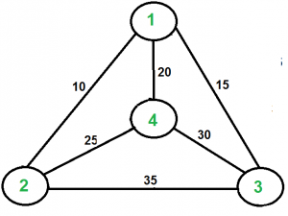

**Implementation Screenshot –**

