*CONNECTING BALTIMORE*

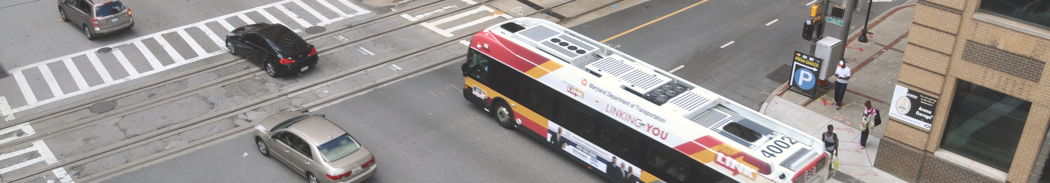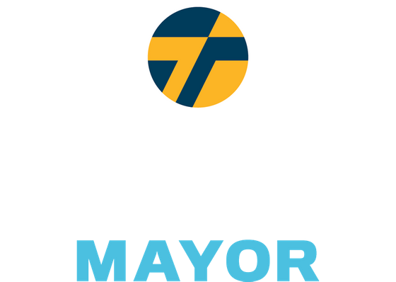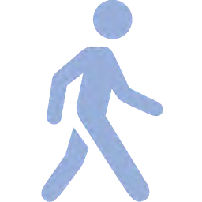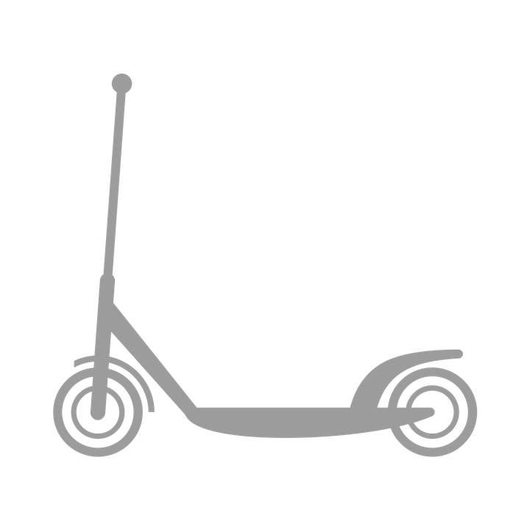

Baltimore should be a defining example of a green and equitable transit system. Current transit deficits correspond to a history of unbalanced economic investments, a backwards approach to sustainability, inequitable distribution of affordable housing, and a failing education system. Together, we will reimagine a transit system for Baltimore with the mobility and needs of all residents in mind.

We will implement Complete Streets to rebuild our crumbling roads and bridges. This will enable safe pedestrian traffic across the city, including East-West avenues serving walkers, bikers, and those riding e-scooters.

In addition to designated bike lanes and green transit avenues, Thiru pledges to complete the Gwynns Falls and Herring Run Trails, which will establish a 35-mile trail loop that connects 80% of Baltimore’s neighborhoods to recreational greenspace.

Not only should a share of e-scooters be distributed to “equity zones” (a quarter are already required to be) — we will also designate parking areas, expand scooter and bike lanes based on scooter usage data, and require companies to automatically reduce prices in neighborhoods with public transit deficits.

A top priority will be to expand free bus circulator routes to include major west-to- east corridors and critical arteries to historically disinvested neighborhoods. This will lay the groundwork for a citywide free public bus system, which will reduce pollution as ridership increases, make the City more accessible, and reduce commute times.

The city that built the first leg of the American railroad should lead the charge to build the first leg of America's first high speed rail between Baltimore and D.C. To guarantee access to commuters of all income levels, the contracted operator will be required to cap the price of commuter passes as a percentage (1-3%) of annual income to ensure this is a transit option for everyone.

To operate in Baltimore City, ride share companies will be required to provide free or reduced fares for riders located in or traveling in transit deserts. Reduced fares will also be applied to trips to critical locations like public transit access points, grocery stores, pharmacies, and schools and community centers.