**Title: Enhancing Urban Vision - The Role of Virtual Reality in Architecture and Urban Planning.**

In the fast-paced world of urban development, architects and urban planners are constantly seeking innovative tools and technologies to aid in the design and visualization of cities and buildings. One such groundbreaking technology is Virtual Reality (VR), which has emerged as a powerful tool in reshaping the way we approach architecture and urban planning.

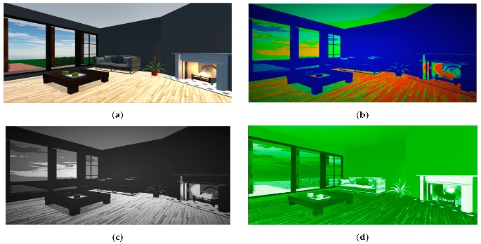 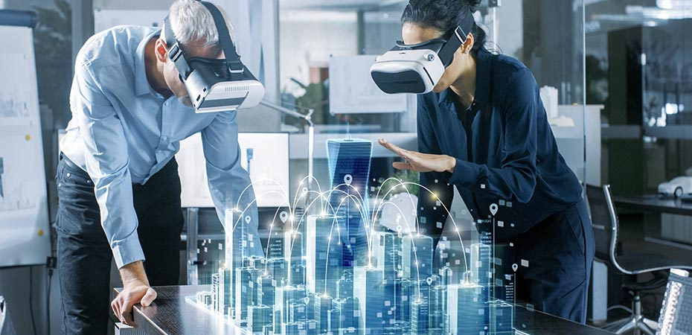

**VR: The Gateway to Immersive Design**

Traditional architectural and urban planning methods often rely on two-dimensional drawings and models to convey complex ideas. While these methods have served us well, they have inherent limitations in conveying the true essence of a space. This is where VR steps in, offering a transformative experience that allows architects and planners to immerse themselves in their designs.

With VR, architects can put on a headset and walk through a building before it's even constructed. They can experience the scale, proportions, and ambiance of the space firsthand. This level of immersion enables architects to identify design flaws, optimize layouts, and ensure that every detail aligns with the intended vision.

**City Planning in a Virtual World:**

Beyond individual buildings, VR is revolutionizing urban planning. Planners can create virtual city models that provide a holistic view of an entire urban landscape. This bird's-eye perspective allows for better decision-making when it comes to zoning, infrastructure development, and traffic flow.

City residents can also benefit from VR in urban planning. Public engagement and feedback become more interactive when citizens can virtually explore proposed developments and offer insights before ground is broken. This participatory approach fosters a sense of community involvement and ensures that urban planning decisions align with the needs and desires of the people who will inhabit these spaces.

**Benefits:**

1. **Cost-Effective Iteration:**

One of the key advantages of VR in architecture and urban planning is the cost savings it offers. Traditionally, changes to architectural designs or urban plans could be costly and time-consuming. With VR, iterations can happen rapidly and inexpensively in the virtual realm, reducing the need for expensive physical models and extensive on-site adjustments.

1. **Collaboration and Communication:**

VR also fosters collaboration among architects, planners, and stakeholders. Multiple team members can enter the virtual world simultaneously, working together to fine-tune designs or analyze urban layouts. This real-time collaboration accelerates decision-making and ensures that everyone is on the same page.

1. **Sustainability and Simulation:**

Sustainability is at the forefront of modern architecture and urban planning. VR aids in simulating various environmental factors, such as sunlight, wind patterns, and energy consumption, to optimize sustainable design choices. This helps in creating eco-friendly buildings and cities that are energy-efficient and environmentally responsible.

**Challenges and Future Prospects:**

While VR presents numerous benefits, there are challenges to overcome. The cost of high-quality VR equipment and software can be a barrier for some firms and municipalities. Additionally, the technology is continually evolving, necessitating ongoing training and adaptation.

Looking ahead, the future of VR in architecture and urban planning holds great promise. As VR technology becomes more accessible and affordable, it is likely to become a standard tool in the industry. Integrating VR with other emerging technologies, such as Artificial Intelligence (AI) and Augmented Reality (AR), will further enhance its capabilities.

**Conclusion:**

In conclusion, Virtual Reality is revolutionizing the fields of architecture and urban planning. It enables architects and planners to immerse themselves in their designs, facilitates collaboration, reduces costs, and supports sustainable practices. While challenges exist, the potential benefits are too significant to ignore. Embracing VR in architecture and urban planning is not just a technological leap; it's a leap toward creating better, more livable cities and spaces for generations to come.