ASSIGNMENT : 7
NAME : AAYUSH JOSHI
PRN : B24CE1130
BATCH : C
BFS :
#include <iostream>
using namespace std;

int n, e;
int links[10][10];
bool visited[10];

void dfs(int node) {
visited[node] = true;
cout << " Indexed page: " << node << endl;

for (int j = 0; j < n; j++) {
if (links[node][j] && !visited[j])
dfs(j);
}
}

int main() {
cout << "Enter number of web pages (max 10): ";
cin >> n;

cout << "\nEnter number of hyperlinks: ";
cin >> e;

// initialize adjacency matrix
for (int i = 0; i < n; i++)
for (int j = 0; j < n; j++)
links[i][j] = 0;

cout << "\nEnter links (from to):\n";
for (int i = 0; i < e; i++) {
int u, v;
cin >> u >> v;
links[u][v] = 1;
}

int start;
cout << "\nEnter seed (start) page number: ";
cin >> start;

// initialize visited array
for (int i = 0; i < n; i++) visited[i] = false;

cout << "\nStarting DFS web crawling from page: " << start << "\n";
dfs(start);

return 0;
}

OUTPUT :

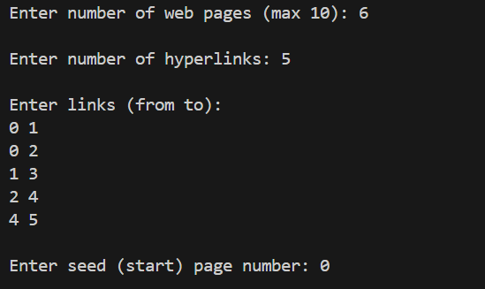
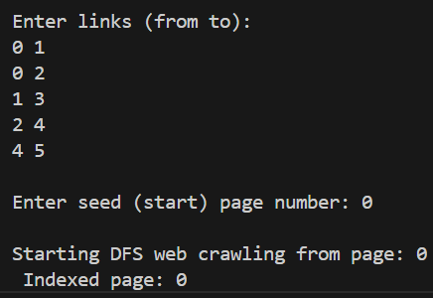
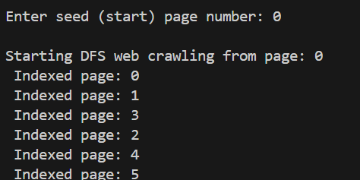
DFS :
#include <iostream>
using namespace std;

int n, e;
int links[10][10];
bool visited[10];

void dfs(int node) {
visited[node] = true;
cout << " Indexed page: " << node << endl;

for (int j = 0; j < n; j++) {
if (links[node][j] && !visited[j])
dfs(j);
}
}

int main() {
cout << "Enter number of web pages (max 10): ";
cin >> n;

cout << "\nEnter number of hyperlinks: ";
cin >> e;

for (int i = 0; i < n; i++)
for (int j = 0; j < n; j++)
links[i][j] = 0;

cout << "\nEnter links (from to):\n";
for (int i = 0; i < e; i++) {
int u, v;
cin >> u >> v;
links[u][v] = 1;
}

int start;
cout << "\nEnter seed (start) page number: ";
cin >> start;

for (int i = 0; i < n; i++) visited[i] = false;

cout << "\nStarting DFS web crawling from page: " << start << "\n";
dfs(start);

return 0;
}

OUTPUT :
