**Server side testing - API Automation Testing using Postman**

Making [a post reques](https://www.youtube.com/watch?v=6hsRYX4mwlE)t into the database using the URL: local host server port details

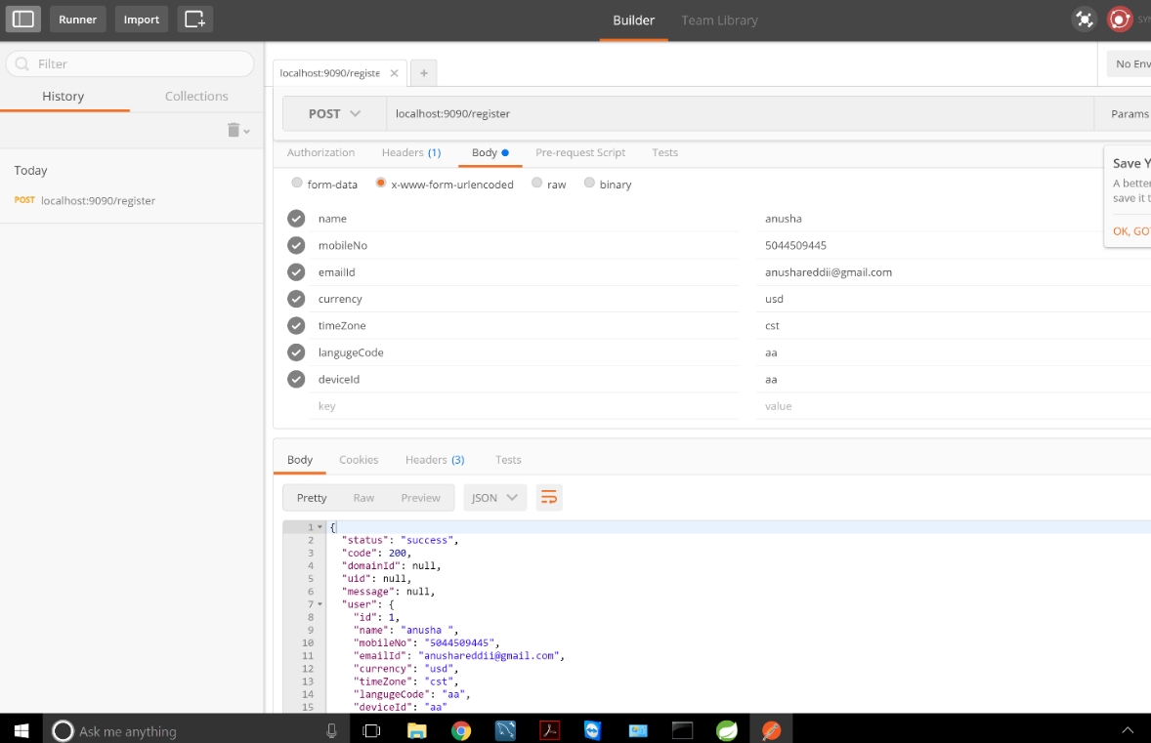

Posting the data to the API end point using POST method

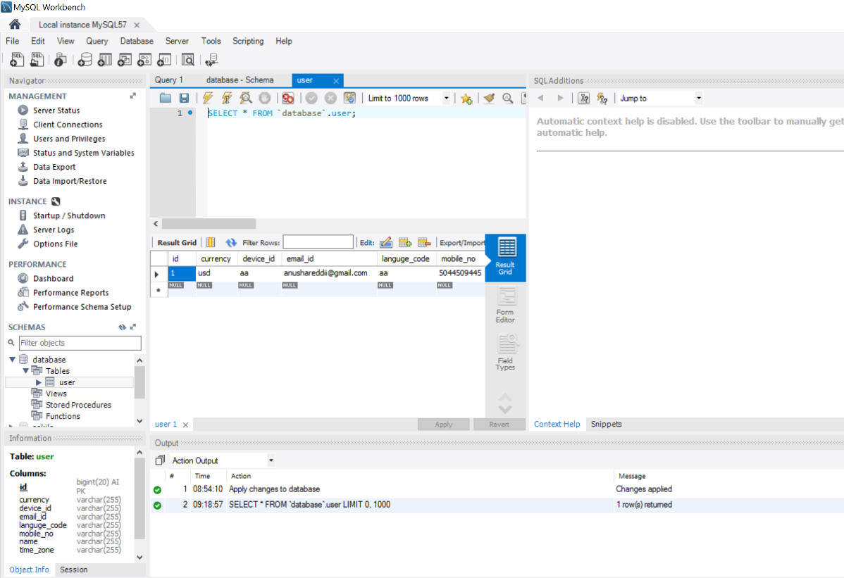

The data posted in the postman is now available in the database.

Result : Test successful.