**Azure Practice Check**

Step 1: Uploading the Code to GitHub

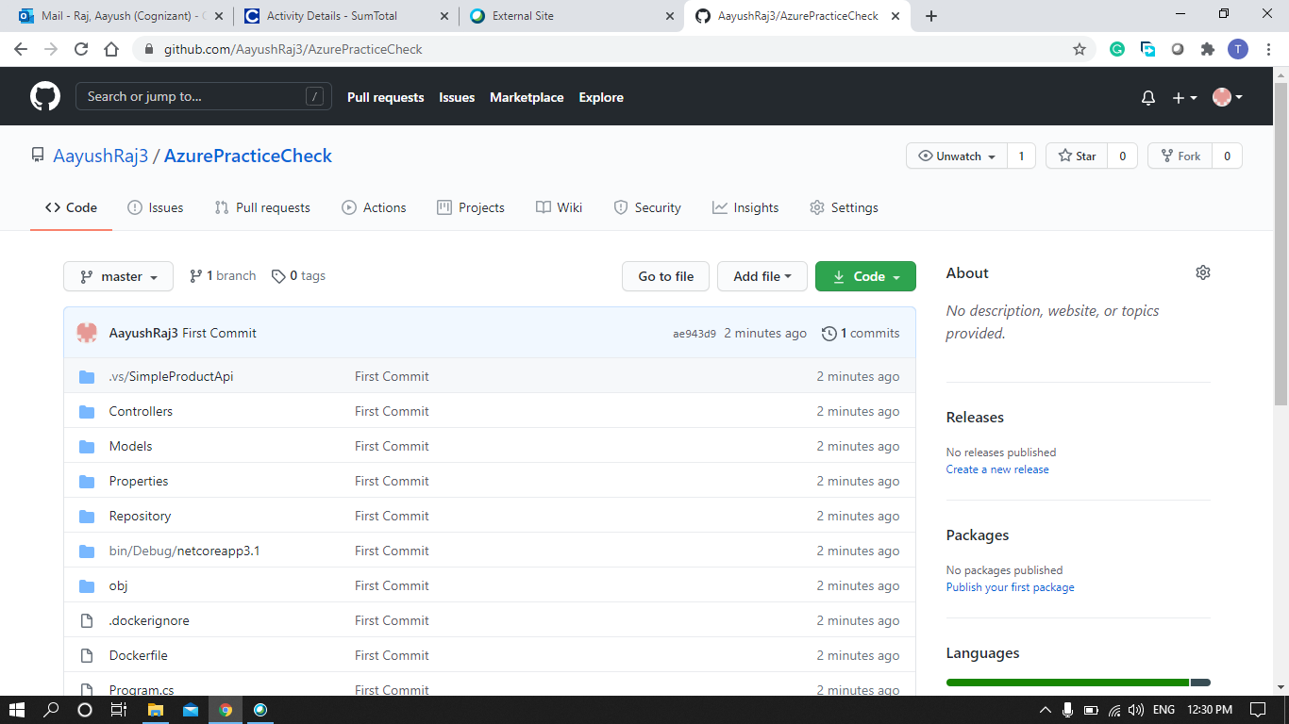

Step2 : Creating a Container Registry

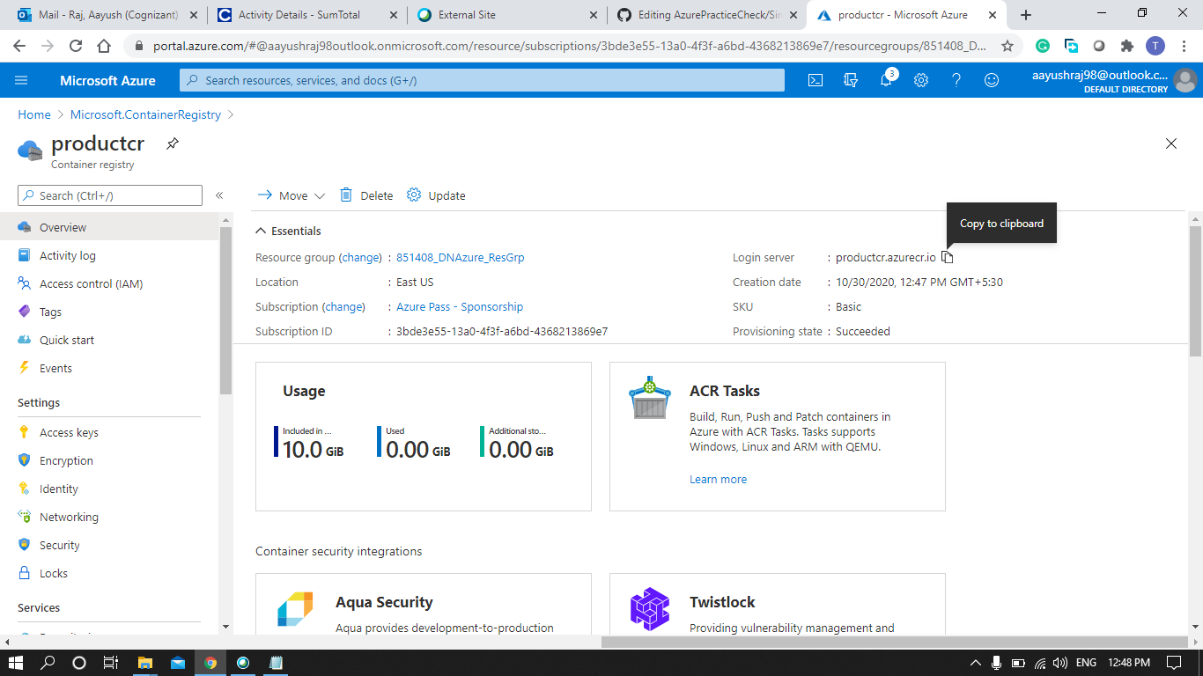

Step 3: Creating Kubernetes Cluster

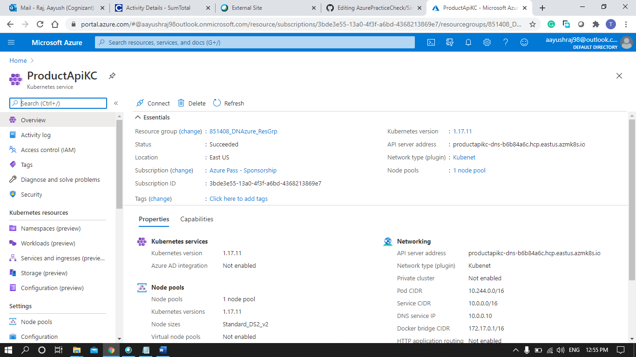

Step 4: Creating an Admin role and secret

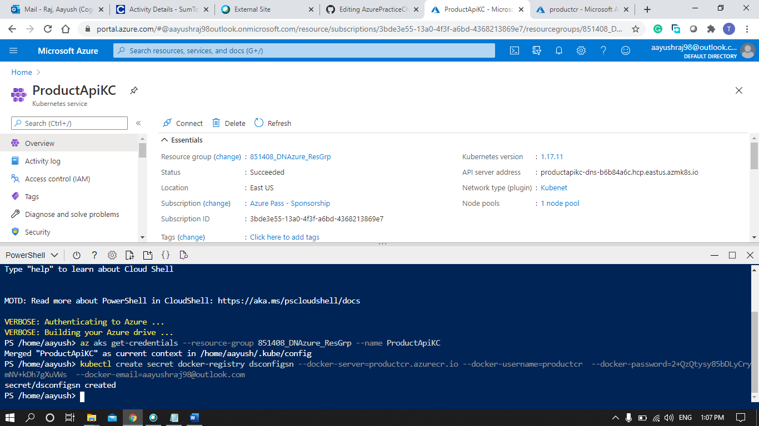

Step 5: Creating a DevOps Project by bring code from GitHub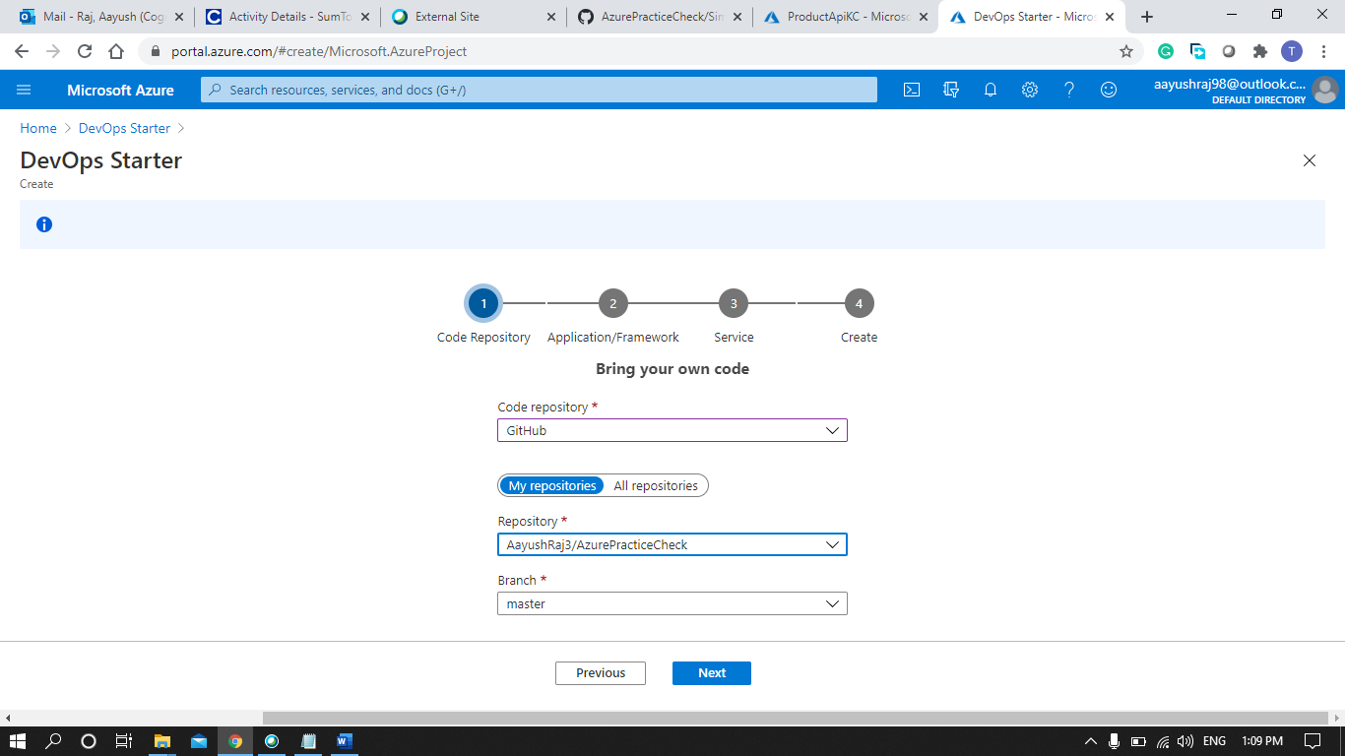

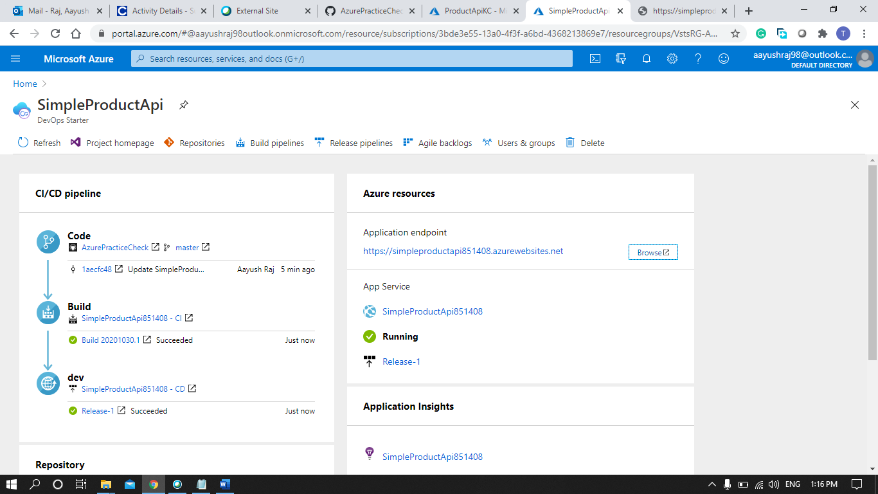

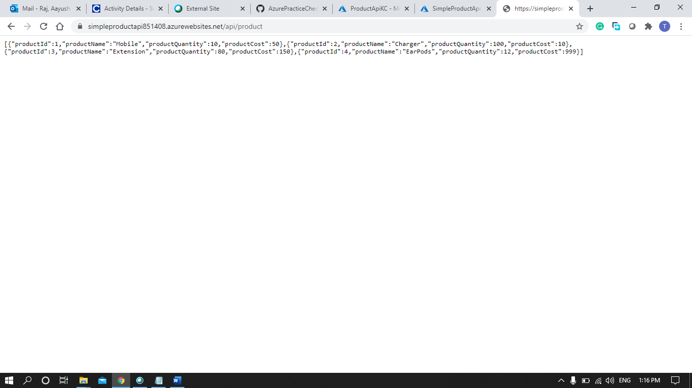

Step 6: Customizing the Build Pipeline by adding a Docker buildAndPush

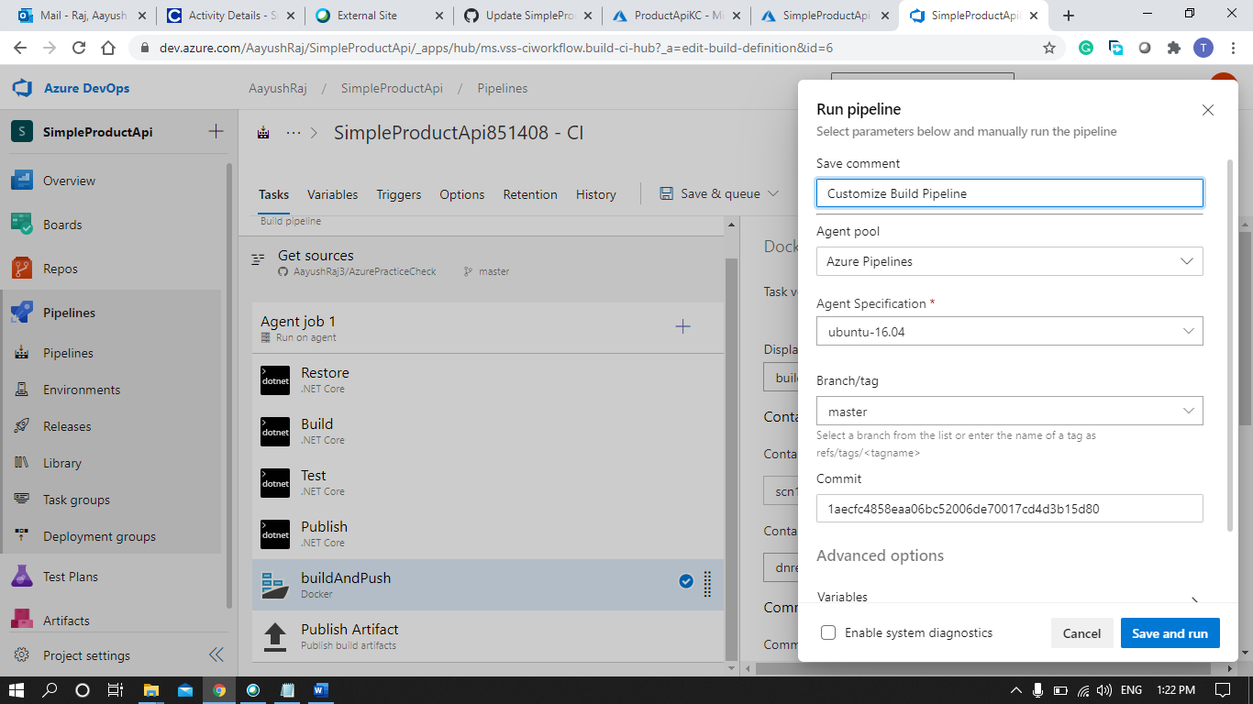

Step 7: Build Pipeline Successfully Completed 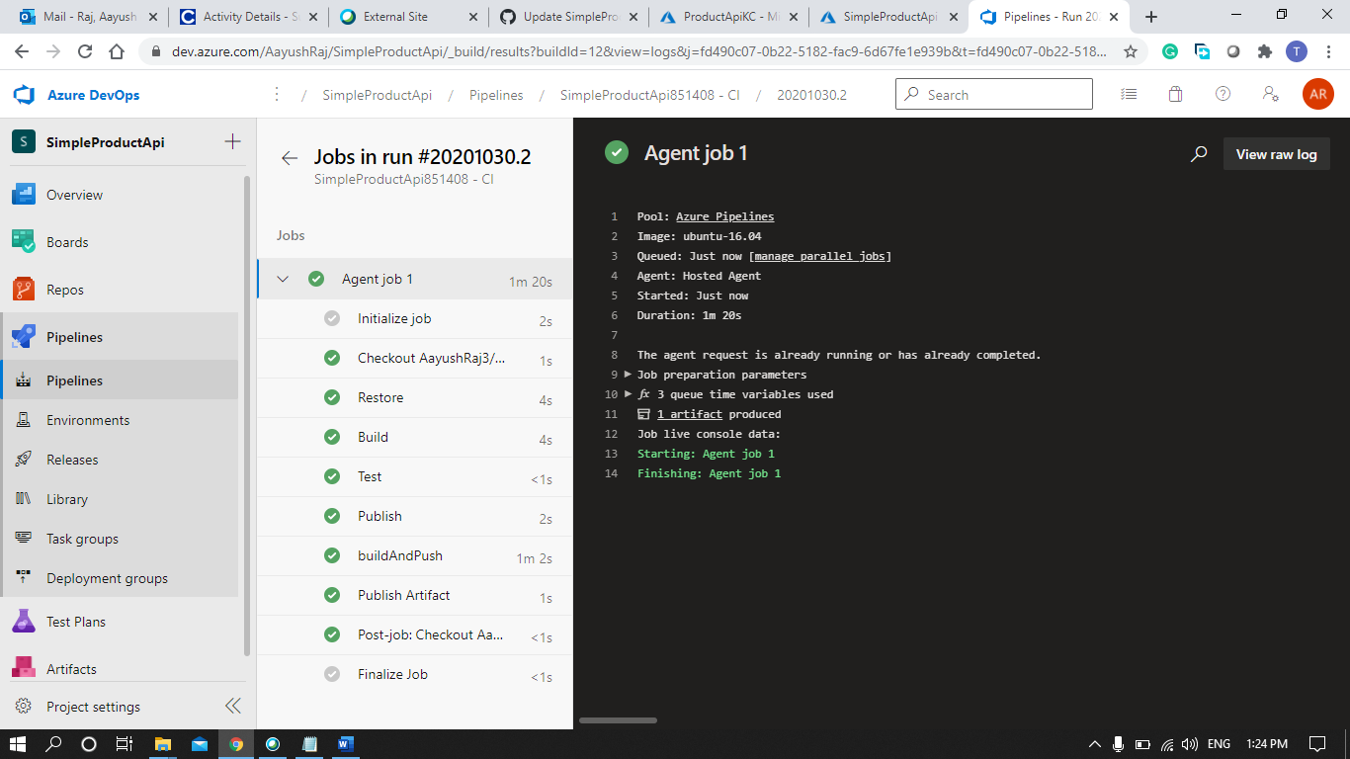

Step 8: Running the Container Instance

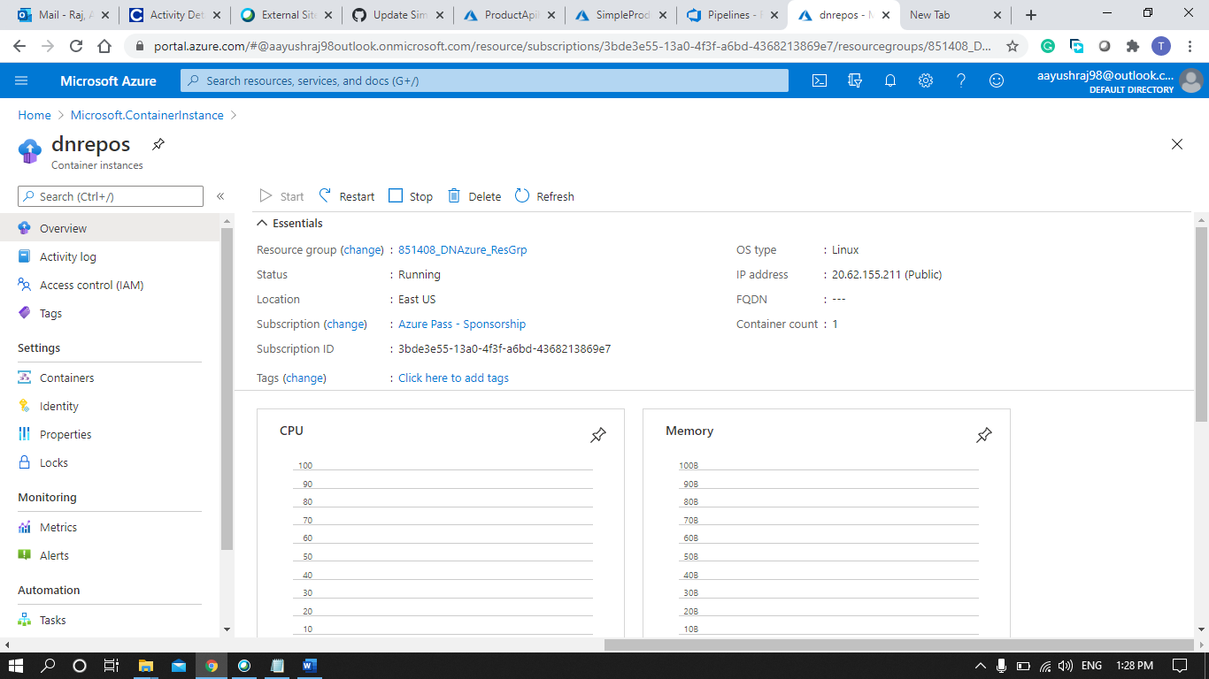

Step 9: Data Successfully Deployed on the IP Address 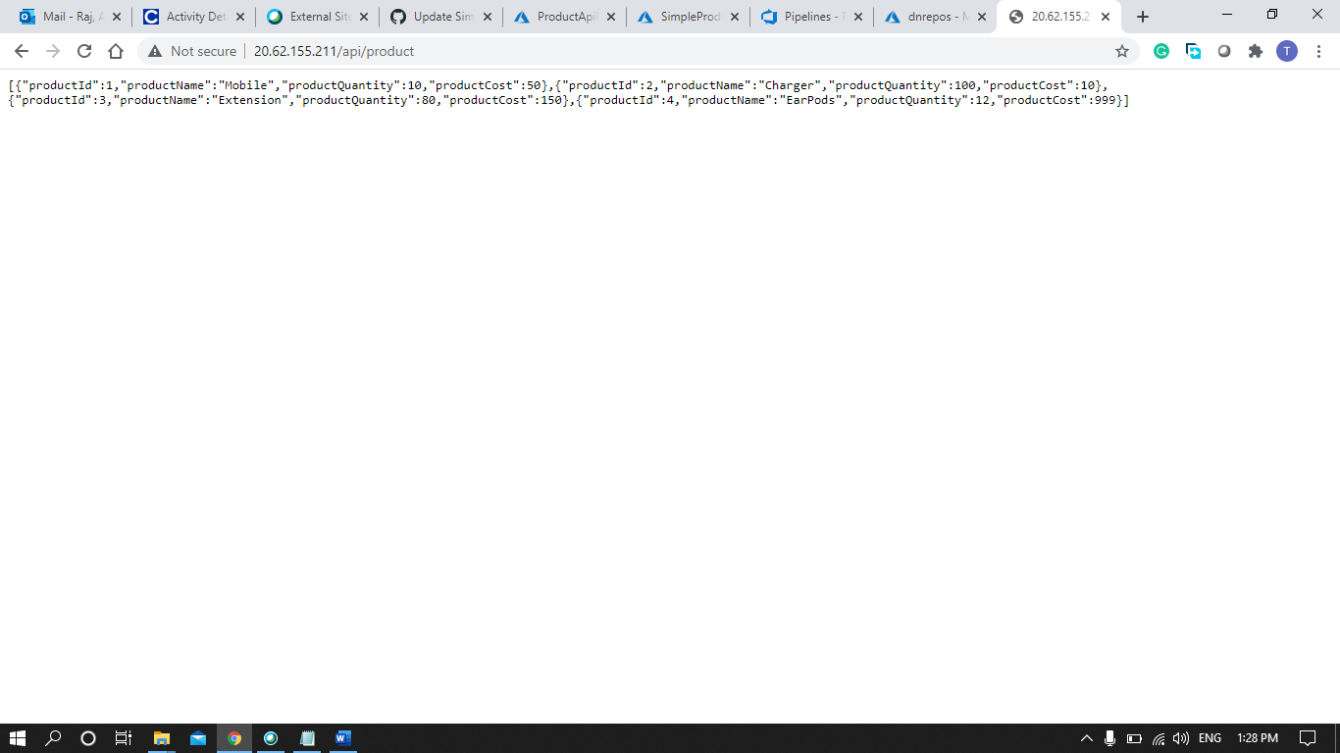

Step 10: Swagger on the Deployed IP Address

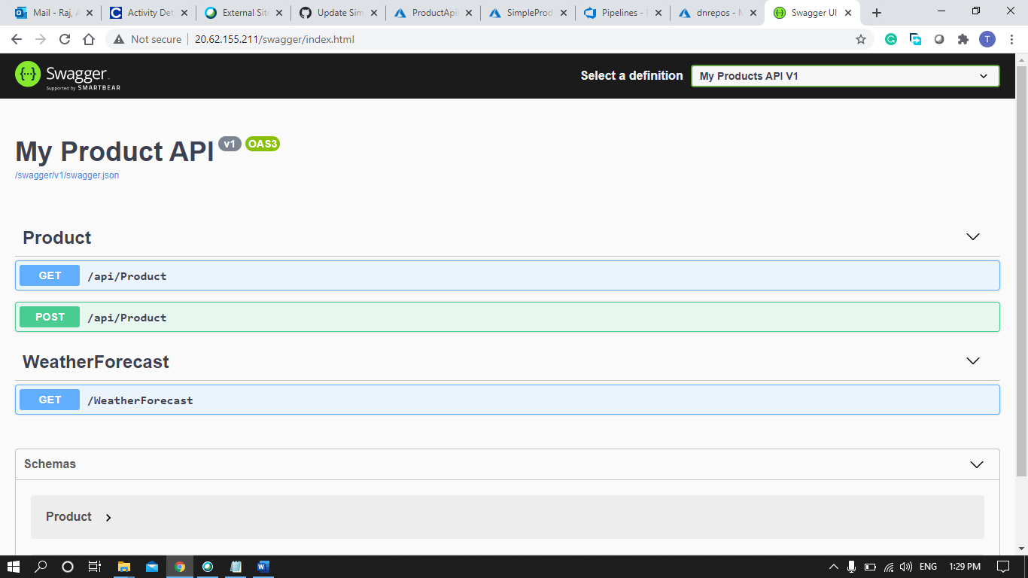

Step 11: Customizing Release Pipeline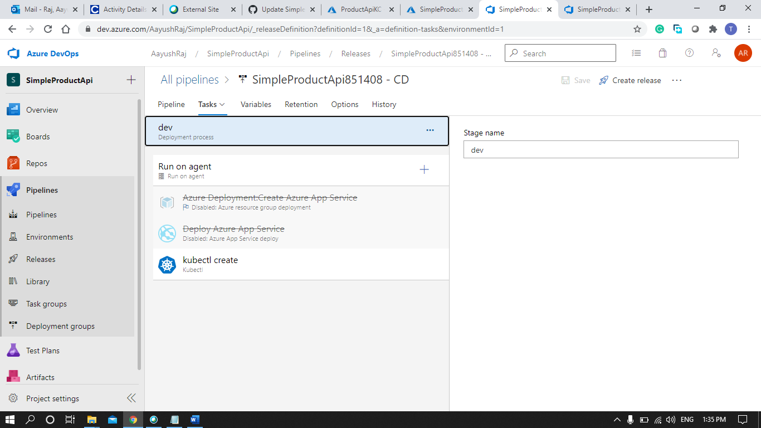

Step 12: Release Pipeline Successfully Executed

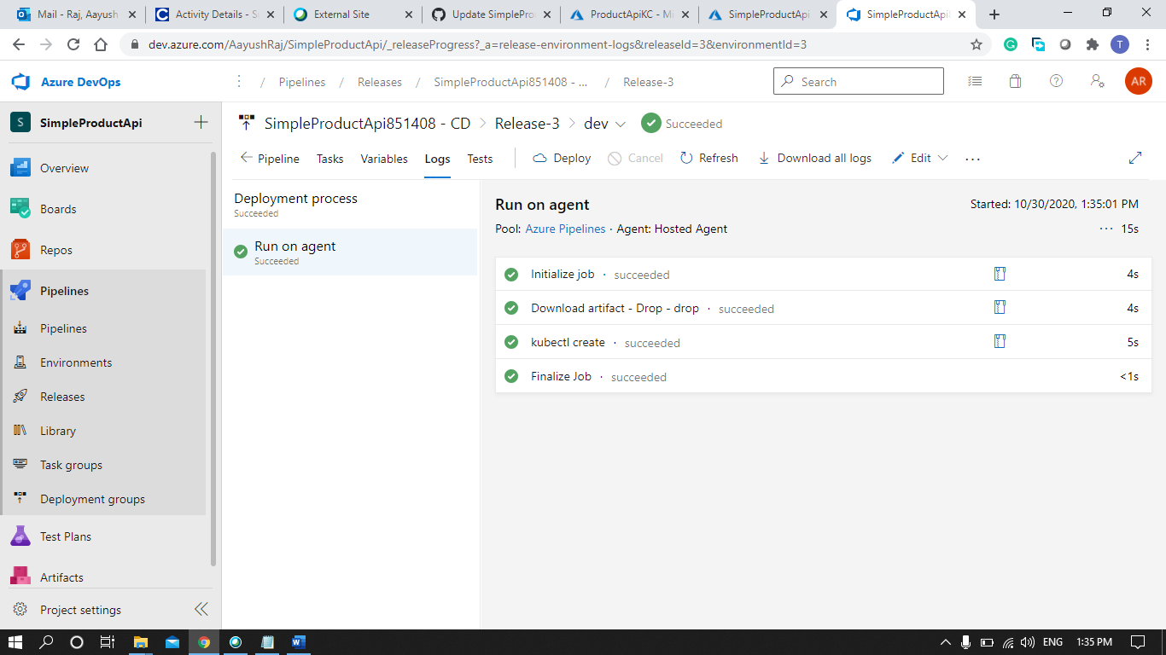

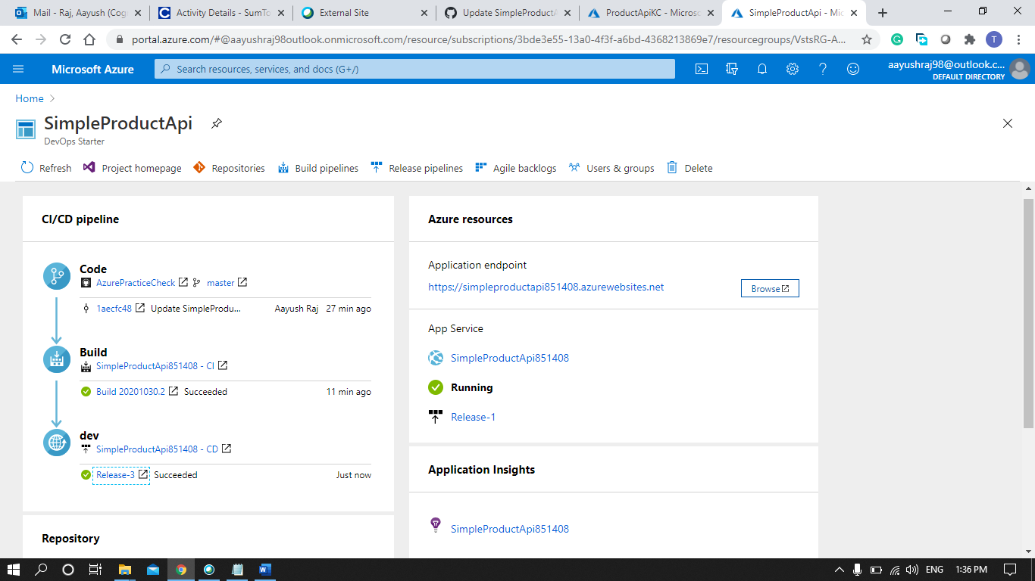

Step 13: Creating an Admin Dashboard.

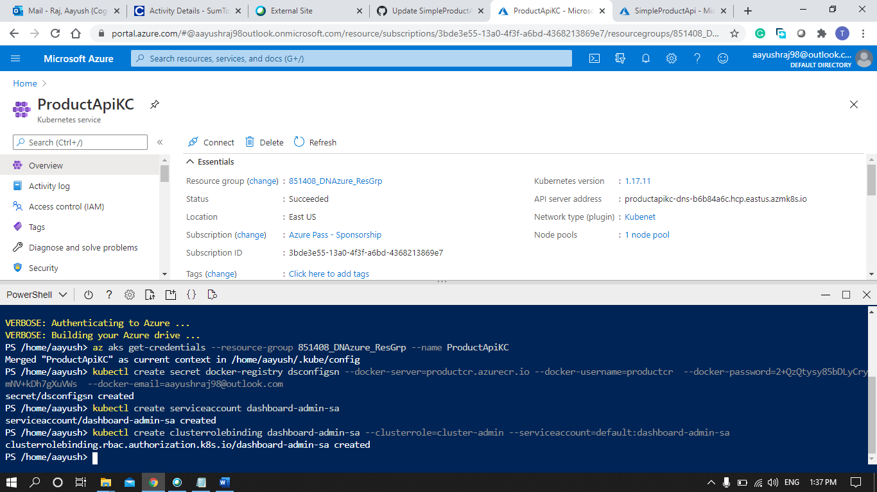

Step 14: Getting the Secrets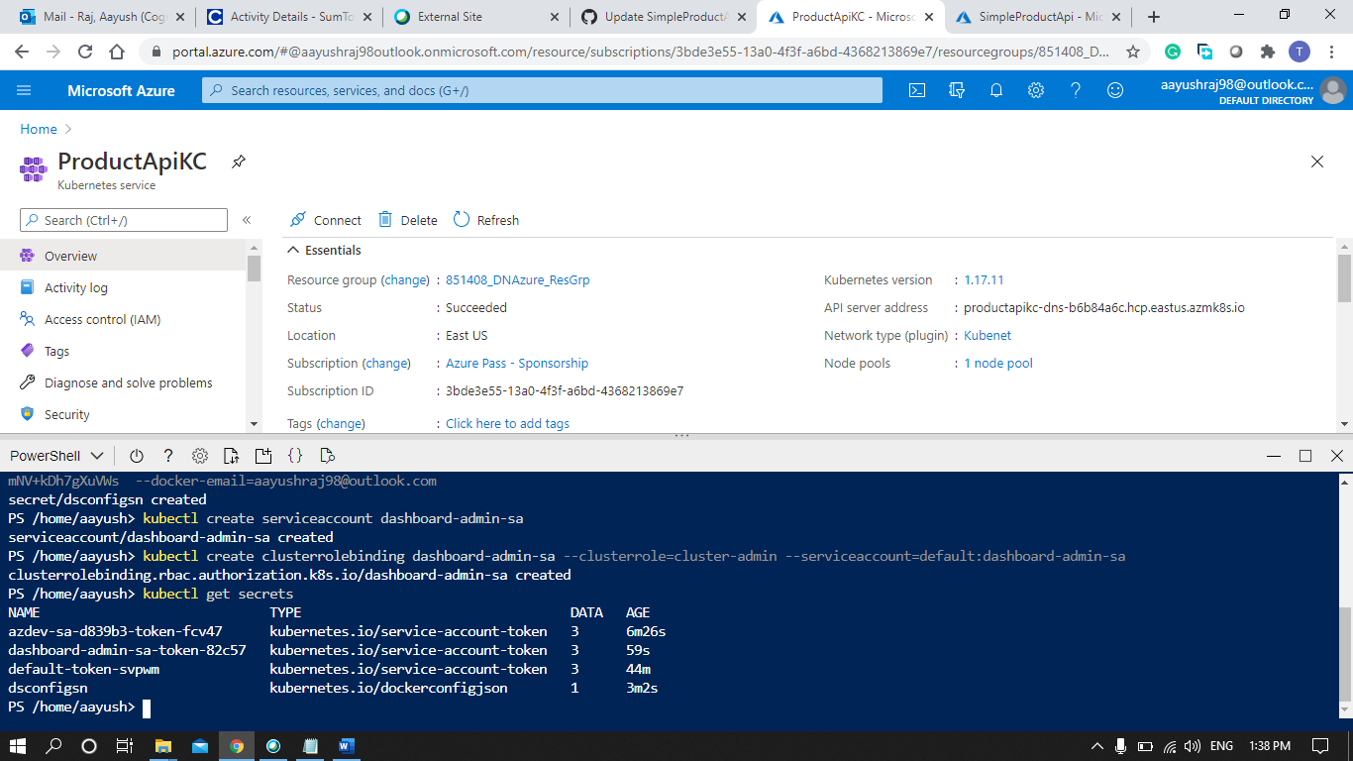

Step 15: Admin Dashboard.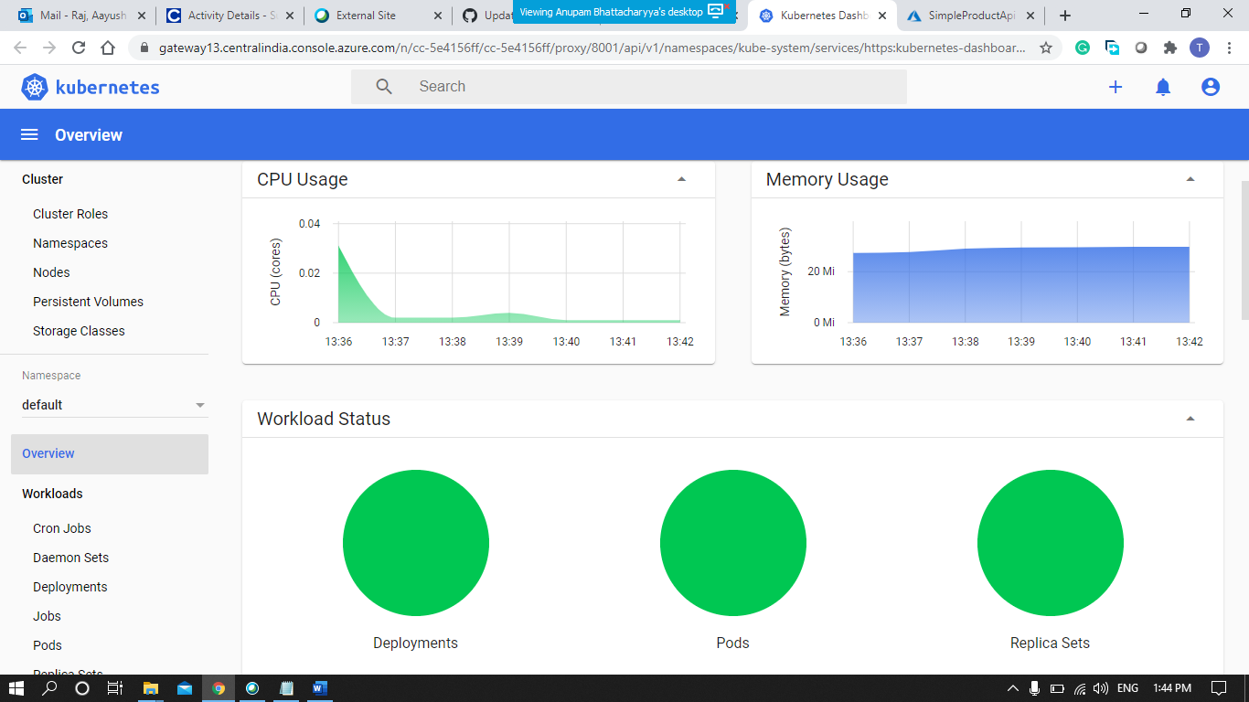

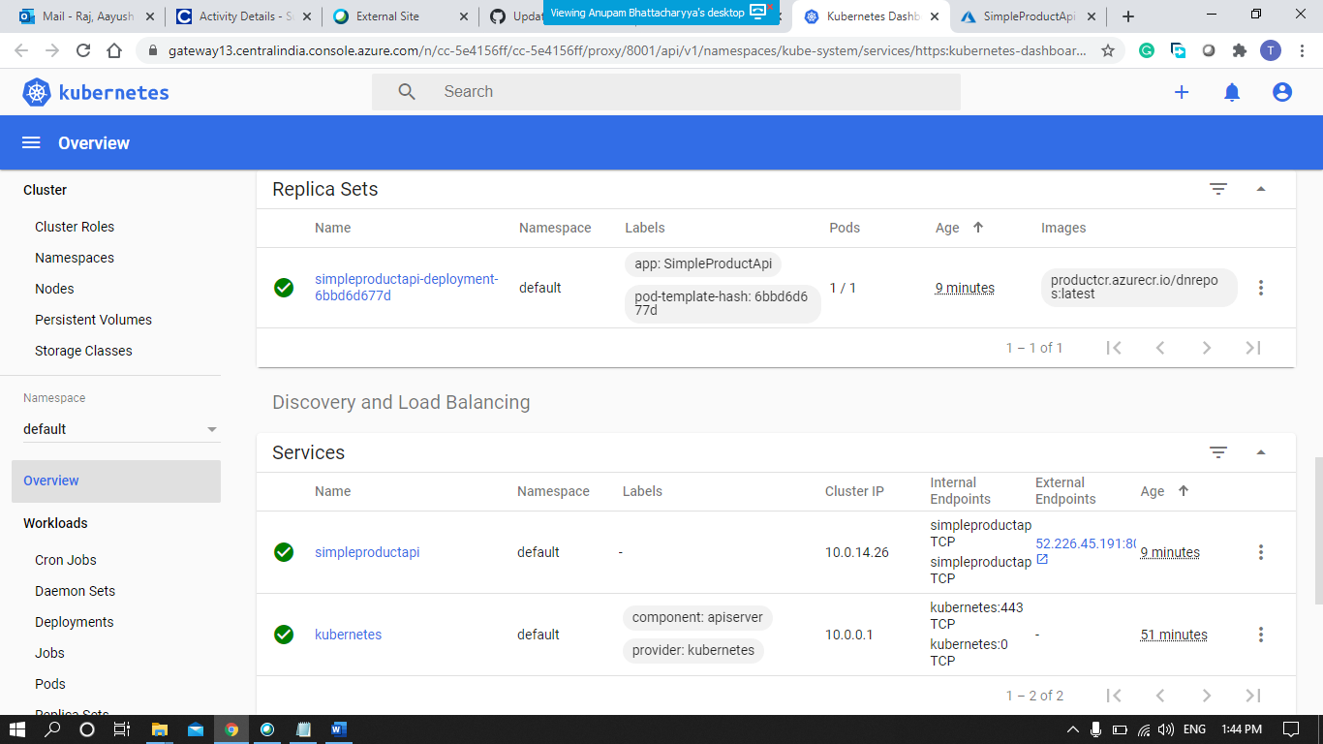

Step 16: Getting Data on the Deployed IP.

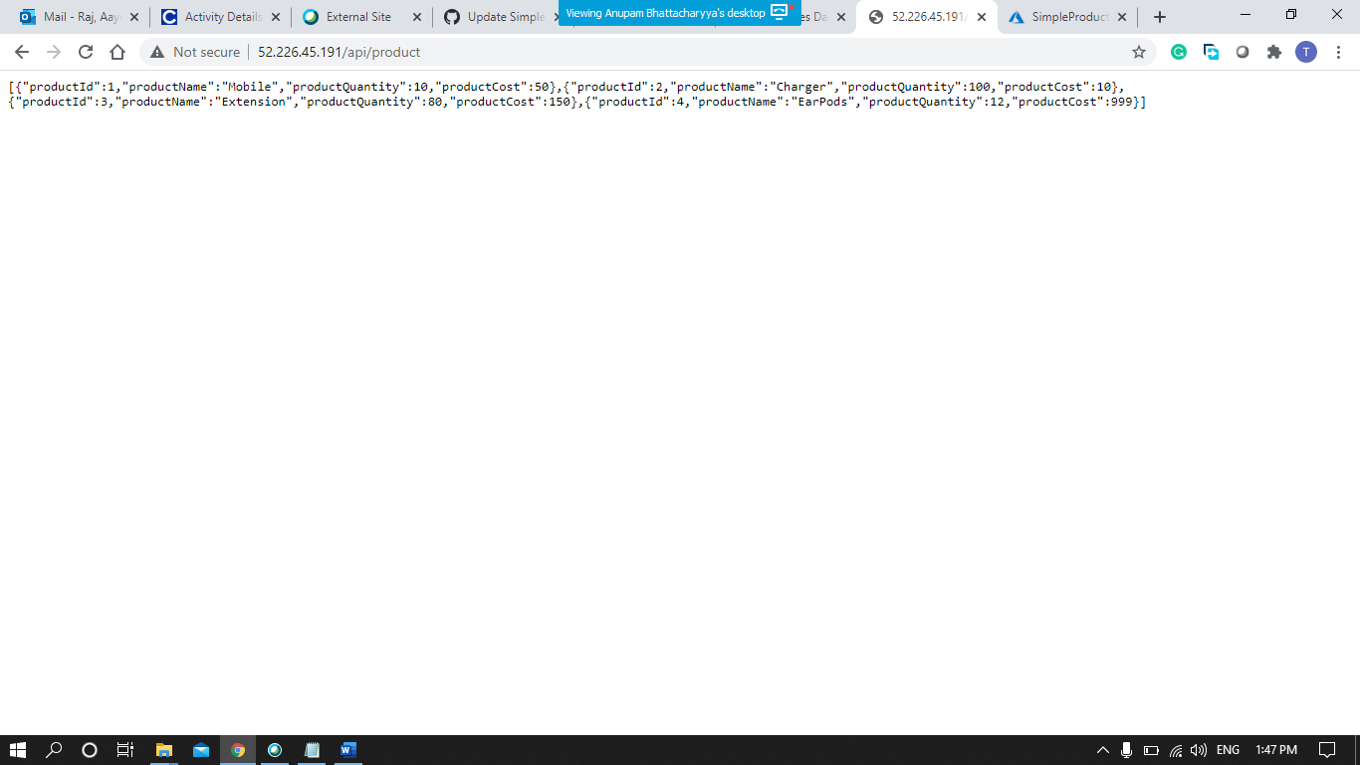

Step 17: Adding Data on the IP using Swagger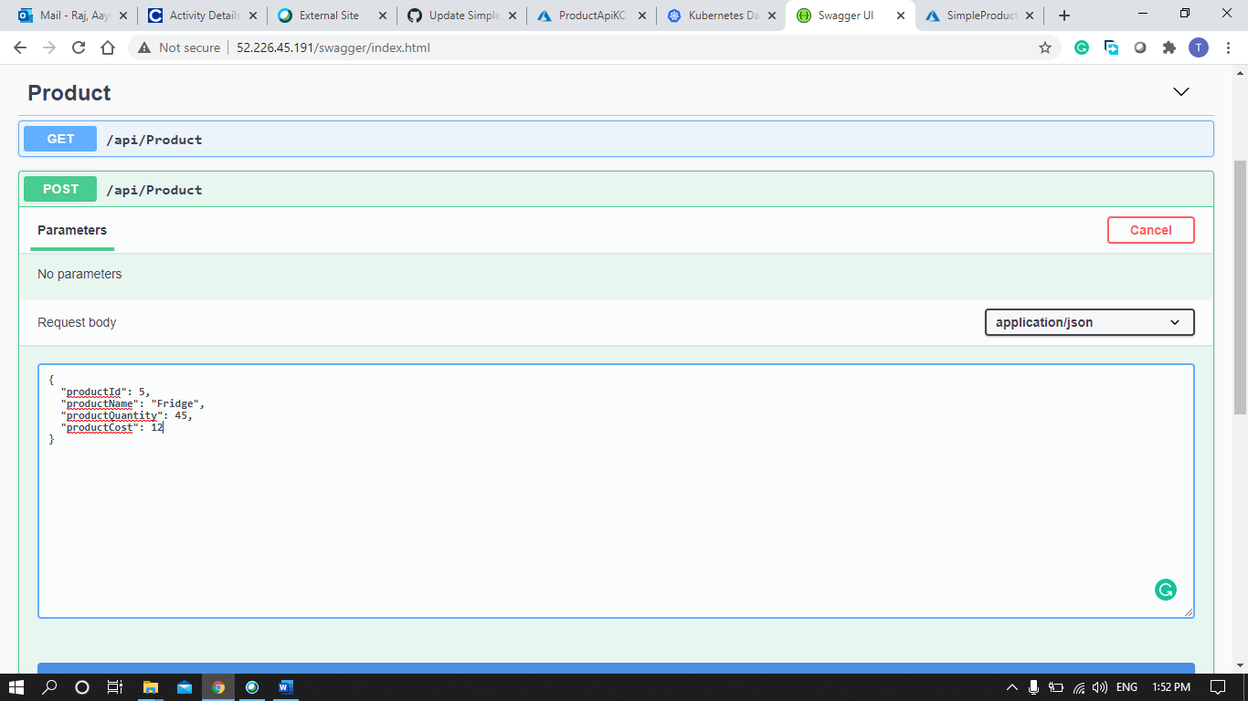

Step 18: Data Successfully Added

