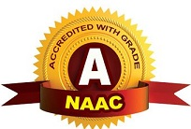
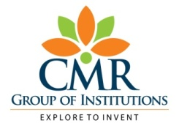
ESTD: 2009
CMR TECHNICAL CAMPUS
UGC AUTONOMOUS
Accredited by NBA & NAAC with ‘A’ Grade
Approved by AICTE, New Delhi and JNTU Hyderabad

Department of CSE [Artificial Intelligence & Machine Learning]

Ref. No: {{ ref_no }} Date:{{ date }}

ATTENDANCE REPORT

S.No | Student ID | Name | Email | Registration ID
{% for student in students %}{{ student.sno }} | {{ student.student_id }} | {{ student.name }} | {{ student.email }} | {{ student.reg_id }}{% endfor %}

HOD
Under the guidance of S. Rao Chintalpudi (HOD CSE-AIML)
Project Contributors:
Ambati Srujana (227R1A6603)
Pamula Shruthi (227R1A6649)
Aakula Sushmitha (237R5A6604)

Kandlakoya (V), Medchal Road, Hyderabad, Telangana – 501401
Ph.No: 9247033440/41: www.cmrtc.ac.in

