Scenario Configuration Commands

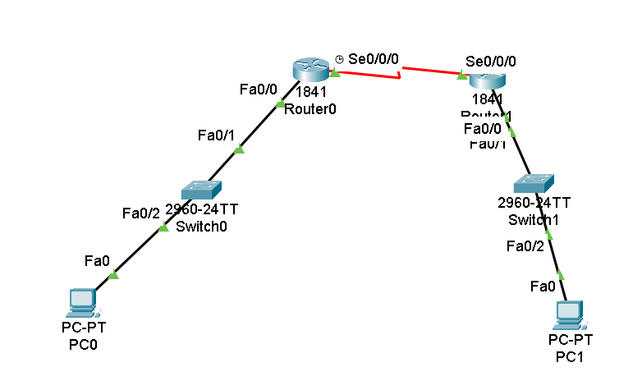

Router 1 Configuration

Router>en

Router#conf t

Enter configuration commands, one per line. End with CNTL/Z.

Router(config)#hostname r1

r1(config)#int fa0/0

r1(config-if)#ip add 1.0.0.1 255.0.0.0

r1(config-if)#no shut

r1(config-if)#

%LINK-5-CHANGED: Interface FastEthernet0/0, changed state to up

%LINEPROTO-5-UPDOWN: Line protocol on Interface FastEthernet0/0, changed state to up

r1(config-if)#int se0/0/0

r1(config-if)#ip add 11.0.0.1 255.0.0.0

r1(config-if)#clock rate 64000

r1(config-if)#no shut

%LINK-5-CHANGED: Interface Serial0/0/0, changed state to down

r1(config-if)#

Router 2 Configuration  
  
Router>en

Router#conf t

Enter configuration commands, one per line. End with CNTL/Z.

Router(config)#hostname r2

r2(config)#int fa0/0

r2(config-if)#ip add 2.0.0.1 255.0.0.0

r2(config-if)#no shut

r2(config-if)#

%LINK-5-CHANGED: Interface FastEthernet0/0, changed state to up

%LINEPROTO-5-UPDOWN: Line protocol on Interface FastEthernet0/0, changed state to up

r2(config-if)#int se0/0/0

r2(config-if)#ip add 11.0.0.2 255.0.0.0

r2(config-if)#no shut

r2(config-if)#

%LINK-5-CHANGED: Interface Serial0/0/0, changed state to up

Router 1 BGP Commands  
  
r1#conf t

Enter configuration commands, one per line. End with CNTL/Z.

r1(config)#router bgp

% Incomplete command.

r1(config)#router bgp 100

r1(config-router)#net 11.0.0.0

r1(config-router)#net 1.0.0.0

r1(config-router)#neighbor 11.0.0.2 remote-as 200

r1(config-router)#%BGP-5-ADJCHANGE: neighbor 11.0.0.2 Up

Router 2 BGP Commands

r2#conf t

Enter configuration commands, one per line. End with CNTL/Z.

r2(config)#router bgp 200

r2(config-router)#net 2.0.0.0

r2(config-router)#net 11.0.0.0

r2(config-router)#neighbor 11.0.0.1 remote-as 100

r2(config-router)#%BGP-5-ADJCHANGE: neighbor 11.0.0.1 Up

r2(config-router)#