Auto Email / Ticket Categorizer
AI/ML Intern Assessment - Fobes Skill Itech
Submitted by: Aayush Saini

1. Objective
The task was to build a small NLP model that reads an incoming support ticket (subject + body text) and automatically predicts which department it should be routed to - Billing, Technical, HR or General. This is basically a text classification problem.

2. Dataset
Since we were told not to use any real-world or public dataset, I created a small dummy dataset myself with 80 tickets in total (20 per category). Each row has a subject, a body and a category label. The tickets are written in the way support tickets usually look, based on common patterns like billing complaints, app errors, HR queries and general questions.
The dataset file is data/tickets.csv and the script used to create it is data/build_dataset.py.

3. Approach
Text cleaning:
Combined the subject and body into one text field, converted everything to lowercase, removed punctuation and numbers, and removed common stopwords using a small custom stopword list. A heavy library like nltk was not used since the stopword list needed here is small and simple.
Feature extraction:
Used TF-IDF instead of plain bag-of-words / word counts. TF-IDF reduces the weight of words that appear in almost every ticket (like "please" or "issue") and gives more weight to words that actually help separate one category from another, which is more useful for a small dataset like this.
Model:
Went with Multinomial Naive Bayes since it is a standard baseline model for text classification and generally works well even with a small dataset, so it was picked over Logistic Regression for this first version.

4. Evaluation
The data was split into 80% train and 20% test (stratified, so each category is represented fairly in the test set).
Test set accuracy: 0.938 (15 out of 16 test tickets predicted correctly)
Classification report:
Category | Precision | Recall | F1-score | Support
Billing | 1.00 | 1.00 | 1.00 | 4
General | 0.80 | 1.00 | 0.89 | 4
HR | 1.00 | 0.75 | 0.86 | 4
Technical | 1.00 | 1.00 | 1.00 | 4

Confusion matrix:
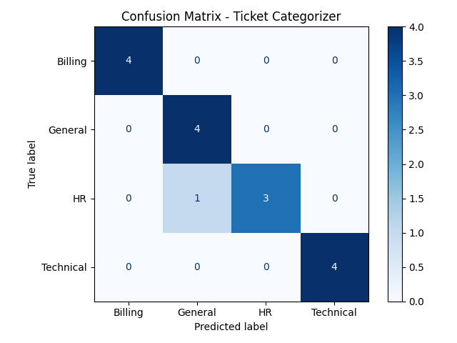
The only mistake the model made was one HR ticket getting predicted as General. Looking at that ticket, it was a fairly generic HR question without strong HR-specific keywords, so this is a reasonable mistake for a model trained on only 80 tickets.

5. Predictions on new sample tickets
Wrote 5 brand new tickets myself (not part of training data) and ran them through the trained model. Along with the category, the model also outputs a confidence score:
Ticket | Predicted category | Confidence | Status | Priority
Charged twice for monthly subscription, asked for refund | Billing | 45.0% | Needs human review | Normal
App crashes every time while uploading a photo | Technical | 49.1% | Needs human review | Urgent
Asked about remaining leave balance for the quarter | HR | 35.7% | Needs human review | Normal
Asked difference between basic and premium plans | General | 29.7% | Needs human review | Normal
Server down, API requests failing, marked urgent | Technical | 32.4% | Needs human review | Urgent

All 5 tickets were categorized correctly, but the confidence scores are on the lower side. This is common with Naive Bayes on a small dataset - the model still picks the right category but is not very "sure" of it in terms of probability.

6. Bonus features implemented
- Confidence score: Every prediction comes with a probability/confidence percentage, not just the label.
- Needs human review threshold: If confidence is below 60%, the ticket is marked "Needs human review" instead of being auto-assigned. In the current run all 5 sample tickets fell below this threshold, so this rule is actually being triggered, which is a good edge-case demonstration.
- Priority tagging: A simple keyword-based rule checks for words like "down", "urgent", "crash", "failed", "error" etc. and tags the ticket as Urgent or Normal alongside the category.
- Mini live demo: A small CLI function (cli_demo) is included in ticket_categorizer.py where a ticket can be typed in and the category, confidence and priority are shown instantly.

7. Limitations and reflection
- The dataset is small (80 tickets), so the 93.8% accuracy number is only indicative and should not be treated as a reliable real-world number.
- Confidence scores are on the lower side even for correct predictions, which is a known behaviour of Naive Bayes on small datasets.
- The 60% review threshold was picked manually and not tuned using a separate validation set.
With more data or more time, I would want to try Logistic Regression alongside Naive Bayes and compare the two, collect a bigger and more varied set of ticket examples so the model has more to learn from, and properly tune the review threshold using a validation set instead of a fixed guess.

8. Files submitted
- data/build_dataset.py - creates the dummy dataset
- data/tickets.csv - the dummy dataset used
- ticket_categorizer.py - main script (cleaning, TF-IDF, model, evaluation, predictions, CLI demo)
- ticket_categorizer.ipynb - same work as a notebook with explanations
- confusion_matrix.png, sample_predictions.csv - outputs generated after running the script
- README.md - how to run the project and a short summary of the approach

