GEMM Engine v1
Microarch Document
Version 1.4 · 2026-10-31
Aayush Soni

Contents
Document information 5
Conventions 5
1. Overview 6
2. Top-level architecture 8
2.1 Block diagram 8
2.2 Top-level ports 11
2.3 Pass pipeline timing 11
2.4 Clock and reset 13
2.5 System expectations 13
2.6 Operation 13
3. Interfaces 15
3.1 Protocol conventions 15
3.2 External interfaces 15
3.3 Internal command buses 17
3.4 Point-to-point signals 18
4. Submodules 20
4.1 Top controller (TC) 20
4.2 Weight controller (WC) 21
4.3 Activation controller (AC) 23
4.4 Output controller (OC) 25
4.5 Accumulator datapath 27
4.6 Systolic array and PE 27
4.7 Skew, deskew and delay lines 28
4.8 Infrastructure 28
5. Memories and storage 29
5.1 SRAM instances 29
5.2 FIFOs 29
5.3 Flop arrays 29
6. Performance 31
7. Verification summary 31
8. Implementation results 31
8.1 Synthesis 31
8.2 Place and route 32
8.3 Power 33
9. Limitations and future work 34
Appendix A. Glossary 36
Appendix B. Parameters and constants 36

Figures
Figure 1: Tiling of C = A · B: the pass (r, n, k) multiplies A_rk by B_kn and accumulates into C_rn. 6
Figure 2: Top level of gemm_top: datapath and control 8
Figure 3: Datapath of gemm_top 9
Figure 4: Control plane of gemm_top 10
Figure 5: One pass at full rate; faded bars are the next pass 12
Figure 6: Abort at c = 16 with AC ready (left) and at c = 17 with AC not ready (right); dashed red boxes are pulses the abort removes 14
Figure 7: Output streams across a block boundary: block b+1's header arrives while c1 still carries block b 16
Figure 8: WC - AC interlock at full rate: flag, go and the next load all at c = 16 18
Figure 9: TC state machine 20
Figure 10: Weight controller high level diagram 22
Figure 11: Activation controller high level diagram 24
Figure 12: Output controller high level diagram 26
Figure 13: Accumulator datapath, one bank 27
Figure 14: PE weight-buffer states 27
Figure 15: Skew and deskew triangles (one register per square, one lane wide) 29

Tables
Table 1: Revision history 5
Table 2: References 5
Table 3: v1 at a glance 7
Table 4: Module hierarchy 10
Table 5: gemm_top ports (DV / DVS buses listed once; the handshake is implied) 11
Table 6: Key cycles of a pass 11
Table 7: Edge-tile handling 14
Table 8: cmd_t, 52 b 15
Table 9: resp_t, 8 b 15
Table 10: Input streams 15
Table 11: C output streams 16
Table 12: c_hdr_t, 16 b 16
Table 13: wcmd_t, 11 b 17
Table 14: acmd_t, 26 b 17
Table 15: Interlock signals 18
Table 16: Array control signals 18
Table 17: Datapath control signals 19
Table 18: TC states 20
Table 19: PE weight-buffer states 28
Table 20: SRAM instances (all ram_1r1w: 1 read + 1 write port, 1-cycle synchronous read) 29
Table 21: Command and ID FIFOs (sync_fifo) 29
Table 22: Large flop arrays 29
Table 23: Measured on the RTL (16.00 cycles per pass in every case) 31
Table 24: Synthesis results (flat netlist, pre-layout) 31
Table 25: Cell area by block (hierarchical synthesis) 32
Table 26: Place-and-route results, Nangate45 typical corner 32
Table 27: Earlier experiments: initial RTL and placement density 33
Table 28: Power at 500 MHz by workload 33
Table 29: Power by block, filter-bank workload (logic counted with the block of the flop it feeds) 33
Table 30: Earlier experiments: filter-bank power at 500 MHz 34
Table 31: gemm_v1 constants 36

Document information
Table 1: Revision history
Version | Date | Change
1.1 | 2026-10-29 | First draft
1.2 | 2026-10-29 | Synthesis results (pre-layout, Nangate45)
1.3 | 2026-10-30 | Place-and-route and power results
1.4 | 2026-10-31 | Weight select from a register; clock-gated weight buffers  1.3 ns at 75% utilization  Add top-level figure

Table 2: References
Reference | What
docs/spec.md | v1 specification: requirements, interfaces, decisions and their reasons
prj/v1/*.sv, rtl/*.sv | RTL this document describes

Conventions
- Bus naming: A DVS bus is <bus>_data / <bus>_valid / <bus>_stall; a DV bus has no stall. Buses are described in Sec 3; module sections point there.
- Cycle notation: c counts cycles from the start of a weight load (c = 0 is the cycle the load's first read is issued). G is the cycle of a pass's go (AC starts the pass); at full rate G = c + 16 of the pass's weight load.
- Constants are named as in gemm_v1_pkg (T = 16 lanes, S = 8 lanes per bank, R = 16 rows per pass, …; Appendix B).
- Banks: Every buffer is split by width into bank 0 (lanes 0–7) and bank 1 (lanes 8–15). Bank 1 is always accessed S = 8 cycles after bank 0.
- Figures: SRAMs are square-cornered; logic and registers are rounded; muxes and adders are drawn as symbols.

1. Overview
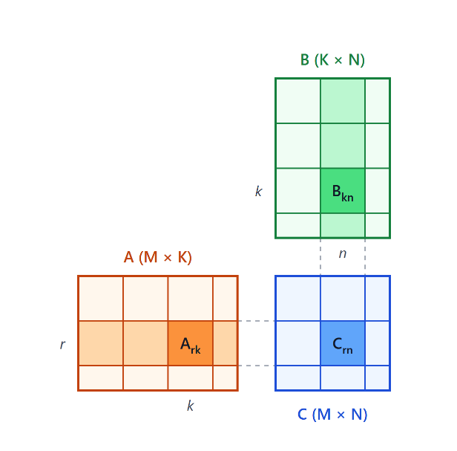
The GEMM engine computes C = A · B for signed int8 matrices of any shape (M, K, N from 1 to 65 536) with exact int32 results. Throughout this document the size conventions are A is M × K, B is K × N, and C is M × N. v1 is built around one 16 × 16 weight-stationary systolic array: B is tiled into 16 × 16 weight tiles, each held in the array for one pass while 16 rows of A stream through it, and k is the innermost loop so one 16 × 16 int32 accumulator holds the C block being built.
Figure 1: Tiling of C = A · B: the pass (r, n, k) multiplies A_rk by B_kn and accumulates into C_rn.

The matrix computation can be represented as C[m][n] = Σₖ A[m][k] · B[k][n]. The GEMM engine tiles A, B, C, effectively computing C_rn = Σₖ A_rk · B_kn, where X_ij represents the (i,j)th tile of matrix X, where each tile is a 16x16 chunk of the entire matrix. The weight-stationary implementation computes the innermost loop of the following algorithm, highlighted in yellow:
for r = 0 .. ⌈M/16⌉ − 1 // block row of C
for n = 0 .. ⌈N/16⌉ − 1 // block column of C
for k = 0 .. ⌈K/16⌉ − 1 // one pass per k
load weight tile B_kn into the array
stream the rows of A_rk through it
ACC = (k == 0 ? 0 : ACC) + A_rk · B_kn // 16 × 16 int32
output ACC as C block C_rn

The host sends one descriptor per GEMM; A and B arrive as two data-only streams in pass order; C leaves as two half-row streams plus a block header. Four controllers sequence the work: the top controller (TC) walks the tile loops, the weight (WC) and activation (AC) controllers own the input banks and feed the array, and the output controller (OC) accumulates and outputs C.
A pass is one iteration of the inner loop and takes 16 cycles:
1. The weight tile is resident. B_kn is held in the array; PE (row j, column i) holds B_kn[j][i].
2. The A rows stream through. Each of the (up to 16) rows of A_rk enters the left edge. Row x carries A_rk[x][0..15], one element per array row.
3. Each column produces one psum. As row x passes through column i, the column accumulates down its 16 PEs:
psum[x][i] = Σⱼ A_rk[x][j] · B_kn[j][i]
So one pass produces a 16 × 16 block of partial sums, psum = A_rk · B_kn: one psum row per A row, 16 columns each.
The v1 core targets int8 convolution and matrix workloads. At 500 MHz (128 G MAC/s peak) it runs a bank of 16 3 × 3 filters over grayscale video at 1080p and 240 fps, or 4K at 60 fps, and a ResNet-18 CNN at about 65 images per second (assuming that pooling, residual adds and requantization are done off chip). At 770 MHz, ResNet-18 runs at about 99 images per second (10.1 ms per image). These rates assume the input streams are fed from on-chip memory at full rate: about 16 GB/s in and up to 32 GB/s out at 500 MHz, and about 25 GB/s and 49 GB/s at 770 MHz. Requantizing the int32 outputs to int8 would cut the output stream by 4×, though v1 does not support it yet.

Table 3: v1 at a glance
Item | v1
Array/ Systolic Array | One systolic (M = 16): 256 PEs, int8 × int8 + 20-bit psum, double-buffered weight per PE
Pass | 16 cycles: one B tile resident, 16 A rows streamed; the next tile loads during the pass
Throughput | One pass per 16 cycles at steady state; cycles ≈ 16 · (M/16)(N/16)(K/16) + 64.
Input banks | A and B: 2 banks × 32 rows × 64 b each (ring buffers)
Accumulator | 2 banks × 16 words × 256 b = 1 KB
Clock / reset | Single clock; synchronous active-high reset; abort_req as a soft reset of control state
Implementation | 770 MHz (1.30 ns), 0.50 mm² die, Nangate45 typical corner; 168 mW on the filter bank at 500 MHz

2. Top-level architecture

2.1 Block diagram
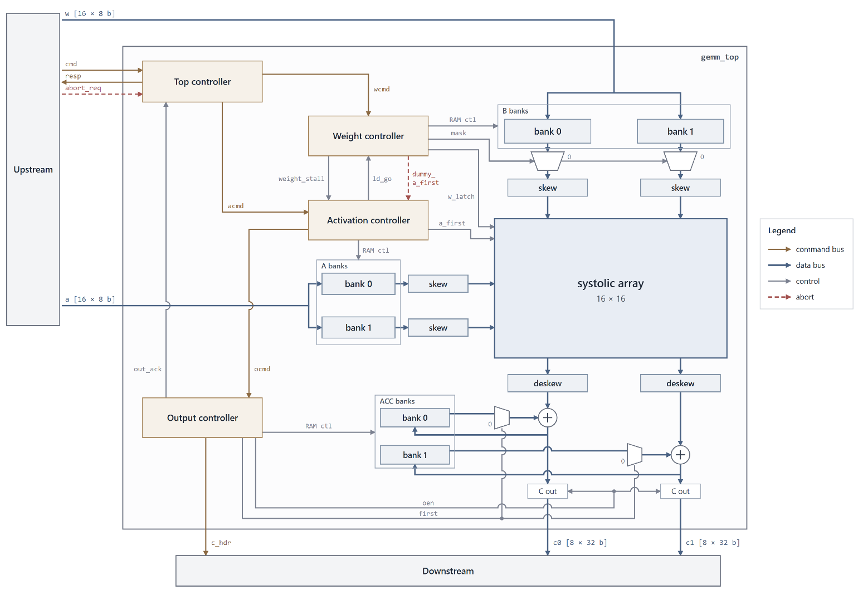
gemm_top instantiates the array, the six input and accumulator banks, the skew and deskew triangles and the four controllers. The first figure shows the whole top level; the next two show the datapath and the control plane in more detail.

Figure 2: Top level of gemm_top: datapath and control
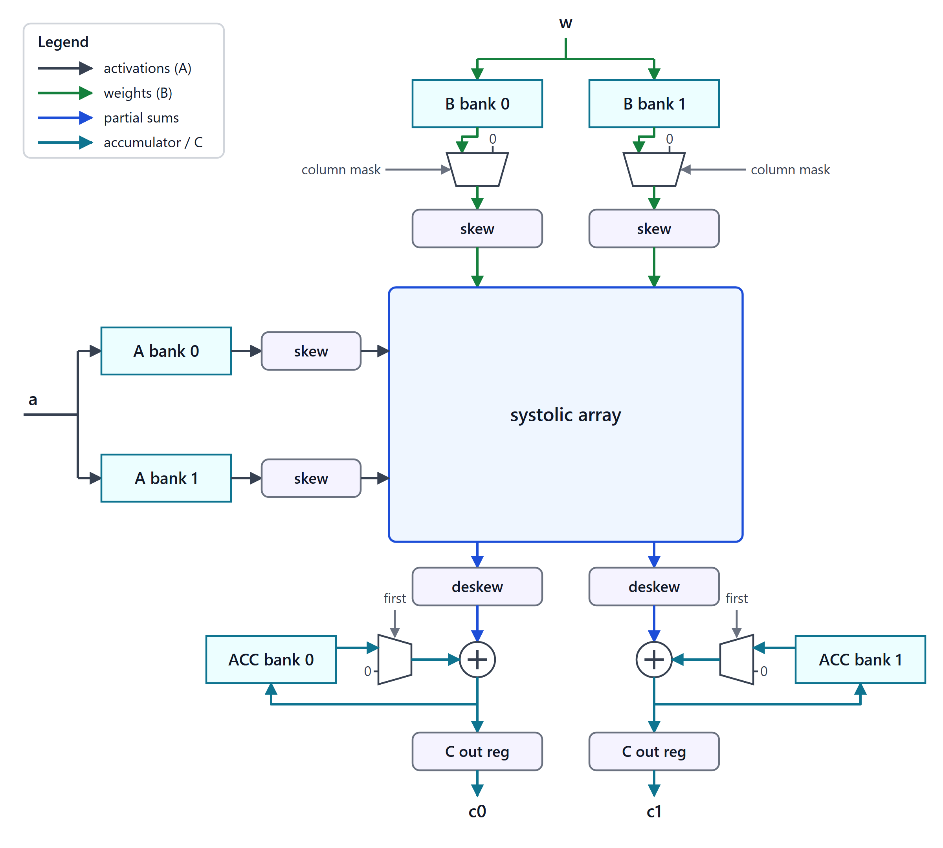
Figure 3: Datapath of gemm_top
B rows are written to both B banks at the same address; bank 1 is read 8 cycles after bank 0, so each half needs only a 0→7 skew triangle (lanes 8–15 get their extra 8 cycles from read timing). Before the skew, a mux per bank forces padding rows and columns to 0. “A” rows take the same path into the array's left edge. Psums leave the bottom of each column, are realigned by a 7→0 deskew per half and added to the accumulator word (or to 0 on a block's first pass); the sum is written back, or on a block's last pass loaded into the C out register.
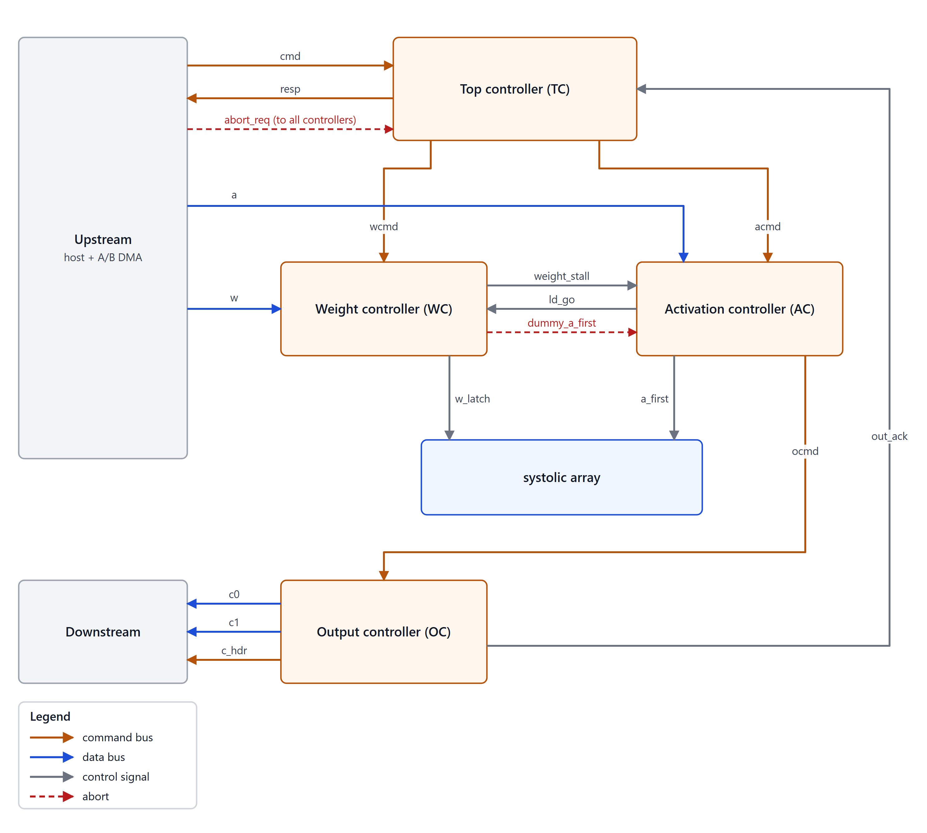
Figure 4: Control plane of gemm_top
TC turns the input descriptor into one pass command per pass, sent to WC (wcmd) and AC (acmd) together. WC and AC each manage their respective bank's pointers and decide on their own when the next tile is complete; they meet through the WC ↔ AC interlock. AC forwards the output fields of each pass command to OC (ocmd) when the pass actually starts, and OC reports each finished GEMM to TC (out_ack).
Table 4: Module hierarchy
Module | File | Role
gemm_top | prj/v1/gemm_top.sv | Top level wrapper: wiring, banks, skews, accumulator datapath
top_controller | prj/v1/top_controller.sv | Descriptor intake, tile loops, pass commands, responses, abort
weight_controller | prj/v1/weight_controller.sv | B banks, weight loads, masks, w_latch, interlock
activation_controller | prj/v1/activation_controller.sv | A banks, passes, a_first, ocmd
out_controller | prj/v1/out_controller.sv | Accumulator control, C out valids, header, out_ack
systolic, pe | rtl/systolic.sv, rtl/pe.sv | 16 × 16 array of PEs
skew, delay_line | rtl/skew.sv, rtl/delay_line.sv | Skew / deskew triangles
ram_1r1w, sync_fifo | rtl/ram_1r1w.sv, rtl/sync_fifo.sv | SRAM wrapper and control FIFOs
gemm_v1_pkg | prj/v1/gemm_v1_pkg.sv | Constants, bus structs, timing constants

2.2 Top-level ports
Table 5: gemm_top ports (DV / DVS buses listed once; the handshake is implied)
Bus | Dir | Payload | Sec
cmd | DVS in | cmd_t {ID, M, K, N}, 52 b | 3.2.1
resp | DV out | resp_t {ID, done, info}, 8 b | 3.2.2
abort_req | in | one-cycle pulse | 3.2.3
w | DVS in | one B row, 16 × int8 | 3.2.4
a | DVS in | one A row, 16 × int8 | 3.2.4
c0, c1 | DV out | C columns 0–7 / 8–15 of one row, 8 × int32 each | 3.2.5
c_hdr | DV out | c_hdr_t block header, 16 b | 3.2.6

2.3 Pass pipeline timing
Figure 5 follows one pass at full rate. The weight load for pass p starts at c = 0; pass p itself starts (AC's go) at c = 16, the same cycle the load for pass p+1 starts. From the go, every later step is a fixed offset.
Table 6: Key cycles of a pass
Event | Cycle | Source
Bank 0 weight reads (bank 1: +8) | c 0–15 (8–23) | WC load counter
weight_stall visible, AC go, next load starts | c 16 | WC flag, AC go
w_latch at the array (column 0) | c 17 | WC register
A reads, bank 0 (bank 1: +8) | G + 0–15 (G + 8–23) | AC pass counter
a_first lane j at the array | G + j | AC shift register
psum row x, column i leaves the array | G + 17 + x + i | array
OC bank 0 ACC read (bank 1: +8) | G + 23 + x | OC read stage
c0 row x valid (c1: +8); header with row 0 | G + 25 + x | OC output registers
out_ack (last pass of a GEMM) | G + 33 + (m − 1) | OC bank 1 timeline

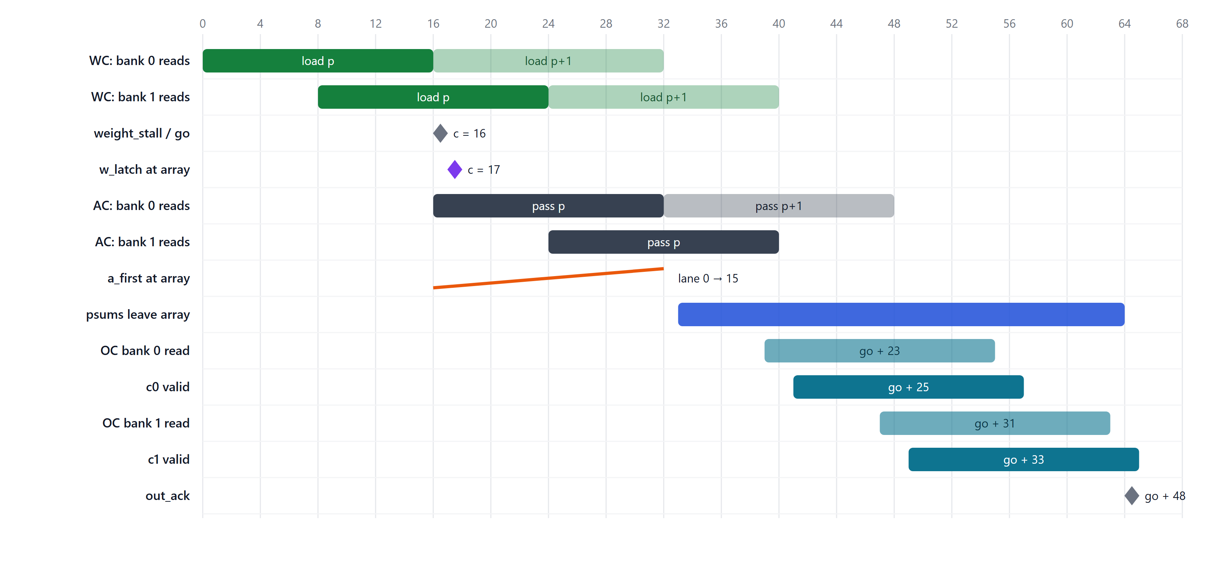
Figure 5: One pass at full rate; faded bars are the next pass

2.4 Clock and reset
- Single clock domain (clk); design uses rising edge sampling.
- rst is synchronous and active high. It clears all control state, the PE flags and the skew registers; SRAM contents and the PE weight buffers are not reset.
- abort_req is a soft reset of control state only. The array, skews and SRAMs keep running, but by clearing the pointers stale data is not read out. Useful if upstream wants to stop an incorrectly generated GEMM descriptor midstream since worst case GEMM calculation will require ~10^12 cycles to complete. The abort request will cancel all outstanding GEMM operation requests.

2.5 System expectations

Host
- Sends one descriptor per GEMM on cmd and reads resp: each accepted descriptor gets one accept and one end response, in order.
- Up to 4 GEMMs can be outstanding (TC's pending FIFO); cmd stalls beyond that.
- Keeps the IDs of outstanding GEMMs unique if it matches blocks or responses by ID (GEMMs finish in order, so order is a fallback).
- Programs upstream with the same shapes as the descriptors.
- Abort is a one-cycle pulse on abort_req; every outstanding GEMM then ends as aborted.

Upstream (A and B streams)
- Sends tiles in the loop order: for each (r, n), A tiles A_r0 … A_r,K−1 and B tiles B_0n … B_K−1,n; A is re-sent for every n and B for every r.
- Within a tile: A rows in M order; B rows in reverse K order (row k-size − 1 first).
- Sends only real rows (k-size B rows, m-size A rows per tile); lanes outside the tile are don't-care.
- May send rows before their GEMM is accepted and may pause between beats; the banks absorb both.
- After an abort, discards every beat of the aborted GEMMs it still holds and sends only the next GEMM's data (stale-beat contract). w_stall / a_stall stay high until the next GEMM's first pass command, so beats in flight are not taken.

Downstream (C and header)
- Must accept every c0, c1 and c_hdr beat in the cycle it is valid (no stall signal).
- Uses the block header (one per block, with its first c0 row) and the output contract (described in Sec 3.2.5–3.2.6): fixed c1 = c0 + 8 timing, m-size rows per block, lanes ≥ n-size are 0.
- After an abort, treats the next header with r_first && n_first as the start of a new GEMM; the aborted GEMM's last block may be cut short.

2.6 Operation

2.6.1 Normal pass sequence
- TC accepts a descriptor (accept response) and issues one pass command per pass to WC and AC, as fast as their 4-entry FIFOs take them.
- WC writes B rows into its banks as they arrive. When the head command's tile is complete (and the interlock allows), it starts a 16-cycle load: zero rows first for a short K tile, then the tile's rows, bank 1 eight cycles behind.
- At c = 16 WC raises weight_stall; AC, holding the matching A rows, starts the pass in the same cycle (go), which also lets WC start the next load.
- w_latch reaches PE[0][0] at c = 17 and a_first one cycle earlier, at c = 16: the PEs latch the new tile, switch their weight select to it, and compute with it as the pass's first A row arrives at c = 17.
- AC forwards the pass's output fields to OC at the go. OC accumulates the 16 psum rows into the ACC; on the block's last pass it outputs them on c0 / c1 with a header on row 0.
- On the GEMM's last pass OC raises out_ack; TC sends the end response.

2.6.2 Back-to-back GEMMs
WC and AC see only a stream of pass commands, not GEMM boundaries, and TC accepts the next descriptor as soon as it has issued the current GEMM's last pass. So the next GEMM's first weight load overlaps the current one's last pass and GEMMs run without a bubble: measured, the next GEMM's first go comes exactly 16 cycles after the previous GEMM's last. Fill and drain are paid once per run of GEMMs.

2.6.3 Edge tiles
Table 7: Edge-tile handling
Partial dim | Handled by | Action
K (k-size < 16) | WC | The load still takes 16 cycles: 16 − k-size zero rows first (no read, bank output forced to 0), then the k-size rows. They land in PE rows 0..k-size − 1. A lanes ≥ k-size meet zero weights.
M (m-size < 16) | AC, OC | AC reads the m-size rows first and idles for the rest of the 16-cycle pass; OC never outputs psum rows ≥ m-size.
N (n-size < 16) | WC, OC | WC's column mask zeroes weight columns ≥ n-size, so those C lanes are exactly 0. With n-size ≤ 8, c1 is idle for the block.

2.6.4 Abort
A one-cycle abort_req reaches all four controllers.
- TC moves to ST_ABORT and sends one aborted end response per outstanding ID, one per cycle; cmd stalls meanwhile.
- WC and AC clear their pointers, command FIFOs and counters; WC clears its interlock flag and pending w_latch, AC drops a go in the abort cycle. Both hold their input stall high until the next GEMM's first pass command.
- OC clears its FIFO, start delay and pipeline, so no further c0 / c1 / c_hdr valid or out_ack appears for aborted passes.
- The array is not reset, so its weight double-buffers must end consistent. Two rules ensure it: a_first diagonals already in flight are kept, and if a tile's w_latch reached the array but its pass never started, WC raises dummy_a_first and AC sends one a_first diagonal with no data (Figure 6).
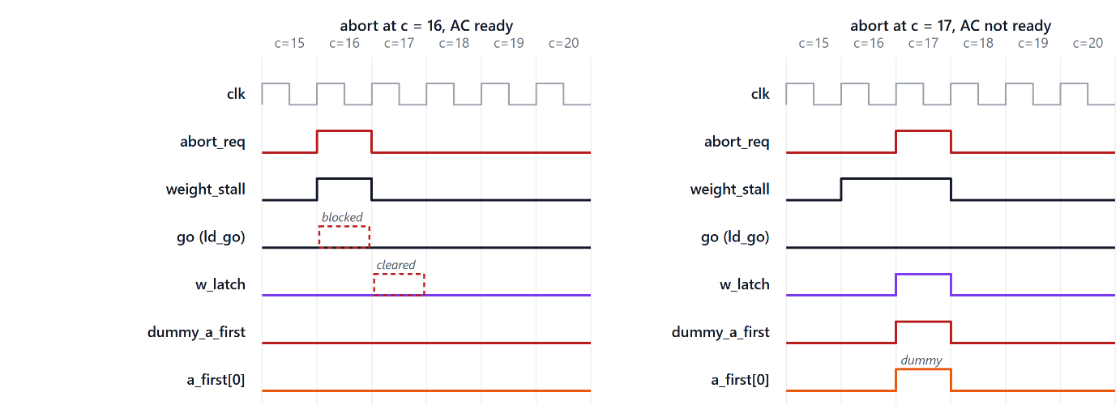
Figure 6: Abort at c = 16 with AC ready (left) and at c = 17 with AC not ready (right); dashed red boxes are pulses the abort removes

3. Interfaces

3.1 Protocol conventions
- DVS (data / valid / stall): a beat transfers in a cycle where valid is high and stall is low, and only then.
- Sinks never assume valid is held: a beat that is withdrawn before it transfers simply did not happen. External sources should hold valid and the data until the transfer (AXI-style); internally, the shared command stall may withdraw valid.
- Every stall comes from registered state; no stall depends on the valid presented in the same cycle.
- DV (data / valid): no backpressure; the sink takes every valid beat.
- Size fields are 4 bits with 0 = 16; descriptor dimensions are 16 bits with 0 = 65 536.
- Structs are packed with the first field in the MSBs.

3.2 External interfaces

3.2.1 cmd (DVS in): GEMM descriptor
Table 8: cmd_t, 52 b
Field | Bits | Meaning
id | 51:48 | GEMM descriptor ID
m | 47:32 | Rows of A and C (elements; 0 = 65 536)
k | 31:16 | Columns of A / rows of B
n | 15:0 | Columns of B and C

TC takes a descriptor only when it has issued every pass of the current GEMM and fewer than 4 GEMMs are outstanding. A descriptor accepted in the abort cycle is aborted too.

3.2.2 resp (DV out): responses
Table 9: resp_t, 8 b
Field | Bits | Meaning
id | 7:4 | Descriptor ID
done | 3 | 0 = accept, 1 = end
info | 2:0 | Accept: warning bits, bit 0/1/2 = M/K/N field was 0. End: status, 0 = OK, 3 = aborted (1, 2 reserved)

Per accepted descriptor: one accept when it is taken, one end when its last C row has left (out_ack) or when it is aborted, all in command order. At most one accept and one end are produced per cycle; a collision delays the end by one cycle (one holding register in TC).

3.2.3 abort_req (in)
One-cycle pulse. Drops all pending work. TC sends an abort end response for every pending descriptor req.

3.2.4 w and a (DVS in): input streams
Table 10: Input streams
Bus | Data | Stall high when
w | w_data[15:0] × int8: one B row (lane = N column) | all 32 B bank slots hold rows bank 1 still needs; or from an abort until the next GEMM's first wcmd
a | a_data[15:0] × int8: one A row (lane = K column) | all 32 A bank slots hold rows bank 1 still needs; or from an abort until the next GEMM's first acmd

3.2.5 c0, c1 (DV out): C half-rows
Table 11: C output streams
Bus | Data | Timing
c0_out, c0_valid | C columns 0–7 of one row, 8 × int32 | row x of a block at G + 25 + x (G = go of the block's last pass)
c1_out, c1_valid | C columns 8–15, 8 × int32 | exactly 8 cycles after c0 row x; only if the block's n-size > 8

- Each active half sends exactly m-size rows per block, on consecutive cycles, in the loop order.
- Lanes ≥ n-size are 0 (c0: lanes ≥ min(n, 8); c1: lanes ≥ n − 8).
- A c1 row can arrive after the next block's header: blocks overlap by up to 8 cycles, and a short next block (even a whole short GEMM) can finish on c0 first (Figure 7). Downstream labels c1 rows by the fixed offset.
- The halves are never realigned in the engine (that would cost about 2k flops); each half can write its own downstream bank.
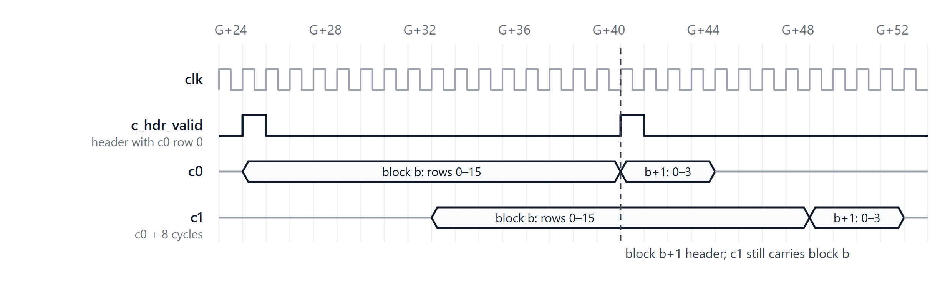
Figure 7: Output streams across a block boundary: block b+1's header arrives while c1 still carries block b

3.2.6 c_hdr (DV out): block header
Table 12: c_hdr_t, 16 b
Field | Bits | Meaning
r_first | 15 | First block row of the GEMM
r_last | 14 | Last block row of the GEMM
n_first | 13 | First block column
n_last | 12 | Last block column
m_size | 11:8 | Rows in this block (0 = 16)
n_size | 7:4 | Columns in this block (0 = 16)
id | 3:0 | Descriptor ID

Valid once per block, in the cycle of its first c0 row; every block has one. A GEMM starts with the header that has r_first && n_first and ends with the last row of the block with r_last && n_last. Note: if the last block’s n-size is ≤ 8, the last c1 data will not appear (since cols 8-15 are not active) and so the last set of transactions will be c_hdr + c0 data and not c_hdr + c0 + c1.

3.3 Internal command buses

3.3.1 wcmd (DVS, TC → WC)
Table 13: wcmd_t, 11 b
Field | Bits | Meaning
k_size | 10:7 | Rows of this B tile (0 = 16)
n_size | 6:3 | Columns of this B tile
tag | 2:0 | Pass index mod 8 (for internal checking and debug)

3.3.2 acmd (DVS, TC → AC)
Table 14: acmd_t, 26 b
Field | Bits | Meaning
k_size | 25:22 | Number of columns of this A tile
first | 21 | k = 0
last | 20 | k = last of the block
gemm_last | 19 | Final pass of the GEMM (= last && r_last && n_last)
r_first | 18 | Block position (for the output header)
r_last | 17 | Block position (for the output header)
n_first | 16 | Block position (for the output header)
n_last | 15 | Block position (for the output header)
m_size | 14:11 | Number of rows of this A tile; rows OC outputs
n_size | 10:7 | Columns OC outputs
id | 6:3 | Descriptor ID
tag | 2:0 | Pass index mod 8

3.3.3 ocmd (DV, AC → OC)
Field | Bits | Meaning
first | 21 | k = 0
last | 20 | k = last of the block
gemm_last | 19 | Final pass of the GEMM (= last && r_last && n_last)
r_first | 18 | Block position (for the output header)
r_last | 17 | Block position (for the output header)
n_first | 16 | Block position (for the output header)
n_last | 15 | Block position (for the output header)
m_size | 14:11 | Number of rows of this A tile; rows OC outputs
n_size | 10:7 | Columns OC outputs
id | 6:3 | Descriptor ID
tag | 2:0 | Pass index mod 8

3.3.4 out_ack (OC → TC)
One-cycle pulse when a GEMM's last C row has left, generated on bank 1's timeline (G + 33 + m − 1 of the GEMM's last pass). TC ends its oldest outstanding GEMM; GEMMs finish in order, so the pulse carries no ID. Bank 1 runs every pass even when c1 is idle, so pulses are in GEMM order and never coincide.

3.4 Point-to-point signals

3.4.1 WC - AC interlock
Table 15: Interlock signals
Signal | Dir | Meaning
weight_stall | WC → AC | A tile is being latched into the PEs' idle buffers and its pass has not started. Set so that it is visible at c = 16; cleared by ld_go
ld_go | AC → WC | AC's go this cycle: the pass for the latched tile starts, so WC may start the next load
dummy_a_first | WC → AC | Abort cycle only: a latched tile's pass never started; AC sends one dummy a_first diagonal.

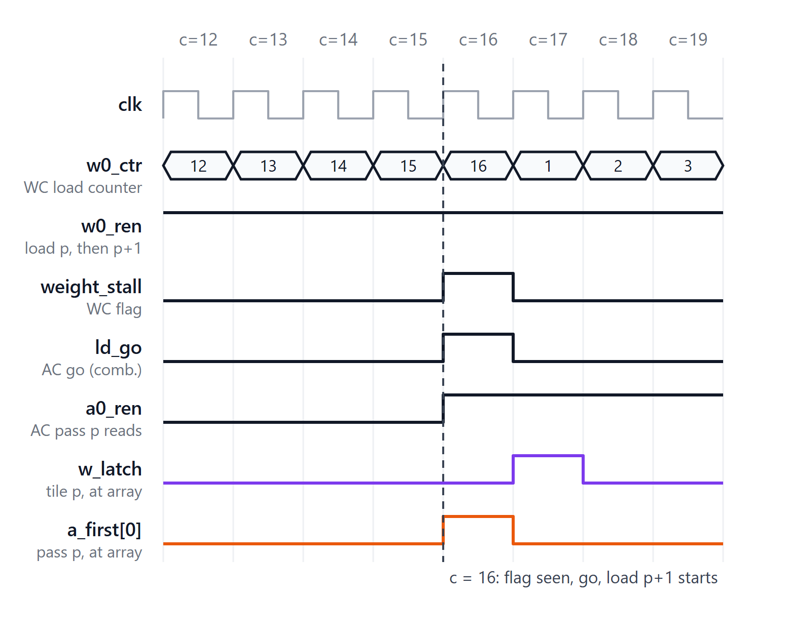
Figure 8: WC - AC interlock at full rate: flag, go and the next load all at c = 16
WC starts a load only when the shadow buffers are free: !weight_stall || ld_go. AC starts a pass only when weight_stall is high (the tile will be latched in time). The path weight_stall flop → AC go logic → WC start logic is combinational but has no loop.

3.4.2 Array control
Table 16: Array control signals
Signal | From | Meaning
w_latch | WC | Registered pulse at c = 17, broadcast to all 16 rows at column 0; the PEs carry it one column per cycle, matching the weight skew
a_first[15:0] | AC | Per-lane pulse, one cycle ahead of a pass's first A row: lane j at G + j (the next state of a 16-stage shift register fed by the go, so bank 1's lanes see the +8 offset too)

3.4.3 Bank RAM ports
Each ram_1r1w bank gets we, waddr, re, raddr from its controller; wmask is all ones. Banks 0 and 1 of A and B are written in the same cycle at the same address (one row per beat); bank 1 reads follow bank 0's by S cycles.

3.4.4 Datapath controls
Table 17: Datapath control signals
Signal | From | Meaning
w0_zero, w1_zero | WC | This cycle's B bank output is a padding row (K edge): force it to 0. Aligned with rdata; bank 1's is 8 cycles later
w_col_mask[15:0] | WC | Lane ≥ n-size of the tile being loaded: force that weight lane to 0. Latched per load (bank 1's copy 8 cycles later)
c0_first, c1_first | OC | Sum stage of a block's first pass: add 0 instead of the ACC read data
c0_oen, c1_oen | OC | Sum stage of an output row: load the C out register (cX_valid follows a cycle later)

4. Submodules

4.1 Top controller (TC)
TC accepts descriptors, walks the tile loops and issues one pass command per pass. It owns the response channel and the abort drain.
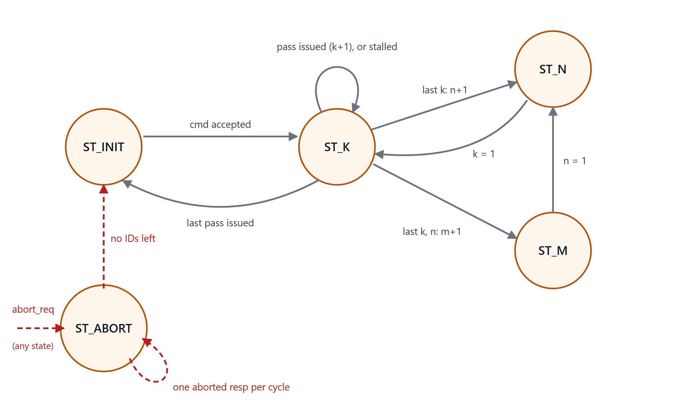
Figure 9: TC state machine
Table 18: TC states
State | Action
ST_INIT | Idle. On cmd_valid with room in the pending FIFO: latch the descriptor, set the k / n / m counters to 1, push the ID, send the accept response, go to ST_K
ST_K | Drive wcmd and acmd for the current (r, n, k). On a transfer: k + 1; at the end of the k loop go to ST_N (n + 1), at the end of the n loop to ST_M (m + 1), after the GEMM's last pass to ST_INIT. Stays while stalled
ST_N | One cycle: k = 1, back to ST_K
ST_M | One cycle: n = 1, to ST_N
ST_ABORT | One aborted end response per cycle for each ID in the pending FIFO, oldest first; ST_INIT when empty

- Loop order: for r (block rows), for n (block columns), for k: k innermost so a block finishes before the next starts.
- Tile sizes: 16, or the dimension's low 4 bits on its last tile (both encoded as 4 bits with 0 = 16). first = (k counter = 1), last / r_last / n_last = the loop-end flags.
- Pending FIFO (sync_fifo, 4 × 4 b): IDs of outstanding GEMMs, pushed at accept, popped at the end response.
- Responses: a registered resp output; an out_ack that collides with an accept is held one cycle (ack_hold). Ends are at least a cycle apart, so one holding register is enough.
- Issue rate: one pass command per cycle in ST_K; the one-cycle ST_N / ST_M steps are hidden by the units' 4-entry FIFOs.

4.2 Weight controller (WC)
WC owns the two B banks: it writes the B stream into them, loads one tile per pass command into the PEs' idle weight buffers, and drives w_latch, the padding masks and its side of the interlock.

Write side
- Pointers carry one wrap bit (6 bits for 32 rows): wptr (rows written), rptr0 / rptr1 (rows read by bank 0 / bank 1).
- A row is written whenever a slot is free: occupancy = wptr − rptr1, counted from bank 1 because bank 1 reads each row last. w_stall = occupancy == W_DEPTH, or the abort hold.
- Both banks are written at wptr in the same cycle.

Commands and load start
- wcmd FIFO stores 4 outstanding requests.
- To begin loading data into the systolic array:
  - A command is present (FIFO not empty)
  - Enough rows written into banks, i.e. (wptr − rptr0) ≥ k-size
  - The load counter is idle or at 16 (prev load is completed).
  - The shadow buffers are free.
- The load counter runs 1..16; a new load can start from 16, so loads are back-to-back.

Read side and masks
- Bank 0 reads in the last k-size cycles of the load; the first 16 − k-size cycles are padding rows.
- Bank 1's read enable and zero flag are bank 0's delayed by S = 8 cycles (delay S).
- The tile's n-size is latched at the load start (bank 0's mask) and copied 8 cycles later (bank 1's), giving w_col_mask.

Interlock, w_latch, abort
- weight_stall is set when the load reaches its last read (visible at c = 16) and cleared by ld_go.
- w_latch is registered from w0_ctr == T, reaching the array at c = 17.
- Abort clears pointers, FIFO, counter, delay line, flag and w_latch. dummy_a_first = abort ∧ weight_stall ∧ (w0_ctr != T): in the load's c = 16 the flag is set but w_latch is still in its register (and is cleared), so no dummy is needed. w_stall is held from the abort until the next wcmd.
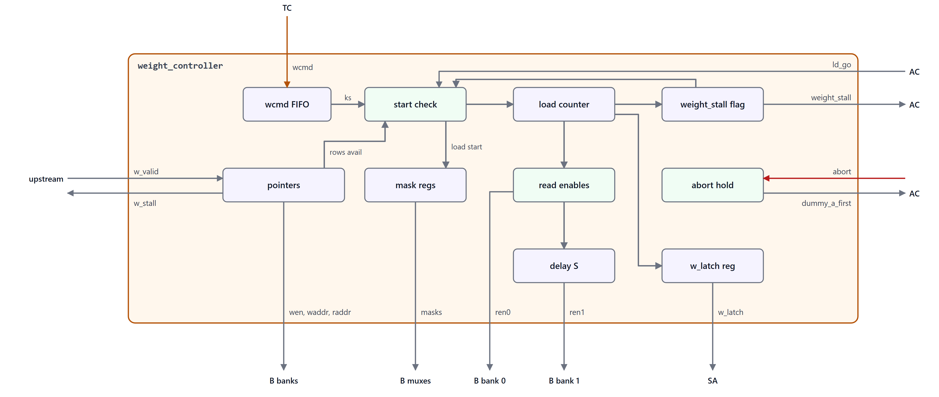
Figure 10: Weight controller high level diagram

4.3 Activation controller (AC)
AC mirrors WC for the A banks and starts each pass (the go). Figure 11 shows its structure.
- Same write side as WC (per-row gating on banks 0/1, occupancy from bank 1, a_stall with the abort hold).
- acmd FIFO, 4 × 26 b. AC starts each pass 16 cycles after WC starts the weight load.
- Go: weight_stall ∧ head present ∧ (wptr − rptr0 ≥ m-size) ∧ pass counter idle or at 16 ∧ !abort_req. The go is ld_go to WC and ocmd_valid to OC, and enters the a_first shift register.
- Reads: bank 0 reads the m-size real rows first (a0_ctr_next ≤ m-size), then idles for the rest of the pass; bank 1 is bank 0 delayed by S. “A” lanes ≥ k-size need no masking since they meet the zero weight rows WC loads. Rows past m-size are not sent, and OC does not output them.
- a_first: a 16-bit shift register fed by the go (or dummy_a_first); lane j is j cycles behind lane 0. The array takes its next state, so lane j arrives at G + j, one cycle before its first A row. It is not cleared on abort, so a diagonal in flight completes and the dummy (entered in the abort cycle) is delivered.
- ocmd: the head's low 22 bits, valid with the go. AC handles the generation instead of TC because adding ocmd txfer to TC would mean extra FIFO depth needed (same cmd is stuck in 3 places across 3 different pass-time segments) and needs extra wiring back to TC. Now AC can decide when to write the ocmd_data.
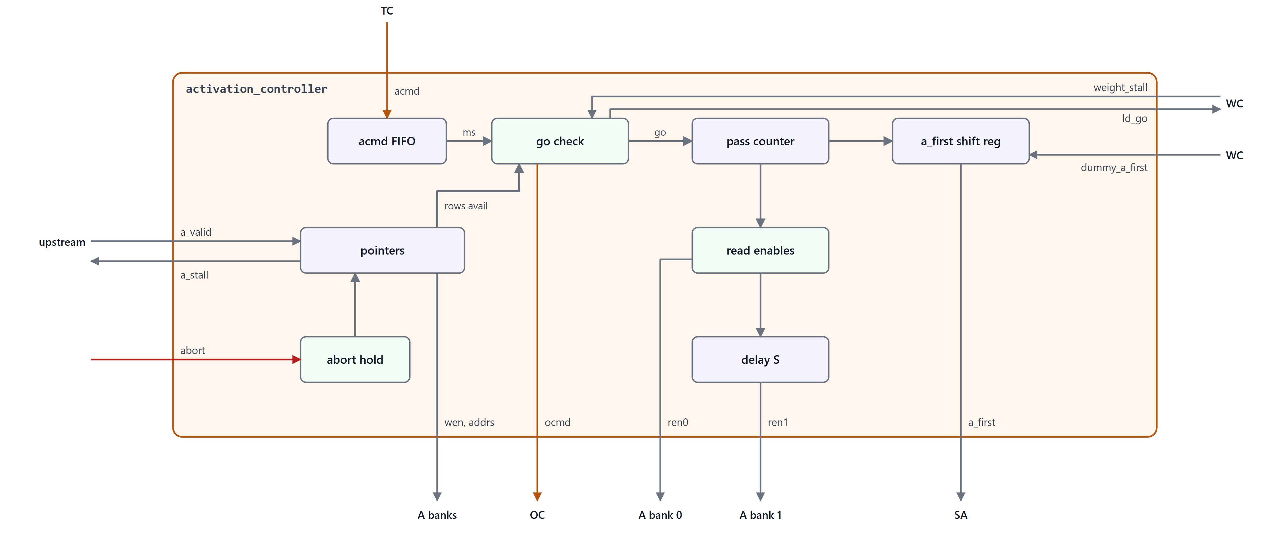
Figure 11: Activation controller high level diagram

4.4 Output controller (OC)
OC is timed entirely from AC's go (cycle G). Each bank has a read stage (row x: ACC read and decode of the pass fields) and a sum stage one cycle later (psum + ACC data: write-back or output). Everything the sum stage needs is decoded in the read stage and registered.
- ocmd FIFO, 4 × 22 b: pushed at each go; the head is bank 0's active pass and is popped at its last read (OC_POP = G + 38). Up to 3 entries are live (each lives 38 cycles, gos are 16 apart).
- Go delay: the go delayed by OC_RD_START = 23 starts bank 0's 16-row counter, so its read of row x is at G + 23 + x, one cycle before the deskewed psum row arrives (OC_PSUM_LAT = 24).
- Bank 1 latches the pass fields when bank 0 reaches row S and reads S cycles later; its row index is a 4-bit counter that wraps every pass.
- Decode (per row x):
  - output row = last ∧ (x < m-size) (bank 1 also needs n-size > 8)
  - write-back = !last
  - cX_first = first
  - header = bank 0 output row 0
  - out_ack = gemm_last ∧ (x = m-size – 1) (on bank 1's timeline).
- Output registers: cX_valid, c_hdr_valid / c_hdr_data and out_ack one cycle after the sum stage, aligned with the C out registers.
- Abort clears the FIFO, go delay, counters and all stage registers.
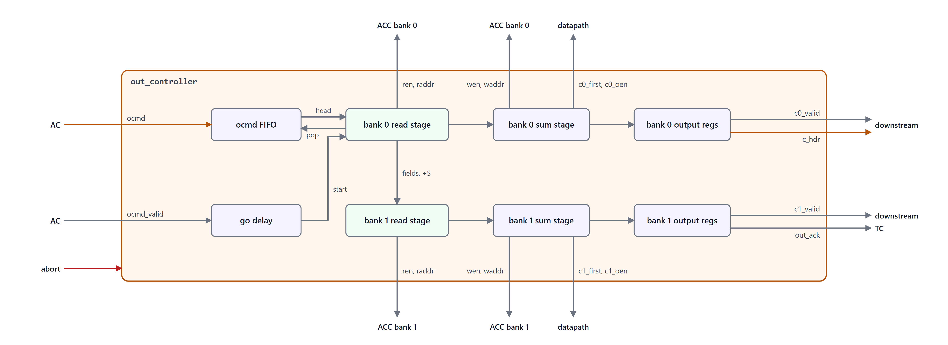
Figure 12: Output controller high level diagram

4.5 Accumulator datapath
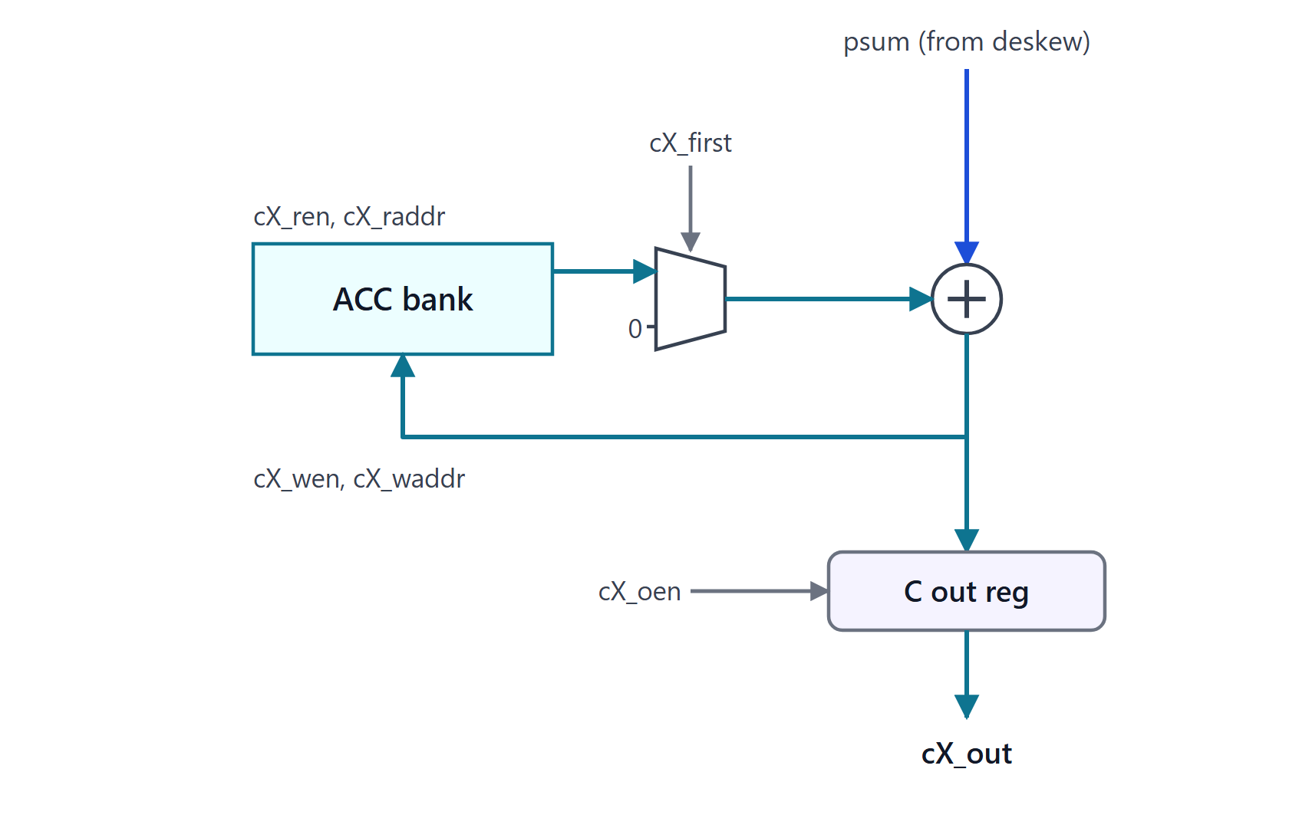
Figure 13: Accumulator datapath, one bank
- Per bank: sum = psum (sign-extended, 20 → 32 b) + (cX_first ? 0 : ACC read data).
- The sum is the ACC write data (cX_wen, non-last passes) and is loaded into the C out register on output rows (cX_oen).
- Row x is read at G + 23 + x and written at G + 24 + x; the next pass reads it 16 cycles later, so the read → add → write loop (2 cycles) never collides, and a read and write in one cycle are always to different rows.
- A block's first pass never uses the ACC data, so stale (or never-written, X) ACC contents never reach C.

4.6 Systolic array and PE
The module systolic (M = 16, NA = 8, NPIN = 20) is a 16 × 16 grid of pe. Activations enter the left edge (lane j = row j = K index j) and move right; weights and psums move down (lane i = column i = N index i); a_first travels with the activations and w_latch with the columns. Each PE computes p_out = p_in + a × w (registered) with its active weight.
Each PE double-buffers its weight with three flags: flag (active buffer), upd (buffer being loaded) and lock (loading stopped).
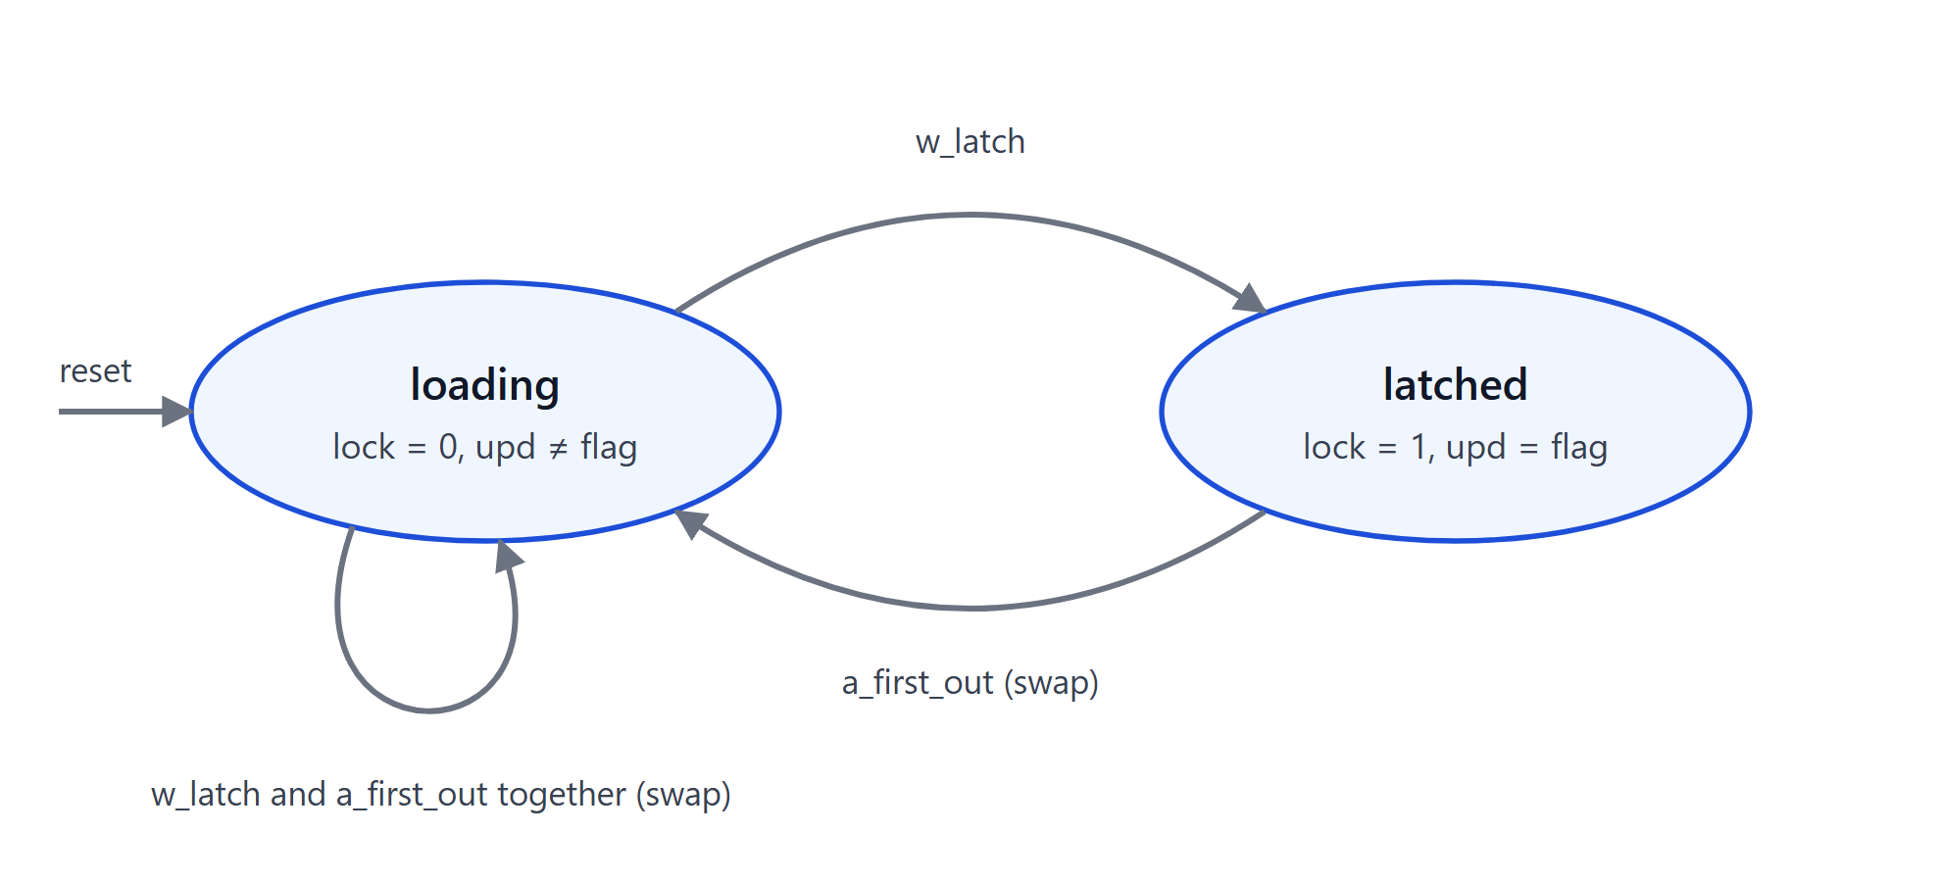
Figure 14: PE weight-buffer states
Table 19: PE weight-buffer states
State | Flags | Meaning
loading | lock = 0, upd != flag | The idle buffer shifts in the next tile while the active one computes
latched | lock = 1, upd = flag | The next tile is held; waiting for its pass's a_first

- w_latch stops the shift (loading → latched); a_first swaps to the new tile and resumes loading into the old one (latched → loading). At full rate w_latch and the registered a_first_out coincide at PE[0][0] (c = 17) and the PE goes straight from loading to loading on the new tile.
- On abort: an extra a_first while loading, or a missing one while latched, leaves the buffers inconsistent for the next GEMM, hence the abort rules in Sec 2.6.4.
Weight select and clock gating. a_first reaches each PE one cycle before its first A row. The PE flips flag on it, so the multiplier takes its weight straight from a register (flag ? weight1 : weight0) and the select stays off the multiply path; lock follows the registered copy a_first_out, which coincides with w_latch. The two weight buffers load only on their enable and have no reset, so synthesis gates their clocks: there are 512 of them, and each changes value in about a quarter of the cycles. Synthesis cannot gate a flop with a synchronous reset, and none is needed: a weight buffer is always written before it is read.

4.7 Skew, deskew and delay lines
- delay_line (D, W): a D-stage register chain of width W; D = 0 is a wire.
- skew (N, W, INCR, START_Z): N delay lines. With INCR = 1, lane j is delayed j (input skew); with INCR = 0, lane j is delayed N − 1 − j (deskew).
- Four input triangles (A and B, two halves each, 8 b) and two output triangles (20 b). The 8-cycle offset between halves comes from bank read timing, not from registers.
Their storage is listed in Sec 5.3.

4.8 Infrastructure
- ram_1r1w (EW, NE, DEPTH, RDW_X): one write and one read port, synchronous read (data one cycle after re, held while re is low), per-element write mask, no reset. With RDW_X = 1 a read of the address being written returns X; bring-up ran every regression in both modes, so the design never depends on it.
- sync_fifo (W, DEPTH): flop-based, first-word fall-through; full / empty from registered state; clr flushes (used on abort).

5. Memories and storage

5.1 SRAM instances
Table 20: SRAM instances (all ram_1r1w: 1 read + 1 write port, 1-cycle synchronous read)
Instance | Purpose | Depth × width | Bits | Controller
u_wei_buf0, u_wei_buf1 | B bank 0 / 1 | 32 × 64 b | 2 × 2048 | WC
u_act_buf0, u_act_buf1 | A bank 0 / 1 | 32 × 64 b | 2 × 2048 | AC
u_out_buf0, u_out_buf1 | ACC bank 0 / 1 | 16 × 256 b | 2 × 4096 | OC
Total |  |  | 16 384 (2 KB)

5.2 FIFOs
Table 21: Command and ID FIFOs (sync_fifo)
FIFO | Entries × width | Contents
TC pending | 4 × 4 b | IDs of outstanding GEMMs
WC command | 4 × 11 b | wcmd_t
AC command | 4 × 26 b | acmd_t
OC command | 4 × 22 b | ocmd_t

5.3 Flop arrays
The large flop arrays are listed below; controller state outside them (pointers, counters, flags, FIFO storage) is a few hundred flops in total.
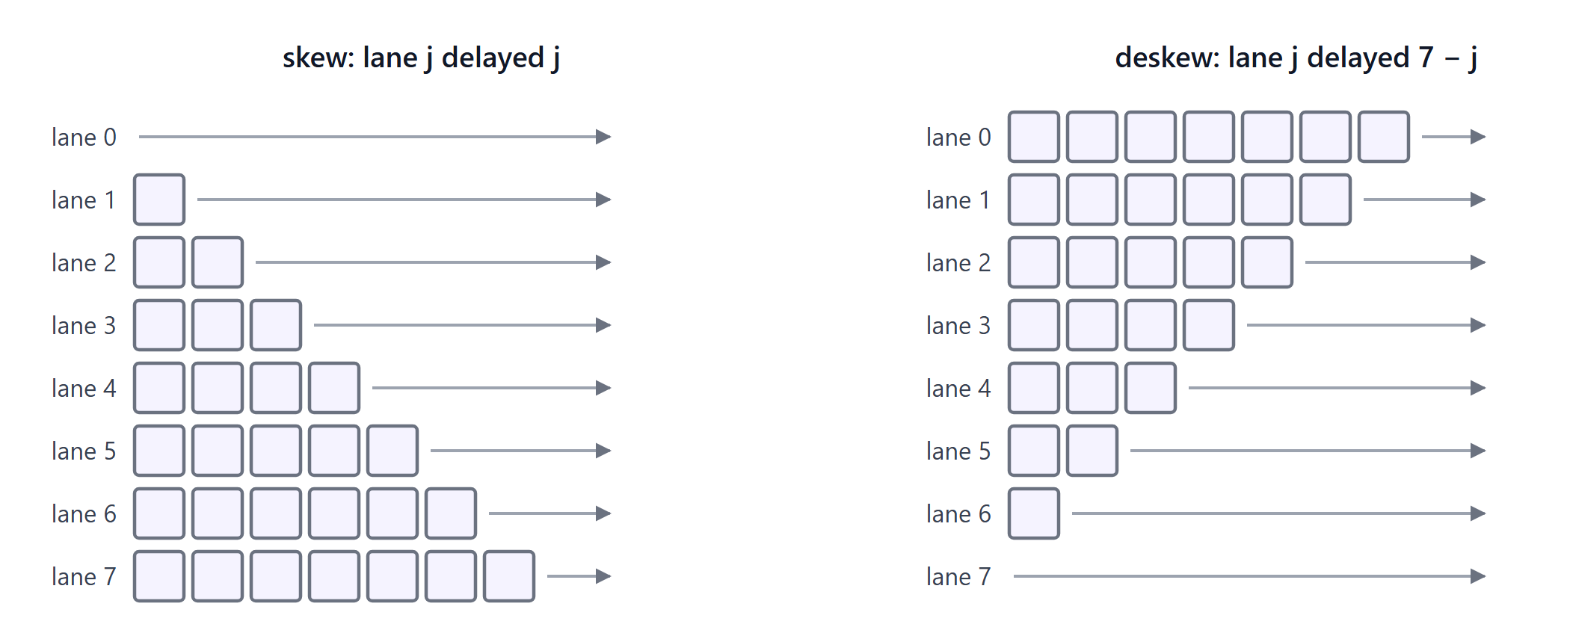
Figure 15: Skew and deskew triangles (one register per square, one lane wide)
Table 22: Large flop arrays
Array | Structure | Flops
A input skews | 2 triangles × 28 regs × 8 b | 448
B input skews | 2 triangles × 28 regs × 8 b | 448
Psum deskews | 2 triangles × 28 regs × 20 b | 1 120
C out registers | 2 × 8 × 32 b | 512
PE array | 256 PEs × 49 (2 weights, activation, psum, flags) | 12 544
WC / AC / OC delay lines | WC: 2 × 8 (read enable, zero flag); AC: 8 + 16 (a_first); OC: 23 (go delay) + 8 | ≈ 80

6. Performance
Cycles from a descriptor's accept to its last C row, with the input streams ready:
cycles ≈ 16 · ceil(M/16) · ceil(N/16) · ceil(K/16) + 64
- Fill, 32 cycles: the first B tile's 16 rows arrive, then the 16-cycle weight load, before the first go.
- Drain, 48 − 16 cycles: the last pass's last c1 row leaves 48 cycles after its go (array, deskew, registers, c1 offset, 15 rows); its own 16 cycles are already counted.
- Back-to-back GEMMs pay fill and drain once per run.
Table 23: Measured on the RTL (16.00 cycles per pass in every case)
Workload | Passes | Cycles | Utilization
48×48 · 48×64 | 36 | 640 | 90.0%
4 × (48×48 · 48×64), back to back | 144 | 2 368 | 97.3%
8 random shapes ≤ 100, back to back | 240–348 | 3 887–5 630 | 98.8–98.9%

Latency: a pass's first C row leaves 25 cycles after its go (c1: 33); a GEMM's end response follows its last C row on bank 1's timeline.

7. Verification summary
- An end-to-end testbench drove gemm_top from descriptors and A/B streams (stream contract followed, padding lanes filled with garbage) and compared every C row, block header, out_ack and response with an exact reference GEMM, plus each pass's psums at the array and deskew outputs, the a_first diagonal, the pass-command fields and the WC/AC tile tags.
- Shapes from 1 to 100 per dimension and K = 65 536 with extreme values; random gaps on both streams; back-to-back GEMMs; out_ack/accept collisions; aborts swept over every pass phase with 0–4 GEMMs outstanding; every SRAM in both RDW_X modes. All runs pass.
- Deliberate faults (no dummy a_first, clearing a_first on abort, wrong output timing or fields, a wrong bank-1 mask) are caught.
- A file-driven testbench runs a real workload, a bank of 16 int8 3 × 3 filters over grayscale video frames via im2col (31 654 × 9 × 16 per frame): bit-exact on the RTL (three frames, 189 924 C rows) and on the routed netlist simulated with zero-delay cell models (one frame, 63 308 C rows and 1 979 headers).

8. Implementation results

8.1 Synthesis
Pre-layout results for gemm_top: Yosys and OpenSTA through OpenROAD-flow-scripts (Docker image openroad/orfs, digest sha256:90683468be0f), Nangate45 typical corner (1.10 V, 25 °C). The scripts are in syn/. Every buffer is synthesized as flops (the Nangate45 platform only has single-port SRAM models, so no SRAM macros are used). Timing uses an ideal clock and the library's default wire-load model; the routed results follow.
Table 24: Synthesis results (flat netlist, pre-layout)
Metric | Value
Cell area | 372 034 µm² (0.37 mm²)
Cells / flops / clock gates | 145 669 / 32 114 / 696
Sequential share of area | 39%
Minimum clock period | 1.525 ns (≈ 656 MHz); I/O paths need at most 0.858 ns
Hold | Met (ideal clock)
Table 25: Cell area by block (hierarchical synthesis)
Block | Area (µm²) | Share
Systolic array: 256 PEs, ≈ 1 000 µm² each | 255 970 | 64.6%
Accumulator banks: 2* 8 Kb of flops | 55 009 | 13.9%
Activation banks: 2* 4 Kb of flops | 28 856 | 7.3%
Weight banks: 2* 4 Kb of flops | 28 579 | 7.2%
Skew and deskew triangles: 6 | 13 813 | 3.5%
gemm_top own logic | 8 512 | 2.1%
TC, WC, AC, OC with their FIFOs | 5 756 | 1.5%
Total | 396 495 | 100%
Hierarchical synthesis keeps every module boundary, so its total is about 7% above the flat netlist. The buffers, 16 Kb of flops, are 28% of the area; SRAM macros would shrink them.
Critical path: From a PE's weight_flag register through its weight-select mux, the 8 × 8 multiply and the 20-bit psum add into p_out: 1.44 ns plus setup before layout.
Clock target: Synthesis maps with ABC's speed script, which does not use the clock period, so the netlist is the same for any target; place and route closes 1.3 ns.

8.2 Place and route
The same flow places and routes the flat netlist (syn/run.sh pnr) at a 1.3 ns clock and 75% core utilization (0.82 placement density), with clock gating and hold repaired to a 0.05 ns margin. It routes with no DRC violations and closes timing.
Table 26: Place-and-route results, Nangate45 typical corner
Metric | Value
Minimum clock period | 1.30 ns (≈ 770 MHz)
Peak throughput | 256 MACs × 2 ops × 770 MHz ≈ 394 GOPS (int8)
Setup / hold slack | 0.00 / +0.04 ns
Critical path | PE weight register → weight select → 8 × 8 multiply → 20-bit psum add → p_out
Cell area | 389 966 µm²
Die | 0.50 mm² (706 µm square), 79% utilization
Timing-repair buffers | 11 059
Clock tree | 9 208 buffers, 2 267 inverters, 696 clock gates; setup skew 0.31 ns
Routing | 0 DRC violations; metal2 61% and metal3 46% of tracks used
Worst IR drop | 5.0 mV
Gate-level simulation | bit-exact on one filter-bank frame
Clock gating gates every flop with an enable: 512 gates on the PE weight buffers, the rest on bank words and controller registers. Each gated flop loses its hold mux, which also shrinks the cell area. The gated branches are harder for clock-tree synthesis to balance, so hold is repaired to a 0.05 ns margin.
Table 27: Earlier experiments: initial RTL and placement density
Metric | Initial RTL, 1.5 ns, 40% util | Final RTL, 1.3 ns, 40% util | Final RTL, 1.3 ns, 75% util
Minimum clock period (ns) | 1.50 | 1.30 | 1.30
Cell area (µm²) | 430 999 | 390 823 | 389 966
Die (mm²) | 1.06 | 0.93 | 0.50
Timing-repair buffers | 6 967 | 11 934 | 11 059
Critical path | a_first → weight select → multiply | weight register → multiply | same
The initial RTL computed each PE's weight select from a_first in the same cycle, behind the buffering of a_first's fanout; that path held it to 1.5 ns. Taking the select from a register closes 1.3 ns, and the gated flops lose about 10% of the cell area. At 75% utilization the die shrinks by 46% at no cost in timing.
Corner: Timing is met at the typical corner (1.10 V, 25 °C) with 50 ps of clock uncertainty. The Nangate45 library in this flow ships no other corner, so the slow-corner setup and fast-corner hold analysis that signoff needs is not available.
Equivalence: The flow's final equivalence check needs more than the 8 GB of memory available and was skipped; a gate-level simulation of the routed netlist stands in for it.

8.3 Power
Power comes from a gate-level simulation of the routed netlist with zero-delay cell models: every net is dumped over 1 000 steady-state cycles, and OpenSTA reads the VCD and computes power with the extracted parasitics, at 500 MHz, Nangate45 typical corner.
Table 28: Power at 500 MHz by workload
Workload | Total (mW) | Excl. buffers (mW) | Array (mW) | Clock tree (mW) | Per useful MAC (pJ)
Random int8 GEMMs: 4 × 48×48 · 48×64, full rate | 257 | 209 | 151 | 40 | 2.01
3 × 3 filter bank (16 filters) over a 240×135 grayscale frame, im2col: K = 9, padding lanes zero | 168 | 150 | 93 | 40 | 2.34
The same with random padding lanes | 176 | 154 | 97 | 40 | 2.44
Idle: clock running, waiting for data | 57 | 53 | 14 | 38 | –
Table 29: Power by block, filter-bank workload (logic counted with the block of the flop it feeds)
Block | Power (mW) | Share
Systolic array | 93.2 | 55.3%
Clock tree | 39.7 | 23.6%
Skew and deskew triangles | 9.7 | 5.7%
Logic driving the output ports | 7.6 | 4.5%
gemm_top own logic | 5.1 | 3.0%
Activation banks | 4.9 | 2.9%
Weight banks | 4.9 | 2.9%
TC, WC, AC, OC | 2.2 | 1.3%
Accumulator banks | 1.1 | 0.6%
Total | 168.4 | 100%
Without the buffers: Counting each buffer's flops, the logic feeding them and their share of the clock tree, the buffers draw 48, 18, 22 and 3 mW in the four workloads; the rest of the engine draws 209, 150, 154 and 53 mW: 1.63 pJ per MAC on random GEMMs and 2.09 pJ per useful MAC on the filter bank. SRAM macros would add their own read and write energy.
Clocking: The engine draws 57 mW when idle, with nearly all of it clocking: the clock tree (38 mW) and the clock pins of the flops that are not gated (13 mW). The 696 clock gates stop the flops behind them, including the PE weight buffers, but they sit at the leaves: the tree above them draws about 40 mW in every workload. Gating the whole array when no pass is in flight would stop that too.
Real data toggles less: Image data cuts the array's power by 38% against random int8 (93 against 151 mW).
Padding lanes: Random instead of zero padding costs 7.5 mW (4.3%) with about half in the A banks and half in the array's a_out registers (the zero weights keep the products themselves at zero). An upstream that pads with zeros would save that power. Alternately masking padding lanes in AC would recover it for any upstream, at the cost of a 128-bit mask and a k-size compare.
Partial K tiles: Per hardware MAC the filter bank costs 1.32 pJ against random data's 2.01 pJ, but with K = 9, 7 of the 16 array rows do no useful work and still pay their clocking and pass psums down, so per useful MAC it costs 2.34 pJ.
Earlier experiments: The same filter-bank window on the initial RTL (weight select in the multiply path, no clock gating) and on the final RTL before the move to 75% utilization:
Table 30: Earlier experiments: filter-bank power at 500 MHz
Filter bank, 500 MHz | Initial RTL  1.5 ns + 40% util | Final RTL  1.5 ns + 40% util | Final RTL  1.3 ns + 75% util
Excl. buffers (mW) | 165.5 | 150.7 | 150.4
Total (mW) | 234.1 | 168.8 | 168.4
Per useful MAC, excl. buffers (pJ) | 2.30 | 2.09 | 2.09
Gating the PE weight buffers saves about 10 mW of flop clocking and 5 mW of logic (the hold muxes). Most of the drop in the total is the bank words, which synthesis also gates. The initial RTL's buffer figure is about 30 mW low: its never-written accumulator flops are X in that simulation, and OpenSTA counts X flops as drawing no internal power.
Limits: The simulation has no delays, so glitch power in the multipliers and adders is not counted. The banks are flop arrays here. As SRAM macros they, and about half of the clock tree (16k of the 32k flops), would go.

9. Limitations and future work
- No mismatch detection between upstream and the descriptor: a wrong stream gives a wrong C, and too few rows stall forever (no timeout). Possible later: debug markers on the streams.
- Stale-beat contract on abort; possible later: the descriptor ID on stream beats so stale beats are dropped in hardware.
- No output backpressure. A stalling downstream would need a local buffer; the array cannot stall mid-pass.
- Fixed configuration: int8 × int8 → int32, R = 16, one 16 × 16 array.
- Power: clock-gate the whole array when no pass is in flight (up to ≈ 50 mW while waiting); remove the reset from the remaining datapath flops; banks as SRAM macros. Mask padding A lanes in AC.
- Clock speed: beyond about 800 MHz, a pipelined MAC.
- v2: the same array as four 8 × 8 cores with muxes at the core boundaries (independent, N-split, K-split modes), compared against v1 on area, timing and utilization.

Appendix A. Glossary
Term | Meaning
Pass | One B tile resident in the array while 16 rows of A stream through: 16 cycles
Block | One 16 × 16 tile of C, built over (K/16) passes
Go | The cycle AC starts a pass (G); every later step of the pass is a fixed offset from it
Load | The 16-cycle shift of a B tile into the PEs' idle weight buffers
Bank 0 / 1 | Width halves of a buffer: lanes 0–7 / 8–15; bank 1 runs S = 8 cycles behind
DVS / DV | data / valid / stall handshake; data / valid only
k-size, m-size, n-size | Tile dimensions. A_tile is m × k, B_tile is k × n, and C_tile is m × n. 4 bits with 0 = 16. This is NOT the size of the entire A/B/C matrices in general, only of one tile used in computing one pass of the systolic array.

Appendix B. Parameters and constants
All constants live in gemm_v1_pkg.
Table 31: gemm_v1 constants
Constant | Value | Meaning
IN_W | 8 | A/B element width
ACC_W | 32 | accumulator / C element width
T | 16 | Array size
S | 8 | Lanes per bank (half-width)
GRID | 2 | Banks per side
R | 16 | Rows per pass
ACC_DEPTH, ACC_AW | 16 (4) | Accumulator words per bank; its address width
W_DEPTH, A_DEPTH  (W_AW, A_AW) | 32 (5) | B / A bank rows. Must be a power of 2  (pointers wrap with one extra bit)
PSUM_W | 20 | Exact psum width for a 16-deep column  PSUM_W=2·IN_W + log2(16)
DIM_W | 16 | Descriptor field
SIZE_W | 4 | Tile size (0 = 16)
TAG_W | 3 | Pass tag width
ID_W | 4 | GEMM ID field width
OC_PSUM_LAT | 24 | go → half-0 row 0 at the OC input: 1 (A bank read) + T + (S − 1) deskew
OC_RD_START, OC_POP | 23, 38 | go → bank 0's first ACC read; its last read (ocmd FIFO pop)
WCMD_W, ACMD_W, OCMD_W, C_HDR_W | 11, 26, 22, 16 | Bus struct widths

