AAYUSH SRIVASTAVA

23AG10003

Indian Institute of Technology, Kharagpur 

Contact-aayush.srivastava0307@gmail.com

|  |
| --- |
| QUANT CLUB TASK-2 REPORT |
| Price Increase Stock Video Footage for Free DownloadLine Graph Down Stock Video Footage for Free Download |



QUANT

CLUB

QUANT CLUB

# Nifty50 Company- Hindustan Unilever Ltd.

## Hindustan Unilever, classified as a Blue Chip Company, exhibits low volatility as indicated by the [LV30 Index](https://www.icicidirect.com/equity/index/nse/nifty-alpha-low-volatility-30/73736).

|  |
| --- |
| TimeFrame – 1 Jan 2020 – 1 Jan 2021 (COVID TimeFrame)    The [2020 stock market crash](https://en.wikipedia.org/wiki/2020_stock_market_crash), triggered by the COVID-19 pandemic, saw widespread panic among investors. Hindustan Unilever Ltd. experienced a dip in stock prices from February to March, mirroring the overall market downturn. This crash highlighted the vulnerability of global markets to external shocks, emphasizing the need for resilience and adaptability in investment strategies.  Top of Form  Close price went down from ~ ₹ 2250 to ~ ₹ 1850  *Technical Indicators*   * SMA-Simple Moving Average * EMA-Exponential Moving Average * MACD- Moving Average Convergence Divergence * RSI-Relative Strenght Index * OBV-On Balance Volume |
| *Simple and Exponental Moving Averages (SMA&EMA)* |
| SMA (Simple Moving Average) and EMA (Exponential Moving Average) are indicators used in technical analysis to assess market trends. SMA calculates the average price of a security over a specific time period, while EMA assigns more weight to recent prices. By comparing these two indicators, investors can gauge short-term versus recent price movements. Crossing of these curves indicates potential shifts in market sentiment, with a bullish trend suggested by the shorter-term SMA crossing above the EMA, and a bearish trend indicated by the opposite scenario.    Let's explore the distinctions between SMA and EMA. Following that, we'll delve into a graphical representation showcasing their intersection points.  Crossover Points (day number,closeprice)- [(14, 2032.82), (23, 2084.52), (28, 2141.08), (30, 2173.07), (34, 2226.48), (45, 2198.7), (49, 2142.93), (55, 1995.13), (63, 2158.68), (65, 2229.38), (68, 2317.98), (69, 2360.38), (70, 2379.31), (85, 2097.95), (104, 2084.36), (115, 2089.54), (122, 2158.66), (128, 2168.55), (136, 2290.79), (143, 2228.71), (146, 2213.8), (148, 2211.85), (153, 2204.6), (156, 2201.12), (161, 2192.26), (168, 2152.43), (176, 2136.34), (177, 2138.13), (179, 2126.41), (184, 2074.39), (194, 2126.56), (199, 2151.78), (201, 2158.62), (212, 2094.46), (220, 2162.89), (226, 2141.52), (230, 2140.25), (232, 2148.89), (239, 2309.0), (245, 2329.43), (251, 2381.99)]    ***Moving Average Convergence Divergence (MACD)***  MACD (Moving Average Convergence Divergence) is a popular momentum indicator used in technical analysis. It measures the relationship between two moving averages of a security's price. When the MACD line crosses above the signal line, it suggests bullish momentum, while a cross below indicates bearish momentum. Traders often use MACD to identify potential trend reversals and confirm the strength of a trend.  *Top of Form*    ***Relative Strenght Index (RSI)***  RSI (Relative Strength Index) is a momentum oscillator used to measure the speed and change of price movements. It ranges from 0 to 100 and typically indicates overbought conditions when above 70 and oversold conditions when below 30. Traders use RSI to identify potential trend reversals and assess the strength of a trend.    From above graph we see when the stocks are overvalued and when they are undervalued  *On Balance Volume (OBV)*  OBV (On-Balance Volume) is a technical indicator used to measure buying and selling pressure. It adds volume on up days and subtracts volume on down days, providing insight into the strength of a price trend. Rising OBV suggests bullish momentum, while falling OBV indicates bearish pressure. Traders use OBV to confirm price movements and identify potential trend reversals. |
| The graph above vividly illustrates a significant surge in volume between May 6th and May 7th, showcasing a remarkable shift.  A plot of the OBV Rate of change better showcases the shift. |

Getting Target Varibales-BUY SELL HOLD

Using a simple algorithm to get our Buy Sell Hold

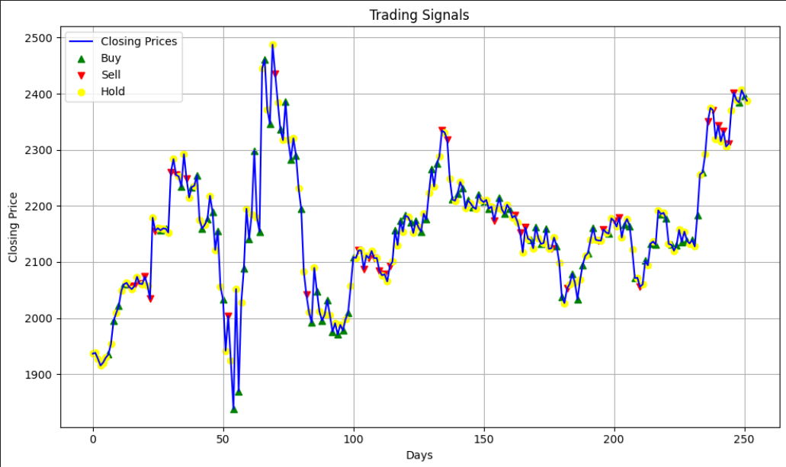

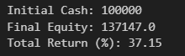

Algorithm Gives ~37% return-

Multivariable Logistical Model – K-Nearest Neighbours

By utilizing a K-Nearest Neighbors (KNN) model on this dataset, traders can automate decisions by leveraging pattern recognition. KNN classifies data points based on their proximity to historical instances, using features like SMA, EMA, MACD, RSI, and OBV to predict buy, sell, or hold actions. This approach integrates quantitative analysis into trading strategies, potentially enhancing outcomes.

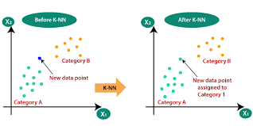

*Results- Accuracy,F1 score*

Results of the model using KNN

We get an accuracy score on 0.61 when weighted.

We get F1 score of 0.59 when weighted.

|  |  |
| --- | --- |
| *Accuracy* | *F1 score* |
| Training-0.8  Testing-0.59 | Buy-0.6  Sell-0.59  Hold-0.55 |

Confusion matrix for our predicted and actual data for a sample

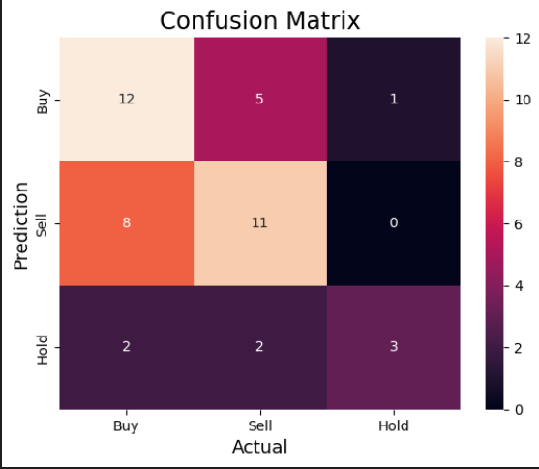

*References*

* <https://en.wikipedia.org/wiki/2020_stock_market_crash>
* <https://towardsdatascience.com/historical-stock-price-data-in-python-a0b6dc826836>

* [https://learndataanalysis.org/source-code-download-historical-stock-data-from-yahoo-finance-using-python/](https://learndataanalysis.org/source-code-download-historical-stock-data-from-yahoo-finance-using-python/%20)
* <https://youtu.be/NjEc7PB0TxQ>
* <https://www.investopedia.com/terms/e/ema.asp>
* <https://www.geeksforgeeks.org/how-to-calculate-an-exponential-moving-average-in-python/>
* <https://www.investopedia.com/terms/m/macd.asp>
* <https://www.investopedia.com/terms/r/rsi.asp>
* <https://www.investopedia.com/terms/o/onbalancevolume.asp>
* <https://python-graph-gallery.com/line-chart-dual-y-axis-with-matplotlib/#:~:text=This%20post%20describes%20how%20to,Y%20axis%20on%20this%20twin>.
* <https://www.investopedia.com/articles/active-trading/041814/four-most-commonlyused-indicators-trend-trading.asp#:~:text=When%20the%20price%20crosses%20above,as%20the%20chart%20above%20shows>.
* <https://youtu.be/J_LnPL3Qg70>
* <https://youtu.be/0p0o5cmgLdE>
* <https://blog.quantinsti.com/machine-learning-k-nearest-neighbors-knn-algorithm-python/>
* <https://youtu.be/4HKqjENq9OU>
* <https://www.geeksforgeeks.org/confusion-matrix-machine-learning/>

-------------------Thank You-----------------

Aayush Srivastava

23AG10003

aayush.srivastava0307@gmail.com