**Group 1**

**Assignment No: 2(A)**

**Title of the Assignment:** Write a program to implement Parallel Bubble Sort. Use existing algorithms and measure the performance of sequential and parallel algorithms.

**Objective of the Assignment:** Students should be able to Write a program to implement Parallel Bubble Sort and can measure the performance of sequential and parallel algorithms.

**Prerequisite:**

1. Basic of programming language
2. Concept of Bubble Sort
3. Concept of Parallelism

**---------------------------------------------------------------------------------------------------------**

**Contents for Theory:**

1. **What is Bubble Sort? Use of Bubble Sort**
2. **Example of Bubble sort?**
3. **Concept of OpenMP**
4. **How Parallel Bubble Sort Work**
5. **How to measure the performance of sequential and parallel algorithms?**

**----------------------------------------------------------------------------------------------------------**

**What is Bubble Sort?**

Bubble Sort is a simple sorting algorithm that works by repeatedly swapping adjacent elements if they are in the wrong order. It is called "bubble" sort because the algorithm moves the larger elements towards the end of the array in a manner that resembles the rising of bubbles in a liquid.

The basic algorithm of Bubble Sort is as follows:

1. Start at the beginning of the array.
2. Compare the first two elements. If the first element is greater than the second element, swap them.
3. Move to the next pair of elements and repeat step 2.
4. Continue the process until the end of the array is reached.
5. If any swaps were made in step 2-4, repeat the process from step 1.

The time complexity of Bubble Sort is O(n^2), which makes it inefficient for large lists. However, it has the advantage of being easy to understand and implement, and it is useful for educational purposes and for sorting small datasets.

Bubble Sort has limited practical use in modern software development due to its inefficient time complexity of O(n^2) which makes it unsuitable for sorting large datasets. However, Bubble Sort has some advantages and use cases that make it a valuable algorithm to understand, such as:

1. Simplicity: Bubble Sort is one of the simplest sorting algorithms, and it is easy to understand and implement. It can be used to introduce the concept of sorting to beginners and as a basis for more complex sorting algorithms.
2. Educational purposes: Bubble Sort is often used in academic settings to teach the principles of sorting algorithms and to help students understand how algorithms work.
3. Small datasets: For very small datasets, Bubble Sort can be an efficient sorting algorithm, as its overhead is relatively low.
4. Partially sorted datasets: If a dataset is already partially sorted, Bubble Sort can be very efficient. Since Bubble Sort only swaps adjacent elements that are in the wrong order, it has a low number of operations for a partially sorted dataset.
5. Performance optimization: Although Bubble Sort itself is not suitable for sorting large datasets, some of its techniques can be used in combination with other sorting algorithms to optimize their performance. For example, Bubble Sort can be used to optimize the performance of Insertion Sort by reducing the number of comparisons needed.

**Example of Bubble sort**

Let's say we want to sort a series of numbers 5, 3, 4, 1, and 2 so that they are arranged in ascending order…

The sorting begins the first iteration by comparing the first two values. If the first value is greater than the second, the algorithm pushes the first value to the index of the second value.

**First Iteration of the Sorting**

**Step 1**: In the case of 5, 3, 4, 1, and 2, 5 is greater than 3. So 5 takes the position of 3 and the numbers

become 3, 5, 4, 1, and 2.

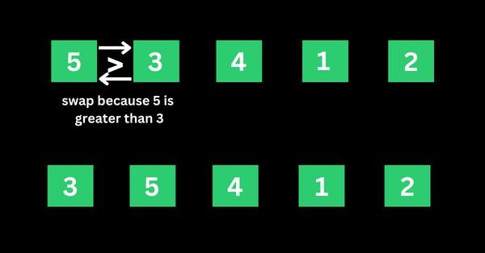

**Step 2**: The algorithm now has 3, 5, 4, 1, and 2 to compare, this time around, it compares the next two values, which are 5 and 4. 5 is greater than 4, so 5 takes the index of 4 and the values now become 3, 4, 5,

1, and 2.

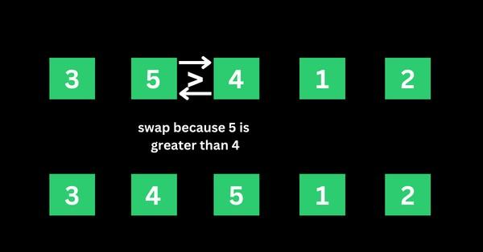

**Step 3**: The algorithm now has 3, 4, 5, 1, and 2 to compare. It compares the next two values, which are 5

and 1. 5 is greater than 1, so 5 takes the index of 1 and the numbers become 3, 4, 1, 5, and 2.

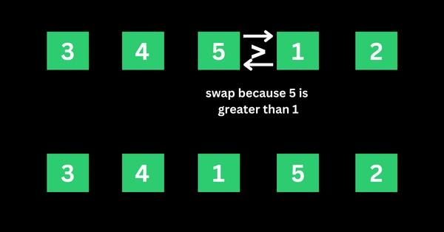

**Step 4**: The algorithm now has 3, 4, 1, 5, and 2 to compare. It compares the next two values, which are 5

and 2. 5 is greater than 2, so 5 takes the index of 2 and the numbers become 3, 4, 1, 2, and 5.

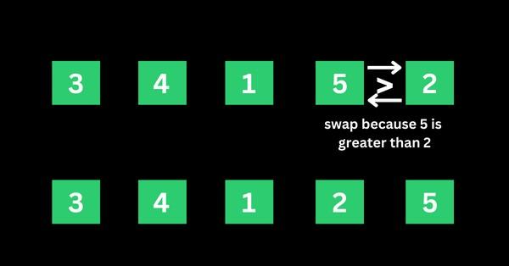

That’s the first iteration. And the numbers are now arranged as 3, 4, 1, 2, and 5 – from the initial 5, 3, 4, 1, and 2. As you might realize, 5 should be the last number if the numbers are sorted in ascending order.

This means the first iteration is really completed.

**Second Iteration of the Sorting and the Rest**

The algorithm starts the second iteration with the last result of 3, 4, 1, 2, and 5. This time around, 3 is smaller than 4, so no swapping happens. This means the numbers will remain the same.

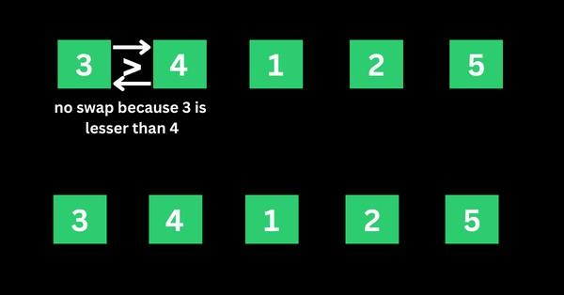

The algorithm proceeds to compare 4 and 1. 4 is greater than 1, so 4 is swapped for 1 and the numbers become 3, 1, 4, 2, and 5.

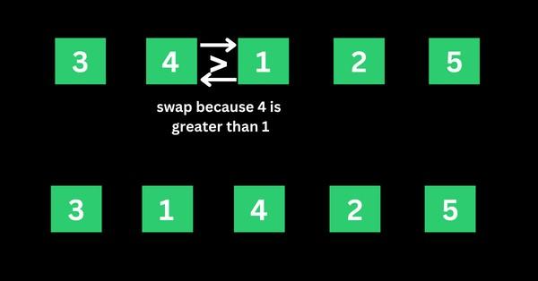

The algorithm now proceeds to compare 4 and 2. 4 is greater than 2, so 4 is swapped for 2 and the numbers become 3, 1, 2, 4, and 5.

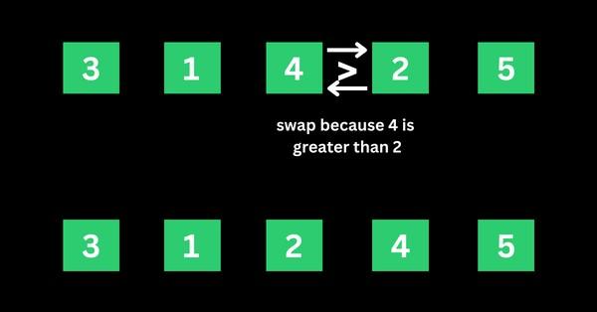

4 is now in the right place, so no swapping occurs between 4 and 5 because 4 is smaller than 5.

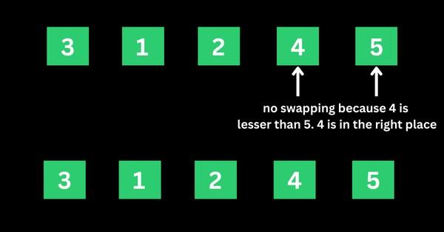

That’s how the algorithm continues to compare the numbers until they are arranged in ascending order of 1, 2, 3, 4, and 5.

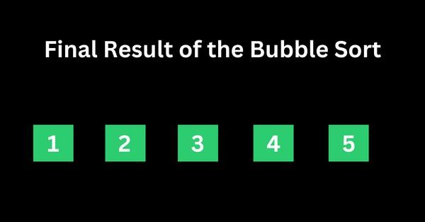

**Concept of OpenMP**

* OpenMP (Open Multi-Processing) is an application programming interface (API) that supports shared-memory parallel programming in C, C++, and Fortran. It is used to write parallel programs that can run on multicore processors, multiprocessor systems, and parallel computing clusters.
* OpenMP provides a set of directives and functions that can be inserted into the source code of a program to parallelize its execution. These directives are simple and easy to use, and they can be applied to loops, sections, functions, and other program constructs. The compiler then generates parallel code that can run on multiple processors concurrently.
* OpenMP programs are designed to take advantage of the shared-memory architecture of modern

processors, where multiple processor cores can access the same memory. OpenMP uses a fork-join model of parallel execution, where a master thread forks multiple worker threads to execute a parallel region of the code, and then waits for all threads to complete before continuing with the sequential part of the code.

**How Parallel Bubble Sort Work**

* Parallel Bubble Sort is a modification of the classic Bubble Sort algorithm that takes advantage of parallel processing to speed up the sorting process.

* In parallel Bubble Sort, the list of elements is divided into multiple sublists that are sorted concurrently by multiple threads. Each thread sorts its sublist using the regular Bubble Sort algorithm. When all sublists have been sorted, they are merged together to form the final sorted list.

* The parallelization of the algorithm is achieved using OpenMP, a programming API that supports parallel processing in C++, Fortran, and other programming languages. OpenMP provides a set of compiler directives that allow developers to specify which parts of the code can be executed in parallel.

* In the parallel Bubble Sort algorithm, the main loop that iterates over the list of elements is divided into multiple iterations that are executed concurrently by multiple threads. Each thread sorts a subset of the list, and the threads synchronize their work at the end of each iteration to ensure that the elements are properly ordered.

* Parallel Bubble Sort can provide a significant speedup over the regular Bubble Sort algorithm, especially when sorting large datasets on multi-core processors. However, the speedup is limited by the overhead of thread creation and synchronization, and it may not be worth the effort for small datasets or when using a single-core processor.

**How to measure the performance of sequential and parallel algorithms?**

To measure the performance of sequential Bubble sort and parallel Bubble sort algorithms, you can follow these steps:

1. Implement both the sequential and parallel Bubble sort algorithms.
2. Choose a range of test cases, such as arrays of different sizes and different degrees of sortedness, to test the performance of both algorithms.
3. Use a reliable timer to measure the execution time of each algorithm on each test case.
4. Record the execution times and analyze the results.

When measuring the performance of the parallel Bubble sort algorithm, you will need to specify the number of threads to use. You can experiment with different numbers of threads to find the optimal value for your system.

Here are some additional tips for measuring performance:

* Run each algorithm multiple times on each test case and take the average execution time to reduce the impact of variations in system load and other factors.
* Monitor system resource usage during execution, such as CPU utilization and memory consumption, to detect any performance bottlenecks.
* Visualize the results using charts or graphs to make it easier to compare the performance of the two algorithms.

**How to check CPU utilization and memory consumption in ubuntu**

In Ubuntu, you can use a variety of tools to check CPU utilization and memory consumption. Here are some common tools:

1. **top:** The top command provides a real-time view of system resource usage, including CPU utilization and memory consumption. To use it, open a terminal window and type top. The output will display a list of processes sorted by resource usage, with the most resource-intensive processes at the top.
2. **htop**: htop is a more advanced version of top that provides additional features, such as interactive process filtering and a color-coded display. To use it, open a terminal window and type htop.
3. **ps**: The ps command provides a snapshot of system resource usage at a particular moment in time. To use it, open a terminal window and type ps aux. This will display a list of all running processes and their resource usage.
4. **free:** The free command provides information about system memory usage, including total, used, and free memory. To use it, open a terminal window and type free -h.
5. **vmstat:** The vmstat command provides a variety of system statistics, including CPU utilization, memory usage, and disk activity. To use it, open a terminal window and type vmstat.

**Conclusion**- In this way we can implement Bubble Sort in parallel way using OpenMP also come to know how to how to measure performance of serial and parallel algorithm

**Assignment Question**

1. **What is parallel Bubble Sort?**
2. **How does Parallel Bubble Sort work?**
3. **How do you implement Parallel Bubble Sort using OpenMP?**
4. **What are the advantages of Parallel Bubble Sort?**
5. **Difference between serial bubble sort and parallel bubble sort**

**Reference link**

* https://[www.freecodecamp.org/news/bubble-sort-algorithm-in-java-cpp-python-with-example-code/](http://www.freecodecamp.org/news/bubble-sort-algorithm-in-java-cpp-python-with-example-code/)

Here, we're using the #pragma omp parallel directive to parallelize the code using OpenMP. Within the parallel block, we have a while loop that runs until the array is sorted. Inside the while loop, we have a #pragma omp for directive that parallelizes the for loop that performs the bubble sort.

Note that the flag variable is used to keep track of whether any swaps were made during an iteration of the for loop. If no swaps were made, then the array is already sorted and we can exit the loop.

explanation of each line of the code:

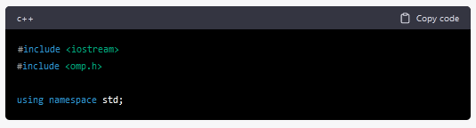

These lines are the standard C++ header files used for input/output operations and OpenMP, respectively.

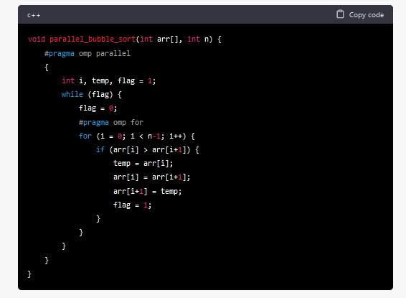

This is the function parallel_bubble_sort() that implements the parallel bubble sort algorithm using OpenMP.

* #pragma omp parallel is a directive that creates a team of threads to execute the parallel code inside the block. In this case, the block contains the code for bubble sort algorithm.
* int i, temp, flag = 1; declares the variables i, temp, and flag that will be used inside the while loop.
* while (flag) is a loop that runs until the flag variable is 0.
* flag = 0; sets the flag variable to 0 before starting each iteration of the for loop.
* #pragma omp for is a directive that parallelizes the for loop, by dividing the loop iterations among the threads in the team. Each thread performs the sorting operation on a subset of the array, thereby making the sorting process faster.
* for (i = 0; i < n-1; i++) is a for loop that iterates over the array, from 0 to n-1.
* if (arr[i] > arr[i+1]) checks if the current element is greater than the next element.
* temp = arr[i]; arr[i] = arr[i+1]; arr[i+1] = temp; swaps the current element with the next element, using a temporary variable.
* flag = 1; sets the flag variable to 1, indicating that a swap has been made.
* Finally, the sorted array is printed using a for loop.

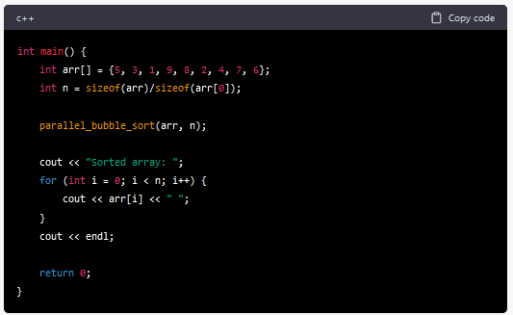

This is the main() function, which initializes an array arr and its size n. The function parallel_bubble_sort() is called with these arguments to sort the array. The sorted array is then printed to the console using a for loop.

**OUTPUT:**

#include<iostream>

#include<stdlib.h>

#include<omp.h>

using namespace std;

void bubble(int *, int);

void swap(int &, int &);

void bubble(int *a, int n)

{

    for(  int i = 0;  i < n;  i++ )

     {

    int first = i % 2;

    #pragma omp parallel for shared(a,first)

    for(  int j = first;  j < n-1;  j += 2  )

      {

    if(  a[ j ]  >  a[ j+1 ]  )

      {

      swap(  a[ j ],  a[ j+1 ]  );

      }

      }

     }

}

void swap(int &a, int &b)

{

    int test;

    test=a;

    a=b;

    b=test;

}

int main()

{

    int *a,n;

    cout<<"\n enter total no of elements=>";

    cin>>n;

    a=new int[n];

    cout<<"\n enter elements=>";

    for(int i=0;i<n;i++)

    {

    cin>>a[i];

    }

    bubble(a,n);

    cout<<"\n sorted array is=>\n";

    for(int i=0;i<n;i++)

    {

    cout<<a[i]<<endl;

    }

return 0;

}

/*

guest-tim1wd@C04L0818:~$ g++ bubble_sort.cpp -fopenmp

guest-tim1wd@C04L0818:~$ ./a.out

 enter total no of elements=>6

 enter elements=>4

2

67

23

1

8

 sorted array is=>

1

2

4

8

23

67

guest-tim1wd@C04L0818:~$

*/

**Assignment No: 2(B)**

**Title of the Assignment:** Write a program to implement Parallel Merge Sort. Use existing algorithms and measure the performance of sequential and parallel algorithms.

**Objective of the Assignment:** Students should be able to write a program to implement Parallel Merge Sort and can measure the performance of sequential and parallel algorithms.

**Prerequisite:**

1. Basic of programming language
2. Concept of Merge Sort
3. Concept of Parallelism

**---------------------------------------------------------------------------------------------------------**

**Contents for Theory:**

1. **What is Merge? Use of Merge Sort**
2. **Example of Merge sort?**
3. **Concept of OpenMP**
4. **How Parallel Merge Sort Work**
5. **How to measure the performance of sequential and parallel algorithms?**

**----------------------------------------------------------------------------------------------------------**

**What is Merge Sort?**

Merge sort is a sorting algorithm that uses a divide-and-conquer approach to sort an array or a list of elements. The algorithm works by recursively dividing the input array into two halves, sorting each half, and then merging the sorted halves to produce a sorted output.

The merge sort algorithm can be broken down into the following steps:

1. Divide the input array into two halves.
2. Recursively sort the left half of the array.
3. Recursively sort the right half of the array.
4. Merge the two sorted halves into a single sorted output array.
   * The merging step is where the bulk of the work happens in merge sort. The algorithm compares the first elements of each sorted half, selects the smaller element, and appends it to the output array. This process continues until all elements from both halves have been appended to the output array.
   * The time complexity of merge sort is O(n log n), which makes it an efficient sorting algorithm for large input arrays. However, merge sort also requires additional memory to store the output array, which can make it less suitable for use with limited memory resources.
   * In simple terms, we can say that the process of merge sort is to divide the array into two halves, sort each half, and then merge the sorted halves back together. This process is repeated until the entire array is sorted.
   * One thing that you might wonder is what is the specialty of this algorithm. We already have a number of sorting algorithms then why do we need this algorithm? One of the main advantages of merge sort is that it has a time complexity of O(n log n), which means it can sort large arrays relatively quickly. It is also a stable sort, which means that the order of elements with equal values is preserved during the sort.
   * Merge sort is a popular choice for sorting large datasets because it is relatively efficient and easy to implement. It is often used in conjunction with other algorithms, such as quicksort, to improve the overall performance of a sorting routine.

**Example of Merge sort**

Now, let's see the working of merge sort Algorithm. To understand the working of the merge sort

algorithm, let's take an unsorted array. It will be easier to understand the merge sort via an example. Let the elements of array are -



* According to the merge sort, first divide the given array into two equal halves. Merge sort keeps dividing the list into equal parts until it cannot be further divided.
* As there are eight elements in the given array, so it is divided into two arrays of size 4.

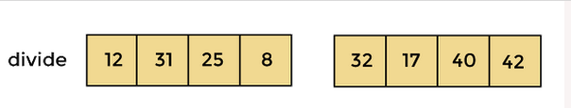

* Now, again divide these two arrays into halves. As they are of size 4, divide them into new arrays of size 2.



* Now, again divide these arrays to get the atomic value that cannot be further divided.



* Now, combine them in the same manner they were broken.
* In combining, first compare the element of each array and then combine them into another array in sorted order.
* So, first compare 12 and 31, both are in sorted positions. Then compare 25 and 8, and in the list of two values, put 8 first followed by 25. Then compare 32 and 17, sort them and put 17 first followed by 32. After that, compare 40 and 42, and place them sequentially.



* In the next iteration of combining, now compare the arrays with two data values and merge them into an array of found values in sorted order.



* Now, there is a final merging of the arrays. After the final merging of above arrays, the array will look like -

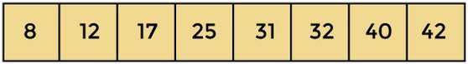

**Concept of OpenMP**

* OpenMP (Open Multi-Processing) is an application programming interface (API) that supports shared-memory parallel programming in C, C++, and Fortran. It is used to write parallel programs that can run on multicore processors, multiprocessor systems, and parallel computing clusters.
* OpenMP provides a set of directives and functions that can be inserted into the source code of a program to parallelize its execution. These directives are simple and easy to use, and they can be applied to loops, sections, functions, and other program constructs. The compiler then generates parallel code that can run on multiple processors concurrently.
* OpenMP programs are designed to take advantage of the shared-memory architecture of modern processors, where multiple processor cores can access the same memory. OpenMP uses a fork-join model of parallel execution, where a master thread forks multiple worker threads to execute a parallel region of the code, and then waits for all threads to complete before continuing with the sequential part of the code.

**How Parallel Merge Sort Work**

* Parallel merge sort is a parallelized version of the merge sort algorithm that takes advantage of multiple processors or cores to improve its performance. In parallel merge sort, the input array is divided into smaller subarrays, which are sorted in parallel using multiple processors or cores. The sorted subarrays are then merged together in parallel to produce the final sorted output.
* The parallel merge sort algorithm can be broken down into the following steps:
* Divide the input array into smaller subarrays.
* Assign each subarray to a separate processor or core for sorting.
* Sort each subarray in parallel using the merge sort algorithm.
* Merge the sorted subarrays together in parallel to produce the final sorted output.
* The merging step in parallel merge sort is performed in a similar way to the merging step in the sequential merge sort algorithm. However, because the subarrays are sorted in parallel, the merging step can also be performed in parallel using multiple processors or cores. This can significantly reduce the time required to merge the sorted subarrays and produce the final output.
* Parallel merge sort can provide significant performance benefits for large input arrays with many elements, especially when running on hardware with multiple processors or cores. However, it also requires additional overhead to manage the parallelization, and may not always provide performance improvements for smaller input sizes or when run on hardware with limited parallel processing capabilities.

**How to measure the performance of sequential and parallel algorithms?**

There are several metrics that can be used to measure the performance of sequential and parallel merge sort algorithms:

1. **Execution time:** Execution time is the amount of time it takes for the algorithm to complete its sorting operation. This metric can be used to compare the speed of sequential and parallel merge sort algorithms.
2. **Speedup**: Speedup is the ratio of the execution time of the sequential merge sort algorithm to the execution time of the parallel merge sort algorithm. A speedup of greater than 1 indicates that the parallel algorithm is faster than the sequential algorithm.
3. **Efficiency:** Efficiency is the ratio of the speedup to the number of processors or cores used in the parallel algorithm. This metric can be used to determine how well the parallel algorithm is utilizing the available resources.
4. **Scalability**: Scalability is the ability of the algorithm to maintain its performance as the input size and number of processors or cores increase. A scalable algorithm will maintain a consistent

speedup and efficiency as more resources are added.

To measure the performance of sequential and parallel merge sort algorithms, you can perform

experiments on different input sizes and numbers of processors or cores. By measuring the execution time, speedup, efficiency, and scalability of the algorithms under different conditions, you can determine

which algorithm is more efficient for different input sizes and hardware configurations. Additionally, you can use profiling tools to analyze the performance of the algorithms and identify areas for optimization

**Conclusion**- In this way we can implement Merge Sort in parallel way using OpenMP also come to know how to how to measure performance of serial and parallel algorithm

**Assignment Question**

1. **What is parallel Merge Sort?**
2. **How does Parallel Merge Sort work?**
3. **How do you implement Parallel Merge Sort using OpenMP?**
4. **What are the advantages of Parallel Merge Sort?**
5. **Difference between serial Merge sort and parallel Merge sort.**

**Reference link**

* <https://www.geeksforgeeks.org/merge-sort/>
* <https://www.javatpoint.com/merge-sort>

**OUTPUT:**

#include<iostream>

#include<stdlib.h>

#include<omp.h>

using namespace std;

void mergesort(int a[],int i,int j);

void merge(int a[],int i1,int j1,int i2,int j2);

void mergesort(int a[],int i,int j)

{

int mid;

if(i<j)

{

     mid=(i+j)/2;

     #pragma omp parallel sections

     {

         #pragma omp section

         {

             mergesort(a,i,mid);

         }

         #pragma omp section

         {

             mergesort(a,mid+1,j);

         }

     }

     merge(a,i,mid,mid+1,j);

}

}

void merge(int a[],int i1,int j1,int i2,int j2)

{

int temp[1000];

int i,j,k;

i=i1;

j=i2;

k=0;

while(i<=j1 && j<=j2)

{

     if(a[i]<a[j])

     {

         temp[k++]=a[i++];

     }

     else

     {

         temp[k++]=a[j++];

    }

}

while(i<=j1)

{

     temp[k++]=a[i++];

}

while(j<=j2)

{

     temp[k++]=a[j++];

}

for(i=i1,j=0;i<=j2;i++,j++)

{

     a[i]=temp[j];

}

}

int main()

{

int *a,n,i;

cout<<"\n enter total no of elements=>";

cin>>n;

a= new int[n];

cout<<"\n enter elements=>\n";

for(i=0;i<n;i++)

{

     cin>>a[i];

}

mergesort(a, 0, n-1);

cout<<"\n sorted array is=>";

for(i=0;i<n;i++)

{

     cout<<"\n"<<a[i];

}

return 0;

}

/*

guest-tim1wd@C04L0818:~$ g++ merge_sort.cpp -fopenmp

guest-tim1wd@C04L0818:~$ ./a.out

 enter total no of elements=>8

 enter elements=>

2

34

45

21

8

9

43

81

 sorted array is=>

2

8

9

21

34

43

45

81

*/

Explanation

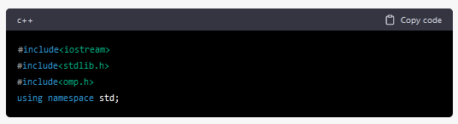

This block of code is a set of header files and a namespace declaration. iostream and stdlib.h are header files, and omp.h is the header file for OpenMP (Open Multi-Processing) library that is used for parallel programming.

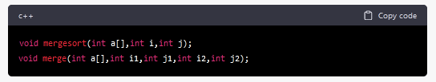

These are function declarations for mergesort and merge functions.

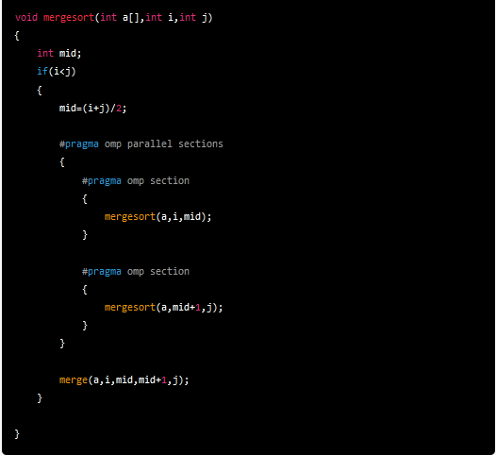

This is the mergesort function, which implements the merge sort algorithm recursively. a[] is the input array that is to be sorted, i and j are the starting and ending indices of the subarray being sorted.

First, it checks whether i is less than j because if i is greater than or equal to j, it means that there is only one element in the subarray, which is already sorted. Then it calculates the midpoint of the subarray using (i+j)/2.

The #pragma omp parallel sections directive creates a parallel region that specifies two parallel sections that can be executed concurrently. The mergesort function is then recursively called on the left and right halves of the subarray in two separate parallel sections.

Finally, the merge function is called to merge the sorted halves of the subarray.

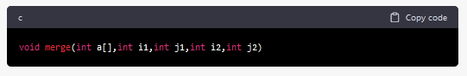

This is the function signature which takes an integer array a and four integer variables i1, j1, i2, and j2. i1 and j1 define the start and end indices of the first sorted subarray, and i2 and j2 define the start and end indices of the second sorted subarray.

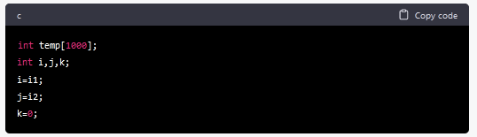

Here, a temporary array temp is created with a size of 1000. Three integer variables i, j, and k are initialized. i and j are set to the start indices of the two subarrays, while k is set to 0.

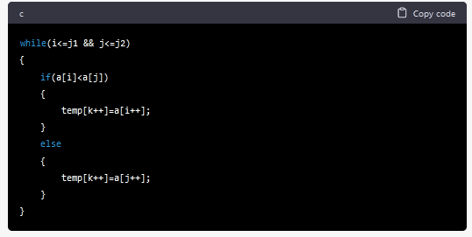

This is a while loop that runs as long as i is less than or equal to j1 and j is less than or equal to j2. Inside the loop, if the element at index i of the first subarray is less than the element at index j of the second subarray, then the element at index i is copied to the temp array at index k, and i and k are incremented. Otherwise, the element at index j is copied to the temp array at index k, and j and k are incremented.

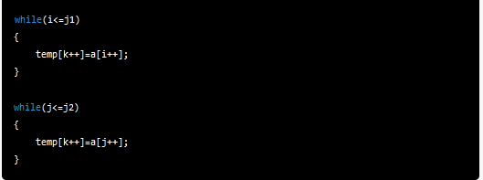

After the above loop terminates, there may be some elements left in one of the subarrays. These loops copy the remaining elements into the temp array.

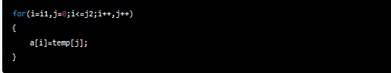

Finally, the sorted temp array is copied back to the original a array. The loop runs from i1 to j2 and copies the elements of temp array to the corresponding indices in the a array. The loop variable j starts from 0 and increments alongside i.