Day: 4

2nd November 2023

Classes using Jupyter Notebook and Python

To install Jupyter Notebook, follow these steps:

**Step 1: Install Python:**

First, ensure Python is installed on your system. You can download it from python.org if not already installed. You can verify the installation by running **python –version**  in the terminal or command prompt

**Step 2: Install Jupyter Notebook:**

You can install Jupyter Notebook using pip, Python’s package manager. Open a terminal or command prompt and run: **pip install notebook**

Once the installation is complete, launch Jupyter Notebook by running: **jupyter notebook** in command prompt

**Alternative:**

**Install Jupyter via Anaconda:**

Alternatively, you can install Jupyter Notebook using the Anaconda distribution, which comes pre-packaged with many useful libraries for data science.

Jupyter Notebook is useful in Python because of its Interactive Development Environment, Proper Visualization and Data Analysis, Documentation and Sharing, etc.

**Understanding Jupyter:**

To run Python program in Jupyter Notebook, you can first search in your device’s search bar and click to Jupyter notebbok, it directly opens in your default browser. And then you can write program by clicking new. You can rename file name by double clicking to the file name, which is shown like this:

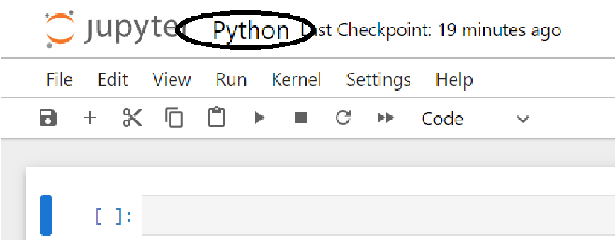

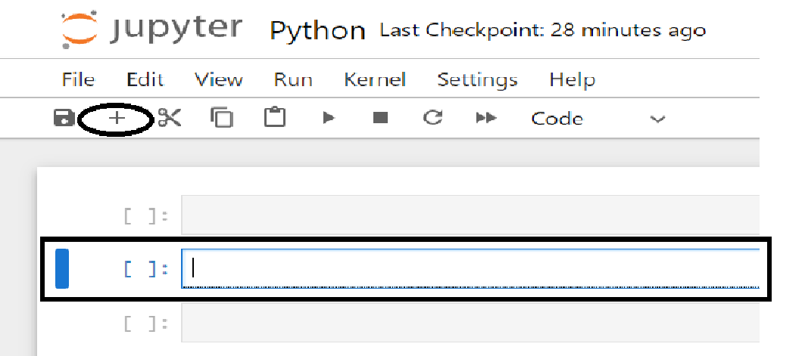You can write a python code of any length in a rectangular box called **Cell**. You can add new cell by clicking the + button as shown in the figure below.   
The cell turns its color Blue when you select any cell; which is called **Command Mode.**

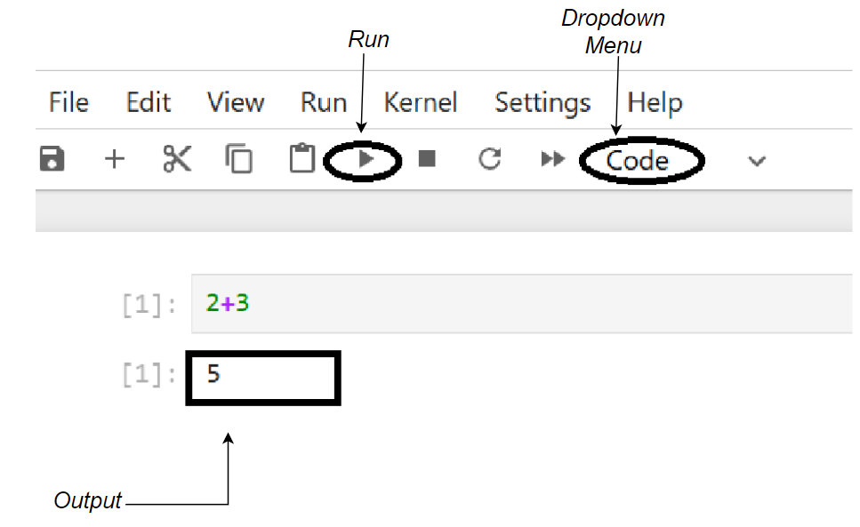

When you double click the cell, it turns its color into Green which means it is in **Edit Mode**. Code can only be written if it is in **code** mode. You can **write** any line of code and **run** that program like this:

If you want to write some sort of text, you have to select Markdown mode instead of **code** from the dropdown menu.

You can change the size of a text by using **“#”** in front of a code using **Markdown Mode.** You can adjust the size by adding the number of hashtags “#”.

**Raw Mode** is similar to Markdown, the only difference is that you can see the cell border.

**Short Cuts:**

[shift]+[enter]: run a cell

Command mode (When the color of a cell is Blue):

a: insert cell above

b: insert cell below

dd: delete a cell

z: undo a delete cell

r: convert cell to raw cell

m: convert cell to Markdown cell

y: convert cell to code cell

c: copy a cell

v: paste a cell

x: cut a cell

o: toggle output

**Edit Mode:**

Ctrl + c: copy a text

Ctrl + v: paste

Ctrl + x: cut

Ctrl + z: undo

Now the very important thing in python is print statement.

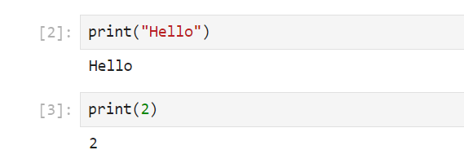Print is the command or function in python which is used to print anything on screen.

Quotes are used to create string values in a Python program. A string is a sequence of characters, such as words, sentences, or symbols. You can use either double quotes (" ") or single quotes (' ') to define a string.

Parenthesis () are used to pass values into a function like print ().

**Introduction to Python:**

Python is one of the high-level programming language. It is a general-purpose language which is used to create variety of applications like web application, desktop application, games, etc. with the help of a python library.

Python was developed by Guido Van Rossum in 1991 at the National Research Institute for Mathematics and computer Science in the Netherlands.

Library is package which consist of different modules and each module will perform different task. To use a module, we have to perform different tasks. First of all, we have to install and import the library.

For example: If you want to use Pandas and its function, first you have to install pandas and import the pandas library.

In some cases, installation is not required like (if you’re using Jupyter notebook, some libraries are pre-installed). Installation is required if you’re using text editor like pycharm or spyder, etc.

To install any type of Python library, pip (Preferred Installer Program) is used.

**pip install library name**

To uninstall any library, you can also use:

**pip uninstall library name**

**Some Types Of Python Libraries:**

1. **system:**

In order to use this library, first you have to install and import it like this:

import sys

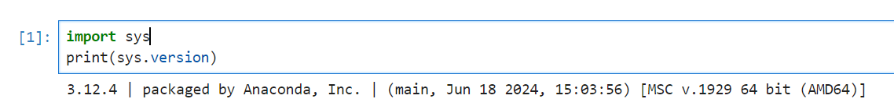To check the version of your python, use the following code:

1. **math:**

It is a common library, which is used for performing some mathematical functions.

Example: When you use the attribute math.pi, it will give you the value of that pi.

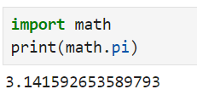

Other different functions like math.ceil, math.floor are also used in math library which is used to roundup the value.

1. **Matplotlib:**

It is used for data visualization.

1. **tkinter:**

This library is used to create desktop applications.

As a data scientist few common libraries are essential. They are: Numpy, Pandas, scikit, seaborn/matplotlib.

**Tokens:**

Token is the smallest element of a program that is meaningful to the interpreter.

**Types of Tokens:**

1. **Keywords:**

Keywords in python are the reserved words (built in words/ pre-defined words) in python and cannot be used as identifiers. Example: import, if, elif, else, for, break, continue, etc.

To see the different keywords available in python, following code can be used:

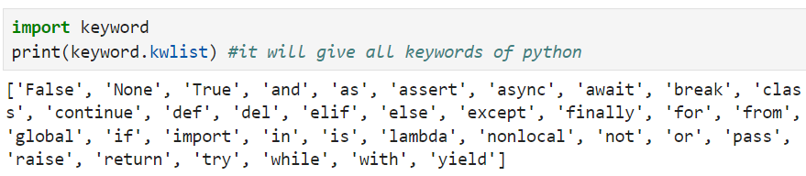

**len** function is used to count the number of keywords in python.

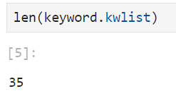

1. **Identifiers:**

An identifier is the name given to entities like functions or variables etc. It helps in differentiating one entity from other. To give names, we follow some rules. They are:

* Numbers are not allowed in the beginning of naming an identifier. They can be used in the middle or in the end.
* Any special character is not allowed other than underscore (_).
* Keywords are not allowed as identifiers.
* Python is case-sensitive language. i.e; it considers lowercase and uppercase letters different.

|  |  |
| --- | --- |
| **Naming identifier in correct way** | **Naming identifier in wrong way** |
| **Rule 1:** | |
| Name2= “Aayusha” | 2name= “Aayush” '''*identifier cannot be initiated with digit* *'''* |
| **Rule 2:** | |
| Name_1= ‘abc’ | name@1= ‘abc’ '''*Identifier cannot use special symbol* *'''* |
| **Rule 3:** | |
| Aay= 123 | Import= 123 '''*Keywords cannot be used as identifier* *'''* |
| **Rule 4:**  var=2  VAR=4  Print(var)  Output: 2 |  |

1. **Comments:**

In Python scripts, comments are lines that are ignored by the Python interpreter while the program is running. They can assist other developers (or even yourself) in better understanding the code when you return to it later. They are used to clarify code and make it easier to read.

**Types of comment:**

1. **Single Line Comment:**

A comment in Python that starts with # and runs until the end of the line.

1. **Multi Line Comment:**

Python does not have a specific syntax for multi-line comments, but you can use multiple single-line comments or docstrings (triple quotes ''' or """) for block comments.

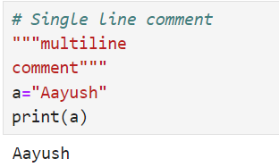

1. **Statements:**

Statements are instructions in python that a Python interpreter can execute.

**Ways of formatting Statements:**

1. **Single Line Statement:**

A single-line statement in Python is a statement that is written and executed on one line. Example: X=5+2

X

1. **Multiple line statement:**

A multiple-line statement in Python spans more than one line, often using line continuation for readability. You can either use backslash (\) or parenthesis(), brackets[], or braces{} to extend a statement across multiple lines.

Example:

P1= 20 + 30\

+ 40 + 50

Print(P1)

1. **Variables:**

They are the reserved memory location to store values. They are created the moment we assign a value to it.

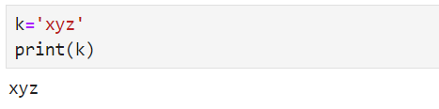

type function is used to check the datatype of a given value.

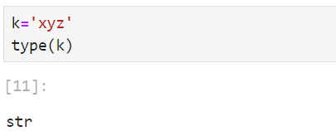

If :

type(2)#*It is integer value denoted by ‘int’*

type(2.5) #*It is float value denoted by ‘float’*

c= True

type(c)

output: bool

1 means “True” and 0 means “False” in Boolean value. Anything apart from 0(zero) is considered True.