Day: 7

November 8 2023

**String Functions:**

These are the built in functions/ predefined functions available in python to work with strings. Below are some commonly used strings functions:

**count():**

It counts the occurrence of a particular character or substring.

**Example:**

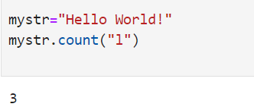

**strip():**

It removes whitespaces from the beginning and end of the string.

**Example:**

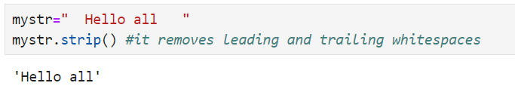

Strip function can also remove special characters from both beginning and end of a string.

**Example:**

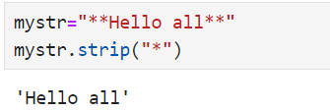

**rstrip():**

removes space/characters from the end of the string.

**Example:**

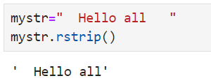

**lstrip():**

removes space/characters from the beginning of a string.

**Example:**

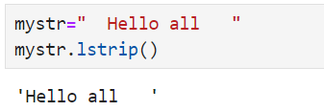

**lower():**

Converts all characters in the string into lowercase.

**Example:**

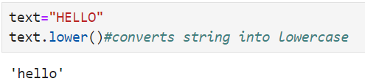

**upper():**

Converts all characters in the string into uppercase.

**Example:**

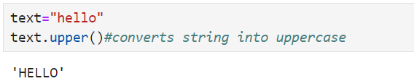

To convert the specific character or string into upper or lower case; string slicing method is used.

**Example:**

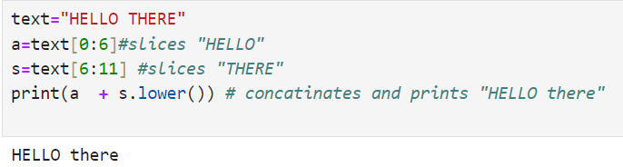

**startswith():**

Checks if the string starts with the specified prefix. Then returns True or False.

**Example:**

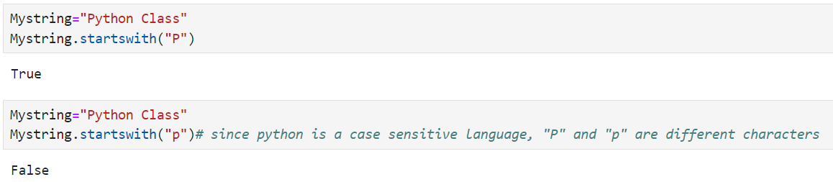

**endswith():**

Checks if the string ends with the specified suffix. Returns True or False.

**Example:**

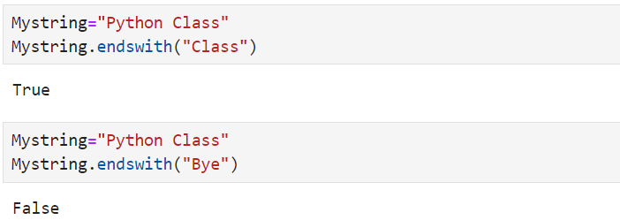

**split():**

Splits the string based on space or character or substring. W have to pass character or substring as argument.

**Example:**

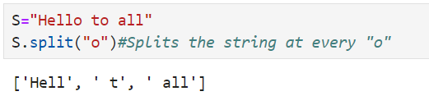

**Use of a print function to print a string and number together:**

**By using format() method:**

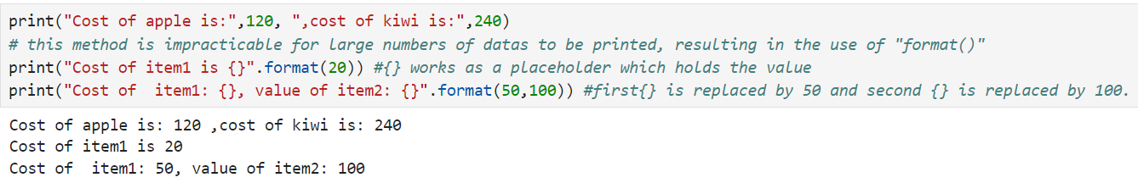

**Typecasting:**

It is the process of converting one datatype to another. It allows you to convert variables or values from one type (integer, float, string) to another explicitly.

***Note: Typecasting will only remove decimals, not rounding***

1. **Auto Typecasting:**

Here, the datatype is converted automatically by the python interpreter based on highest priority without user involvement.

Highest priority to conversion is given to float datatype. And the integer, and then the Boolean. The least priority is given to string.

**Example:**

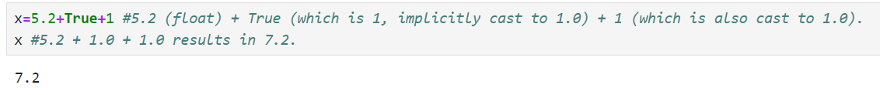

1. **Forced Typecasting:**

Data type is converted forcefully using predefined functions by users.

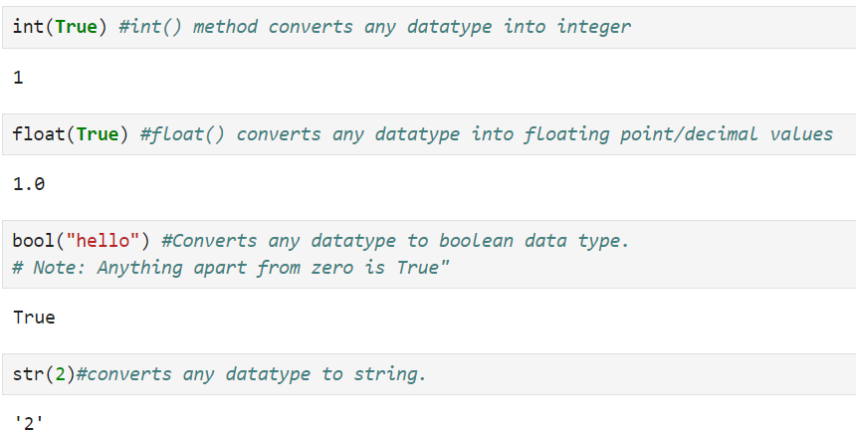**Example:**