Day: 9

15th November, 2023

**4. Nested if Statements:**

Nested if statement is an if statement inside another if or control statement. This allows for more complex decision-making process.

**Syntax:**

if condition1:

//statements

if condition2:

//statements

else:

//statements

else:

//statements

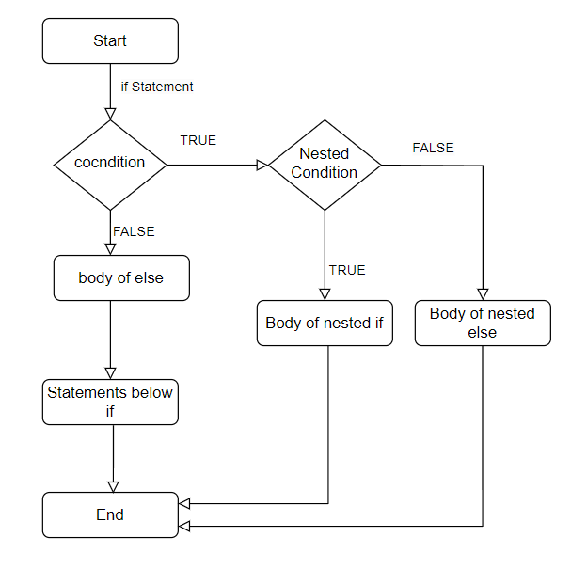

**Fig: Flowchart of Nested-if Statement**

**Example:**

Write a Python program that checks a person's eligibility for driving and marriage based on their age. If the person is 18 or older, they are eligible to drive. If they are 21 or older, they are also eligible for marriage. If they are younger than 21 but at least 18, they are not eligible for marriage. If they are under 18, print that they are not an adult yet.

Source code:

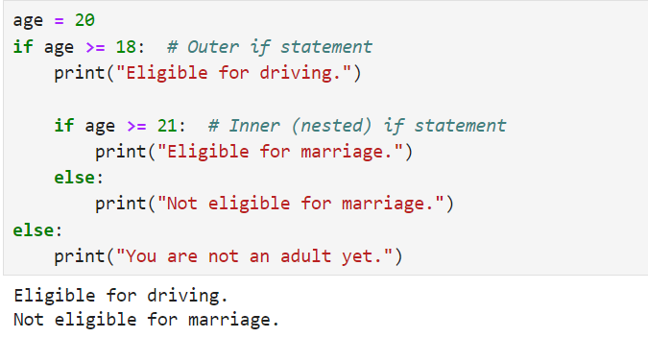

Write a Python program that uses nested if statements to check multiple conditions for a given variable ‘i’. If ‘i’ is equal to 10, it checks whether ‘i’ is smaller than 15. If true, it further checks if ‘i’ is smaller than 12, printing appropriate messages for each condition. Provide the output for the case where ‘i’ = 10.

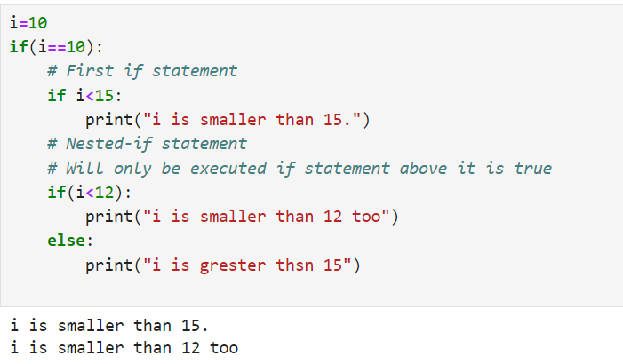

**Packages or Libraries:**

1. **Datetime Library:**

This library is used to work with date and time. It provides many modules:

1. **Date:**

Which helps to work with date and lets you create date in year, month and day format. It provides the functions like:

today()=> Gives date of today.

isoweekday()=> Gives day of week

Attributes: day, year, month.

**Example:**

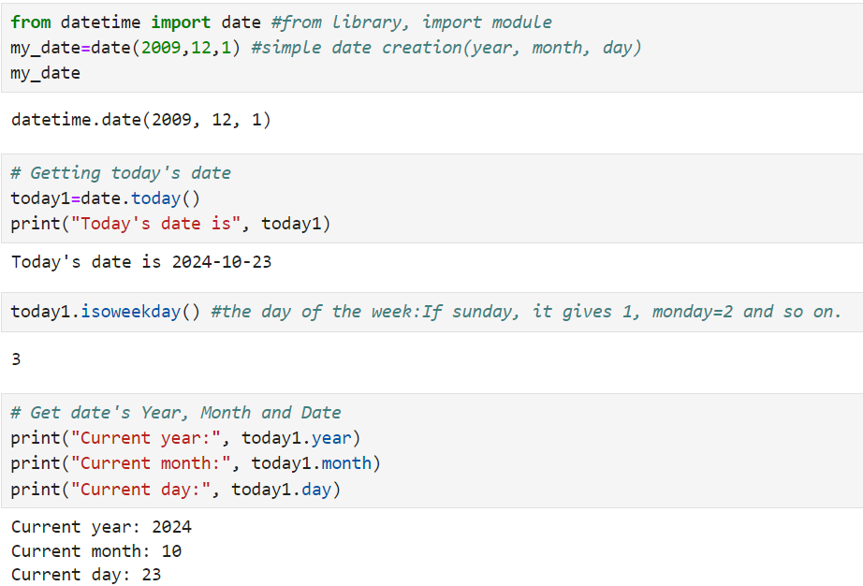

1. **Datetime Module:**

Which helps to get details about date and time together in the format of year, month, day, hour, minute, second, microsecond.

Functions: now()=> It provides current date and time according to the system.

**Example:**

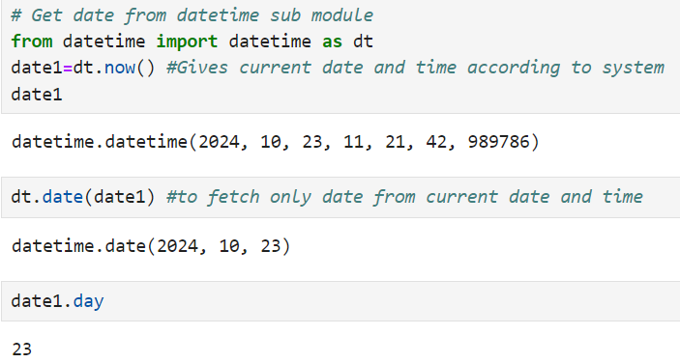

1. **Time Module:**

Helps to work with time with format of hour, minute, second.

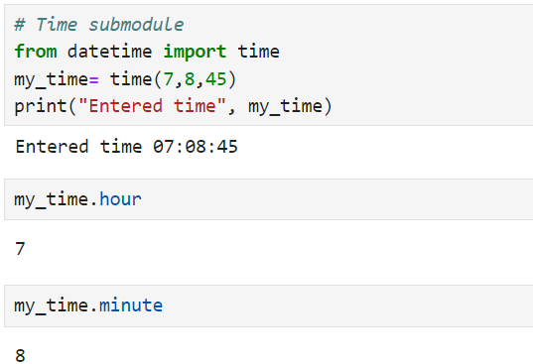 **Example:**

1. **Timedelta Module:**

It is used to give future data and even to find difference between two data.

**Example:**

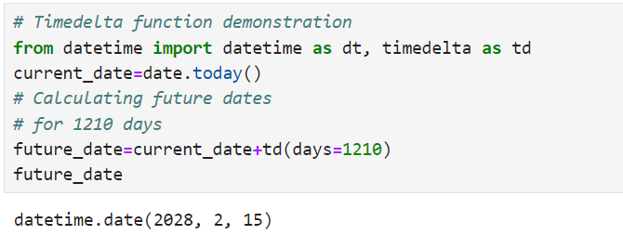

This code demonstrates how to use the timedelta function to calculate a future date by adding a specific number of days to the current date. Here, it adds 1210 days to today's date, showcasing the simplicity of date manipulation in Python.

**Data Structures in Python:**

Data Structures are a way of storing or organizing more than one elements so that it can be easily accessed depending upon the situation.

Types of Data Structures in Python:

1. List
2. Tuple
3. Sets
4. Dictionary
5. **List:**

List is a collection of more than one element enclosed inside square brackets []. Every element is separated by a comma.

**Example:**

