# A Minor Project Proposal Report on

**New Age Shopping**

Submitted in Partial Fulfillment of the Requirements for

the Degree of **Bachelor of Engineering in Software Engineering**

Under Pokhara University

Submitted by:

**Aayush Basnet 171601**

**Jiwan Gharti 171719  
Jayas Sapkota 171718**

**Shibu Chapagain 171748**

Under the Supervision of:

**Dr. Roshan Chitrakar**

Date: **25 - 03 - 2021**

 **Department of Science and Technology**

**NEPAL COLLEGE OF**

**INFORMATION TECHNOLOGY**

Balkumari, Lalitpur, Nepal

# Abstract

*‘New age shopping’ is a web-based application. It’s an e-commerce platform for a retail store. Store owner can modify his own private e-commerce store as per their preference. It enables customers to select goods and make order. The method of payment that we are going to implement in this webapp is Online payment.*

*This webapp will be designed using HTML, CSS, JavaScript and Python. We will be using ‘smtplib’ module which is a mail sending interface provided by Python. Bootstrap and Django as a framework of CSS and Python respectively will be used along with its dependencies. It will have PostgreSQL as database.*

**Keywords**: *e-commerce, webapp, goods, order, smtplib*

# Problem Statement

In this busy world, people have time limits. Going to shopping and spending hours and hours doesn’t make us productive. And selling offline through the shop limits the income of the seller. Seller cannot reach a greater number of customers to make huge number of transactions. Here, the challenge is to guide the customer having lack of time to buy goods by saving their time and to provide services to customer 24/7 hours.

After the implementation of our webapp people can shop the item through their home or their office which ultimately saves the time to go to the store. They can utilize the shopping time in other productive works. Not only that they can also search for their desirable item in just a matter of time. Customers will be able to shop the item in the reasonable price. This will ultimately change the way of shopping and help to live life in modern way. On the other hand, the seller can get chance to reach more customers and increase their profit.

# Project Objective

The main objectives of the project are as follows:

* To reach out to a larger Audience.
* To provide user interface where customers can do online shopping in easy way.
* To understand the present status and trends of E-Commerce
* To make accurate, efficient, and time saving e-commerce platform.
* To modernize the primitive way of shopping.

# Significance of the Study

Electronic commerce, or e-commerce, is the way of shopping for and commercializing product and services on the web. Aside from buying and selling, many people use the Internet as a source of information to compare prices and see what's new before making a purchase online or in a physical store.

With the increasing Internet, the global business community is rapidly moving towards Business-to Business (B2B) e-Commerce. The buyers gain a clear advantage when the Internet gives them access to the global market, by which they can compare prices across regions, find out whether prices vary by order fragmentation and get awareness about substitute products. Due to transparency of the market, customer can compare the services of various e-commerce sites easily. For instant, in case of e-commerce the competitors are one click away from customer. If clients are not happy with the products, prices or services offered by a particular ecommerce site, they are able to change much more easily than in the physical. From the Sellers’ point of view, they don’t need to have physical existence of shop.

In this project, we provide the buyers wide variety of products, lower cost of product than traditional shopping, exciting offers and shopping deals notifications and many more.

# Scope and Limitations

## 4.1. Scope

E-commerce has bloomed over the years and is one of the fastest-growing domains in the online world. Though it took some time for this to be accepted by the end-users, today we are at a point where the majority of the people love to shop online. There were numerous concerns revolving around online shopping at its launch, but over years people tend to have started trusting E-commerce for all their shopping needs. Our New Age Shopping e-commerce provides the following scope:

* This web application will be designed to give a friendly interface to the users.
* The customers can put review comments about a product and see the review comments of other customers before making a final buy.

This project can be useful in following areas:

* Retail, Wholesale and Marketing

## 4.2. Limitations

Although our project provides reliability by providing alternative to traditional shopping, we have some limitations, which is to be taken into consideration. Some of the limitations of our projects are:

* Our project has limited product dataset.
* It lacks in advance security.
* Its shortfall is advance searching.

# Literature review

E-Shopping is the latest development of human history. Commerce has evolved over the centuries. Prior to the evolution of money, it was the simple-barter process where things could be exchanged, say milk for grains. It opens new doors for the problems of real-world shopping phenomenon. The idea of integrated market and services solved many problems and today it is not a barrier to shop at a specific location, but we can shop wherever we want. E-Shopping provides multiple opportunities involving many challenges as well.

In the context of Nepal, different people have developed different methods, techniques and tried working in this field. Different key words had been put to search such websites and we found some of them:

1. Daraz Nepal
2. Sasto Deal

# Technical Description of the Project

## 6.1. HTML

HTML (Hyper Text Markup Language) is the standard markup language for documents designed to be displayed in a web browser. Web browsers receive HTML documents from a web server or from local storage and render the documents into multimedia web pages. HTML describes the structure of a web page semantically and originally included cues for the appearance of the document.

## 6.2. CSS

Cascading Style Sheets (CSS) is a style sheet language used for describing the presentation of a document written in a markup language such as HTML. CSS is designed to enable the separation of presentation and content, including layout, colors, and fonts. CSS is used to define styles for your web pages, including the design, layout and variations in display for different devices and screen sizes.

## 6.3. Python

Python is an interpreted, high-level and general-purpose programming language. Python's design philosophy emphasizes code readability with its notable use of significant indentation. Its language constructs and object-oriented approach aim to help programmers write clear, logical code for small and large-scale projects. Python is dynamically-typed and garbage-collected.

## 6.4. JavaScript

JavaScript is high-level, often just-in-time compiled, and multi-paradigm. It has curly-bracket syntax, dynamic typing, prototype-based object-orientation, and first-class functions. Alongside HTML and CSS, JavaScript is one of the core technologies of the World Wide Web. JavaScript enables interactive web pages and is an essential part of web applications.

## 6.5. Django

Django is a Python-based free and open-source web framework that follows the model-template-views (MTV) architectural pattern. Django's primary goal is to ease the creation of complex, database-driven websites. The framework emphasizes reusability and "pluggability" of components, less code, low coupling, rapid development, and the principle of don't repeat yourself.

## 6.6. Bootstrap

Bootstrap is a free and open-source CSS framework directed at responsive, mobile-first front-end web development. It contains CSS- and (optionally) JavaScript-based design templates for typography, forms, buttons, navigation, and other interface components.

# Methodology and Validation

## Architecture

### Use Case Diagram

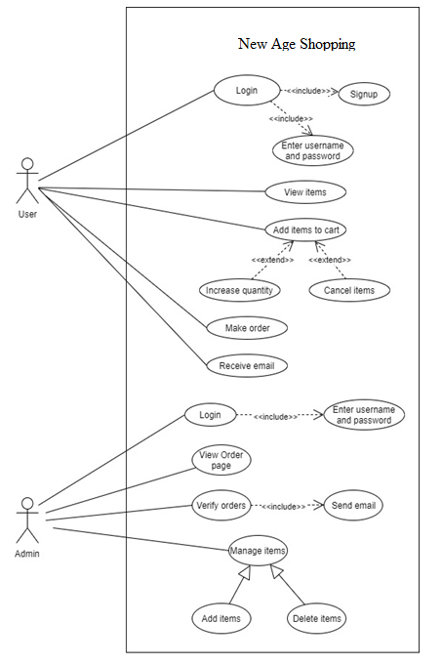

## Model

We have used the Spiral Model of Software Process Model. This Evolutionary S/W process model combines the interactive nature Prototyping Model plus the control and systematic aspect of linear sequential model. It has potential for rapid development of incremental versions of the software. Software is developed in a series of incremental releases.

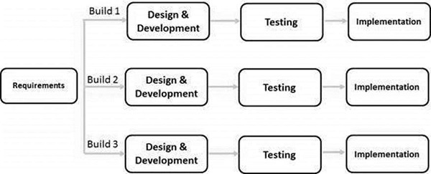

# Proposed Deliverable/ Output

Using this system, we will be able to let people view, add to cart, order and purchase the products. New Age Shopping as its final phase will provide proper management. The end product will have the following end results:

* System will be extended to integrate month long data
* System will be flexible to read data from a source folder
* More interactive user interface

# Project Task and Time schedule

The project schedule has been designed as per requirements and constraints involved. This

project is scheduled to be completed in about 31 days. Requirement analysis have been given

more emphasis. Research and database management is to be done first and well documented.

Debugging and Testing is to be done prior to the completion of the project.

|  |  |  |  |
| --- | --- | --- | --- |
| Time Period | Start | Finish | Duration(in days) |
| Requirement Analysis | 03/27/2021 | 04/02/2019 | 5 |
| Design | 04/02/2021 | 04/07/2021 | 5 |
| Coding | 04/07/2021 | 04/24/2021 | 17 |
| Implementation | 04/24/2021 | 04/28/2021 | 4 |
| **Total** |  |  | 31 |

# Bibliography/Reference

[1]Title:“Django”,[online].Available,URL:”https://en.wikipedia.org/wiki/Django_(web_framework) [Accessed: 24-March-2021 at 05:12 pm].

[2] Title:“HTML”,[online].Available,URL:“ https://en.wikipedia.org/wiki/HTML.” [Accessed: 23-March-2021 at 05:15 am].

[3] Title:“JavaScript”,[online].Available,URL:“ https://en.wikipedia.org/wiki/JavaScript” [Accessed: 24-March-2021 at 05:12 pm].

[4] Title:“CSS”,[online].Available,URL:“ https://en.wikipedia.org/wiki/CSS” [Accessed: 23-March-2021 at 05:12 am].

[5] Title:“Bootstrap”,[online].Available,URL:“https://en.wikipedia.org/wiki/Bootstrap_(front-end_framework)” [Accessed: 23-March-2021 at 05:12 am].

[6] Title: “E-Commerce – A Study of Benefits and Challenges”, [online]. Available, URL: “http://ignited.in/I/a/78872” [Accessed: 25-March-2021 at 03:12 pm].