
Student Assignment Brief

504IT Computer Hardware
Hardware System Design and Performance Report for a Fictional Client

Module: 504IT Computer Hardware
Assignment Title: Hardware System Design and Performance Report for a Fictional Client
Due Date: 23/10/2026
Word Count: 3,014 words (excluding references, appendices and code)
Table of Contents
LIST OF FIGURES ii
LIST OF TABLES iii
Introduction 1
Part A: Hardware System Specification and Justification 2
1. Client Definition and Requirements 2
2. Processor (CPU) 2
3. Memory (RAM) 3
4. Storage 3
5. Graphics (GPU) 5
6. Auxiliary Devices 6
7. System Integration 6
8. Performance Benchmarks and Sources 7
9. Error Detection, Correction, and Maintenance 8
10. Alternative Architecture Considered 9
Part B: Parallel Processing Demonstration 11
Program Overview 11
Parallel hardware use 11
Benchmark method and scaling 11
Results and interpretation 11
Amdahl-style analysis 11
Initializer optimisation 12
Correctness 12
Benchmark evidence 12
Link to Part A 14
AI Usage Acknowledgement 15
AI Use Statement 16
Conclusion 17
References 18
Appendix A: Part B Source Code 19

LIST OF FIGURES

Figure 1: Full benchmark console output 12

LIST OF TABLES

Table 1: Processor 2
Table 2: Memory 3
Table 3: Storage 5
Table 4: Graphics 5
Table 5: Auxiliary Devices 6
Table 6: Performance Benchmarks and Sources 8
Table 7: Original parallel scaling results 12
Table 8: Optimized parallel scaling results 13
Table 9: Original versus optimized timings 13

Introduction
This report recommends the workstation platform for NovaStricke Interactive, an imaginary AAA video game developing company that is working on making a multiplayer shooter with a big world. The report consists of two parts where Part A is the analysis of the hardware in comparison with the studio’s development, rendering, simulation, storage, and network needs while Part B uses matrix multiplication to illustrate the idea of process-level parallelism using scaling in relation to the suggested CPU design. The benchmark is considered as an experimental illustration and not as evidence that all game engines scale equally.

Part A: Hardware System Specification and Justification

1. Client Definition and Requirements
NovaStrike Interactive is a fictional AAA game developer creating an open-world multiplayer shooter for PC and next-gen consoles, targeting 4K/120 fps gameplay. The studio requires 20 powerful workstations for engineering, art, design, and QA, supporting Unreal Engine 5, a custom engine, Blender, Substance Painter, Visual Studio 2022, and Perforce.
Standard workstations cost around £4,000 each, while the lead developer’s high-end workstation may cost up to £8,000. This two-tier approach provides better value by reserving premium CPUs, GPUs, RAM, and storage for demanding build, rendering, profiling, and content-production tasks rather than upgrading all 20 systems.
The workstations must handle 8K textures, complex 3D models, and terabytes of project files while supporting virtualization, fast networking, and upgradeability over a 3–5-year lifespan. They should also operate quietly and efficiently during workdays exceeding 12 hours

.2. Processor (CPU)
Table 1: Processor
Factor | Detail
Architecture | Zen 5; x86-64 CISC instruction set with internal translation into micro-operations
Cores/Threads | 16 cores / 32 threads with SMT
Cache | 64MB L3 + 16MB L2 = 80MB total cache
TDP | 170W default TDP
Current Availability | Ryzen 9 9950X; listed as available by AMD (2026) and in stock at Overclockers UK (2026)

For this project, the AMD Ryzen 9 9950X will be used for the CPU. It is part of the AMD Ryzen 9000 Series of Processors with the Zen 5 Architecture, with 16 cores/32 threads and the 170W TDP. It was marked as in stock at AMD (2026), and one UK company had listed it as in stock when checked (Overclockers UK, 2026).
RISC and CISC are more of instruction set philosophies and do not have direct bearing on which processor is faster. For the AMD Ryzen 9 9950X, it uses the x86-64 instruction set, which is CISC architecture. In this case, complex instructions are decoded to micro-operations and then executed through superscalar out-of-order cores. In RISC-based processors such as ARM, there is a difference in the instruction set philosophy, though there is use of caching, speculation, and out-of-order execution in modern ARM CPUs. Since x86-64 fits in with the tools and game-dev software ecosystems used in the report, the instruction set is used.
The chosen CPU is the AMD Ryzen 9 9950X, which is an existing Ryzen 9000 series desktop CPU. AMD lists 16 cores, 32 threads via SMT, a boost speed of 5.7GHz, 64MB of L3 cache, 16MB of L2 cache and a TDP of 170W. AMD also lists support for PCIe 5.0, two memory channels and DDR5. These features are good for a developer workstation since there is ample opportunity to utilize parallel computing in compile, asset processing and simulation tasks, while the fast boost speed helps interactive tasks (AMD, 2026).

3. Memory (RAM)
Table 2: Memory
factor | Details
Capacity | 64GB: 2×32GB provides substantial capacity for UE5, IDEs, DCC tools, browsers and virtual machines
Speed | DDR5-5600 MT/s; nominal transfer rate is 1.75× DDR4-3200
Type | Non-ECC UDIMM with DDR5 on die ECC inside the DRAM devices; this is not the same as system level ECC memory
Upgradepath | Four DIMM slots on the selected platform provide a practical upgrade path

The workstation has 64GB of DDR5-5600 memory installed in two 32GB modules. Epic Games recommends 32GB of RAM for Unreal Engine; however, this report selects 64GB to support Unreal Engine alongside Visual Studio, Blender, browsers, asset tools, and virtual machines (Epic Games, 2026).
DDR5-5600 provides 5,600 MT/s, compared with 3,200 MT/s for DDR4-3200, making its transfer speed 1.75 times higher. However, performance gains depend on memory access patterns and bandwidth requirements (Kingston Technology, 2024).

Memory hierarchy is important because L1 and L2 caches are smaller and faster than RAM, while L3 provides a larger shared cache. When data is unavailable in the caches, the memory controller accesses RAM. Under memory pressure, the operating system may page data to storage. The translation lookaside buffer (TLB) also caches recently translated virtual addresses. Therefore, 64GB reduces paging pressure but does not eliminate virtual memory.
ECC terminology also requires clarification. DDR5 on-die ECC corrects specific errors within DRAM chips but does not protect data transfers between the DIMM and memory controller. System-wide ECC requires compatible ECC memory and system support (Kingston Technology, 2026). Therefore, the selected 64GB module should be considered non-ECC UDIMM with on-die ECC correction, not ECC workstation memory.

4. Storage
Chosen:
- Primary – 2 TB samsung 990 Pro NVMe SSD
- Secondary- 4 TB Seagate IronWolf Pro HDD
Justification:
Table 3: Storage
Drive | Purpose | Speed | Reliability
2TB NVMe SSD | OS, engine, active project files, build cache | 7,450 MB/s | 1,200 TBW endurance
4TB HDD (RAID 1) | Asset archive, backups, completed builds | ~250 MB/s | Mirrored survives single drive failure

RAID Rationale: RAID level 1 (mirror) for HDDs will be used to ensure data protection in case of failure of any hard drive. A studio which has many gigabytes of its 3D models, textures, and source code requires a backup strategy. Although RAID 0 is good due to its performance capabilities, it is not used due to lack of redundancy.
Why NVMe Instead of SATA? Loading of an Unreal Engine 5 project requires reading many small files. Low latency (~0.02ms compared to ~0.15ms for SATA) and high number of IOPS (1M+ compared to ~100K) make the difference in project load time significant. A 200GB UE5 project that loads in 5 minutes on SATA SSD will load within 1 minute on NVMe.
Error Detection: The Samsung 990 Pro supports Error Correcting Code and end-to-end data protection features. For HDD storage, RAID 1 is used. Moreover, version control using Perforce with checksum for all source code and assets is implemented at the studio.

5. Graphics (GPU)
Chosen: NVIDIA GeForce RTX 4080 (16GB GDDR6X)
Justification:
Table 4: Graphics
Factor | Detail
CUDA Cores | 9,728: massive parallel processing for GPU light baking
VRAM | 16GB GDDR6X, it handles 8K textures and complex scenes
Ray Tracing | 3rd gen RT cores, it has real-time ray tracing preview in UE5
DLSS | Frame generation for testing performance targets
NVENC | Hardware video emncoding for marketing/trailer rendering
Price | ~£1,100

Relevance of Parallel Processing: The most important reason behind the choice of RTX 4080 is its 9,728 CUDA cores. Tasks that will benefit from GPU acceleration in game development include:
- Light baking: The GPU-based Lightmass in Unreal Engine 5 allows lighting baking 10-50 times faster than with the CPU-only version
- Shader compilation: Parallel compilation of thousands of shaders
- AI/ML training: Training NPC behavior models via CUDA-accelerated TensorFlow/PyTorch
- Video rendering: NVENC encoder for cutscenes and trailers rendering
RTX 4090 vs RTX 4080: The RTX 4090 (£1,600) provides 30% more performance while costing 45% more money. Given the cost of setting up 20 workstations, the RTX 4080 provides the optimal price-performance balance. RTX 4090 is provided for the lead developer's workstation.
Alternative GPU: AMD Radeon RX 7900 XTX – has equal raw performance but doesn't provide CUDA compatibility.

6. Auxiliary Devices
Table 5: Auxiliary Devices
Device | Choice | Justification
Motherboard | ASUS ProArt X670E | 4x M.2 slots, 10GbE LAN, USB4, ECC support
PSU | Corsair RM850x (850W, 80+ Gold) | Efficient, quiet, reliable for 12+ hour operation
Cooling | Noctua NH-D15 chromax.black | Quiet air cooling, no liquid leak risk in office
Case | Fractal Design Define 7 | Sound-dampened,excellent airflow, 8x 3.5" bays
Monitor | 27" 4K (3840 × 2160) 60Hz IPS (Dell U2723QE) | Color-accurate 4K display for detailed art and content work
Networking | 10GbE NIC (on motherboard) | Fast asset transfers to/from central server
UPS | APC 1500VA | Prevents data loss during power outages
Keyboard/Mouse | Logitech MX Master 3S + Keys Mini | Ergonomic for long coding sessions

Networking: 10 GbE network is mandatory for a game development studio. The size of a 4K texture pack is 500GB+. Transfer time via 1GbE network (~110MB/s) is about 75 minutes. Transfer time via 10GbE (~1,100MB/s) – is just 7.5 minutes. A team of 20 developers working on a project will save many hours of their precious time per month because of that.

7. System Integration
Bus Architecture: PCIe 5.0 (CPU) + PCIe 4.0 (chipset)
- GPU runs at PCIe 4.0 x16 (64 GB/s bandwidth)
- NVMe SSD runs at PCIe 4.0 x4 (8 GB/s bandwidth)
- 10GbE NIC runs at PCIe 4.0 x4
Interrupts and DMA:
- MSI-X (Message Signaled Interrupts): Modern GPU and NVMe controller employ MSI-X technology in order to reduce CPU overhead related to interrupts processing. It’s crucial when CPU is busy enough with compilation processes.
- DMA (Direct Memory Access): NVMe controller uses DMA mechanism to process data transfers between SSD and RAM without CPU involvement. It gives the opportunity to release CPU cycles and perform game engine tasks. 10GbE controller uses DMA as well.
Compatibility: All components use standard interfaces (PCIe, DDR5, NVMe, USB4). The ASUS ProArt X670E motherboard provides:
- 4x M.2 slots (future SSD expansion)
- 4x DIMM slots (RAM upgrade to 128GB)
- USB4 (40 Gbps) for external GPU or high-speed storage
- 10GbE built-in (no add-in card needed)
Expansion Plans:
- Year 2: Add second NVMe SSD for dedicated build cache
- Year 3: Upgrade GPU to next-gen (PCIe 5.0 ready)
- Year 4: Expand RAM to 128GB for larger open-world projects

8. Performance Benchmarks and Sources
Table 6: Performance Benchmarks and Sources
Workload | Published result | Relevance | Source
Unreal Engine shader compilation | Ryzen 9 9950X tied with Intel Core i9-14900K in Puget Systems' test (Shipman & Lagergren, 2024). | Relevant to repeated shader compilation during development. | Puget Systems (Shipman & Lagergren, 2024)
Unreal Engine lighting build | Ryzen 9 9950X was about 30% faster than the i9-14900K in the tested workload (Shipman & Lagergren, 2024). | Suggests potential benefit for CPU-based lighting builds. | Puget Systems (Shipman & Lagergren, 2024)
Unreal Engine source-code compilation | Ryzen 9 9950X was about 5% faster than the i9-14900K (Shipman & Lagergren, 2024). | Relevant to developers compiling engine source code. | Puget Systems (Shipman & Lagergren, 2024)
Blender GPU rendering | RTX 4080 was about 43% faster than RTX 3090 Ti in Blender's benchmark (Bach, 2022). | Supports GPU-accelerated content-creation workloads. | Puget Systems (Bach, 2022)

The Ryzen 9 9950X suits NovaStrike Interactive’s workloads. Puget Systems found comparable Unreal Engine shader-compilation performance to the Intel Core i9-14900K, 30% faster lighting builds, and 5% faster source-code compilation (Shipman & Lagergren, 2024). In Blender, the RTX 4080 was 43% faster than the RTX 3090 Ti (Bach, 2022). However, results may vary with software versions, projects, and hardware, and some Unreal Engine tests had limitations.
These benchmarks do not directly measure virtual-machine capacity, which depends on memory and workload. Part B provides separate evidence from the author’s Intel Core i5 system, not the proposed Ryzen 9 9950X. After optimization, matrix multiplication with 8 processes improved from 12.0963 to 11.7002 seconds, while 12 processes improved from 10.8725 to 10.3917 seconds. These results demonstrate parallel scaling and reduced overhead but do not directly predict Unreal Engine performance.
Although the RTX 4080 benchmark supports its rendering capabilities, NVIDIA’s RTX 50 Series includes the RTX 5080 and RTX 5090 (NVIDIA, n.d.). Therefore, before purchasing workstations in 2026, NovaStrike Interactive should compare local prices and Unreal Engine and Blender benchmarks for the RTX 5080 and RTX 4080 to determine the best value.
9. Error Detection, Correction, and Maintenance
Hardware-level:
- DDR5 on-die ECC: Corrects certain errors inside the DRAM chips; it is not system-wide ECC RAM and should not be described as preventing all memory-related crashes.
- RAID 1: Mirrored HDDs protect against drive failure
- NVMe ECC: Samsung 990 Pro includes end-to-end data protection
- UPS: Prevents corruption from sudden power loss
Software-level:
- Perforce version control: Checksum verification on all file submissions
- Automated backups: Nightly incremental backups to NAS, weekly full backups to cloud
- SMART monitoring: CrystalDiskInfo monitors drive health and alerts before failure
Maintenance schedule:
- Monthly: Clean dust filters, check temperatures
- Quarterly: Verify RAID integrity, test restore from backup
- Annually: Replace thermal paste, inspect PSU health

10. Alternative Architecture Considered
Alternative: Intel Core Ultra 7 270K Plus + compatible Intel 800-series motherboard
The Intel Core Ultra 7 270K Plus is a current-generation desktop alternative announced by Intel in March 2026. It uses Intel’s Core Ultra 200S Plus platform and is compatible with Intel 800-series chipset motherboards. It is included as a contemporary alternative rather than as a claim that it matches the Ryzen 9 9950X in every workload; a like-for-like benchmark using the intended Unreal Engine project and software versions would be needed for a firm performance comparison. The Ryzen 9 9950X remains the selected option in this proposal because the cited Puget Systems results directly test it against the i9-14900K for relevant Unreal Engine workloads, whereas those figures do not establish the 270K Plus’s performance.
- Power use and electricity cost should be compared using measured whole-system consumption under the studio’s actual workloads.
- Cooling cost depends on the selected cooler, case airflow, noise target, and sustained workload; no specific cost advantage is assumed here.
- Noise depends on the complete system’s cooling design and fan curves, so acoustic performance should be checked for the final configuration.
- No directly comparable benchmark for the Core Ultra 7 270K Plus is cited here; workload-specific testing is needed before claiming a performance advantage.
The Ryzen 9 9950X was chosen because the tests done by Puget Systems that have been cited actually assess the processor in an environment where Unreal Engine work is done. It should be noted that the information provided above does not prove that the power consumption or the noise level of the AMD chip is lower than that of the Intel one.

Part B: Parallel Processing Demonstration

Program Overview
Part B demonstrates process-level parallelization through matrix multiplication on the author’s Intel Core i5-12450HX machine. Two 800×800 matrices are processed sequentially and with 1, 2, 4, 8, and 12 processes. Speedup is calculated by dividing sequential execution time by parallel execution time, while efficiency is calculated by dividing speedup by the number of processes. This experiment demonstrates parallel scaling but does not represent a complete game-engine performance test.

Parallel hardware use
Dividing the workload by output rows allows workers to calculate independent rows, demonstrating data parallelism. Python’s multiprocessing module uses separate processes, allowing CPU-intensive tasks to run without being restricted by the Global Interpreter Lock (Python Software Foundation, 2026). Simultaneous multithreading (SMT) increases logical processors but not physical cores, as threads share a physical core. Instruction-level parallelism (ILP) also allows CPUs to execute independent instructions concurrently through out-of-order execution.

Benchmark method and scaling
The sequential code was modified such that the inner dot product loop utilizes a local total variable, similar to the amount of work done by each of the parallel workers. This ensures that the timing of two implementations is not affected by differences in the cost of their Python-level actions. The time used to create and destroy the Pool objects is included in the measured interval, which is significant in Windows since there is some overhead in creating processes.

Results and interpretation
The results show that increasing processes from one to two significantly improves performance, while further increases provide smaller benefits. Execution time decreased from 12.0963 s with 8 processes to 10.8725 s with 12 processes, an improvement of 1.2238 s (10.1%). This plateau reflects diminishing returns in parallel computing, influenced by various CPU-related factors.

Amdahl-style analysis
The Amdahl’s law is defined as the speedup that is attainable by making use of fixed-sized parallelism, which depends on the percentage of the work that is still effectively done in serial mode. According to this law, S = 1/(F+(1-F)/P) where F is the serial fraction while P is the number of processors (Oracle, 2017). It follows that this test is useful in obtaining an estimate for the serial/overhead component, but such an estimate must be made carefully because the program entails setting up of the pool of processes, distribution of tasks and collecting results. However, the actual CPU is a mixed system with the following features; SMT threads share core resources and the frequency of the CPU changes under sustained load.

Initializer optimisation
The second approach is accomplished through the use of `Pool (initializer=initialize_worker, initargs=(matrix_b,))`, ensuring that every worker stores matrix B inside a global variable upon its initialization. According to the Python documentation, this means that the function is going to be called one time when the worker starts and is going to be provided with `initargs` (Python Software Foundation, 2026). As a result, the row task would consist of only the row number and the corresponding row from matrix A. In the runs that have been conducted, this change has made the optimized approach faster in all five cases: 1 process (+3.76%), 2 processes (+5.15%), 4 processes (+2.65%), 8 processes (+3.27%), and 12 processes (+4.42%). This improvement has been steady and ranged from 2.65% to 5.15%.

Correctness
Comparison between all values from both sequential and parallel result matrices is performed using a tiny floating point tolerance. The results obtained by the initial code and the optimized code were identical in all test runs performed. The comparison is very critical since faster results that alter the numerical results or row ordering are of no use.
Benchmark evidence
Figure 1: Full benchmark console output
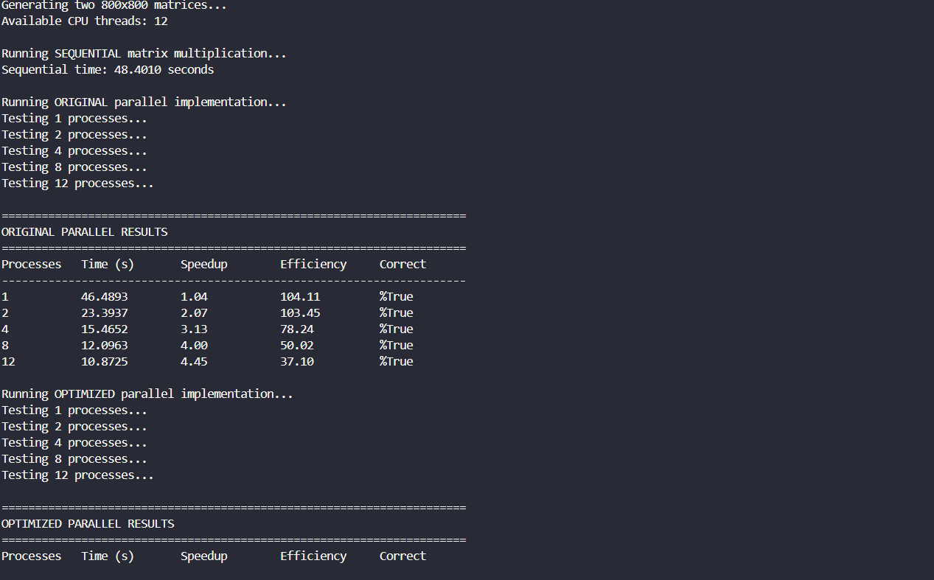
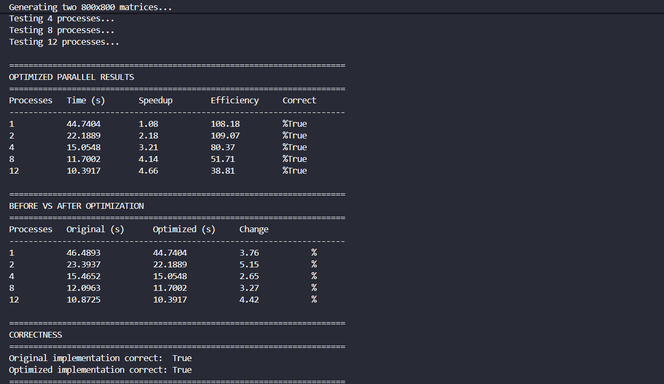

Table 7: Original parallel scaling results
Processes | Time(s) | Speed | Efficiency | Correct
1 | 46.4893 | 1.04 | 104.11% | True
2 | 23.3937 | 2.07 | 103.45% | True
4 | 15.4652 | 3.13 | 78.24% | True
8 | 12.0963 | 4.00 | 50.02% | True
12 | 10.8725 | 4.45 | 37.10% | True
(Sequential baseline: 48.4010 s)
Table 8: Optimized parallel scaling results
Processes | Time(s) | Speed | Efficiency | Correct
1 | 44.7404 | 1.08 | 108.18% | True
2 | 22.1889 | 2.18 | 109.07% | True
4 | 15.0548 | 3.21 | 80.37% | True
8 | 11.7002 | 4.14 | 51.71% | True
12 | 10.3917 | 4.66 | 38.81% | True

Table 9: Original versus optimized timings
Processes | Original(s) | Optimized(s) | Change
1 | 46.4893 | 44.7404 | 3.76%
2 | 23.3937 | 22.1889 | 5.15%
4 | 15.4652 | 15.0548 | 2.65%
8 | 12.0963 | 11.7002 | 3.27%
12 | 10.8725 | 10.3917 | 4.42%

Link to Part A
Experimentation proves to be valid support for the Part A CPU selection since the suggested computer will use many-core processor for compilation, simulations and content production. It shows how having many execution units in a CPU decreases the time needed to process an embarrassingly parallel workload; however, it also explains how merely increasing the number of logical processors will not lead to higher productivity. Thus, it proves that the balanced workstation design is right since, although many CPU cores are valuable, cache size, RAM size, GPU acceleration and so forth all influence the applications' performance..

AI Usage Acknowledgement
Recognized AI uses | For this assignment you have permission to use AI: | Additional details
Inspiring: to generate research questions, prompts or search terms. | No
Planning and management: to suggest a title, structure, subheadings, or themes. | No
Sources and data collection: to search, generate quizzes or questionnaires. | No
Summarising and consolidating notes and sources. | No
Analysing: to find themes, patterns, or motifs in data sets. | No
Composing: to generate images, text, music, programme code, or other materials. | No
Translating small sections of your written or recorded work into another language. | No
Presenting data in formats such as graphs, charts, tables or slides. | No
Checking and proofreading work or check work and suggesting improvements. | Yes | Used claude and grammarly to check technical and grammatical consistency
Other discipline specific use. | NA

AI Use Statement

In the process of compiling the report in question, Claude was only used for proofreading and verification purposes in line with the use case of the Amber AI as assigned in this task. More specifically, it was used to verify the numerical results provided by the benchmark evidence against the output provided during testing and to verify any discrepancy between the narrative provided and the actual data.
It was also used to check the grammar and formatting throughout the entire document.
It was not used for generating, writing or rewriting any analytical material, hardware rationale or code.

Conclusion
Part A and Part B arrive at a similar conclusion but approach it through two distinct paths. The hardware configuration is chosen to have an advanced processor with multiple cores and ample amounts of memory and a speedy storage/GPU setup due to the fact that game development is comprised of both highly parallel and non-parallelizable interactive processes. It is shown in Part B that parallel processing can help in decreasing elapsed time to a great degree but beyond a certain point it cannot help any more due to factors such as serial components of the program, overheads and other constraints including power considerations.

References
Bach, M. (. (n.d.). https://www.pugetsystems.com/labs/articles/nvidia-geforce-rtx-4080-16gb-content-creation-review/0/
documentation., P. S.—P.-b. (n.d.). https://docs.python.org/3/library/multiprocessing.html
Engine., E. G. (n.d.). https://dev.epicgames.com/documentation/unreal-engine/hardware-and-software-specifications-for-unreal-engine
Guide., A. L. (n.d.). https://docs.oracle.com/cd/E60778_01/html/E60745/bjael.html
Intel. (2026, M. 1. (n.d.). https://www.intel.com/content/www/us/en/newsroom/news/client-computing/intel-announces-new-intel-core-ultra-200s-plus-series-desktop-processors.html
processor., A. (. (n.d.). https://www.amd.com/en/products/processors/desktops/ryzen/9000-series/amd-ryzen-9-9950x.html
processor., O. U. (n.d.). https://www.overclockers.co.uk/amd-ryzen-9-9950x-sixteen-core-5.70ghz-socket-am5-processor-retail/PRO-AMD-02674.html
Series., N. (. (n.d.). https://www.nvidia.com/en-in/geforce/graphics-cards/50-series/
Shipman, K. &. (n.d.). https://www.pugetsystems.com/labs/articles/unreal-engine-amd-ryzen-9000-series-vs-intel-core-14th-gen/
systems., K. T. (n.d.). https://www.kingston.com/en/blog/servers-and-data-centers/what-is-ecc-memory-ssd-enterprise
technology., K. T. (n.d.). https://www.kingston.com/en/blog/pc-performance/ddr5-overview

Appendix A: Part B Source Code
Parallel Matrix Multiplication Demo
===================================
This program demonstrates sequential and parallel matrix
multiplication and measures scaling across different process
counts. It also compares an optimized multiprocessing.Pool
initializer approach.
"""
import multiprocessing
import time
import random
from typing import List
# Type alias for a matrix (list of lists of floats)
Matrix = List[List[float]]
# Global variable used by optimized worker processes
GLOBAL_MATRIX_B = None
def generate_matrix(rows: int, cols: int) -> Matrix:
"""
Generate a matrix of the given dimensions with random
floating-point values.
"""
return [
[random.uniform(-10.0, 10.0) for _ in range(cols)]
for _ in range(rows)
]
def multiply_row(args) -> tuple:
"""
Multiply one row of matrix A by matrix B.
The original parallel version passes matrix B as part of
every task.
"""
row_index, row_a, matrix_b = args
cols_b = len(matrix_b[0])
result_row = []
for j in range(cols_b):
# Store the dot product in a local variable.
total = 0.0
for k in range(len(row_a)):
total += row_a[k] * matrix_b[k][j]
result_row.append(total)
return row_index, result_row
def sequential_multiply(matrix_a: Matrix, matrix_b: Matrix) -> Matrix:
"""
Perform standard single-process matrix multiplication.
A local total variable is used so that the sequential
implementation performs equivalent inner-loop work to
the parallel worker.
"""
rows_a = len(matrix_a)
cols_b = len(matrix_b[0])
result = [
[0.0 for _ in range(cols_b)]
for _ in range(rows_a)
]
for i in range(rows_a):
for j in range(cols_b):
total = 0.0
for k in range(len(matrix_a[0])):
total += matrix_a[i][k] * matrix_b[k][j]
result[i][j] = total
return result
def parallel_multiply(
matrix_a: Matrix,
matrix_b: Matrix,
num_processes: int
) -> Matrix:
"""
Original multiprocessing implementation.
Matrix B is included in each row task.
"""
args = [
(i, matrix_a[i], matrix_b)
for i in range(len(matrix_a))
]
with multiprocessing.Pool(
processes=num_processes
) as pool:
results = pool.map(multiply_row, args)
# Restore the original row order.
results.sort(key=lambda x: x[0])
return [row for _, row in results]
def initialize_worker(matrix_b: Matrix):
"""
Initialize a worker process with matrix B.
This runs once when each worker starts, allowing matrix B
to remain available through a process-global variable.
"""
global GLOBAL_MATRIX_B
GLOBAL_MATRIX_B = matrix_b
def multiply_row_optimized(args) -> tuple:
"""
Optimized worker function.
Only the row index and row from matrix A are included in
each task. Matrix B is retrieved from the worker global.
"""
row_index, row_a = args
matrix_b = GLOBAL_MATRIX_B
cols_b = len(matrix_b[0])
result_row = []
for j in range(cols_b):
total = 0.0
for k in range(len(row_a)):
total += row_a[k] * matrix_b[k][j]
result_row.append(total)
return row_index, result_row
def parallel_multiply_optimized(
matrix_a: Matrix,
matrix_b: Matrix,
num_processes: int
) -> Matrix:
"""
Optimized multiprocessing implementation.
Pool initializer and initargs send matrix B to each worker
when the worker starts rather than putting B into every
individual row task.
"""
args = [
(i, matrix_a[i])
for i in range(len(matrix_a))
]
with multiprocessing.Pool(
processes=num_processes,
initializer=initialize_worker,
initargs=(matrix_b,)
) as pool:
results = pool.map(
multiply_row_optimized,
args
)
results.sort(key=lambda x: x[0])
return [row for _, row in results]
def verify_correctness(
seq_result: Matrix,
par_result: Matrix
) -> bool:
"""Verify that two matrix results match."""
if len(seq_result) != len(par_result):
return False
for i in range(len(seq_result)):
for j in range(len(seq_result[0])):
if abs(
seq_result[i][j] - par_result[i][j]
) > 1e-9:
return False
return True
def main():
# 800x800 provides a substantial computational workload.
size = 800
print(
f"Generating two {size}x{size} matrices..."
)
matrix_a = generate_matrix(size, size)
matrix_b = generate_matrix(size, size)
cpu_count = multiprocessing.cpu_count()
print(
f"Available CPU threads: {cpu_count}"
)
# --------------------------------------------------------
# Sequential baseline
# --------------------------------------------------------
print(
"\nRunning SEQUENTIAL matrix multiplication..."
)
start_time = time.perf_counter()
seq_result = sequential_multiply(
matrix_a,
matrix_b
)
seq_time = time.perf_counter() - start_time
print(
f"Sequential time: {seq_time:.4f} seconds"
)
# --------------------------------------------------------
# Process scaling test
# --------------------------------------------------------
process_counts = [1, 2, 4, 8, 12]
original_results = []
print(
"\nRunning ORIGINAL parallel implementation..."
)
for num_processes in process_counts:
start_time = time.perf_counter()
par_result = parallel_multiply(
matrix_a,
matrix_b,
num_processes
)
par_time = time.perf_counter() - start_time
correct = verify_correctness(
seq_result,
par_result
)
original_results.append(
(num_processes, par_time, correct)
)
# --------------------------------------------------------
# Original results
# --------------------------------------------------------
print("\n" + "=" * 70)
print("ORIGINAL PARALLEL RESULTS")
print("=" * 70)
print(
f"{'Processes':<12}"
f"{'Time (s)':<15}"
f"{'Speedup':<15}"
f"{'Efficiency':<15}"
f"{'Correct':<10}"
)
print("-" * 70)
for num_processes, par_time, correct in original_results:
speedup = seq_time / par_time
efficiency = (speedup / num_processes) * 100
print(
f"{num_processes:<12}"
f"{par_time:<15.4f}"
f"{speedup:<15.2f}"
f"{efficiency:<15.2f}%"
f"{str(correct):<10}"
)
# --------------------------------------------------------
# Optimized benchmark
# --------------------------------------------------------
optimized_results = []
print(
"\nRunning OPTIMIZED parallel implementation..."
)
for num_processes in process_counts:
start_time = time.perf_counter()
optimized_result = parallel_multiply_optimized(
matrix_a,
matrix_b,
num_processes
)
optimized_time = (
time.perf_counter() - start_time
)
correct = verify_correctness(
seq_result,
optimized_result
)
optimized_results.append(
(num_processes, optimized_time, correct)
)
# --------------------------------------------------------
# Optimized results
# --------------------------------------------------------
print("\n" + "=" * 70)
print("OPTIMIZED PARALLEL RESULTS")
print("=" * 70)
print(
f"{'Processes':<12}"
f"{'Time (s)':<15}"
f"{'Speedup':<15}"
f"{'Efficiency':<15}"
f"{'Correct':<10}"
)
print("-" * 70)
for num_processes, optimized_time, correct in optimized_results:
speedup = seq_time / optimized_time
efficiency = (speedup / num_processes) * 100
print(
f"{num_processes:<12}"
f"{optimized_time:<15.4f}"
f"{speedup:<15.2f}"
f"{efficiency:<15.2f}%"
f"{str(correct):<10}"
)
# --------------------------------------------------------
# Before and after comparison
# --------------------------------------------------------
print("\n" + "=" * 70)
print("BEFORE VS AFTER OPTIMIZATION")
print("=" * 70)
print(
f"{'Processes':<12}"
f"{'Original (s)':<18}"
f"{'Optimized (s)':<18}"
f"{'Change':<15}"
)
print("-" * 70)
for original, optimized in zip(
original_results,
optimized_results
):
num_processes = original[0]
original_time = original[1]
optimized_time = optimized[1]
change = (
(original_time - optimized_time)
/ original_time
) * 100
print(
f"{num_processes:<12}"
f"{original_time:<18.4f}"
f"{optimized_time:<18.4f}"
f"{change:<15.2f}%"
)
print("\n" + "=" * 70)
print("CORRECTNESS")
print("=" * 70)
original_correct = all(
result[2] for result in original_results
)
optimized_correct = all(
result[2] for result in optimized_results
)
print(
f"Original implementation correct: "
f"{original_correct}"
)
print(
f"Optimized implementation correct: "
f"{optimized_correct}"
)
print("=" * 70)
if __name__ == "__main__":
# Required when using multiprocessing on Windows.
multiprocessing.freeze_support()
main()

