# **Lab Report 4**

**Aayushi Mehta AU2020057**

# **Introduction**

Human contingency learning is closely connected to the theory that individuals (and animals in general) tend to learn the answer that has the best possibility of attaining a certain objective. Human contingency learning is the act of learning statistical connections between inputs and/or responses, either implicitly or explicitly. Response times, accuracy, causal inferences, and emotional assessments are only a few of the effects of exposure to stimulus pairings. For instance, in the color-word contingency paradigm, participants select the colour of the printed words.Learning preset sequences of connected motor activities is a job of everyday significance and of significant therapeutic value for recovering motor function after brain injuries. Clinicians that are well-versed in sequence learning can enhance and customise treatment programmes for stroke patients. Investigating how a localised lesion affects a person's capacity to successfully learn motor sequences might also help us understand the physiological processes that underlie motor sequence learning. We'll discuss some of the most recent theories on motor sequence learning in healthy individuals in the first section of this article. We'll concentrate on the concerned brain areas and how the temporal stage model predicts they ought to function.Next, we'll consider what research on stroke patients' motor sequence learning can teach us. We'll start by concentrating on the impact that the lesion's location has. Then, we'll check to determine if different lesion sites have an impact on various learning stages. Finally, we will discuss the consequences for clinical rehabilitation and make recommendations for further study.

Motor sequence learning is the process of executing a specified ordered list (sequence) of motor activities with increasing spatial and temporal precision.This learning process can take place with or without cognitive knowledge of the learning process itself or the arrangement of its elements.The generally recognised idea that there are two different modes of learning—explicit and implicit modes of learning—results from these divergence between conscious and unconscious learning

# 

# 

# 

# **Method**

The serial reaction time task (SRTT) is the method that is examined motor sequence learning the most frequently. Cues—visual stimuli—appear at various points on a screen to the participants (here 150,-50,50,-150).Participants are instructed to respond to each cue by pressing the appropriate button as quickly as possible (z, x, c, v).The reaction time is the time between the presentation of the cue and the motor response.Learning is characterized by a reduction in reaction time.However, a number of contaminating factors, including motivation and visuomotor associations, can influence this decrease in reaction time.As a result, the reaction time for random sequences is compared to that for predetermined sequences.As a measure of sequence-specific motor learning, the decrease in reaction time between random and sequential sequences is frequently used.In the event that the participants do not become aware of the predefined sequence, the SRTT paradigm investigates implicit sequence motor learning.However, if participants learn about this sequence, this indicates that motor sequence learning is explicit.There are numerous variations of the SRTT.

**Results**

Mean of SequentialRT: 0.7392827914

Mean of RandomRT: 0.3675214041

Difference: 0.3717613873

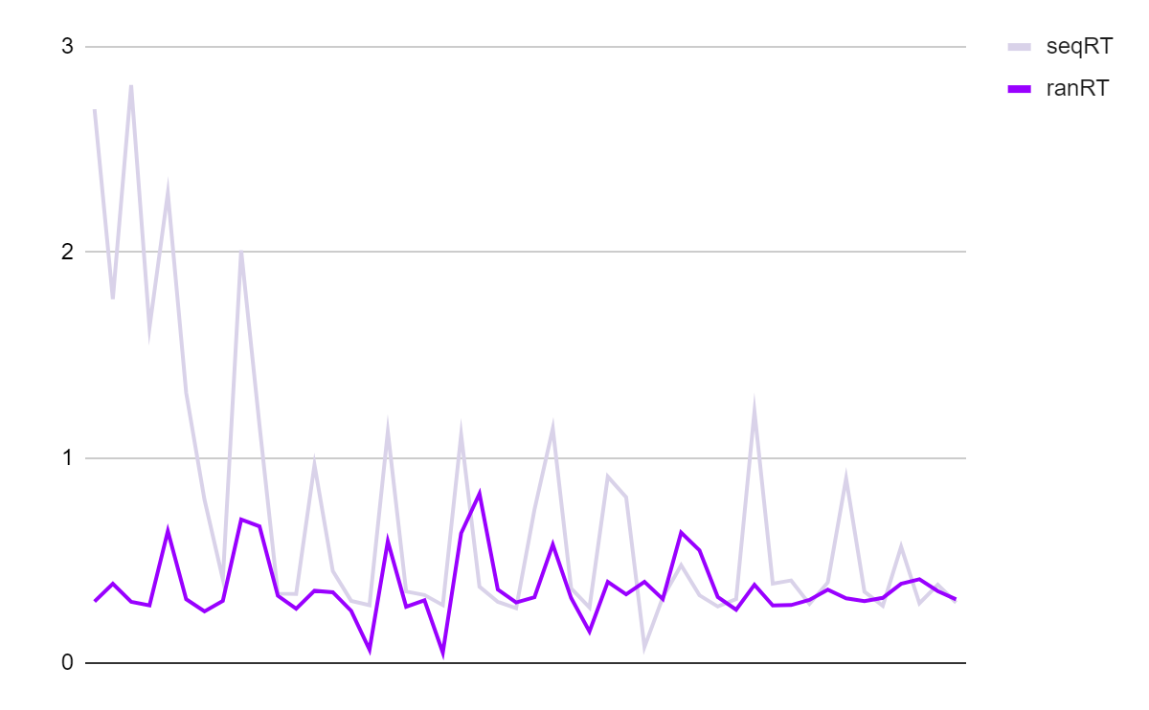

The above graph shows the change in RT across trials.

The dissociation of a movement sequence's motor control components from its spatial-sequential order is another crucial concept for comprehending motor sequence learning.The order of movements in space and time is the focus of the spatial-sequential task component, while the sensorimotor integration of movements, including the speed of individual movements and their timing, is the focus of movement dynamics.

It has been hypothesized that these parts are learned simultaneously, with distinct contributions from various brain regions.As a result, learning the motor components takes longer than learning the sequential/spatial order of movement.Improvements in motor learning are thought to be dominated in later stages by the implementation and optimization of required motor components, while improvements in the early stages are thought to be dominated by learning the sequential and spatial characteristics of the movements.

# **Discussiona**

The rapid and adaptable acquisition of a sequence during the early learning phase enables rapid performance enhancement.Improved encoding of movement in spatial coordinates is primarily responsible for this performance boost, which has an impact on the task's spatial-sequential component.

The first stage of spatial-sequential learning proceeds effector-unspecifically.Sequential movements are encoded into a spatial coordinate system, and the majority of the time, the sequence is learned without regard to the body part that performs them.However, effector-specific storage of motor information appears to occur during the later stages of learning.As a result, the efficiency with which learning is transferred between the hands is most important during the initial learning phase and decreases as learning progresses.

The "consolidation" phase is the second phase, and it is characterized by the stabilization of the learned motor sequence.Training leads to gradual improvements in performance as well as an increase in resistance to interference.The BG's capacity to break up large sequences into smaller subsequences is crucial to this procedure.

A slower rate of learning is characteristic of the transition from the early learning phase to the consolidation phase.

Because the transition between Stages II and III is so fluid, it's hard to tell them apart clearly.But learning goes through a slow, late phase called "automatization" at some point.With a slow learning rate at this point, performance will be optimized.The execution of the movement becomes "automatic," and it can be done completely implicitly or with less attention.