Question 3: Does the amount of time a student spend studying affect student’s stress and/or their health risk?

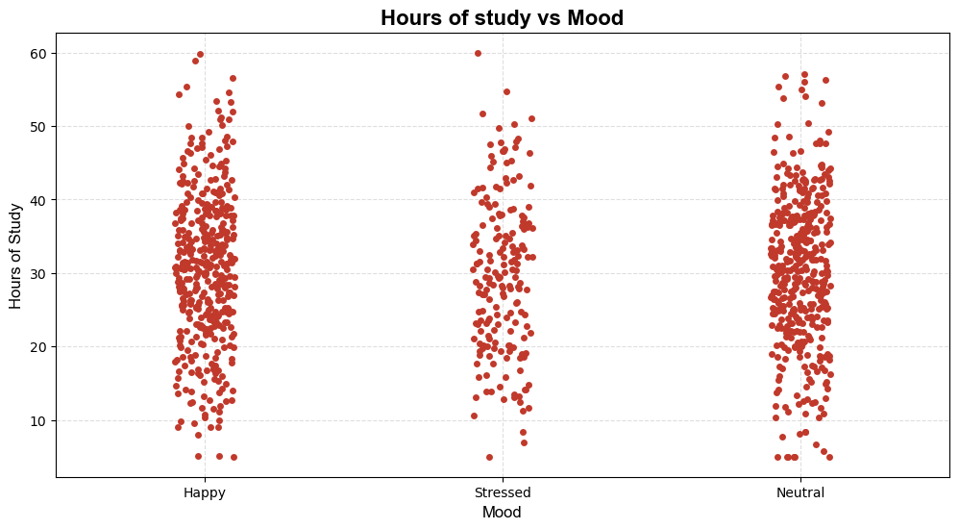
1st I have a strip plot provides the following insights:
Insights:
Mood and Study Hours: There is no strong or clear differentiation in study hours between the moods. Students with all moods (Happy, Stressed, Neutral) appear to study for a similar range of hours. Students who study excessively (above 50 hours) seem distributed across all mood categories, suggesting other factors (like stress tolerance, work-life balance, or coping strategies) may influence mood.
Data Distribution:
- Happy: A wide spread of study hours, with many students studying between 20 and 40 hours. Outliers can be seen with very high study hours (near 60).
- Stressed: Similarly distributed, with most students studying between 20 and 40 hours. A few students with high study hours may experience stress due to overcommitment.
- Neutral: Comparable distribution to the other moods, with the majority of students studying around 20-40 hours.
Possible Causes: Happy students might manage their time well, balancing study hours and relaxation. Stressed students may face challenges such as high workloads or inefficient study practices. Neutral students might not have strong emotional responses, possibly due to indifference or effective coping mechanisms.
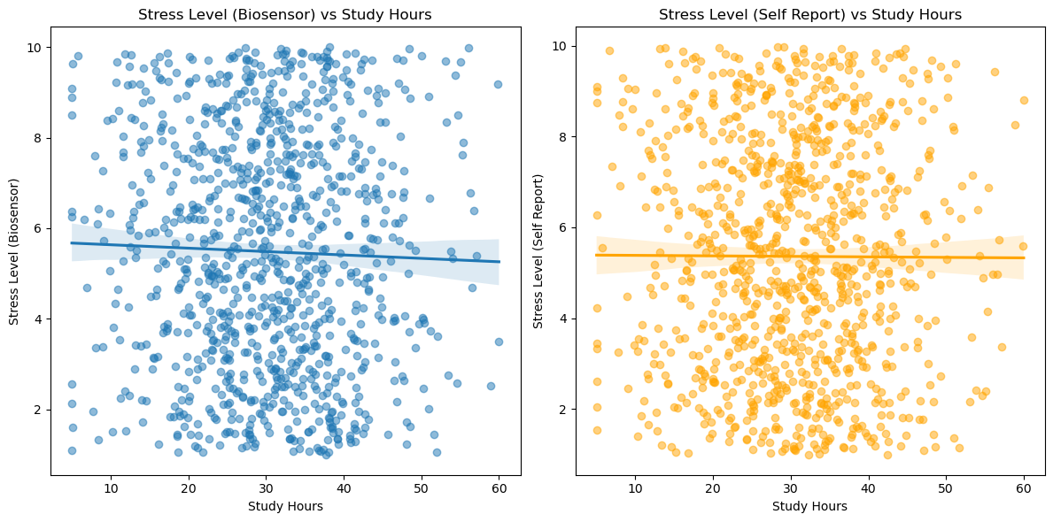
2nd I have these 2 scatter plots with regression lines provide the following insights:
Insights:
Stress Level (Biosensor) vs. Study Hours: The regression line is almost flat, indicating no strong relationship between study hours and biosensor-measured stress levels. Data points are widely scattered, suggesting variability in stress levels independent of study hours.
Stress Level (Self Report) vs. Study Hours: Similarly, the regression line shows little to no slope, indicating a weak or nonexistent relationship between study hours and self-reported stress levels. The data also shows significant dispersion, reinforcing the lack of a clear trend.
These findings suggest that the number of hours a student spends studying does not strongly influence their stress levels in this dataset
Minimal Correlation: Both biosensor-measured (-0.03) and self-reported stress levels (-0.005) show negligible correlation with study hours. This implies that study hours alone are not a strong predictor of stress levels.
Measurement Comparison: Stress levels from biosensors and self-reports appear consistent in showing no strong dependency on study hours.
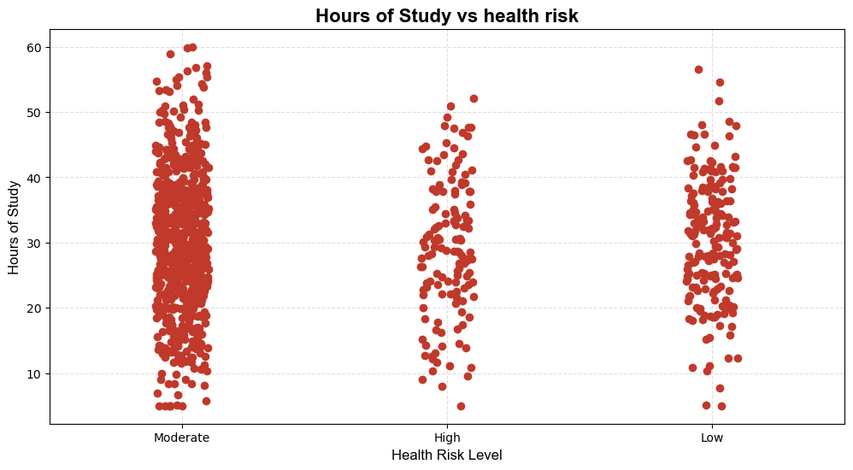
3rd I have another strip plot that provides the following insights:
Insights:
Study Hours vs. Health Risk: There doesn't appear to be a clear or strong relationship between hours of study and health risk levels. Students with moderate, high, or low health risks study for a wide range of hours, suggesting that factors other than study hours might play a larger role in determining health risk.
Measurement Comparison: Study Hours have a weak negative correlation with Health Risk Numeric (-0.03), indicating a minimal relationship.

