Aayushi

9921103231

F6

**COA-WEEK 6**

Q1

CODE:

a:

MVI A, 00h

MOV B, 45h

MOV C, 2Ah

ADD B

SUB C

HLT

OUTPUT:

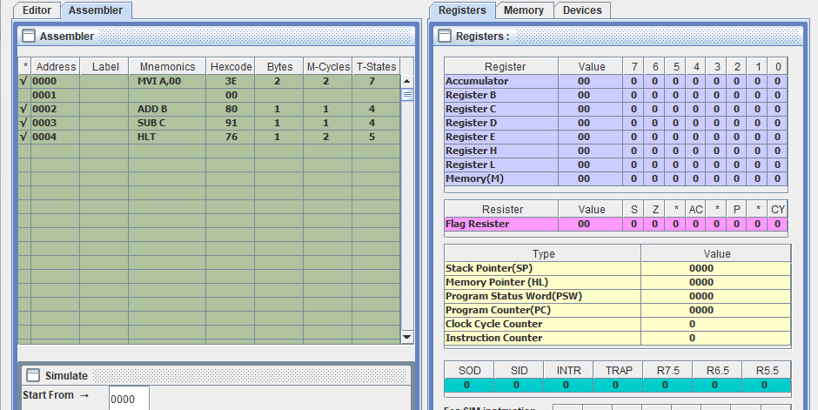

b:

CODE:

MVI A, 00h

LDA 2000H

MOV B, A

LDA 2001H

ADD B

HLT

OUTPUT:

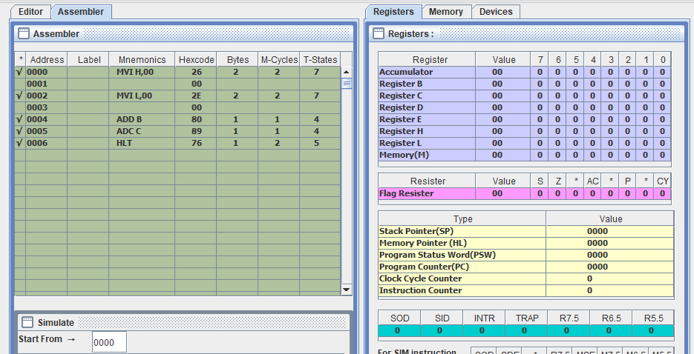

a:

CODE:

MVI H, 00h

MVI L, 00h

MOV B, 45h

MOV C, 2Ah

ADD B

ADC C

HLT

OUTPUT:

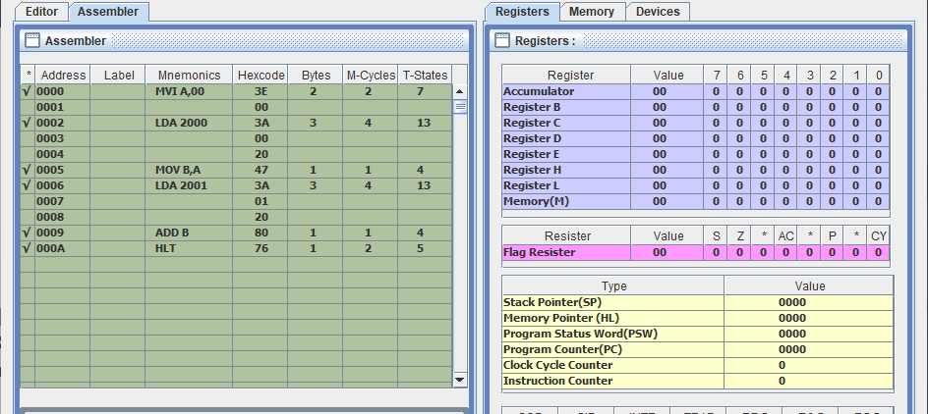

b:

CODE:

LHLD 2000H

MOV D, H

MOV E, L

LHLD 2002H

ADD D

ADC E

SHLD 3000H

HLT

OUTPUT:

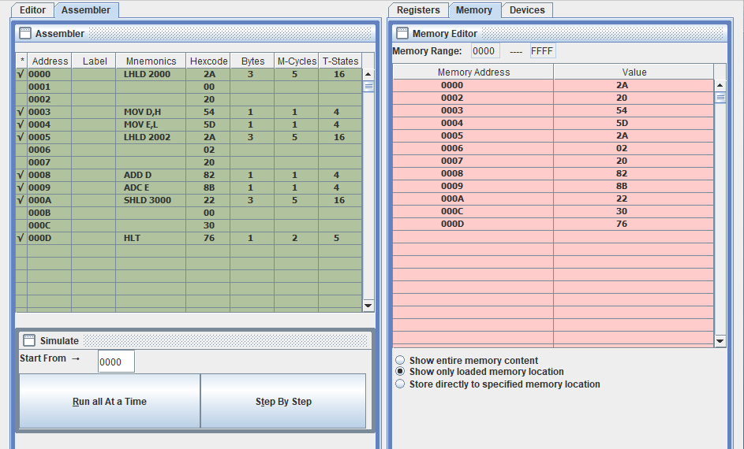

Q2

CODE:

LDA 3000H

MOV B, A

LDA 3001H

ADD B

STC

DAA

LDA 3002H

STA 3002H

RRC

LDA 3003H

RLC

STA 3003H

HLT

OUTPUT:

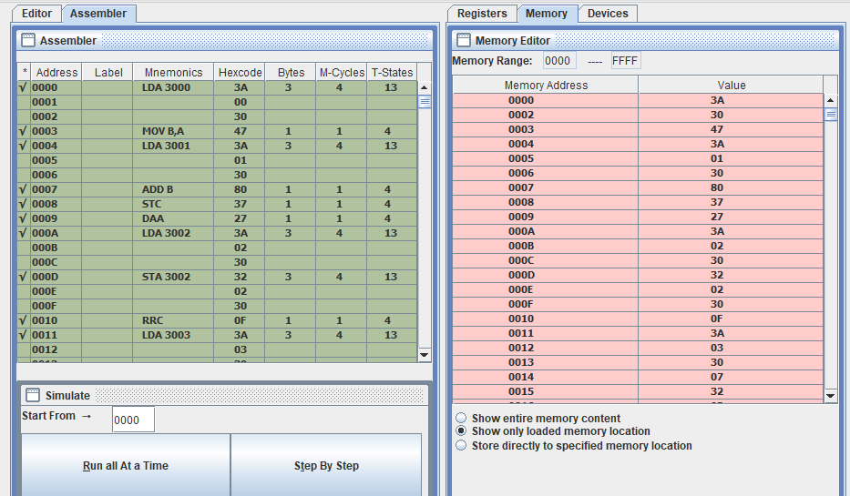

Q3

CODE:

MVI A, 00h

MVI B, 02h

MVI C, 03h

LOOP:

ADD B

DCR C

JNZ LOOP

HLT

OUTPUT:

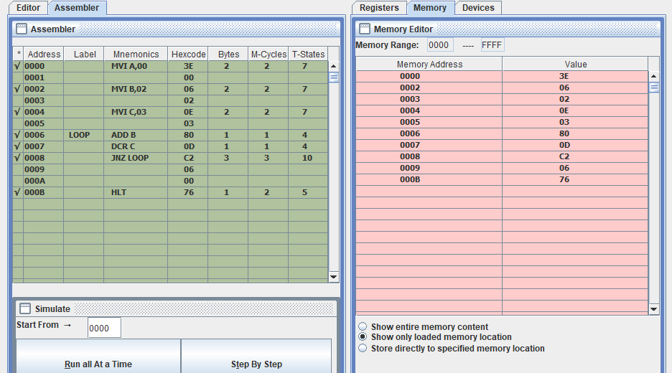

Q4

CODE:

MVI C, 0Ah

LXI H, 4000H

LXI D, 5000H

COPY_LOOP:

MOV A, M

STAX D

INX H

INX D

DCR C

JNZ COPY_LOOP

HLT

OUTPUT:

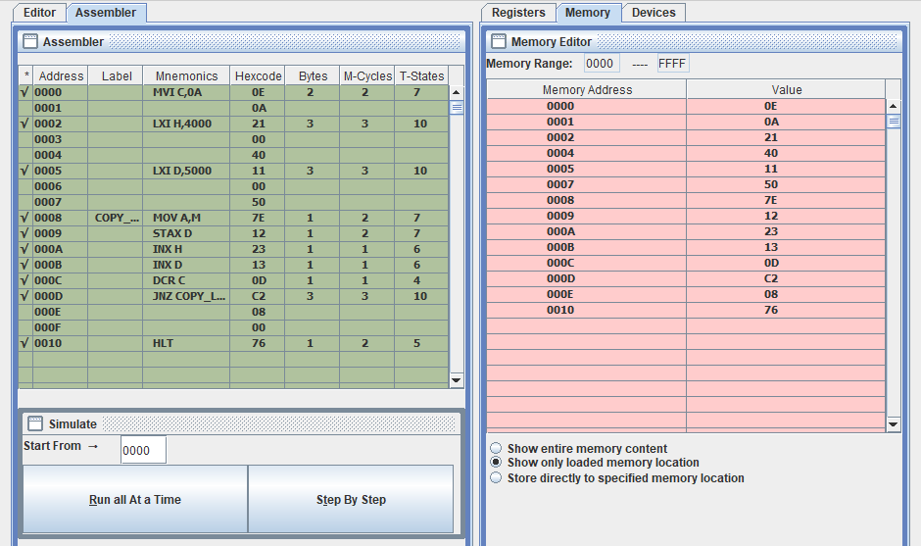

Q5

CODE:

MVI C, 0Ah

LXI H, 4000H

LXI D, 4100H

LXI B, 4200H

ADD_LOOP:

MOV A, M

ADD M

MOV M, A

INX H

INX D

INX B

DCR C

JNZ ADD_LOOP

HLT

OUTPUT:

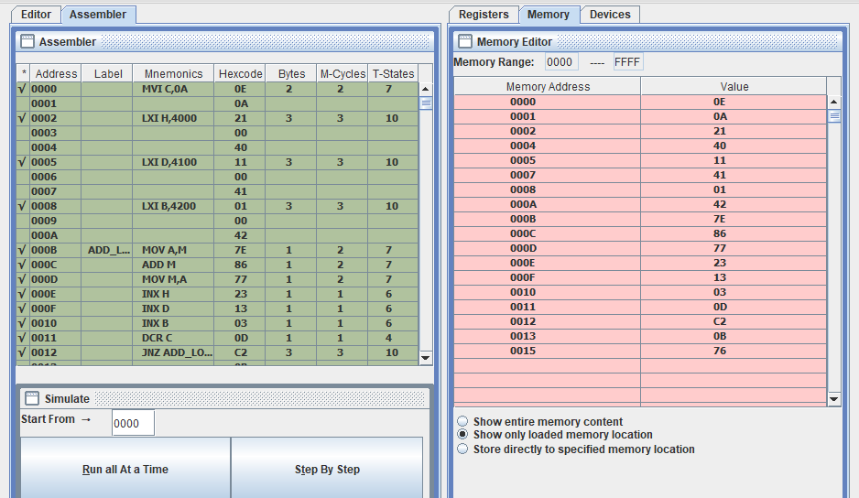

Q6

Multiplication of Two 8-bit Numbers:

CODE:

MVI A, 08h

MVI B, 07h

MVI C, 00h

MVI D, 00h

MULTIPLY_LOOP:

RAR

JC ADD_A

ADD_A:

ADD B

DAA

DCR A

JNZ MULTIPLY_LOOP

HLT

OUTPUT:

Division of Two 8-bit Numbers:

CODE:

MVI A, 24h

MVI B, 04h

MVI C, 00h

MVI D, 00h

DIVIDE_LOOP:

CMP B

JC DONE

SUB B

INR C

JMP DIVIDE_LOOP

DONE:

HLT

OUTPUT: 