POSTGRES COMMANDS

| Psql -h 127.0.0.1 -Ufran | Open connection with user fran and enter password fran1234 |
| --- | --- |
| \l | To see all the databases |
| \c <dbname> | To switch to a db |
| Inside db-->\dt | To see all the tables inside a db |
| \dn | To see a list of schemas |
| Set search_path to <schema_name> | To acess the schema and lok inside it |
| \dt aayushi.* | See all tables inside a schema |
|  |  |
|  |  |
|  |  |
|  |  |
|  |  |
|  |  |
|  |  |
|  |  |

Psql -h 127.0.0.1 -Ufran

do \l to see all the dbs

sitch to a db with \c dbname

\dt will show you all table inside this db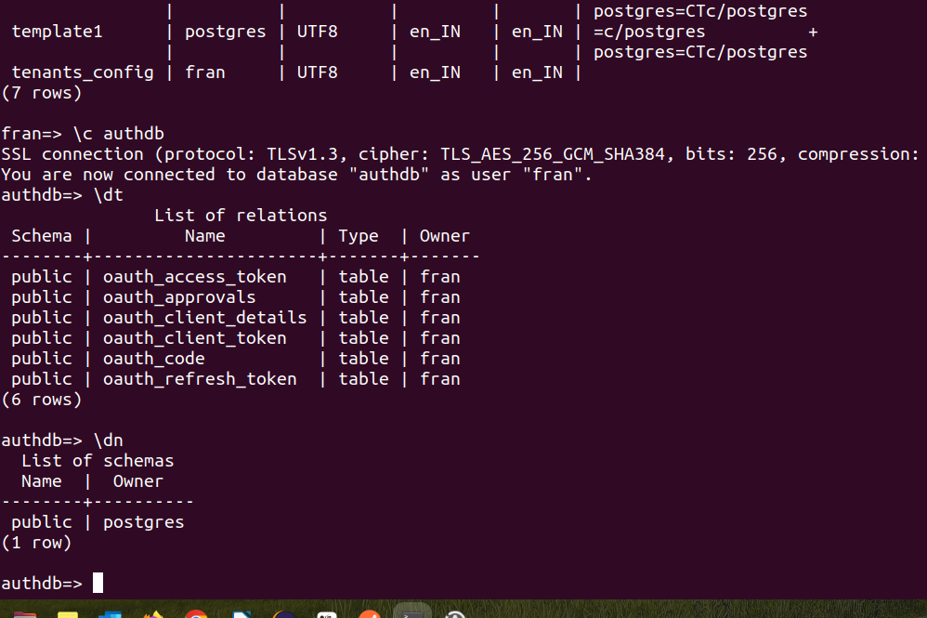

\dn will show you all the schemas inside a db

in order to see what is inside a schema you need to set a asearch path the the schema name thendo a dt

then younwill be able to see everything.

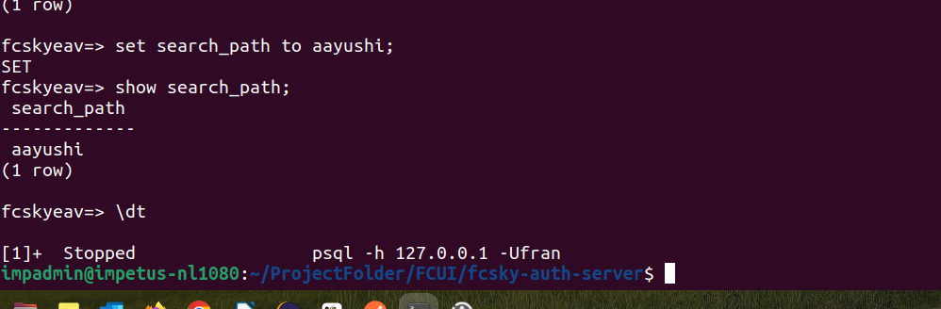

Now i have switched to the db tenants_config

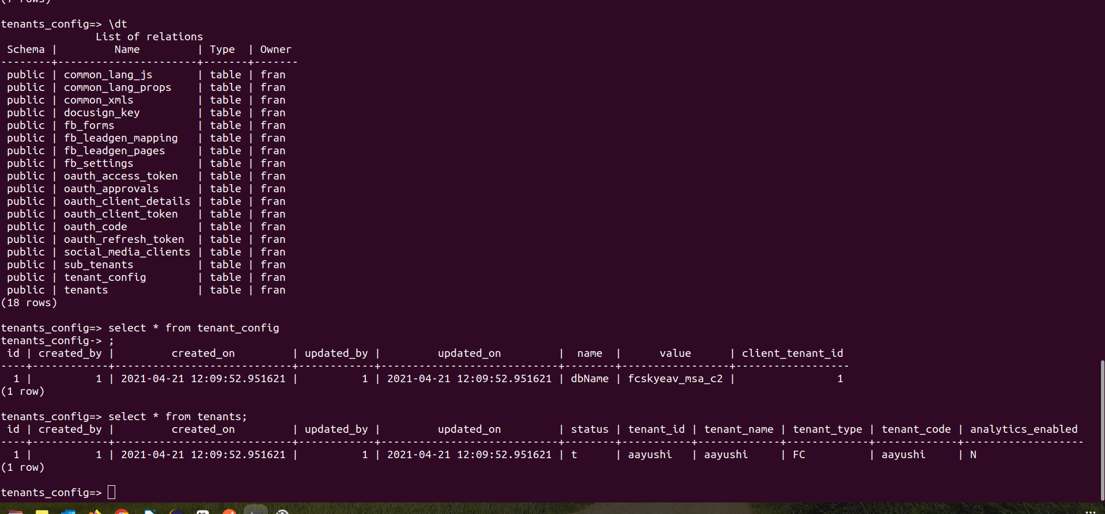

if i want to see all tales inside the schema we can do 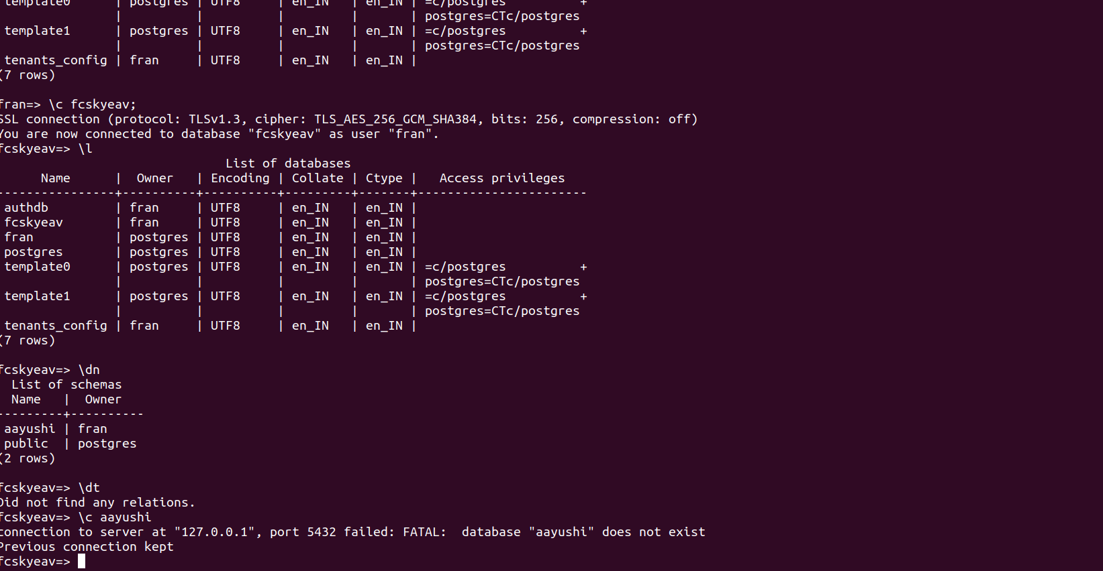

we will see the below:

aaa