MYSQL
Steps to install mysql
1.sudo apt update
2.sudo apt install mysql-server
3.sudo mysql_secure_installation
4.sudo systemctl start mysql
5.sudo systemctl enable mysql
Access mysql shell by
6.sudo mysql
Stop mysql
7.sudo systemctl stop mysql

Some handy linux command
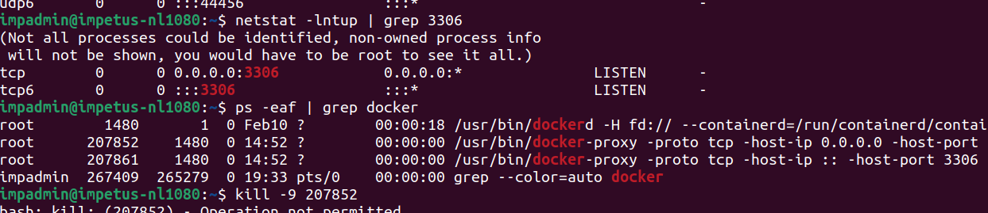
if you want to check if some port is being used

