POSTGRES COMMANDS

Psql -h 127.0.0.1 -Ufran | Open connection with user fran and enter password fran1234
\l | To see all the databases
\c <dbname> | To switch to a db
Inside db-->\dt | To see all the tables inside a db
\dn | To see a list of schemas
Set search_path to <schema_name> | To acess the schema and lok inside it
\dt aayushi.* | See all tables inside a schema

Psql -h 127.0.0.1 -Ufran

do \l to see all the dbs
sitch to a db with \c dbname

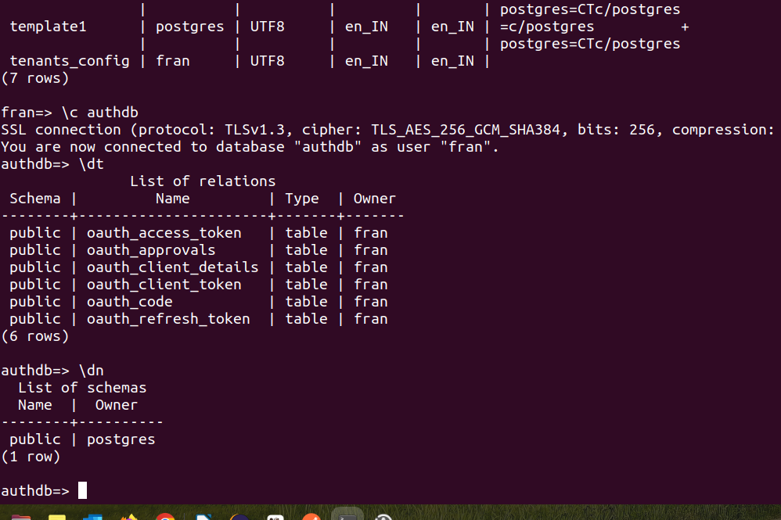
\dt will show you all table inside this db
\dn will show you all the schemas inside a db

in order to see what is inside a schema you need to set a asearch path the the schema name thendo a dt
then younwill be able to see everything.
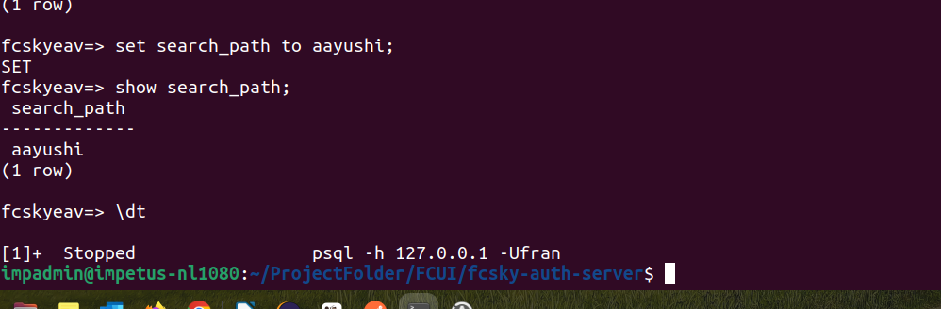

Now i have switched to the db tenants_config
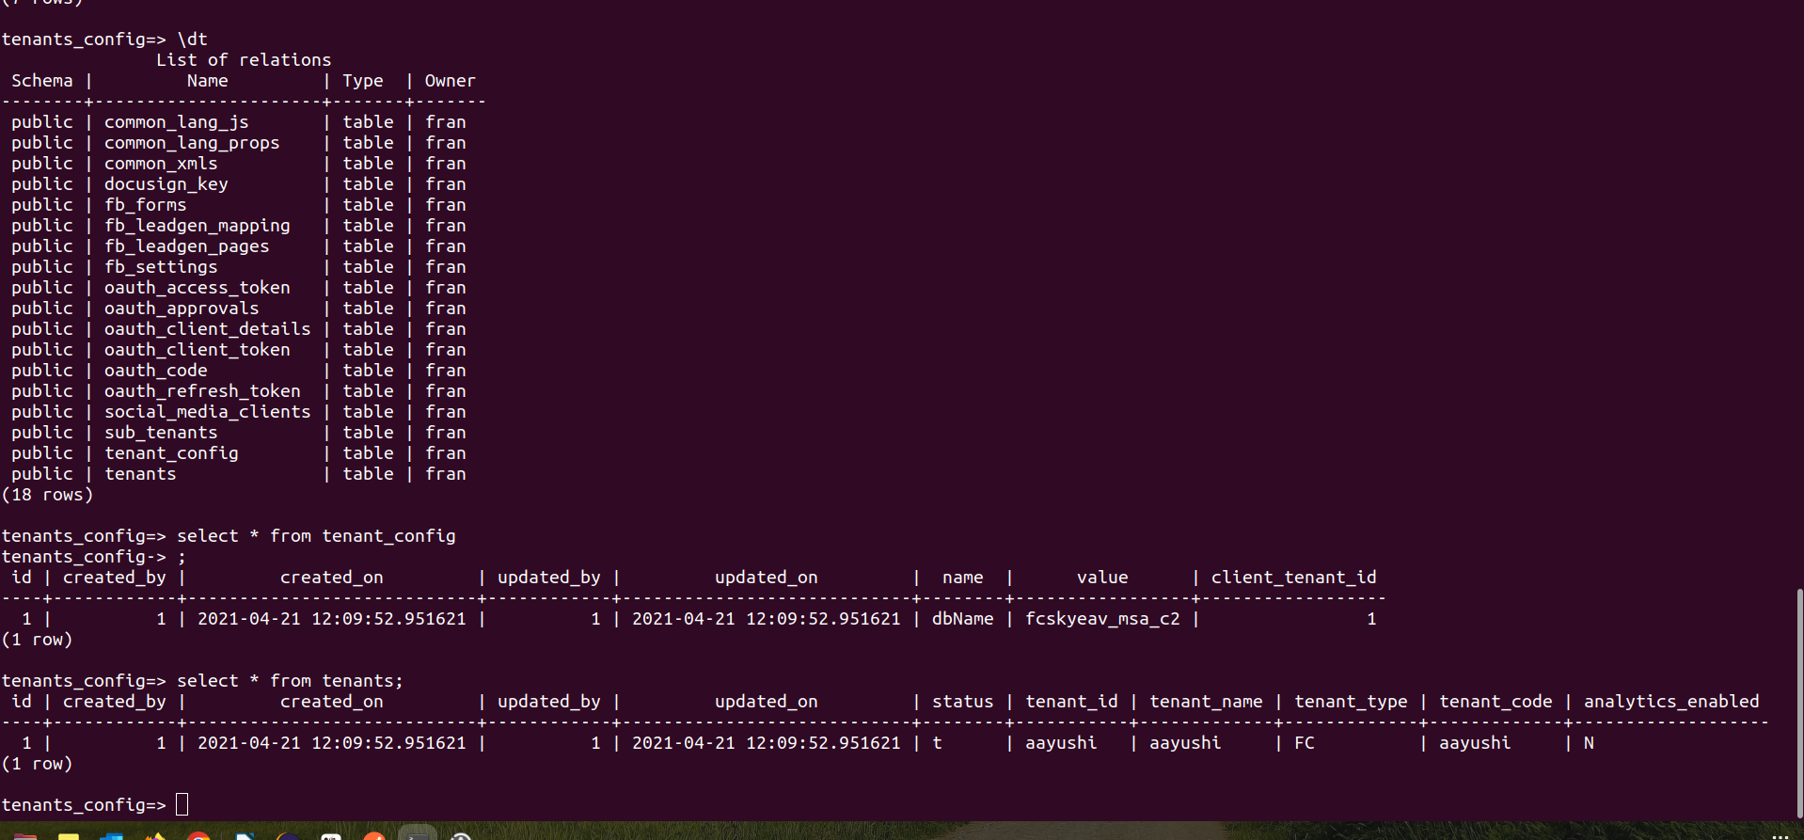
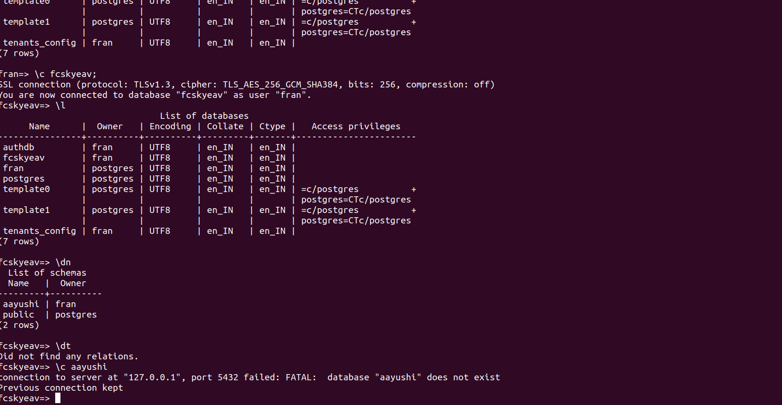
if i want to see all tales inside the schema we can do
we will see the below:

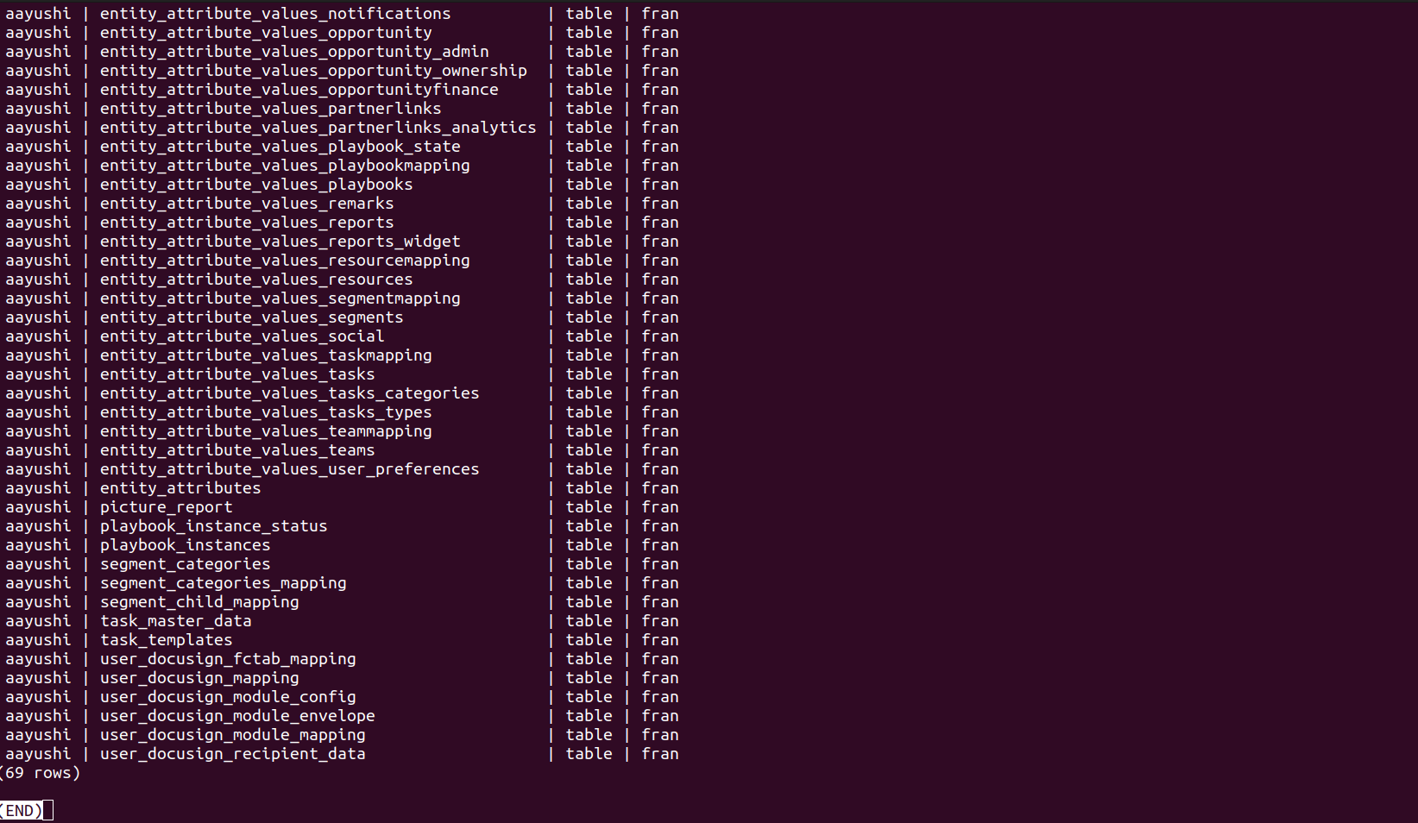
aaa

