**EFS**

Efs stands for elastic file system and it is meant to be a managed network file system that can be mounted over many ec2 that too across multi az.

It is highly available and is expensive na dyou have to pay only for the amount of usage.

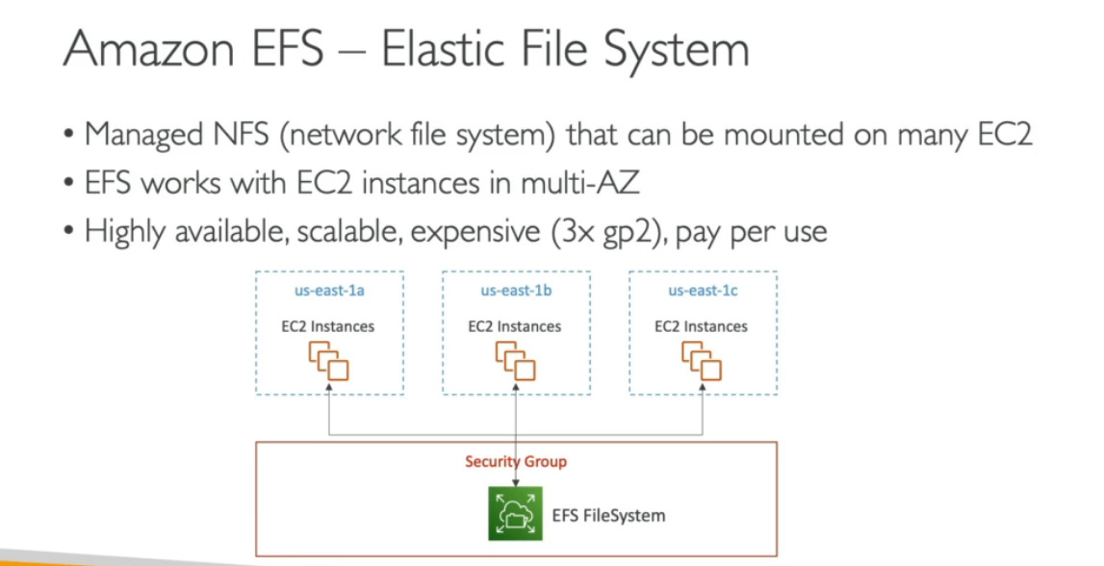

Applications of efs include :content management,web serving ,data sharing and wordpress

It uses the nfs v4.1 protocol

It uses a security group to access the efs as can be seen in dig above.

**Imp:**it is imp to note that it is only compatible with linux based ami and not with windows

It uses encryption at rest using kms

You need not to do the capacity planning the file system scales automatically and it is costed according to theusage.

**Important can come in exam :the performance and storage classes**

**Throughput**

Throughput is a way to find the efficiency of a CPU. It can be defined as the number of processes executed by the CPU in a given amount of time. For example, let's say, the process P1 takes 3 seconds for execution, P2 takes 5 seconds, and P3 takes 10 seconds. So, throughput, in this case, the throughput will be (3+5+10)/3 = 18/3 = 6 seconds

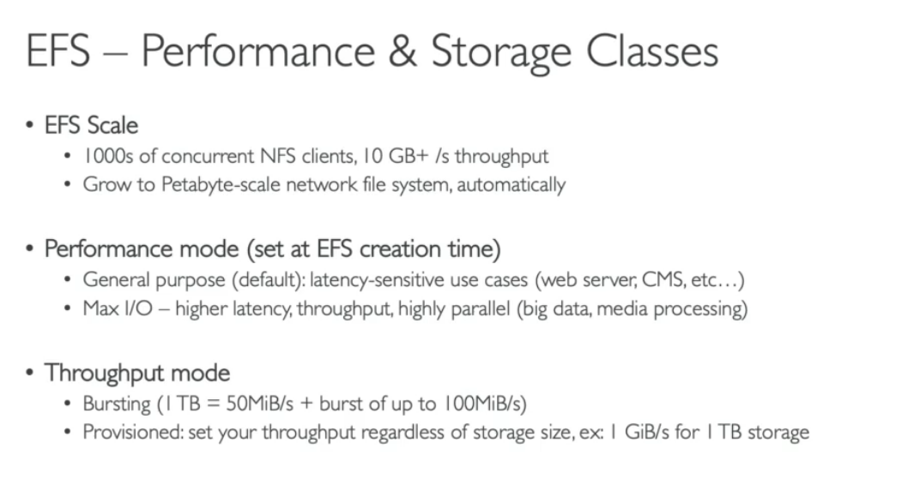

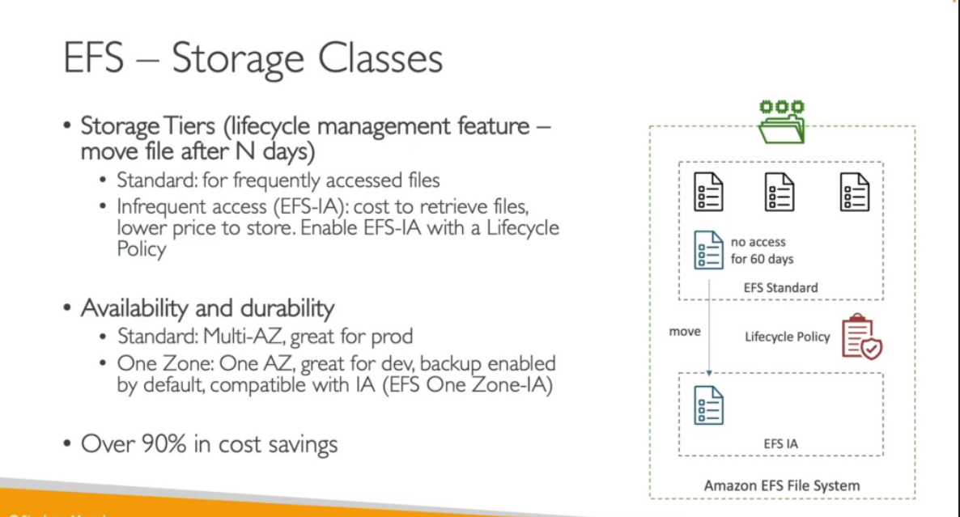

**CREATING AN EFS**

First we have to select for the efs

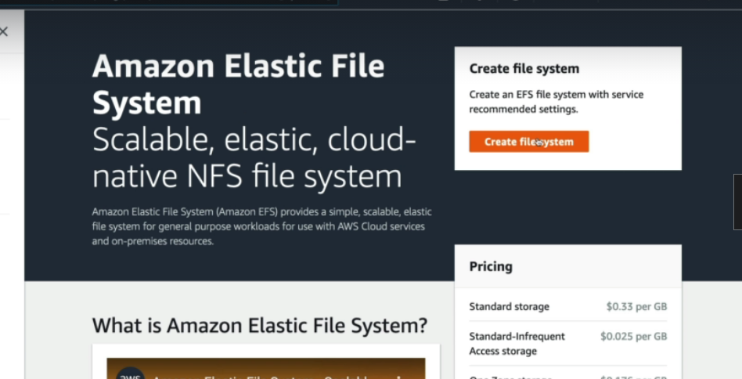

Now we have the following options to choose from :

1.**availability and durability**

In this one we have two options means if we want our application to be production ready then we will go for regional in which the data will be stored across multiple az.

The second one is the one zone in which the data will be stored in one az only and you have to selecte that region.This will be resilient to failure.This can be used for the testing purpose only.

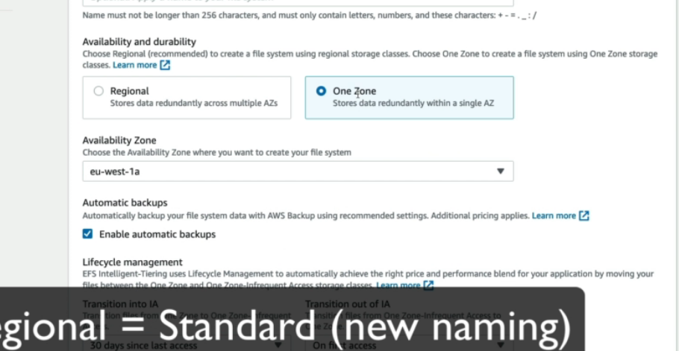

2.**automatic backup**

You can specify if you wanttoa llow automatic backup or not.

3.**Lifecycle management**

This feature is a cost saving feature in which we specify to move our data to an infrequent access storage if it is not being accessd for some amount of time.and also we can set when it needs to transition out of the ia means when it is first accessed.

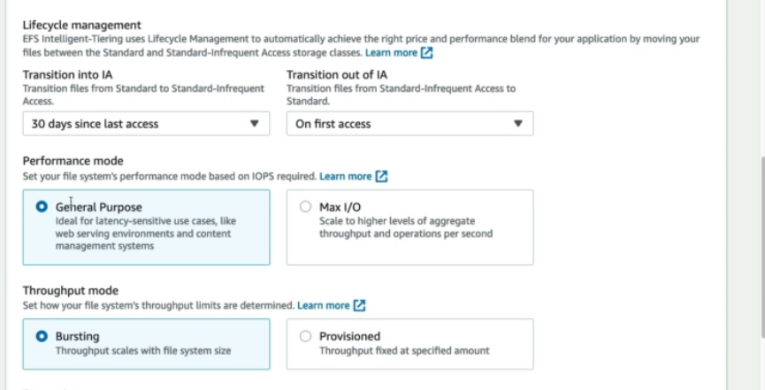

4.**performance mode**

We have two options in this in which if we speak of general purpose then it is ideal for latency sensitive use cases like web serving environments and content management system.

And max io is used in case we have big data applications where we need to do a lot of input an doutput operation

**5.Throughput mode**