**LOAD BALANCING**

**WHAT IS LOAD BALANCING**

Load balancers are the servers that forware traffic to multiple servers downstream.

The client sending the request need not to know to which server is it forwarding its request to.

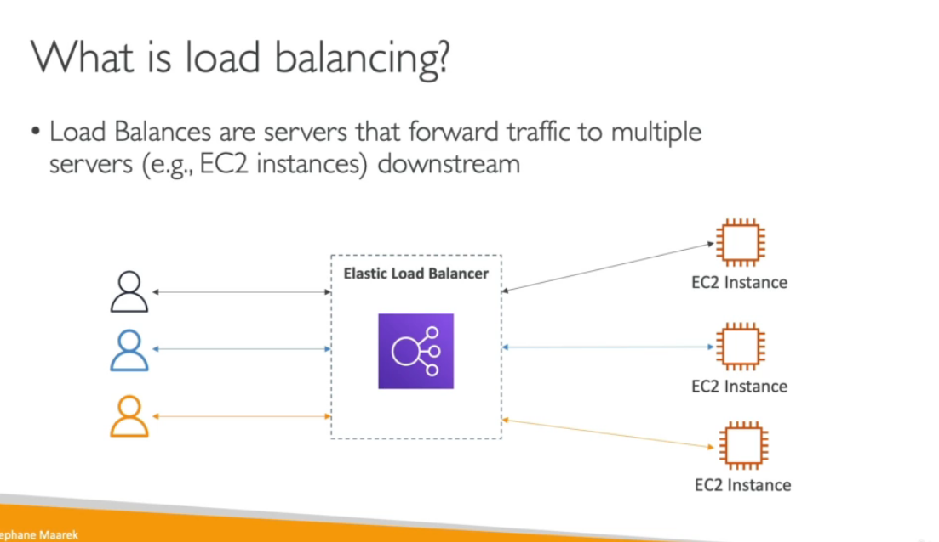

**WHY DO WE USE AN ELASTIC LOAD BALANCER**

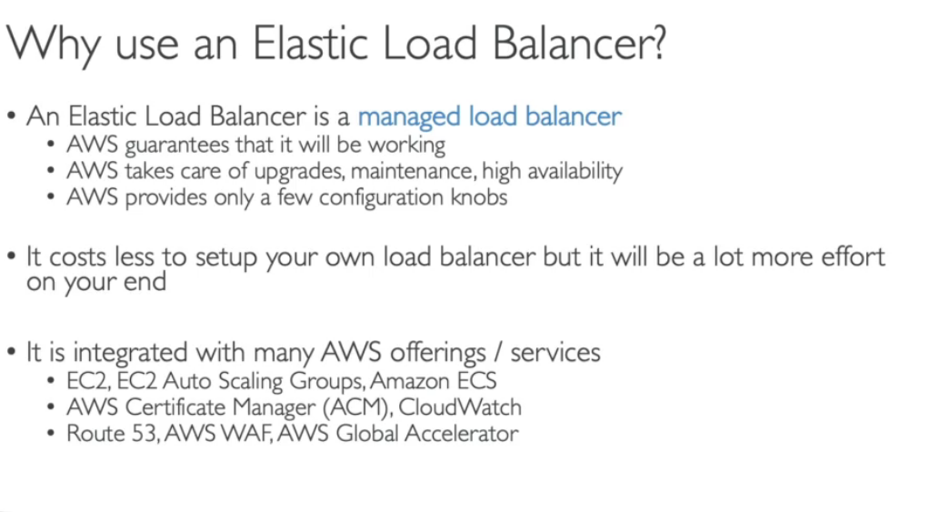

**HEALTH CHECK**

Health check is a way for your load balancer to know if an ec2 instance is up and running or not.

Because if an ec2 instance is not running then the load balancer should not send any traffic to that instance.

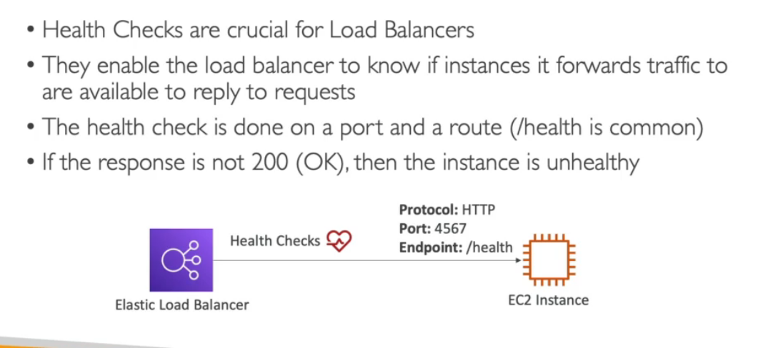

**TYPES OF LOAD BALANCERS**

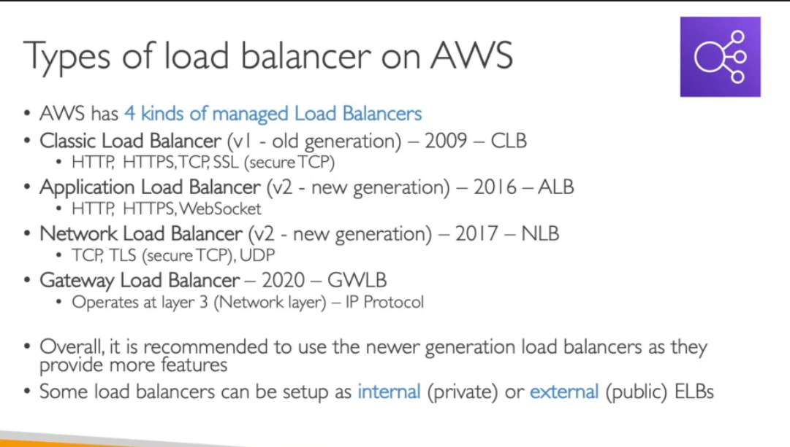

**LOAD BALANCER SECURITY GROUP**

Users can access the load balancer from anywhere and it can be accessed via http/https.but they will not have access to our ec2 instance.

Now there will be a security group attached to our ec2 that will only allow traffic from a certain security group which is linked to a load balancer.

