**APPLICATION LOAD BALANCER**

Alb is a layer7 load balancer means it works at http.

It can load balance across multiple ec2.And the group of those ec2 is known as target groups.

We can also do load balancing to multiple application son the same machine in case of containerization.

It also support redirect from http to https.

**Routing**

A load balancer can route to different path as it maintains routing table to different target groups.

It has a port mapping feature to redirect to a dynamic port in ecs

**TARGET GROUPS**

The target groups can be one of the following:

1.thay can be ec2 instances

2.can be ecs tasks

Lambda functions

Ip addresses

Alb can route to multiple target groups.

ple as shown below:

We can create two target groups in which we can route the traffic coming for mobile as query string to the target group1 and traffic coming for platfprm=desktop to the second target group which is a private ip on premise servers.

**GOOD TO KNOW**

OUR ALB will have an ip assigned to it.

The servers behind the load balancer will not be able to see the ip address of the client.

The true ip of the client can be inserted in the x-forwarded for header and we can also get port from x-forwarded-port and protocol from the x-forwarded-proto header.

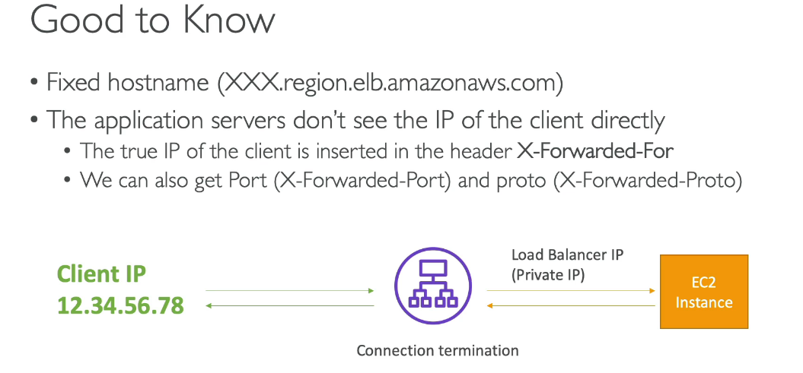

**ALB HANDS ON**

1.firt launch ec2 insatnces with some user data.we can proced without key pair.for target group we will do http and ssh traffic into our instance allowed.Launch these two instances.

Check if instances are up and running

2.Now we want only one url to access both of these ec2 instances.

So we go to load balancers.

Now we start creating the load balancer

In the network mapping we need to state where do we want our alb to be deployed into.

Now we need to assign security group to our alb.

**Now we have to set where on alb we want to listen the requests and then forward it to where.**

So now we will be creatinga target group which will be containing our ec2 instances.

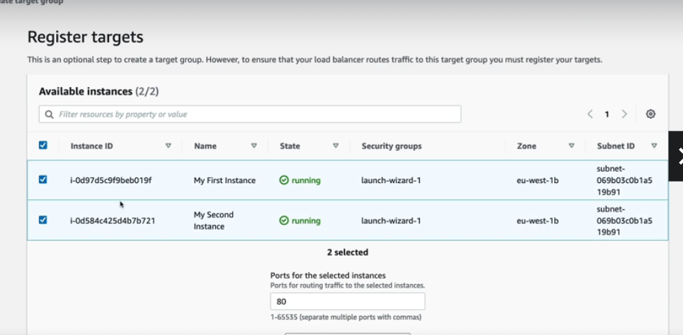

Now the load balancer is ready and a dns name is available to us to access the target groups behind.

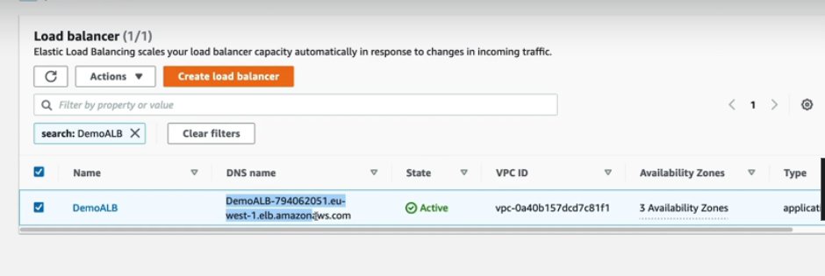

If we go to our target group and check for targets then we will see that both our instances are healthy

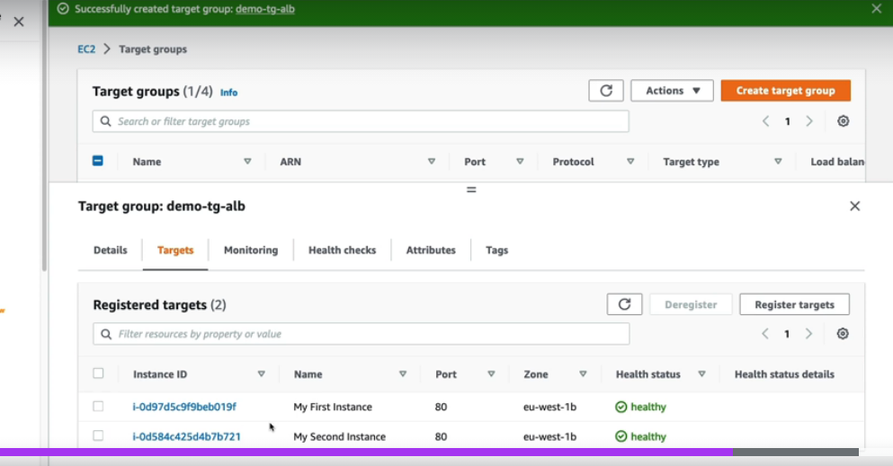

**MAKING THE EC2 BE ONLY ACCESSIBLE O THE LOAD BALANCERE**

We need to make the security group of ec2 such that it should only allow http from the security group of load balancer

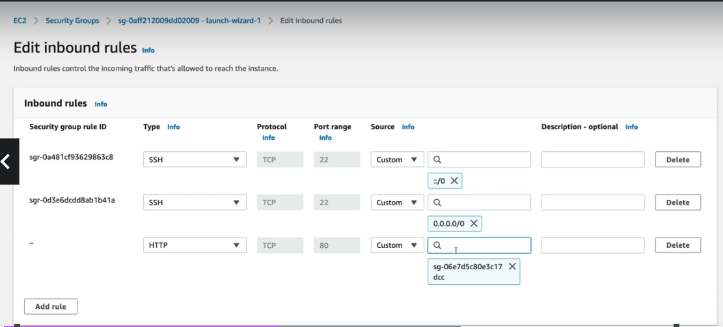

2.**ALB RULES FOR REQUEST PARAMETER**

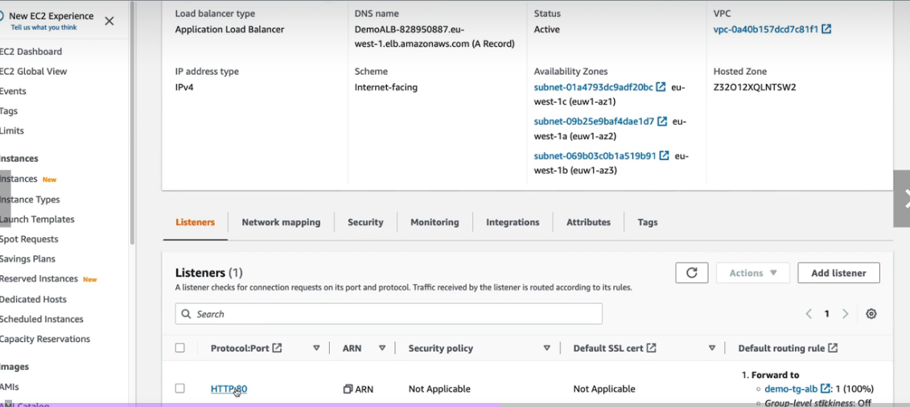

Go to the alb and then go under listeners.

We see that the rule says that all the request from our alb is targeted towards our demo target alb group which is our ec2 instancs.

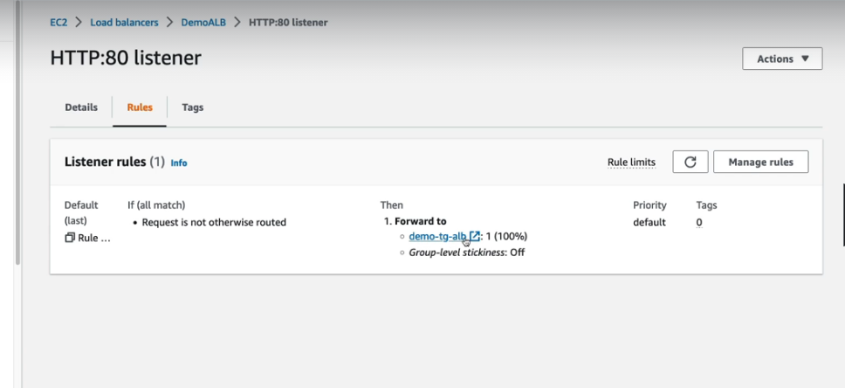

We will add rules as shown below for the different paths



