**NETWORK LOAD BALANCER**

**FOR EXAM**

We need to keep in mind that when there is a request for tcpor udp it is the nlb.

Secondly if exam tests you on that you need to have some specific ips for your application then you need to thik for the nlb.

Also remember that nlb has one static ip per az.

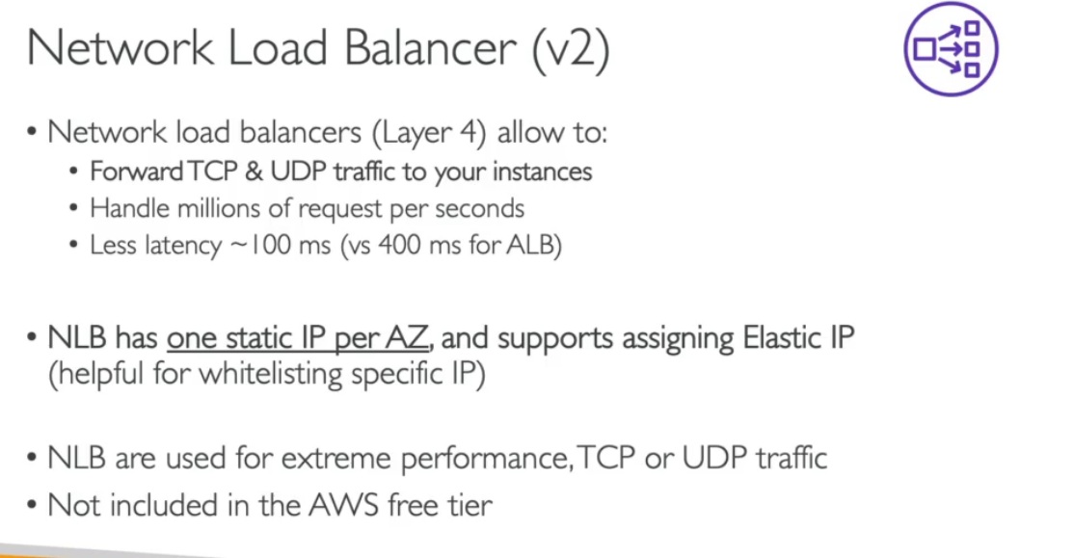

**WHAT CAN BE THE TARGET GROUPS FOR AN NLB**

The target groups for an nlb can be a set of ec2 instances or some ip addresses and they must be private ips and also it can be an application load balancer

Also it is imp to keep in mind that the health checks supported by nlb are tcp,http,https protocols.

